学号 E21514033 专业 软件工程 姓名 何铭春

实验日期 **4.12**  教师签字 成绩

实验报告

【实验名称】 Java实验一

【实验目的】

1. 基本的Java程序实验
2. 使用Java中Scanner输入
3. 学会分离类和测试类

【实验原理】

1. 使用Java类结构分离类和主函数。
2. 在类中设置函数供主函数调用

【实验内容】

类定义：

import java.util.Scanner;

//用星型输出等腰三角形

class TriangleH{

int border;

public void show(){

Scanner reader = new Scanner(System.in);

System.out.println("请输入底边长：");

border = reader.nextInt();

int showCounter = border;

int Counter = 0;

while(showCounter>0){

for(int i=0;i<Counter;i++){

System.out.print(" ");

}

for(int i=0;i<showCounter;i++){

System.out.print("*");

}

System.out.println("");

showCounter = showCounter - 2;

Counter = Counter + 1;

}

}

}

//个人信息类

class Personal{

String ID = "JT2011023";

String name = "张三";

String sex = "男";

int hign = 168;

double weight = 54.3;

public void printTheInformation(){

System.out.print("学号：");

System.out.println(ID);

System.out.print("姓名：");

System.out.println(name);

System.out.print("性别：");

System.out.println(sex);

System.out.print("身高：");

System.out.print(hign);

System.out.println("cm");

System.out.print("体重：");

System.out.print(weight);

System.out.println("kg");

}

}

//圆锥类计算体积

class Circular{

double r;

double h;

double v;

public double calculate(){

Scanner reader = new Scanner(System.in);

System.out.println("请输入圆锥的半径：");

r = reader.nextDouble();

System.out.println("请输入圆锥的高：");

h = reader.nextDouble();

v = 3.14*r*r*(1.0/3)*h;

return v;

}

}

//判断三条边是否形成三角形

class Triangle{

double border1;

double border2;

double border3;

public boolean juggle(){

Scanner reader = new Scanner(System.in);

System.out.println("请输入第一条边的长度：");

border1 = reader.nextDouble();

System.out.println("请输入第二条边的长度：");

border2 = reader.nextDouble();

System.out.println("请输入第三条边的长度：");

border3 = reader.nextDouble();

boolean flag = false;

if (border1 + border2 > border3){

if (border1 + border3 > border2){

if (border2 + border3 > border1){

flag =true;

}

}

}

return flag;

}

}

//显示两个浮点数四则运算结果哦

class Calculate{

double num1;

double num2;

public void show(){

Scanner reader = new Scanner(System.in);

System.out.println("请输入第一个数：");

num1 = reader.nextDouble();

System.out.println("请输入第二个数：");

num2 = reader.nextDouble();

System.out.print("加法的结果：");

System.out.println(num1+num2);

System.out.print("减法的结果：");

System.out.println(num1-num2);

System.out.print("乘法的结果：");

System.out.println(num1*num2);

System.out.print("除法的结果：");

System.out.println(num1/num2);

}

}

//圆柱体面积和体积计算

class Cylinder{

double r;

double h;

double v;

double s;

public void set(){

Scanner reader = new Scanner(System.in);

System.out.println("请输入底边半径：");

r = reader.nextDouble();

System.out.println("请输入高的长度：");

h = reader.nextDouble();

}

public double getV(){

v = Math.PI*r*r*h;

return v;

}

public double getS(){

s = Math.PI*r*r*2 + 2*Math.PI*r*h;

return s;

}

}

//输出三位数中的水仙花数

class Daffodil{

static int num;

public static void set(int aNum){

num = aNum;

}

public static boolean juggle(){

int a = num / 100;

int b = (num % 100)/10;

int c = num % 100 % 10;

int temp = a*a*a + b*b*b + c*c*c;

if (temp == num){

return true;

}

else {

return false;

}

}

public static void show(){

for (int i=100; i<=999; i++) {

Daffodil.set(i);

if (Daffodil.juggle()) {

System.out.print(i+"\t");

}

}

}

}

//输出数列

class Fibonacci{

static int first = 1;

static int second = 1;

public static void show(){

System.out.print(Fibonacci.first+" ");

System.out.print(Fibonacci.second+" ");

int lastLast = Fibonacci.first;

int last = Fibonacci.second;

for (int i=0;i<18;i++){

int now = lastLast + last;

System.out.print(now+" ");

lastLast = last;

last = now;

}

}

}

//输出乘法表

class Multiplication{

public static void show(){

int counter = 1;

for (int i=1;i<=counter;i++){

for (int j=1;j<=i;j++){

System.out.print(counter);

System.out.print("*");

System.out.print(j);

System.out.print("=");

System.out.print(counter*j);

System.out.print("\t");

}

System.out.println("");

if (counter < 9){

counter ++;

}

}

}

}

测试类代码：

import java.util.Scanner;

public class Test {

public static void main(String[] args){

System.out.println("第一题：");

TriangleH hmc = new TriangleH();

hmc.show();

System.out.print("\n");

System.out.println("第二题：");

Personal test = new Personal();

test.printTheInformation();

System.out.print("\n");

System.out.println("第三题：");

Circular aTest = new Circular();

System.out.println(aTest.calculate());

System.out.print("\n");

System.out.println("第四题：");

Triangle bTest = new Triangle();

System.out.println(bTest.juggle());

System.out.print("\n");

System.out.println("第五题：");

Calculate cTest = new Calculate();

cTest.show();

System.out.print("\n");

System.out.println("第六题：");

Cylinder dTest = new Cylinder();

dTest.set();

System.out.println(dTest.getS());

System.out.println(dTest.getV());

System.out.print("\n");

System.out.println("第七题：");

Daffodil.show();

System.out.print("\n");

System.out.println("第八题：");

Fibonacci.show();

System.out.print("\n");

System.out.println("第九题：");

Multiplication.show();

System.out.print("\n");

}

}

实验结果：

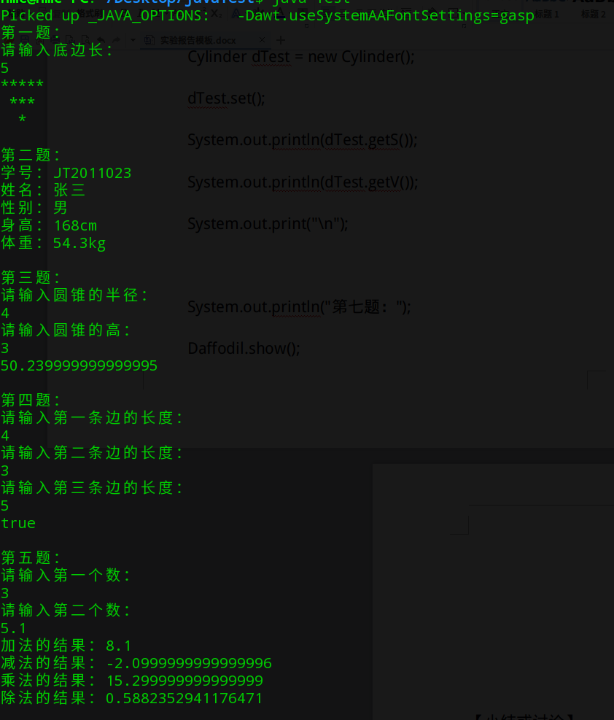

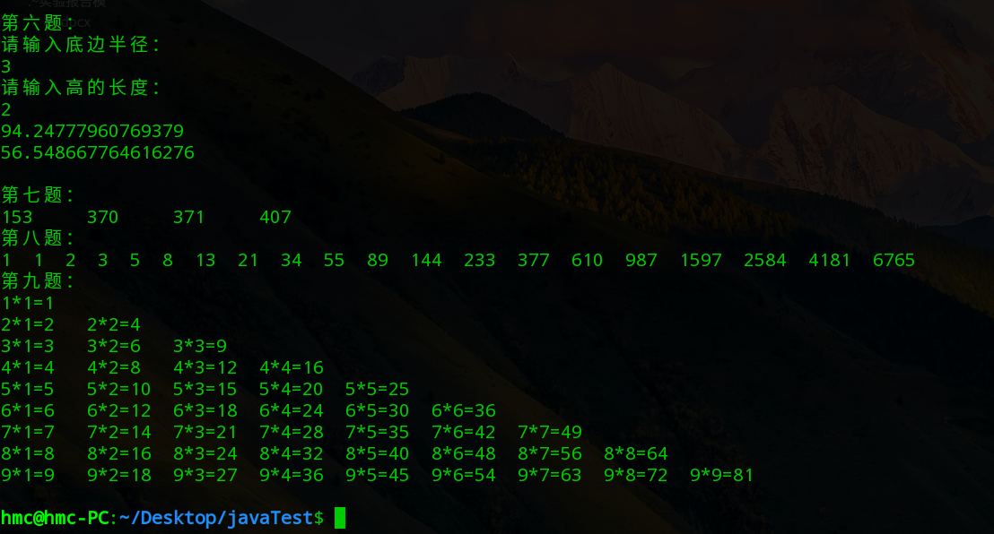

【小结或讨论】

1. 将Java类和测试分开，整理文件结构。
2. 熟悉Java输入和输出。