学号 E21514033 专业 软件工程 姓名 何铭春

实验日期 **2018.5.24**  教师签字 成绩

实验报告

【实验名称】 Java实验六

【实验目的】

1. 熟悉图形界面编程
2. 理解Java底层运算原理

【实验原理】

Swing图形技术

【实验内容】

题目一：

实验截图：

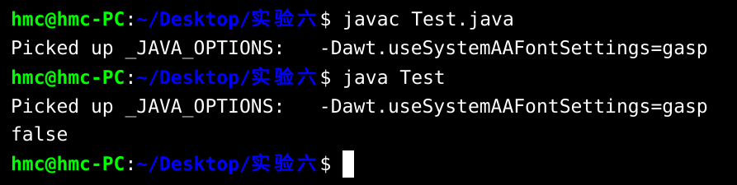

题目二：

实验截图：

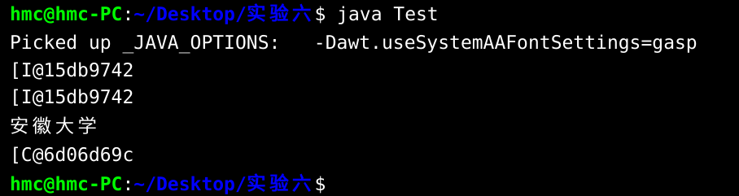

题目三：

实验截图：

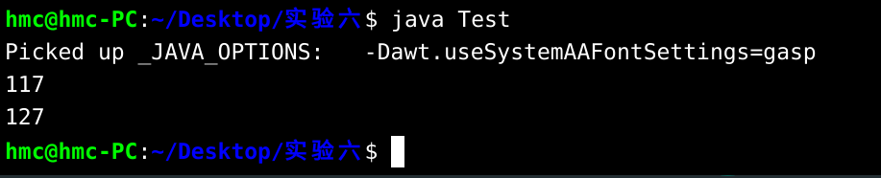

题目四：计算器

源代码：

import javax.swing.*;

import static javax.swing.JFrame.*;

import java.awt.event.*;

import java.awt.*;

import java.io.*;

import java.text.*;

class MyJFrame extends JFrame{

MyJFrame(String s,int x,int y,int w,int h){

setLayout(new FlowLayout());

setTitle(s);

setBounds(x,y,w,h);

setDefaultCloseOperation(EXIT_ON_CLOSE);

}

}

class CalculateHandler implements ActionListener {

JTextArea first;

JTextArea second;

JComboBox op;

JTextArea show;

public void setJTextArea(JTextArea first, JTextArea second,JTextArea show){

this.first = first;

this.second = second;

this.show = show;

}

public void setJComBox(JComboBox op){

this.op = op;

}

public void actionPerformed(ActionEvent e) {

NumberFormat nbf=NumberFormat.getInstance();

nbf.setMinimumFractionDigits(2);

double firstNumber = 0;

double secondNumber = 0;

int flag = 0;

try {

firstNumber = Double.parseDouble(first.getText());

secondNumber = Double.parseDouble(second.getText());

} catch(Exception error) {

show.append("输入错误\n");

flag = 1;

}

double answer = 0;

String choose = (String)op.getSelectedItem();

if (flag == 0) {

try {

if (choose == "+") {

answer = firstNumber + secondNumber;

}

else if (choose == "-") {

answer = firstNumber - secondNumber;

}

else if (choose == "*") {

answer = firstNumber * secondNumber;

}

else if (choose == "/") {

answer = firstNumber / secondNumber;

}

show.append(nbf.format(firstNumber)+" "+(String)op.getSelectedItem()+" "+nbf.format(secondNumber)+" = "+nbf.format(answer)+"\n");

} catch(Exception error) {

show.append("发生错误");

}

}

}

}

public class Test {

public static void main(String[] args) {

JFrame hmc = new MyJFrame("简单计算器", 400, 400, 600, 600);

hmc.setLayout(new FlowLayout());

Box firstLine = Box.createHorizontalBox();

JTextArea first = new JTextArea(2,10);

// hmc.add(new JScrollPane(first));

// hmc.add(first);

String[] op = {"+","-","*","/"};

JComboBox opBox = new JComboBox<>(op);

opBox.setPreferredSize(new Dimension(150, 30));

// hmc.add(opBox);

JTextArea second = new JTextArea(2,10);

// hmc.add(new JScrollPane(first));

// hmc.add(second);

JButton calculate = new JButton("计算");

// hmc.add(calculate);

firstLine.add(Box.createHorizontalStrut(10));

firstLine.add(first);

firstLine.add(Box.createHorizontalStrut(10));

firstLine.add(opBox);

firstLine.add(Box.createHorizontalStrut(10));

firstLine.add(second);

firstLine.add(Box.createHorizontalStrut(10));

firstLine.add(calculate);

firstLine.add(Box.createHorizontalStrut(10));

Box secondLine = Box.createHorizontalBox();

JTextArea answer = new JTextArea(20,20);

// hmc.add(answer);

secondLine.add(Box.createHorizontalStrut(10));

secondLine.add(answer);

secondLine.add(Box.createHorizontalStrut(10));

Box whole = Box.createVerticalBox();

whole.add(Box.createVerticalStrut(10));

whole.add(firstLine);

whole.add(Box.createVerticalStrut(20));

whole.add(secondLine);

whole.add(Box.createVerticalStrut(20));

hmc.add(whole);

//事件

CalculateHandler listener = new CalculateHandler();

listener.setJTextArea(first, second, answer);

listener.setJComBox(opBox);

calculate.addActionListener(listener);

hmc.pack();

hmc.setVisible(true);

}

}

实验截图：

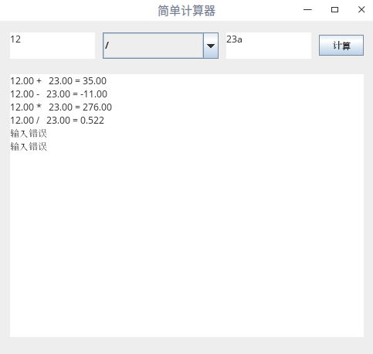

【小结或讨论】

1. 图形编程实践
2. 使用Box布局方式，类似网页