学号 E21514033 专业 软件工程 姓名 何铭春

实验日期 **12.12**  教师签字 成绩

实验报告

【实验名称】 设备管理

【实验目的】

理解设备管理的概念和任务，掌握独占设备的分配、回收等主要算法的原理并编程实现。

【实验原理】

分配设备，首先根据I/O请求中物理设备名查找系统设备表SDT。从中找出该设备的DCT，再根据DCT中设备状态字段，可知该设备是否忙碌。若忙，便将进程挂到设备队列上；否则，按照一定的算法，计算本次设备分配的安全性。

【实验内容】

1.数据结构：

DCT表中数据类型，dtype类型，busy是否忙碌，queue队列

class dev():

def __init__(self,dtype,deviceid,busy,counter):

self.dtype=dtype

self.id=deviceid

self.busy=busy

self.counter=counter

self.queue={}

设备类型表，dtype：类型，amount剩余数量

class devClass():

def __init__(self,dtype,amount,counter,number):

self.dtype=dtype

self.amount=amount

self.counter=counter

self.number=number

SDT表中数据，dtype类型，DCT：连接到DCT表

class devSystem():

def __init__(self,dtype,id,DCT):

self.dtype=dtype

self.id=id

self.DCT=DCT

2.输出函数

def printIt(self):

if self.busy==0:

busyStr="空闲"

else:

busyStr="忙碌"

print("设备类型：%-15s\t编号：%-4d\t %-10s"%(self.dtype,self.id,busyStr))

3.addDev函数，添加新的设备

addDev(DCT,SDT,DCCT)

4.addWork函数，添加作业

5.deleteWork函数，删除作业

def deleteWork(workList,DCT,DCCT):

workInt=int(input("请输入要结束的作业编号："))

for i in workList:

if workInt==i.wid:

choose=i

break

DCCT["screen"].amount=DCCT["screen"].amount+choose.dtype1

DCCT["DVD"].amount=DCCT["DVD"].amount+choose.dtype2

DCCT["printer"].amount=DCCT["printer"].amount+choose.dtype3

for i in DCT:

if i.id in choose.devList:

i.busy=0

实验截图：

①添加设备

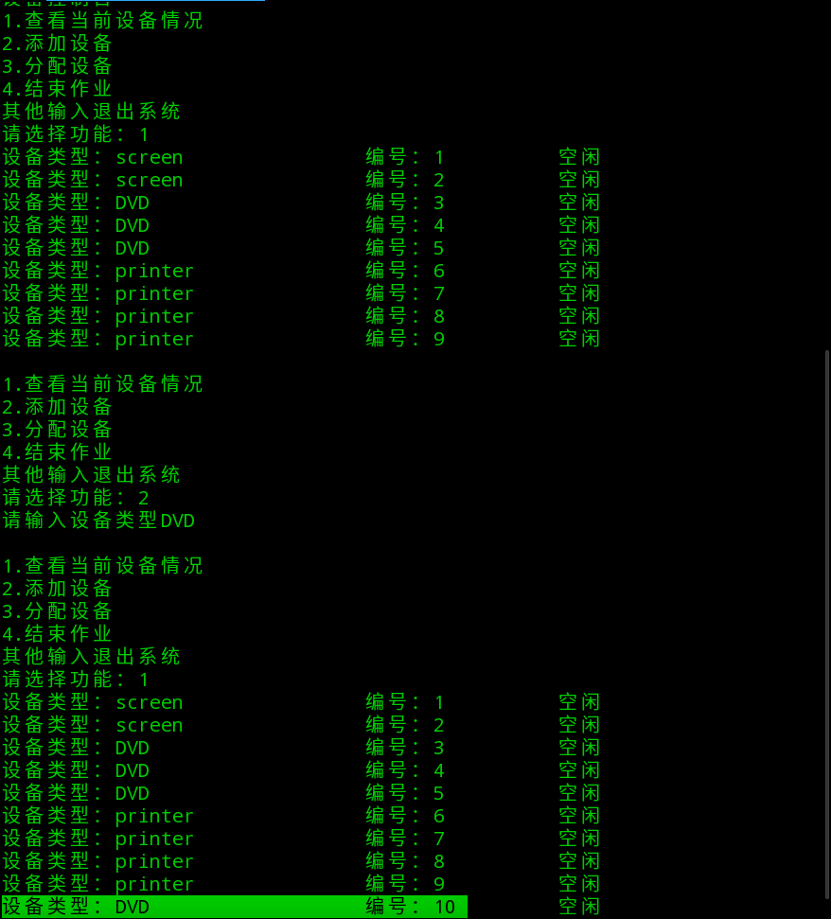

②添加作业：

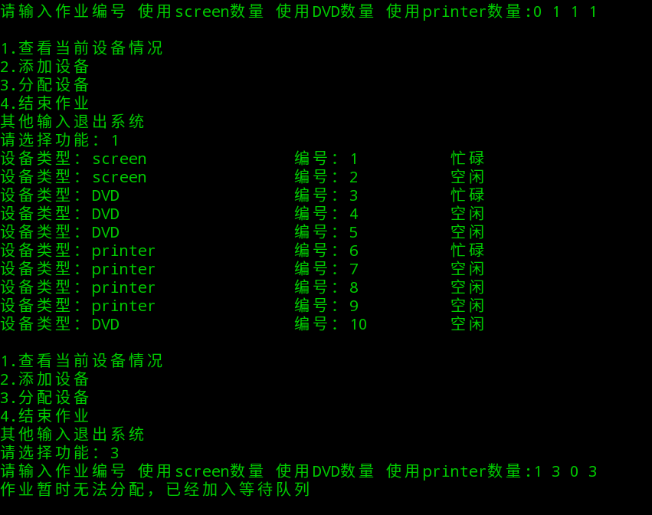

③结束作业

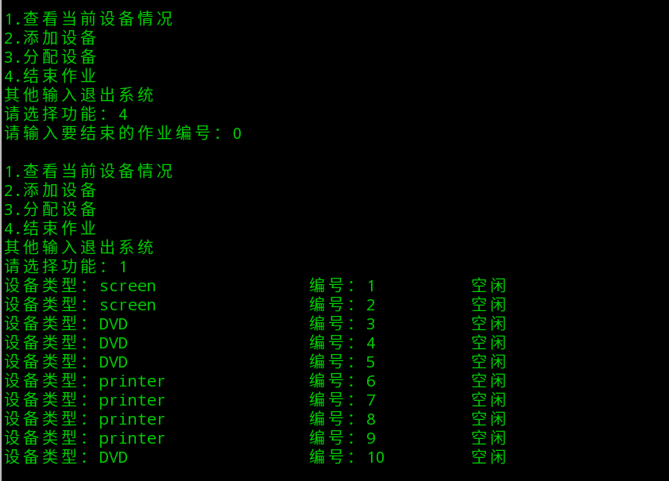

【小结或讨论】

1.按照课本上建立相应的表结构和表中数据，通过查找表方式分配设备和添加设备。

2.设置队列，当作业无法分配时加入等待队列。

3.新增作业结构，用于释放相应设备。

完整源代码：

class dev():

def __init__(self,dtype,deviceid,busy,counter):

self.dtype=dtype

self.id=deviceid

self.busy=busy

self.counter=counter

self.queue={}

def printIt(self):

if self.busy==0:

busyStr="空闲"

else:

busyStr="忙碌"

print("设备类型：%-15s\t编号：%-4d\t %-10s"%(self.dtype,self.id,busyStr))

class devClass():

def __init__(self,dtype,amount,counter,number):

self.dtype=dtype

self.amount=amount

self.counter=counter

self.number=number

class devSystem():

def __init__(self,dtype,id,DCT):

self.dtype=dtype

self.id=id

self.DCT=DCT

global DCT

DCT=[]

global SDT

SDT=[]

global DCCT

DCCT={}

global workList

workList=[]

screen=devClass("screen",2,6,2)

DVD=devClass("DVD",3,12,3)

printer=devClass("printer",4,20,4)

DCCT["screen"]=screen

DCCT["DVD"]=DVD

DCCT["printer"]=printer

dev1=dev("screen",1,0,6)

dev2=dev("screen",2,0,6)

dev3=dev("DVD",3,0,12)

dev4=dev("DVD",4,0,12)

dev5=dev("DVD",5,0,12)

dev6=dev("printer",6,0,20)

dev7=dev("printer",7,0,20)

dev8=dev("printer",8,0,20)

dev9=dev("printer",9,0,20)

DCT.append(dev1)

DCT.append(dev2)

DCT.append(dev3)

DCT.append(dev4)

DCT.append(dev5)

DCT.append(dev6)

DCT.append(dev7)

DCT.append(dev8)

DCT.append(dev9)

dS1=devSystem("screen",1,"dev1")

dS2=devSystem("screen",2,"dev2")

dS3=devSystem("DVD",3,"dev3")

dS4=devSystem("DVD",4,"dev4")

dS5=devSystem("DVD",5,"dev5")

dS6=devSystem("printer",6,"dev6")

dS7=devSystem("printer",7,"dev7")

dS8=devSystem("printer",8,"dev8")

dS9=devSystem("printer",9,"dev9")

SDT.append(dS1)

SDT.append(dS2)

SDT.append(dS3)

SDT.append(dS4)

SDT.append(dS5)

SDT.append(dS6)

SDT.append(dS7)

SDT.append(dS8)

SDT.append(dS9)

def addDev(DCT,SDT,DCCT):

dtype=input("请输入设备类型")

num=len(DCT)+1

tempdev=dev(dtype,num,0,DCCT[dtype].counter)

DCT.append(tempdev)

temp="dev"+str(num)

tempdS=devSystem(dtype,num,temp)

DCCT[dtype].amount=DCCT[dtype].amount+1

DCCT[dtype].number=DCCT[dtype].number+1

class work():

def __init__(self,wid,dtype1,dtype2,dtype3):

self.wid=wid

self.dtype1=dtype1

self.dtype2=dtype2

self.dtype3=dtype3

self.devList=[]

def addWork(workList,DCT,DCCT):

while True:

workStr=input("请输入作业编号 使用screen数量 使用DVD数量 使用printer数量:")

tempList=workStr.split(" ")

for i in workList:

if i.wid==int(tempList[0]):

print("与已存在作业编号相同")

break

if int(tempList[1])<DCCT["screen"].amount and int(tempList[2])<DCCT["DVD"].amount and int(tempList[3])<DCCT["printer"].amount:

tempWork=work(int(tempList[0]),int(tempList[1]),int(tempList[2]),int(tempList[3]))

DCCT["screen"].amount=DCCT["screen"].amount-int(tempList[1])

DCCT["DVD"].amount=DCCT["DVD"].amount-int(tempList[2])

DCCT["printer"].amount=DCCT["printer"].amount-int(tempList[3])

for i in range(0,int(tempList[1])):

for i in DCT:

if i.busy==0 and i.dtype=="screen":

tempWork.devList.append(i.id)

i.busy=1

break

for i in range(0,int(tempList[2])):

for i in DCT:

if i.busy==0 and i.dtype=="DVD":

tempWork.devList.append(i.id)

i.busy=1

break

for i in range(0,int(tempList[3])):

for i in DCT:

if i.busy==0 and i.dtype=="printer":

tempWork.devList.append(i.id)

i.busy=1

break

workList.append(tempWork)

break

else:

print("作业暂时无法分配，已经加入等待队列")

break

def deleteWork(workList,DCT,DCCT):

workInt=int(input("请输入要结束的作业编号："))

for i in workList:

if workInt==i.wid:

choose=i

break

DCCT["screen"].amount=DCCT["screen"].amount+choose.dtype1

DCCT["DVD"].amount=DCCT["DVD"].amount+choose.dtype2

DCCT["printer"].amount=DCCT["printer"].amount+choose.dtype3

for i in DCT:

if i.id in choose.devList:

i.busy=0

def main():

global DCT

global SDT

global DCCT

print("设备控制台")

while True:

print("1.查看当前设备情况")

print("2.添加设备")

print("3.分配设备")

print("4.结束作业")

print("其他输入退出系统")

choose=int(input("请选择功能："))

if choose==1:

for i in DCT:

i.printIt()

print("")

elif choose==2:

addDev(DCT,SDT,DCCT)

print("")

elif choose==3:

addWork(workList,DCT,DCCT)

print("")

elif choose==4:

deleteWork(workList,DCT,DCCT)

print("")

else:

print("退出")

break

main()