1. Go to http://www.lakesideconstructioneasttexas.com/wp-admin/
User name: DallasHerring
PW: Batman78

2. Open 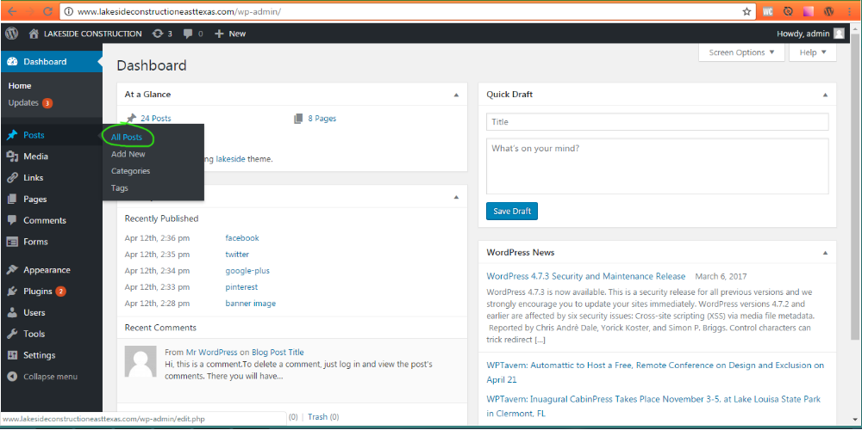 “All Posts”;

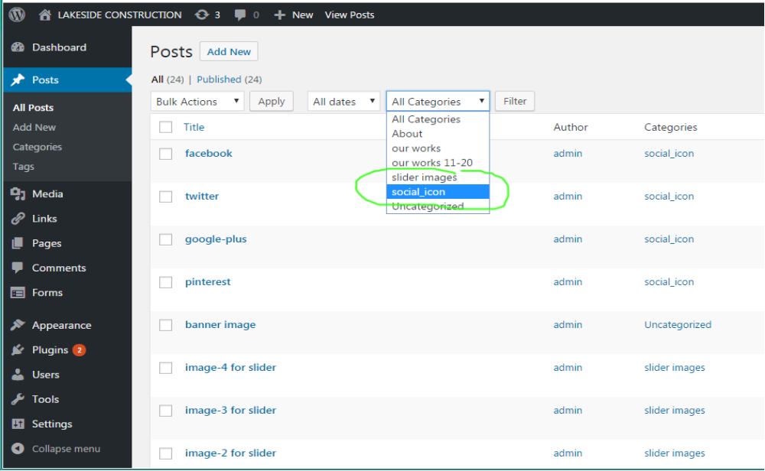3. Use filter by categories (for social link select “social_icon” , and press button “Filter”):

4. Click “Edit”:
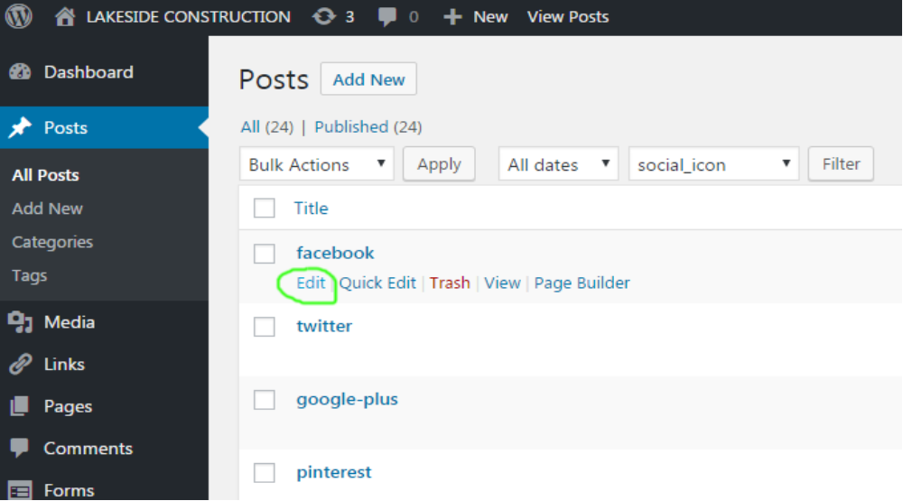

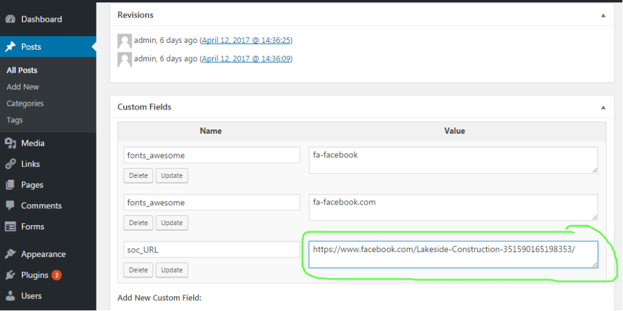5. Scroll down (to “Custom fields” section), and edit your link:

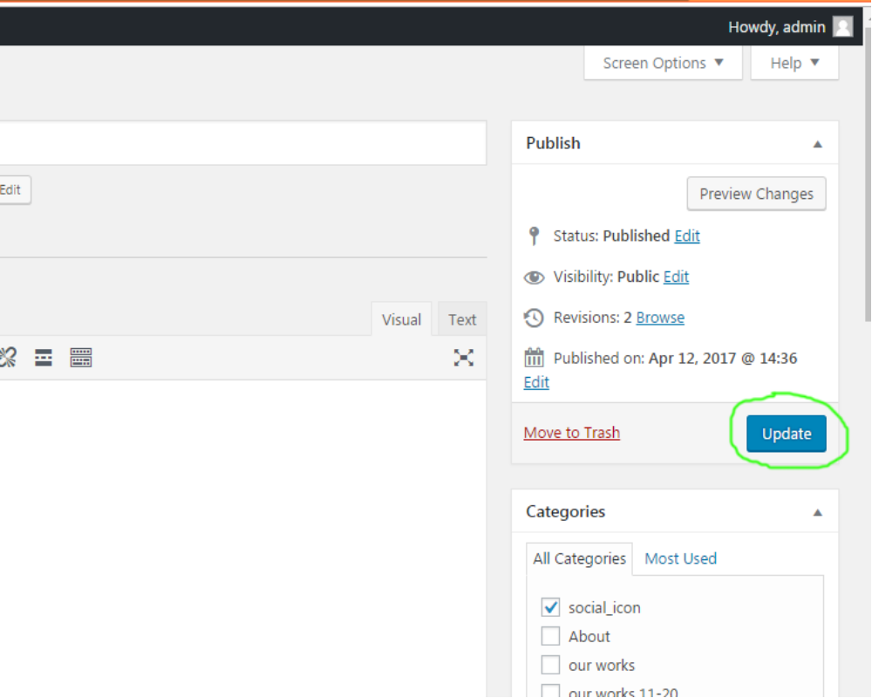6. Scroll to top, and press button “Update”:

