Thermidity

Battery powered Thermometer and Hygrometer

Contents
Description 1
Components 2
Usage 3
Technical Specification 4
Technical Details 5
Comparison with other Thermometers and Hygrometers 6
Troubleshooting 7
Safety Notes 7
References 8

Description

Thermidity is a simple thermometer and hygrometer. During its development, particular effort was made for good readability of the display, high accuracy, low power consumption and using few but high-quality components.
The ability to update the software allows for future adjustments and improvements.
All components used are RoHS compliant.
Lead-free solder was used in the production of this thermometer.

Made with 💜 by Dode

Components

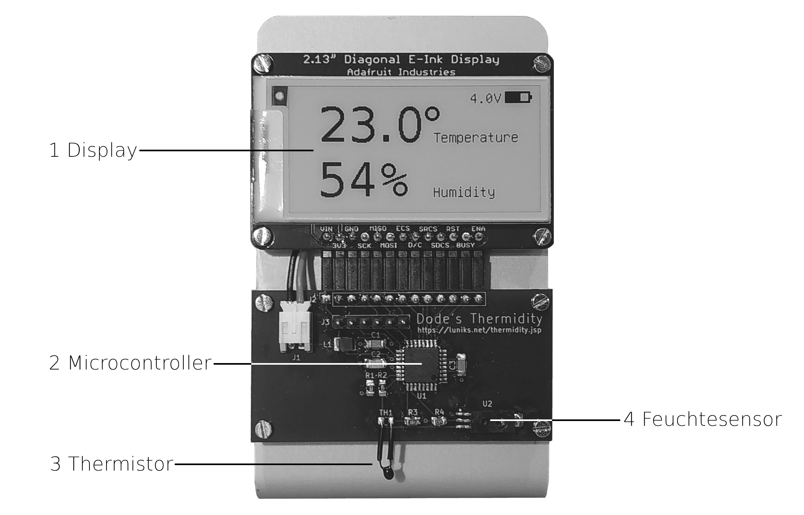
- Display Adafruit Monochrome 2.13" 250x122
- Microcontroller Atmel/Microchip AVR ATmega328P
- Thermistor (Temperature Sensor) NTC 100kΩ 0.1°C
- Humidity Sensor Honeywell HIH-5030

Usage

⚠
Make sure not to apply pressure on the display and the other components and not to damage or bend the temperature sensor when inserting the batteries.

- Open the battery case by slightly pressing on the markings at the bottom and sliding the cover upwards
- Insert the batteries, observe the polarity
- Place the cover on the case and close it by slightly pressing on the markings and sliding it downwards
- After about 1.5 seconds the current temperature and humidity is displayed
- Place the thermometer at a location where it is not exposed to moisture or direct sunlight for longer periods of time

⚠
When placing the thermometer, please take care not to scratch the surface of delicate furniture with the edges of the aluminium frame.

Technical Specification

Parameter | Value
Operating Voltage | 3 – 5V
Operating Temperature | 0 – 50°C
Average Power Supply Current | about 90µA
Operating Time with alkaline battery AAA/Micro¹ | about 12 months
Accuracy Temperature Measurement | ±0.1°C
Accuracy relative Humidity Measurement | ±3%
Measuring Range Temperature² | -40 – +99.9°C
Measuring Range Humidity | 0 – 99%
Measuring Interval | about 32 sec.
Update Interval | about 5 min.
Display Resolution | 255 x 122 Pixel
CPU Clock | 8 MHz

¹ Operating time can be shorter when using rechargeable batteries because of the lower voltage and possibly lower capacity, and the higher self-discharge.
² Operation temperature is limited to 0 – 50°C by the display. Storage temperature is -25 – +70°C.

Technical Details

Measurement of temperature and humidity is done about every 32 seconds ratiometrically with a 10-bit analogue digital converter and 16-times oversampling, yielding a virtual resolution of 12 Bit.
A moving average is updated with each measurement. About every 5 minutes, the measurement values are calculated from that average, and the display is updated with the result.
To reduce power consumption, the display is updated in fast mode. Each 10th update however, a full update is done to remove ghosting that can possibly occur at low temperatures.
If no measurement value changed since last update, the display is not updated unnecessarily to further reduce power consumption and extend the lifetime of the display.
For additional reduction of power consumption, the sensors are switched off between measurements, and the CPU is put to sleep mode and woken up by a watchdog at a regular interval.
When the battery voltage goes below a minimum of 3V, the watchdog is retired so the CPU is not woken up any more and thus does not perform further measurements and display updates. With the achieved reduction of power consumption, a harmful total discharge of rechargeable batteries is delayed significantly.
⚠
Because the device is not powered down completely and an idle current of about 20µA remains, empty (rechargeable) batteries should soon be replaced or recharged, respectively.

Comparison with other Thermometers and Hygrometers

Direct comparison of the measurement values of this thermometers with for example commercially available “Weather Stations” can reveal a certain deviation. Causes for this can be:
- The device used for comparison is inaccurate: The accuracy of weather stations commonly is only ±0.5 – 1°C temperature and sometimes more than ±5% relative Humidity. It should be noted that humidity sensors with high accuracy, as used in this device, are very expensive.
- Different sensitivity: The sensors of this thermometer are not inside a case, so it is possibly more sensitive to for example draught as other devices.
- Different display update interval: This thermometer updates the display only about every 5 minutes.

Troubleshooting

Problem | Cause | Solution
Display is not updated | Batteries weak  (<= 3.0V) | Replace/recharge batteries
Display is greyish and blurry | Batteries weak  (<= 3.0V) | Replace/recharge batteries
Humidity displayed is +99% | Condensation caused by spontaneous rise of temperature | Let the device acclimate itself
Device is wet |  | Remove batteries and let the device dry
Device is frozen |  | Remove batteries and let the device thaw and dry

Safety Notes

The thermometer is not splash proof and therefore not suitable to be operated close to for example a bathroom sink.
Do not expose the thermometer to direct sunlight for long periods of time as this can cause degraded performance of the display.
⚠
The display is made of glass. Attention risk of injury when damaged.
Should the display break, avoid contact with possibly leaking liquid. In case of contact, wash with water and soap.

References

Email: torsten.roemer@luniks.net
Website: https://luniks.net/thermidity.jsp
Source code: https://github.com/gitdode/thermidity

