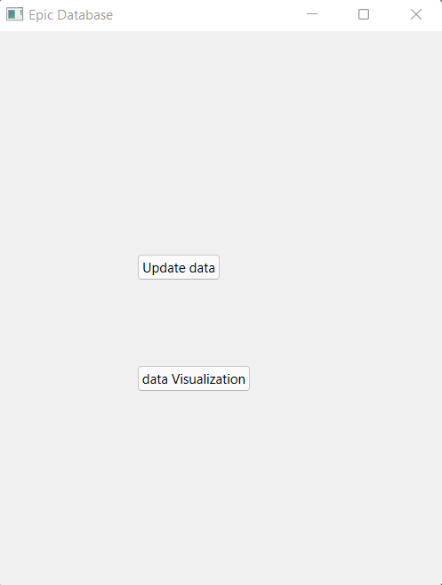

1.This is what happens when we Start GUI.py

2.Pressing the update data will show this after it is done updating

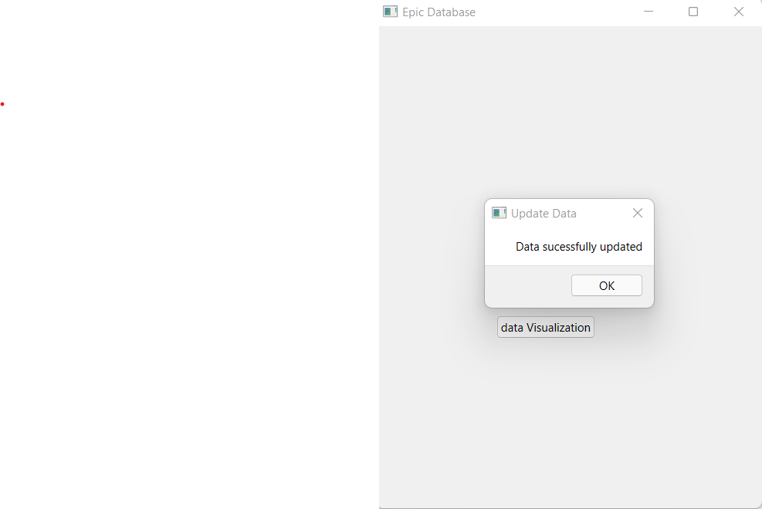

3. This is what happens if you press the data visualization without data

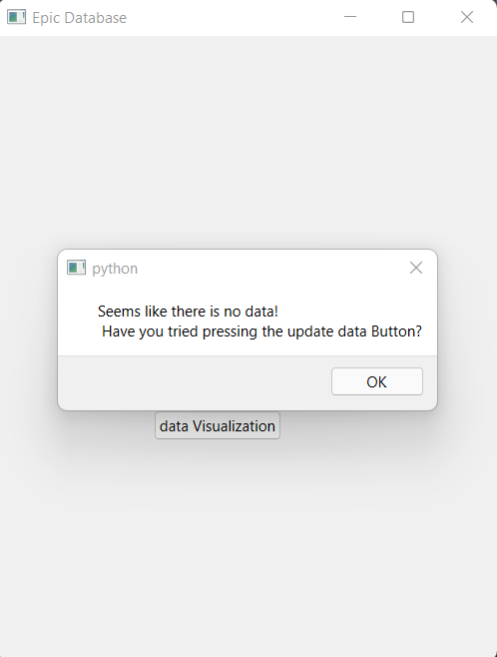

4. This is the menu where you can select various data visualizations

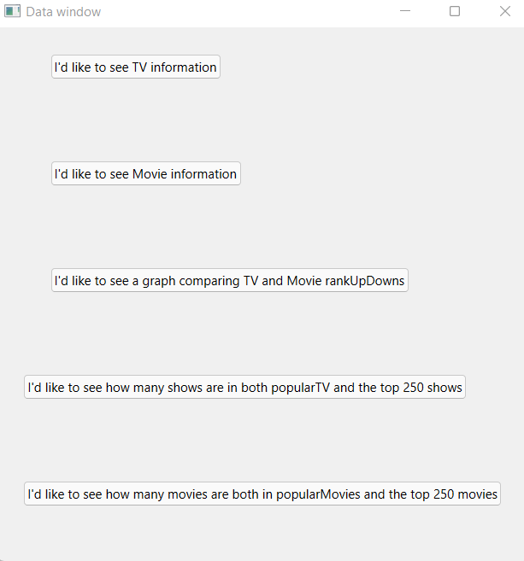

5. Pressing the tv information pulls up this menu where you can choose to make a variety of tables

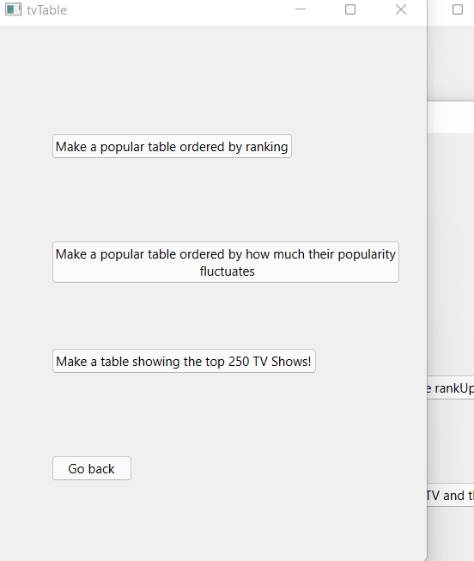

6.Pressing one of these buttons brings up their respective table. For example here is the ranking table. Additionally when pressing on an ID it brings up that show’s ranking

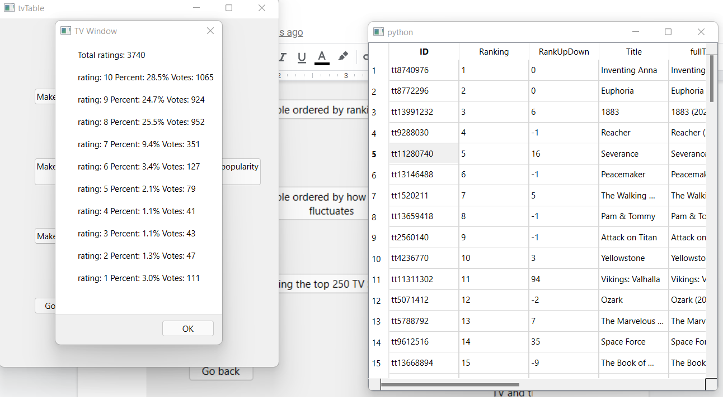

7.If the movie Information button is pressed, it brings up the menu in the middle, and if one of the table creation buttons is pressed it creates the table based on the buttons description. Here is an example of the rankings table. As with the TV tables. Pressing on any of the ids will bring up the movie’s ratings

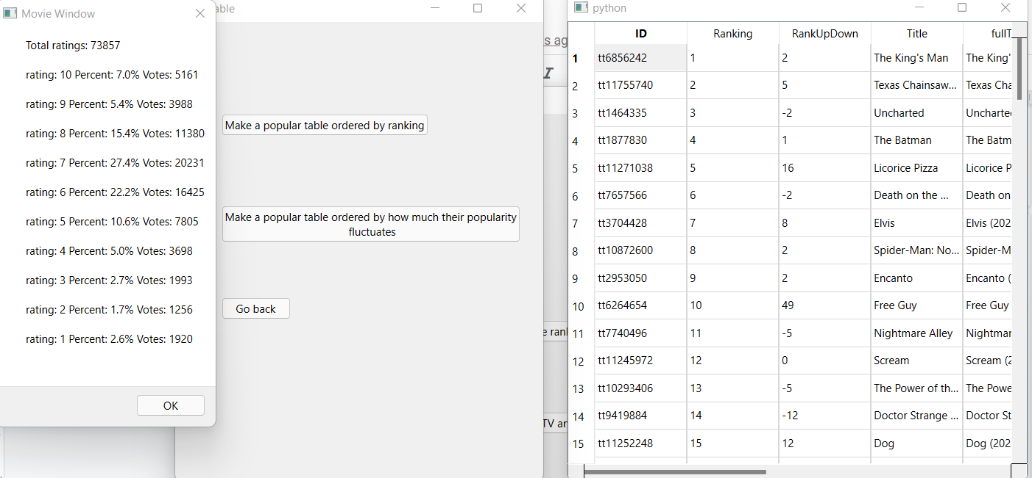

8.If the graph button is pressed, a graph is shown on screen with Red and white lines and labels for what they represent. The red lines indicate that those columns went up and white means it’s the number of items that went down

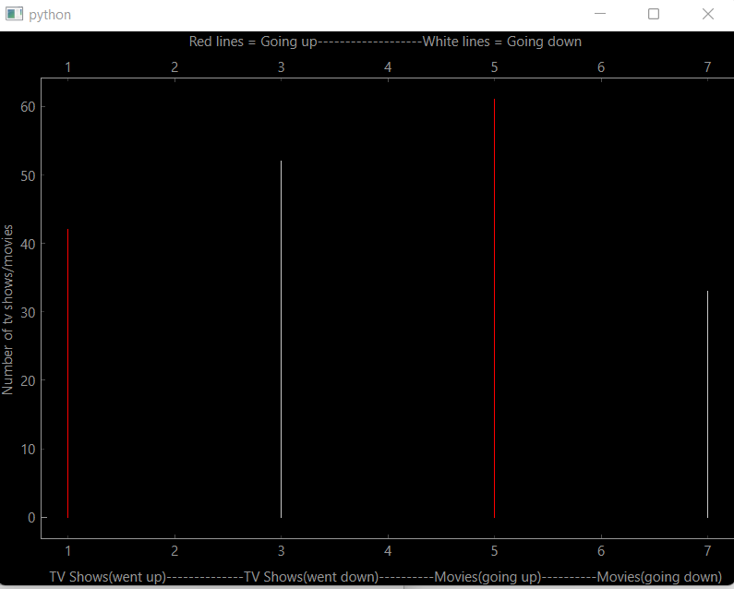

9. If either of the buttons at the bottom are pressed, they show the inner join of either the TV tables or the movie tables and prints them as a text box

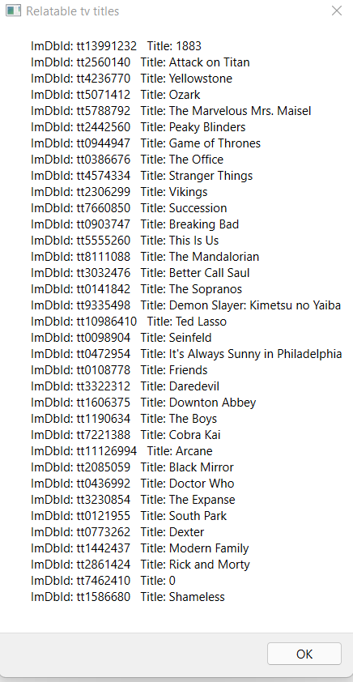

The movie join

