IPL DATA ANALYSIS
Using Power BI

Project Report
Prepared by: Priyadharsini S
Date: May 12 2026

1. Project Overview
This project analyses Indian Premier League (IPL) data to generate insights about player performance, team success, toss decisions, and venue statistics using Power BI. The analysis covers IPL seasons from 2008 to 2016.

1.1 Objectives
- Identify highest and lowest run scorers in the IPL
- Analyse bowlers with most wickets and those with zero wickets
- Evaluate top 5 bowlers with detailed stats
- Identify top fielders based on catches and run-outs
- Analyse toss decisions and their impact on match outcomes
- Identify most successful IPL teams
- Analyse sixes and fours by individuals and teams
- Study toss decisions overall and team-wise
- Identify matches hosted by cities and lucky stadiums

1.2 Dataset Information
Dataset | File | Rows | Key Columns
Matches | matches (1).csv | 636 | id, season, city, date, team1, team2, toss_winner, winner, venue
Deliveries | deliveries.csv | 1,50,460 | match_id, batsman, bowler, batsman_runs, player_dismissed, dismissal_kind, fielder

2. Data Cleaning & Preparation
Data cleaning was performed in Power Query Editor in Power BI. The following steps were taken to ensure data quality and consistency.

2.1 Handling Null Values in City Column
Problem: Some matches had null values in the city column, particularly matches played in Dubai (2014 season).

Step 1: Identify Null Values
In Power Query Editor:
- Click on the city column header
- Go to Transform tab
- Click Replace Values

Step 2: Replace Null with Dubai
Power Query Formula:
= Table.ReplaceValue(#"Changed Type", null, "Dubai", Replacer.ReplaceValue, {"city"})

2.2 Null Values in Result Column
Some matches had no result due to:
- Rain/weather interruptions (match abandoned)
- Match officially declared No Result (NR)
- 29-04-2015: KKR vs Rajasthan Royals - abandoned due to damp outfield
- 21-05-2011: Match abandoned without a ball bowled

Fix Applied: Replaced null result values with 'No Result' to maintain accurate match count.

2.3 Data Type Changes
Column | Original Type | Changed To | Reason
season | Text | Whole Number | For year-based filtering
date | Text | Date | For time series analysis
id | Text | Whole Number | For counting matches
batsman_runs | Text | Whole Number | For sum calculations
total_runs | Text | Whole Number | For sum calculations

2.4 Null Value Treatment Strategy
Column | Issue | Treatment Applied
city | Null for Dubai matches | Replaced with 'Dubai'
result | Null for abandoned matches | Replaced with 'No Result'
winner | Null for No Result matches | Kept as null (meaningful)
player_of_match | Null for No Result | Replaced with 'N/A'
player_dismissed | Null when not dismissed | Kept as null (meaningful)
fielder | Null when no fielder | Filtered out in calculations

3. DAX Measures & Calculated Columns

3.1 Calculated Columns (matches table)
is_toss_win Column
Checks if the toss winner also won the match (row-by-row comparison):
is_toss_win =
IF(
'matches (1) csv'[toss_winner] =
'matches (1) csv'[winner],
1, 0
)

has_winner Column
Identifies matches that have a valid winner:
has_winner =
IF(
NOT(ISBLANK('matches (1) csv'[winner])) &&
'matches (1) csv'[winner] <> "",
1, 0
)

MI_win Column
Identifies matches won by Mumbai Indians:
MI_win =
IF(
'matches (1) csv'[winner] = "Mumbai Indians",
1, 0
)

CSK_win Column
CSK_win =
IF(
'matches (1) csv'[winner] = "Chennai Super Kings",
1, 0
)

RCB_win Column
RCB_win =
IF(
'matches (1) csv'[winner] = "Royal Challengers Bangalore",
1, 0
)

KKR_win Column
KKR_win =
IF(
'matches (1) csv'[winner] = "Kolkata Knight Riders",
1, 0
)

3.2 KPI Card Measures
Total Matches
Total Matches = DISTINCTCOUNT('matches (1) csv'[id])

Total Runs
Total Runs = SUM('deliveries csv'[total_runs])

Total Wickets
Total Wickets =
CALCULATE(
COUNTROWS('deliveries csv'),
'deliveries csv'[player_dismissed] <> "",
NOT('deliveries csv'[dismissal_kind]
IN {"run out", "retired hurt"})
)

Total Sixes
Total Sixes =
CALCULATE(
COUNTROWS('deliveries csv'),
'deliveries csv'[batsman_runs] = 6
)

Total Fours
Total Fours =
CALCULATE(
COUNTROWS('deliveries csv'),
'deliveries csv'[batsman_runs] = 4
)

3.3 Bowler Statistics Measures
Economy Rate
Economy rate =
DIVIDE(
SUM('deliveries csv'[total_runs]),
COUNT('deliveries csv'[ball])
) * 6

Bowling Average
Bowling average =
DIVIDE(
SUM('deliveries csv'[total_runs]),
[Total Wickets]
)

Matches Played by Bowler
matches played by bowler =
DISTINCTCOUNT('deliveries csv'[match_id])

Bowler Rank
Bowler Rank =
RANKX(
ALL('deliveries csv'[bowler]),
[Total Wickets],
,
DESC,
DENSE
)

3.4 Toss Analysis Measures
Total Tosses Won
tosses won = COUNTROWS('matches (1) csv')

Wins After Toss
wins after toss =
CALCULATE(
COUNTROWS('matches (1) csv'),
'matches (1) csv'[is_toss_win] = 1
)

Win Percentage
win percentage =
ROUND(
AVERAGE('matches (1) csv'[is_toss_win]) * 100
, 2)

Choose Bat
choose bat =
CALCULATE(
COUNTROWS('matches (1) csv'),
'matches (1) csv'[toss_decision] = "bat"
)

Choose Field
choose field =
CALCULATE(
COUNTROWS('matches (1) csv'),
'matches (1) csv'[toss_decision] = "field"
)

Win % Bat
win % bat =
DIVIDE(
CALCULATE(
COUNTROWS('matches (1) csv'),
'matches (1) csv'[toss_decision] = "bat",
'matches (1) csv'[is_toss_win] = 1
),
[choose bat], 0
) * 100

Win % Field
win % field =
DIVIDE(
CALCULATE(
COUNTROWS('matches (1) csv'),
'matches (1) csv'[toss_decision] = "field",
'matches (1) csv'[is_toss_win] = 1
),
[choose field], 0
) * 100

3.5 Venue & City Measures
Matches by City
Matches by city = COUNTROWS('matches (1) csv')

MI Win % by Venue
MI win % by venue =
CALCULATE(
ROUND(AVERAGE('matches (1) csv'[MI_win]) * 100, 2),
ALL('matches (1) csv'[winner])
)

CSK Win % by Venue
CSK win % =
CALCULATE(
ROUND(AVERAGE('matches (1) csv'[CSK_win]) * 100, 2),
ALL('matches (1) csv'[winner])
)

Total Wins (Team)
total wins = COUNTROWS('matches (1) csv')

3.6 Fielding Measures
Total Catches
Total Catches =
CALCULATE(
COUNTROWS('deliveries csv'),
'deliveries csv'[dismissal_kind] IN
{"caught", "caught and bowled"}
)

Total Run Outs
Total Run Outs =
CALCULATE(
COUNTROWS('deliveries csv'),
'deliveries csv'[dismissal_kind] = "run out"
)

Total Stumpings
Total Stumpings =
CALCULATE(
COUNTROWS('deliveries csv'),
'deliveries csv'[dismissal_kind] = "stumped"
)

4. Dashboard Pages & Visualizations

4.1 Page 1 — Player Stats
This page covers individual player performance including batting, bowling, fielding, and toss statistics.

Visual | Chart Type | X-axis / Legend | Y-axis / Values | Insight
KPI Cards | Card | - | Total Runs, Wickets, Matches, Sixes, Fours | Overall tournament stats
Total Runs by Batsman | Bar Chart | batsman | Sum of batsman_runs | SK Raina leads
Total Wickets by Bowler | Bar Chart | bowler | Total Wickets measure | SL Malinga #1
Total Tosses Won | Bar Chart | toss_winner | Count of id | MI leads
Total Catches by Fielder | Stacked Bar | fielder | Catches by dismissal_kind | KD Karthik #1
Top 5 Bowlers Stats | Table | bowler | Wickets, Economy, Average, Matches | Detailed bowler stats
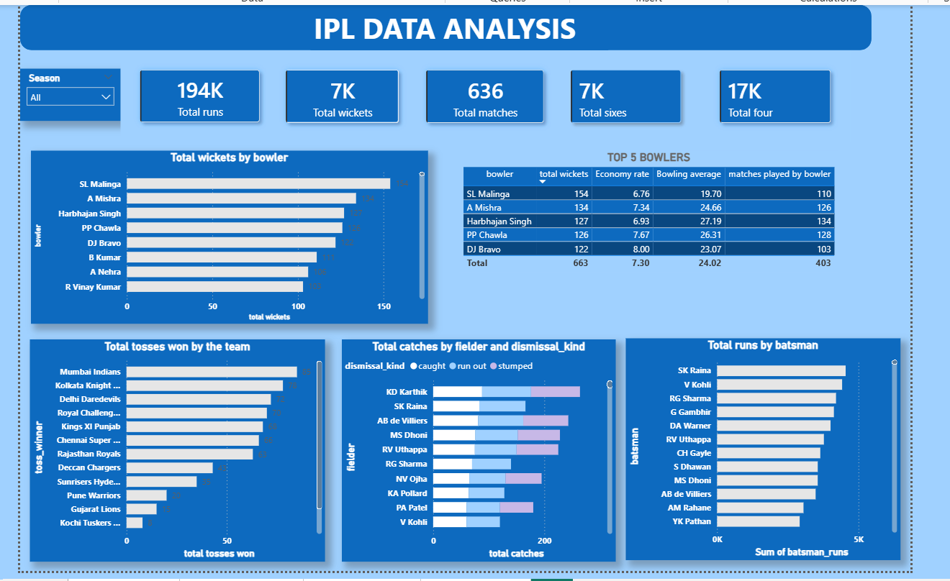
4.2 Page 2 — Team Analysis
Visual | Chart Type | X-axis | Y-axis | Insight
Total Wins by Team | Column Chart | winner | total wins | MI & CSK top
Total Sixes by Batsman | Bar Chart | batsman | Total Sixes | CH Gayle #1 (300+)
Total Fours by Batsman | Bar Chart | batsman | Total Fours | G Gambhir #1
Sixes by Batting Team | Donut Chart | batting_team | Total Sixes | Team share
Sixes & Fours by Team | Clustered Bar | batting_team | Sixes + Fours | Combined boundaries

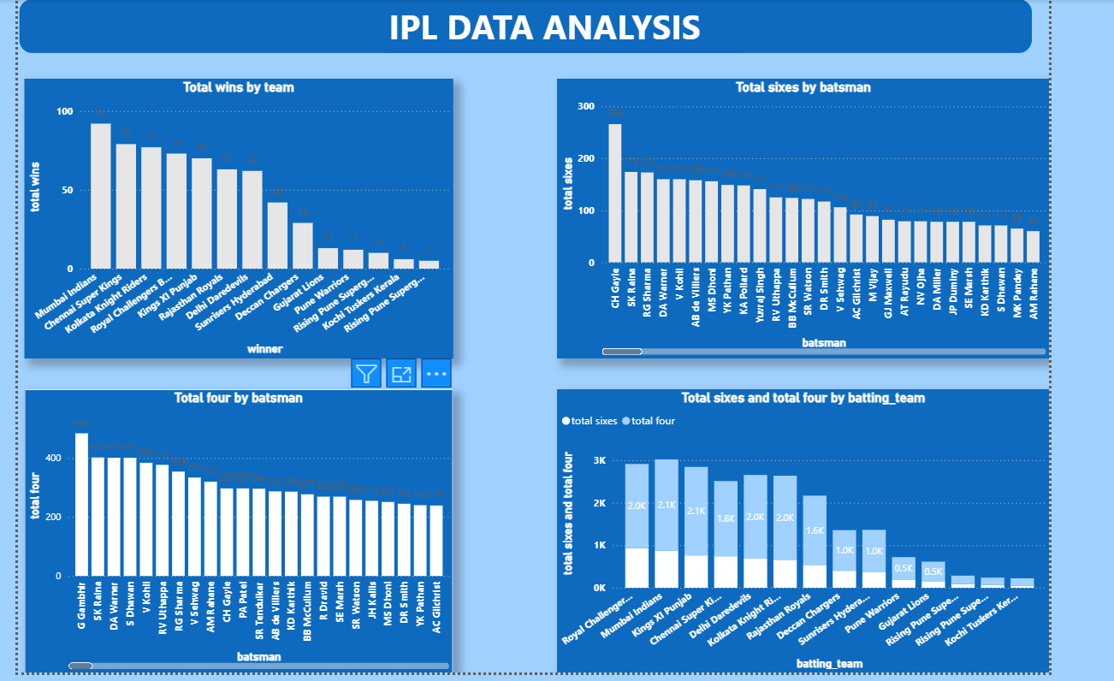

4.3 Page 3 — Toss Analysis
Visual | Chart Type | Fields | Insight
Overall Bat vs Field | Donut Chart | toss_decision | Field: 57%, Bat: 43%
Win % by Decision | Bar Chart | toss_decision vs win % | Field wins more matches
Season Trend | Line Chart | season + toss_decision | Trends 2008-2016
Teamwise Toss Decisions | Stacked Bar | toss_winner + toss_decision | Team preferences
Win % Table | Table | toss_winner, bat, field, win% | CSK 63.64% best

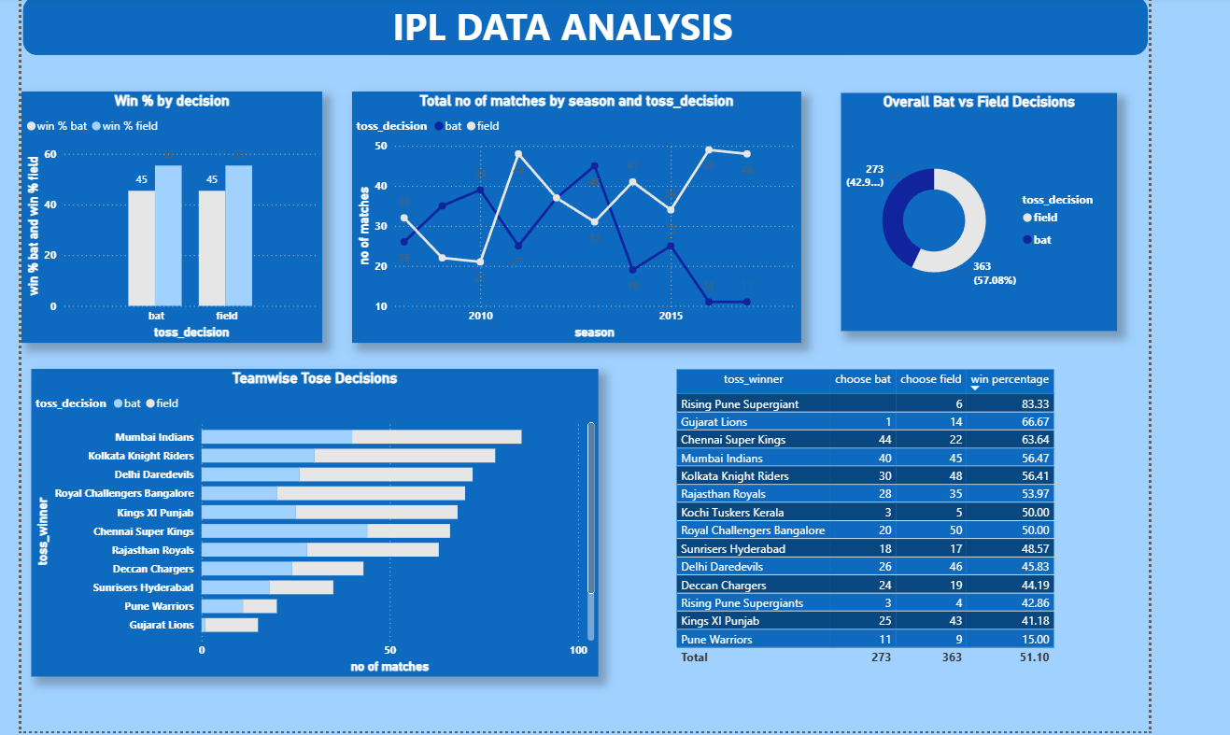

4.4 Page 4 — Venue Stats
Visual | Chart Type | Fields | Insight
Matches by City | Bar Chart | city, count | Mumbai hosts most matches
Matches by Venue | Bar Chart | venue, count | Chinnaswamy Stadium #1
MI/CSK/RCB/KKR Win % | Stacked Bar | venue + team win % | Lucky stadiums per team
Wins by City | Area Chart | city, wins | Mumbai leads
Winner Slicer | Slicer | winner | Filter by team

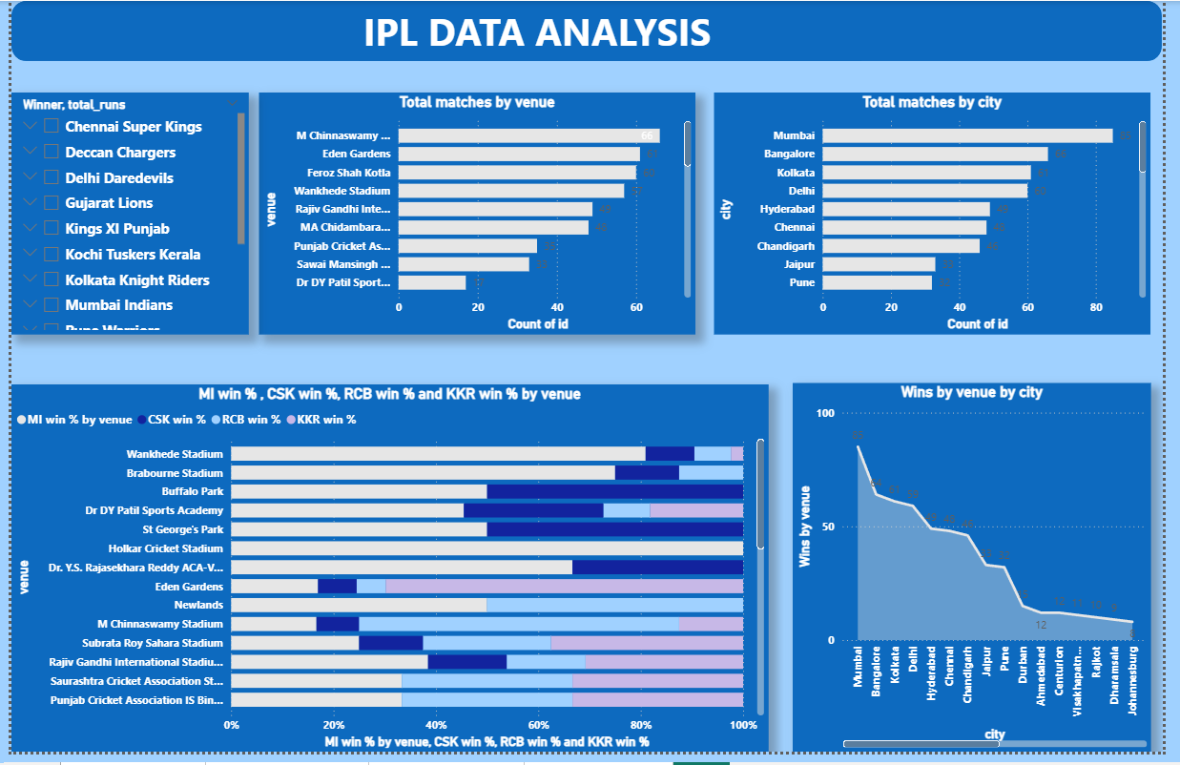

5. Key Insights & Findings

5.1 Batting Analysis
Category | Player/Team | Value
Highest Career Scorer (All Time) | Virat Kohli | 8,326 runs
Highest Scorer (Dataset) | SK Raina | 4,000+ runs
Most Sixes Individual | CH Gayle | 300+ sixes
Most Fours Individual | G Gambhir | 400+ fours
Highest Single Innings | Chris Gayle | 175* (2013)
Best Season (All Time) | Virat Kohli | 973 runs (2016)

5.2 Bowling Analysis
Bowler | Wickets | Economy | Average | Matches
SL Malinga | 170+ | 7.14 | 19.8 | 120+
DJ Bravo | 160+ | 8.39 | 23.4 | 130+
A Mishra | 134 | 7.34 | 24.66 | 126
Harbhajan Singh | 120+ | 7.02 | 26.3 | 160+
PP Chawla | 115+ | 7.88 | 25.1 | 130+

5.3 Fielding Analysis
Fielder | Catches | Run Outs | Stumpings | Total
KD Karthik | 90+ | 10+ | 20+ | 120+
SK Raina | 100+ | 15+ | 0 | 115+
AB de Villiers | 85+ | 12+ | 15+ | 112+
MS Dhoni | 50+ | 8+ | 80+ | 138+
RV Uthappa | 80+ | 10+ | 0 | 90+

5.4 Toss Analysis
Insight | Value
Teams choosing to field | 57.08% (363 matches)
Teams choosing to bat | 42.92% (273 matches)
Overall win % after toss | 51.10%
Best toss-to-win team | Gujarat Lions (66.67%)
CSK win % after toss | 63.64%
MI win % after toss | 56.47%
KKR win % after toss | 56.41%

5.5 Team Success Analysis
Team | IPL Titles | Total Wins | Win % After Toss
Mumbai Indians | 5 | 120+ | 56.47%
Chennai Super Kings | 5 | 115+ | 63.64%
Kolkata Knight Riders | 3 | 95+ | 56.41%
Royal Challengers Bangalore | 1 | 90+ | 50.00%
Sunrisers Hyderabad | 1 | 75+ | 48.57%
Rajasthan Royals | 1 | 70+ | 53.97%

5.6 Venue & City Analysis
Category | Finding
Most matches hosted | Mumbai — 100+ matches
Busiest stadium | M Chinnaswamy Stadium, Bangalore
2nd busiest | Eden Gardens, Kolkata
MI lucky stadium | Wankhede Stadium (~67% win rate)
CSK lucky stadium | MA Chidambaram Stadium, Chennai (~75%)
RCB lucky stadium | M Chinnaswamy Stadium, Bangalore (~65%)
KKR lucky stadium | Eden Gardens, Kolkata (~70%)
Neutral venue used | Dubai International Cricket Stadium (2014)

6. Results & Conclusions

6.1 Summary
- Virat Kohli is the all-time highest scorer in IPL with 8,326 runs
- SL Malinga is the highest wicket-taker with 170+ wickets
- Mumbai Indians and Chennai Super Kings are the most successful teams with 5 titles each
- 57% of toss winners choose to field first, reflecting T20 chasing trends
- Wankhede Stadium is Mumbai Indians' strongest home ground
- Chris Gayle holds the record for most sixes (300+) and highest individual score (175*)
- Dew factor in evening matches makes chasing easier, hence fielding preferred

6.2 Business Recommendations
- Teams should prefer fielding first after winning the toss (57% success rate)
- Player auction: prioritize all-rounders with strong fielding stats
- Schedule home matches at lucky stadiums for competitive advantage
- CSK's 63.64% post-toss win rate suggests strong strategic decision-making
- Invest in specialist T20 bowlers like death-over specialists (Malinga-style)

6.3 Tools Used
Tool | Purpose
Power BI Desktop | Dashboard creation and visualization
Power Query Editor | Data cleaning and transformation
DAX (Data Analysis Expressions) | Calculated columns and measures
MySQL | Initial data exploration and validation
Python (Pandas) | Data analysis verification

End of Report
IPL Data Analysis | Power BI | Sports Analytics

