Title Goes Here

Myfirstname Mylastname1,✉, and Yourfirstname Yourlastname2

02 February, 2022

Text of abstract

1 University of One Place  
2 University of Another Place

✉ Correspondence: [Myfirstname Mylastname <[fl@oneplace.edu](mailto:fl@oneplace.edu)>](mailto:fl@oneplace.edu)

Keywords: keyword 1; keyword 2; keyword 3

Highlights: These are the highlights.

# 1 Introduction

Here is a citation (Marwick, 2017)

# 2 Background

# 3 Methods

# 4 Results

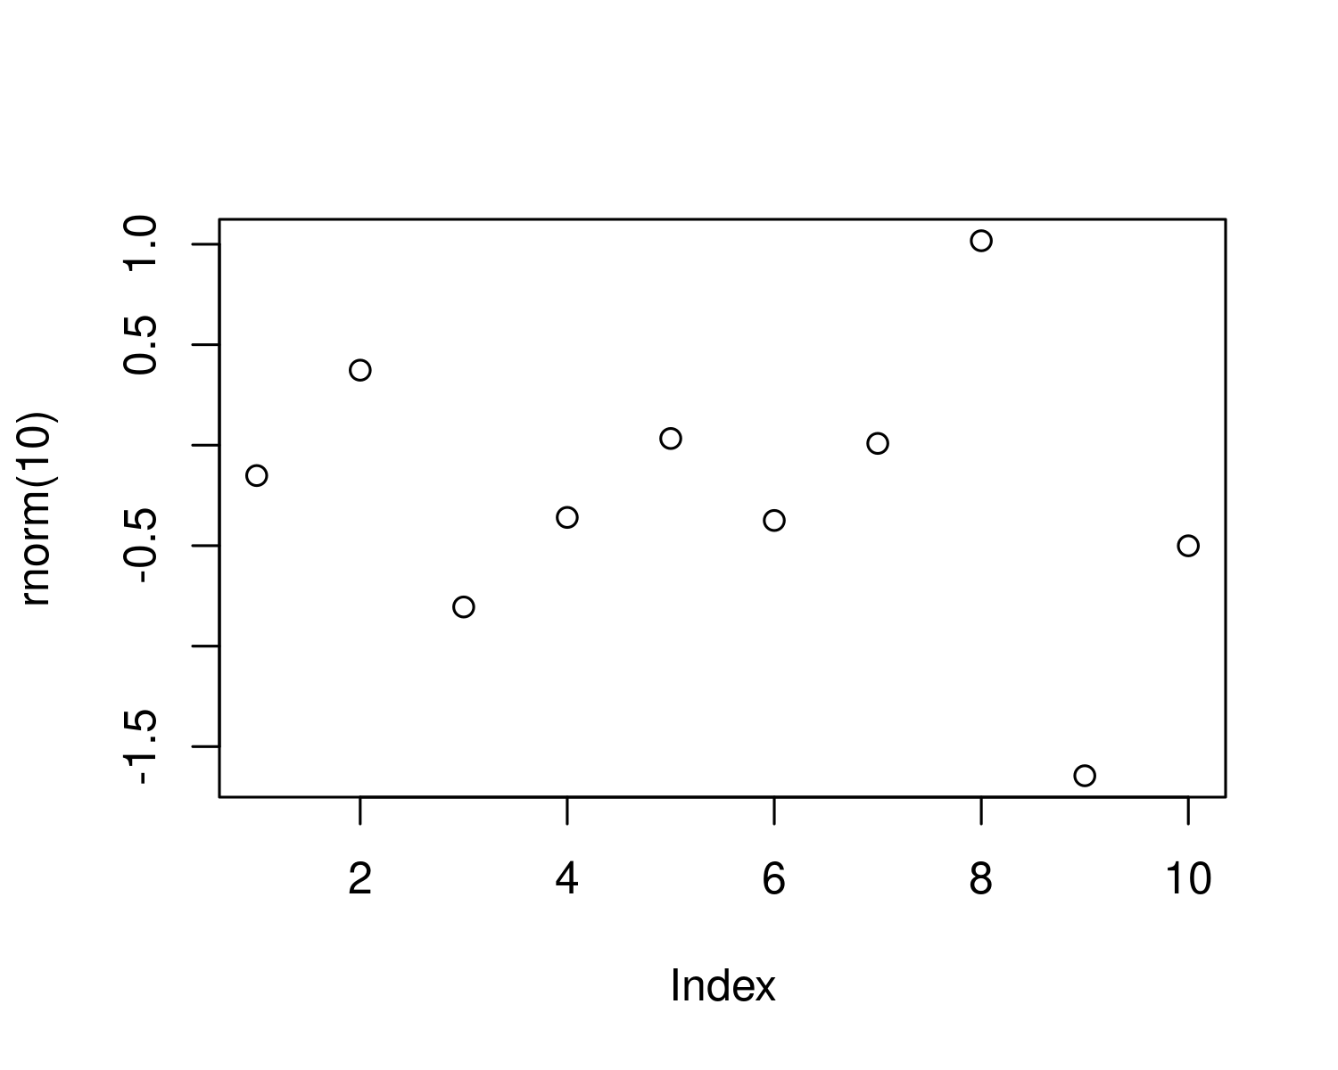

Figure 4.1: A plot of random numbers

Figure 4.1 shows how we can have a caption and cross-reference for a plot

Here is an example of inline code 3.14 in the middle of a sentence.

# 5 Discussion

# 6 Conclusion

# 7 Acknowledgements

# 8 References

Marwick, B., 2017. Computational reproducibility in archaeological research: Basic principles and a case study of their implementation. Journal of Archaeological Method and Theory 24, 424–450. <https://doi.org/10.1007/s10816-015-9272-9>

### 8.0.1 Colophon

This report was generated on 2022-02-02 16:05:08 using the following computational environment and dependencies:

#> ─ Session info ───────────────────────────────────────────────────────────────  
#> setting value  
#> version R version 4.1.2 (2021-11-01)  
#> os Ubuntu 20.04.3 LTS  
#> system x86_64, linux-gnu  
#> ui X11  
#> language (EN)  
#> collate C.UTF-8  
#> ctype C.UTF-8  
#> tz UTC  
#> date 2022-02-02  
#> pandoc 2.14.0.3 @ /usr/lib/rstudio-server/bin/pandoc/ (via rmarkdown)  
#>   
#> ─ Packages ───────────────────────────────────────────────────────────────────  
#> package * version date (UTC) lib source  
#> bookdown 0.24 2021-09-02 [1] RSPM (R 4.1.0)  
#> brio 1.1.3 2021-11-30 [1] RSPM (R 4.1.0)  
#> cachem 1.0.6 2021-08-19 [1] RSPM (R 4.1.0)  
#> callr 3.7.0 2021-04-20 [1] RSPM (R 4.1.0)  
#> cli 3.1.1 2022-01-20 [1] RSPM (R 4.1.0)  
#> crayon 1.4.2 2021-10-29 [1] RSPM (R 4.1.0)  
#> desc 1.4.0 2021-09-28 [1] RSPM (R 4.1.0)  
#> devtools 2.4.3 2021-11-30 [1] RSPM (R 4.1.0)  
#> digest 0.6.29 2021-12-01 [1] RSPM (R 4.1.0)  
#> ellipsis 0.3.2 2021-04-29 [1] RSPM (R 4.1.0)  
#> evaluate 0.14 2019-05-28 [1] RSPM (R 4.1.0)  
#> fastmap 1.1.0 2021-01-25 [1] RSPM (R 4.1.0)  
#> fs 1.5.2 2021-12-08 [1] RSPM (R 4.1.0)  
#> glue 1.6.1 2022-01-22 [1] RSPM (R 4.1.0)  
#> highr 0.9 2021-04-16 [1] RSPM (R 4.1.0)  
#> htmltools 0.5.2 2021-08-25 [1] RSPM (R 4.1.0)  
#> knitr 1.37 2021-12-16 [1] RSPM (R 4.1.0)  
#> lifecycle 1.0.1 2021-09-24 [1] RSPM (R 4.1.0)  
#> magrittr 2.0.2 2022-01-26 [1] RSPM (R 4.1.0)  
#> memoise 2.0.1 2021-11-26 [1] RSPM (R 4.1.0)  
#> pkgbuild 1.3.1 2021-12-20 [1] RSPM (R 4.1.0)  
#> pkgload 1.2.4 2021-11-30 [1] RSPM (R 4.1.0)  
#> prettyunits 1.1.1 2020-01-24 [1] RSPM (R 4.1.0)  
#> processx 3.5.2 2021-04-30 [1] RSPM (R 4.1.0)  
#> ps 1.6.0 2021-02-28 [1] RSPM (R 4.1.0)  
#> purrr 0.3.4 2020-04-17 [1] RSPM (R 4.1.0)  
#> R6 2.5.1 2021-08-19 [1] RSPM (R 4.1.0)  
#> remotes 2.4.2 2021-11-30 [1] RSPM (R 4.1.0)  
#> rlang 1.0.0 2022-01-26 [1] RSPM (R 4.1.0)  
#> rmarkdown 2.11 2021-09-14 [1] RSPM (R 4.1.0)  
#> rprojroot 2.0.2 2020-11-15 [1] RSPM (R 4.1.0)  
#> rstudioapi 0.13 2020-11-12 [1] RSPM (R 4.1.0)  
#> sessioninfo 1.2.2 2021-12-06 [1] RSPM (R 4.1.0)  
#> stringi 1.7.6 2021-11-29 [1] RSPM (R 4.1.0)  
#> stringr 1.4.0 2019-02-10 [1] RSPM (R 4.1.0)  
#> testthat 3.1.2 2022-01-20 [1] RSPM (R 4.1.0)  
#> usethis 2.1.5 2021-12-09 [1] RSPM (R 4.1.0)  
#> withr 2.4.3 2021-11-30 [1] RSPM (R 4.1.0)  
#> xfun 0.29 2021-12-14 [1] RSPM (R 4.1.0)  
#> yaml 2.2.2 2022-01-25 [1] RSPM (R 4.1.0)  
#>   
#> [1] /cloud/lib/x86_64-pc-linux-gnu-library/4.1  
#> [2] /opt/R/4.1.2/lib/R/library  
#>   
#> ──────────────────────────────────────────────────────────────────────────────

The current Git commit details are:

#> Local: master /cloud/project/initest  
#> Remote: master @ origin (https://github.com/sprocketsullivan/initest.git)  
#> Head: [b09354d] 2022-02-02: commit readme