Duration by itself does not seem to be a strong predictor for whether a movie will be successful or not.

It also makes little sense to plot the profits of all movies, regardless of genre agains their runtime.

These 5 genres cover approximately 85% of the available data:

Action, Adventury, Animation, Comedy and Drama.

Most of the data cannot provide an ideal length for a movie genre, as most of the correlations are not very strong. However, they can provide useful boundaries, outside of which movies of a specific genre would be likely to be unsuccesful.

**Action**

ROI vs Runtime is almost flat, no significant correlation.

Profit ($) increases for longer movies, but so does the cost (more explosions!), thus ROI remains stable. If budget is not an issue, longer action movies should be considered for wider raw profit margin.

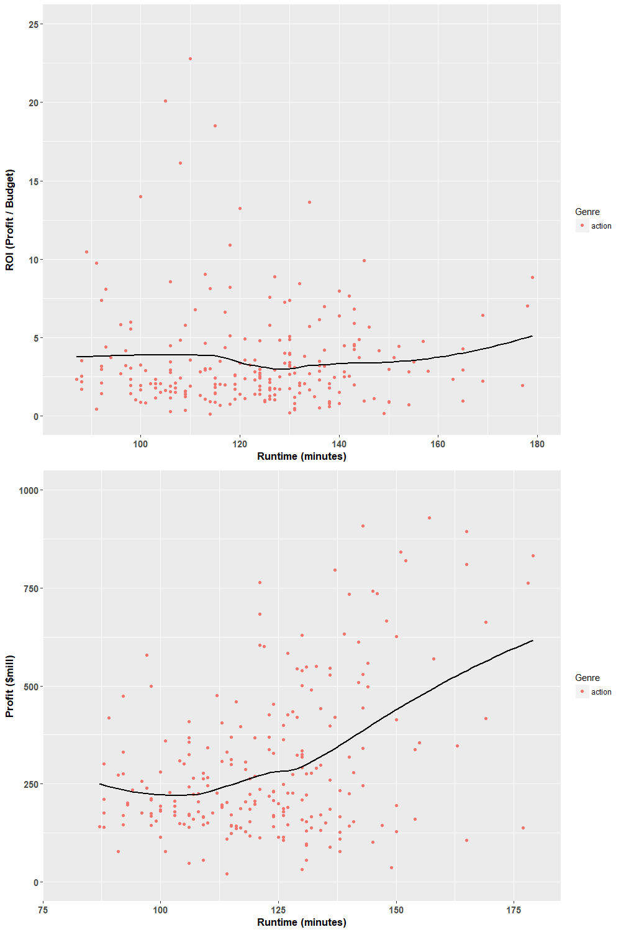

**Animation**

It seems that the ideal runtime for animations is usually around 85-90 minutes. However, the small number of 110-120 minute animations provided seem to be performing extremely well. Thus, ideas for longer animation movies should not be dismissed, provided the idea seems promising.

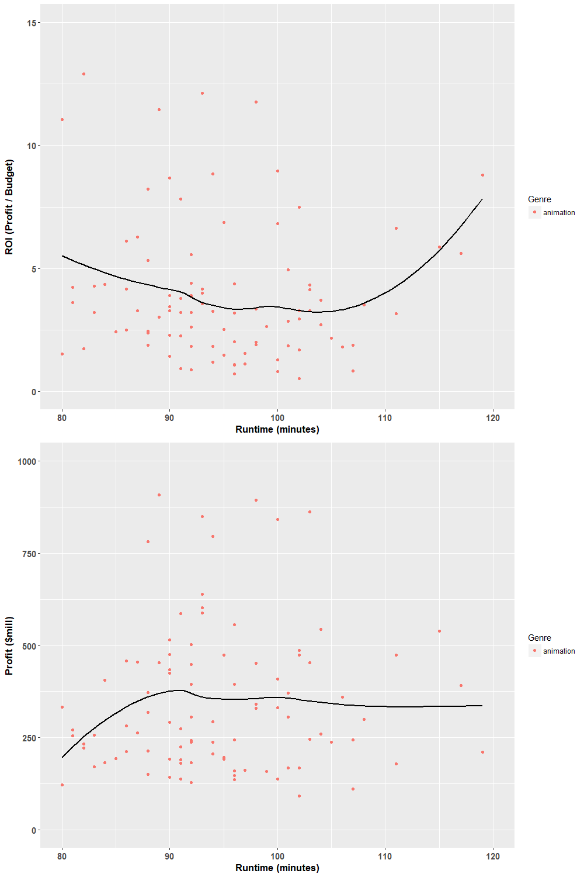

**Comedy**

A range of 80 to 130 minutes seems appropriate for this genre. Anything longer seems to have a somewhat negative impact.

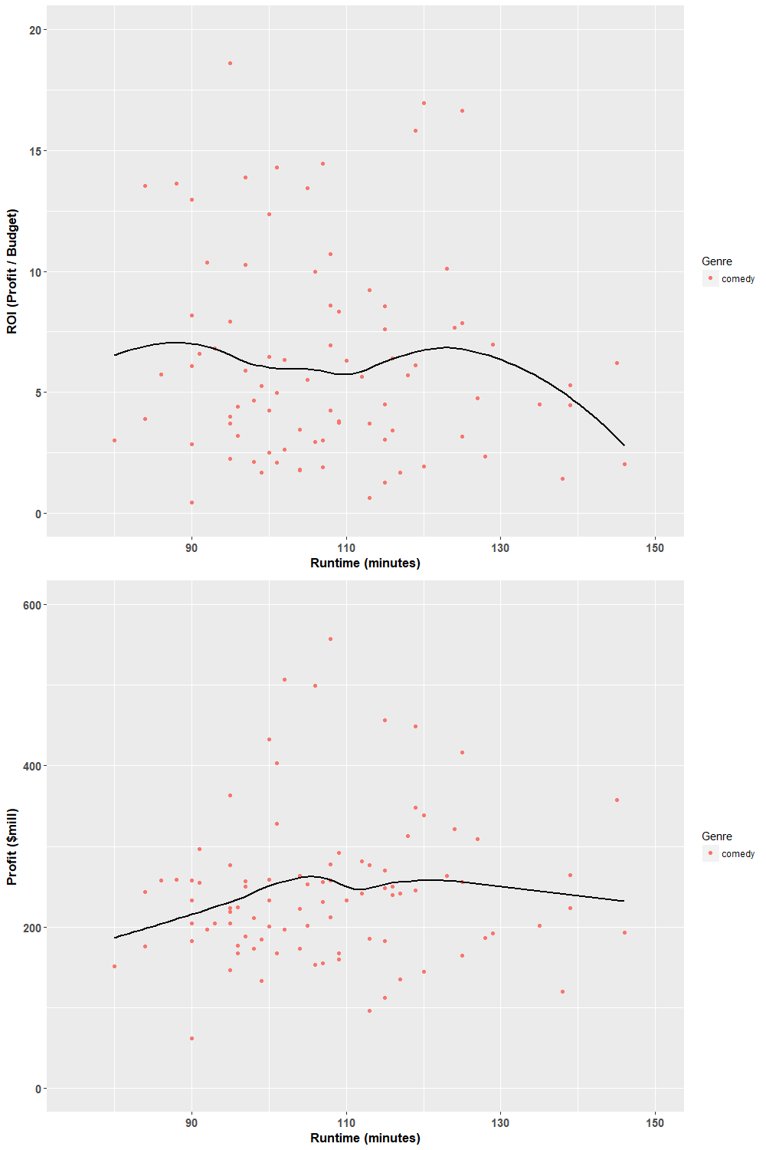

**Drama**

105-125 seems to be the ideal range for this genre. Durations outside that range seem to have a slight negative impact . 