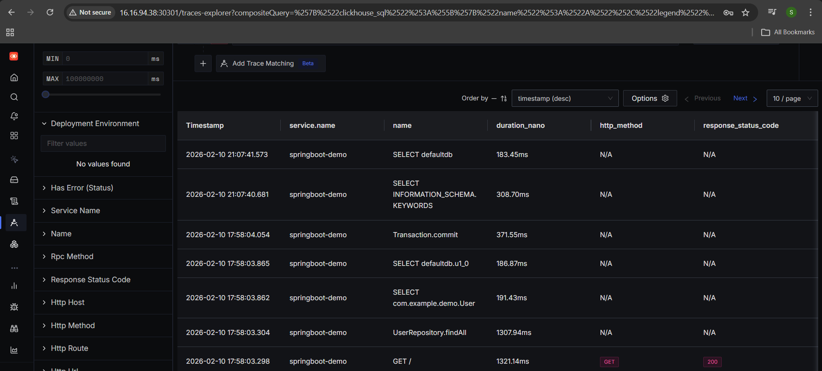

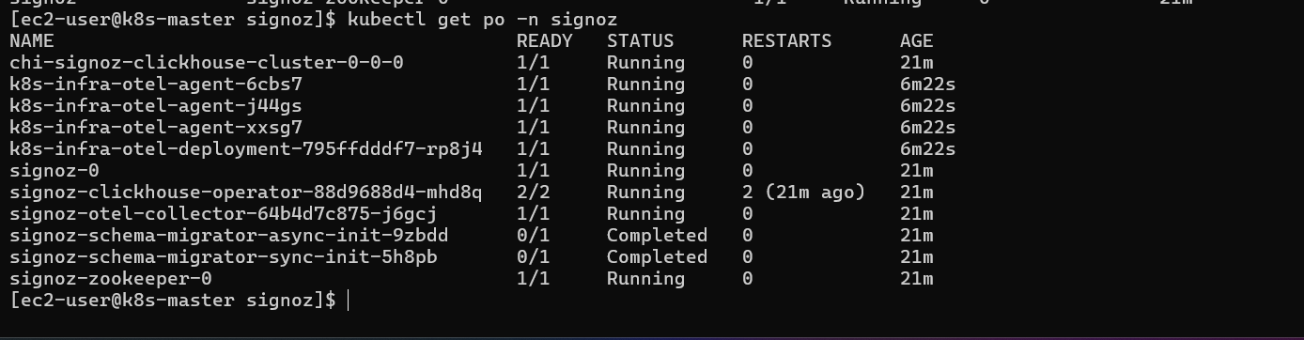
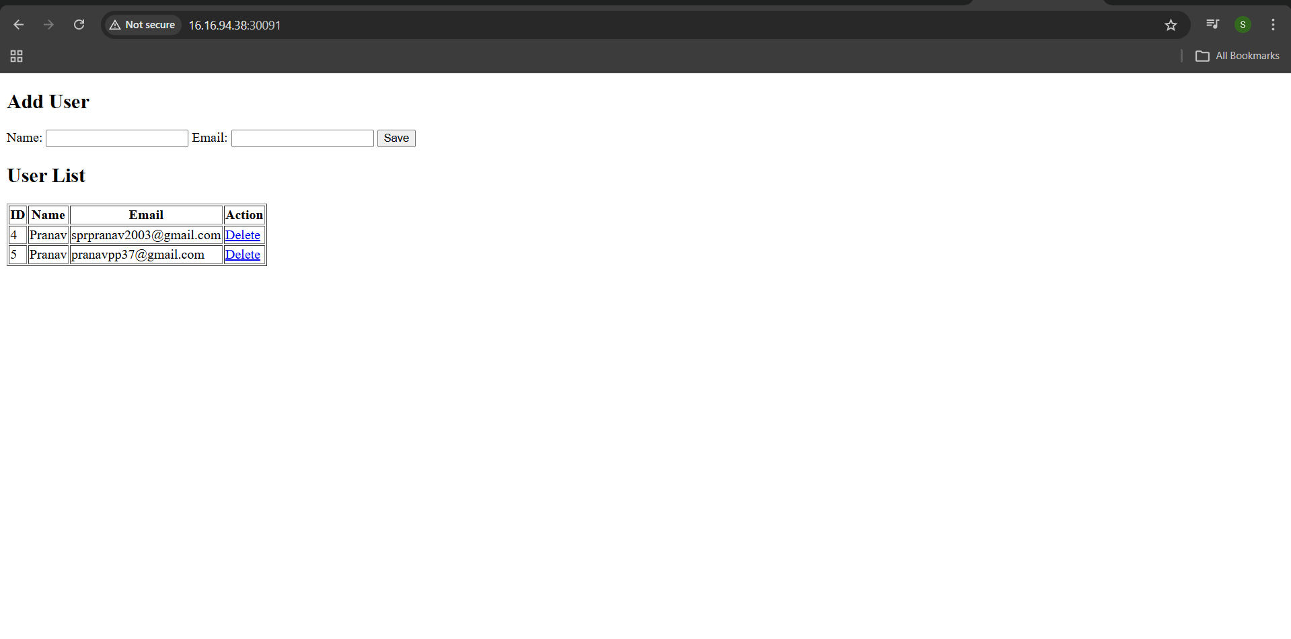

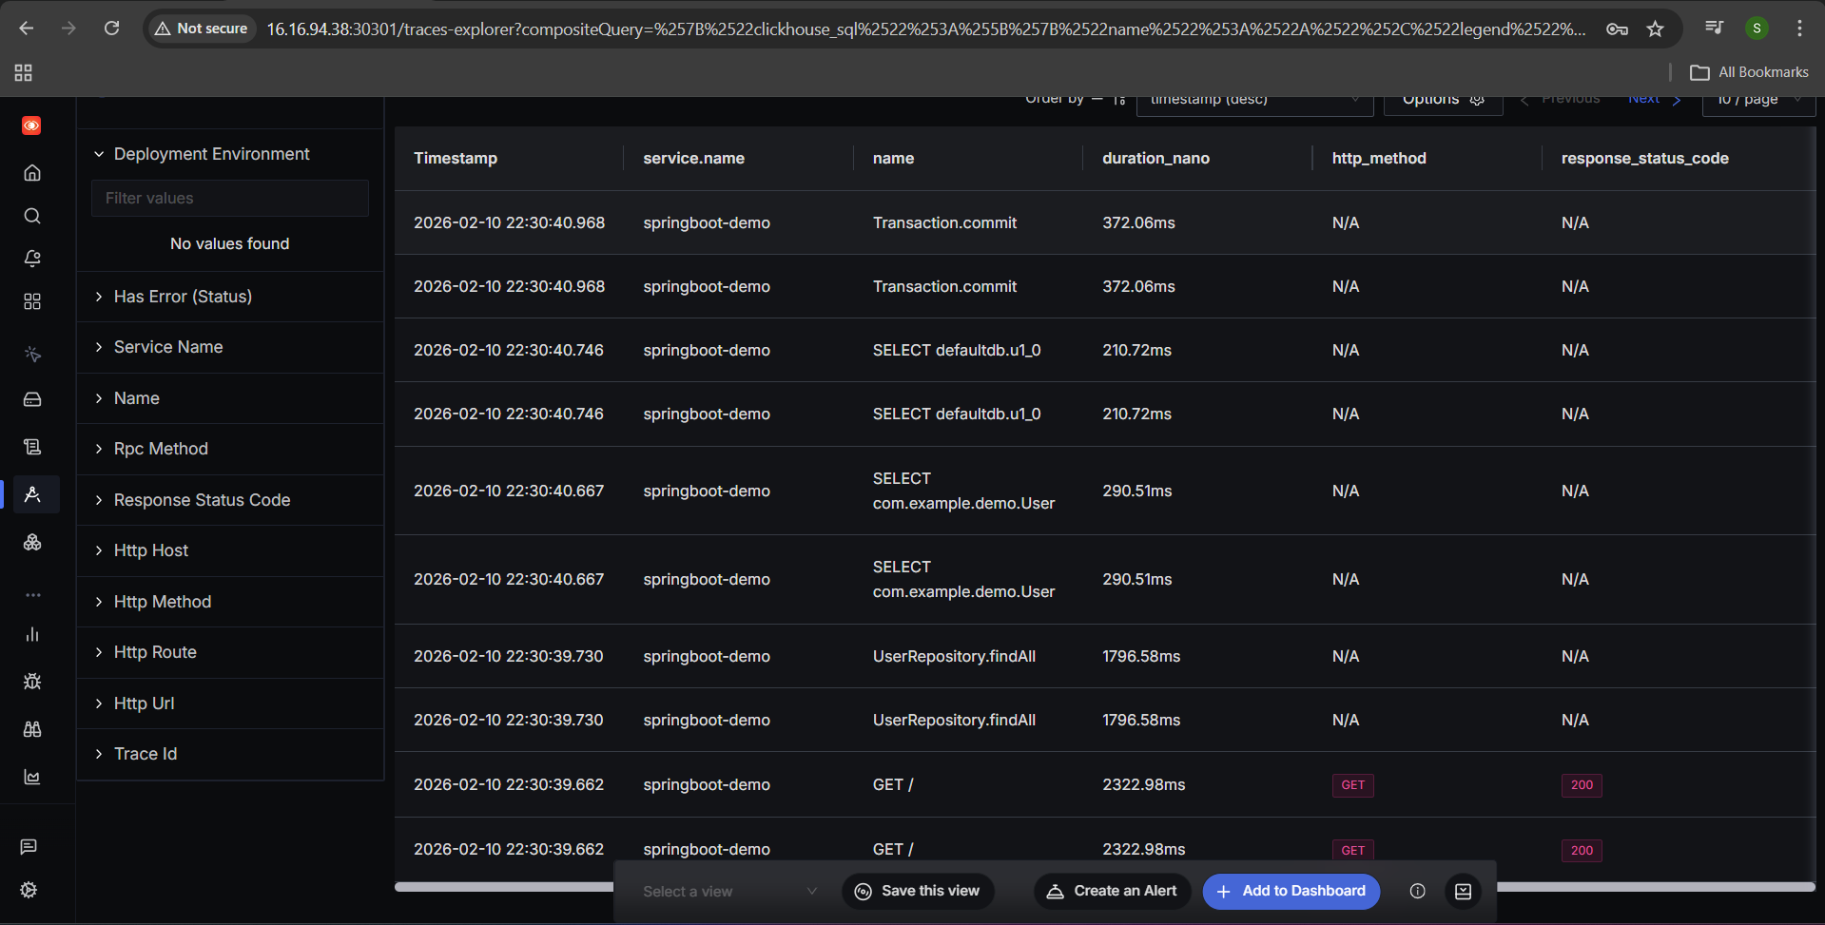
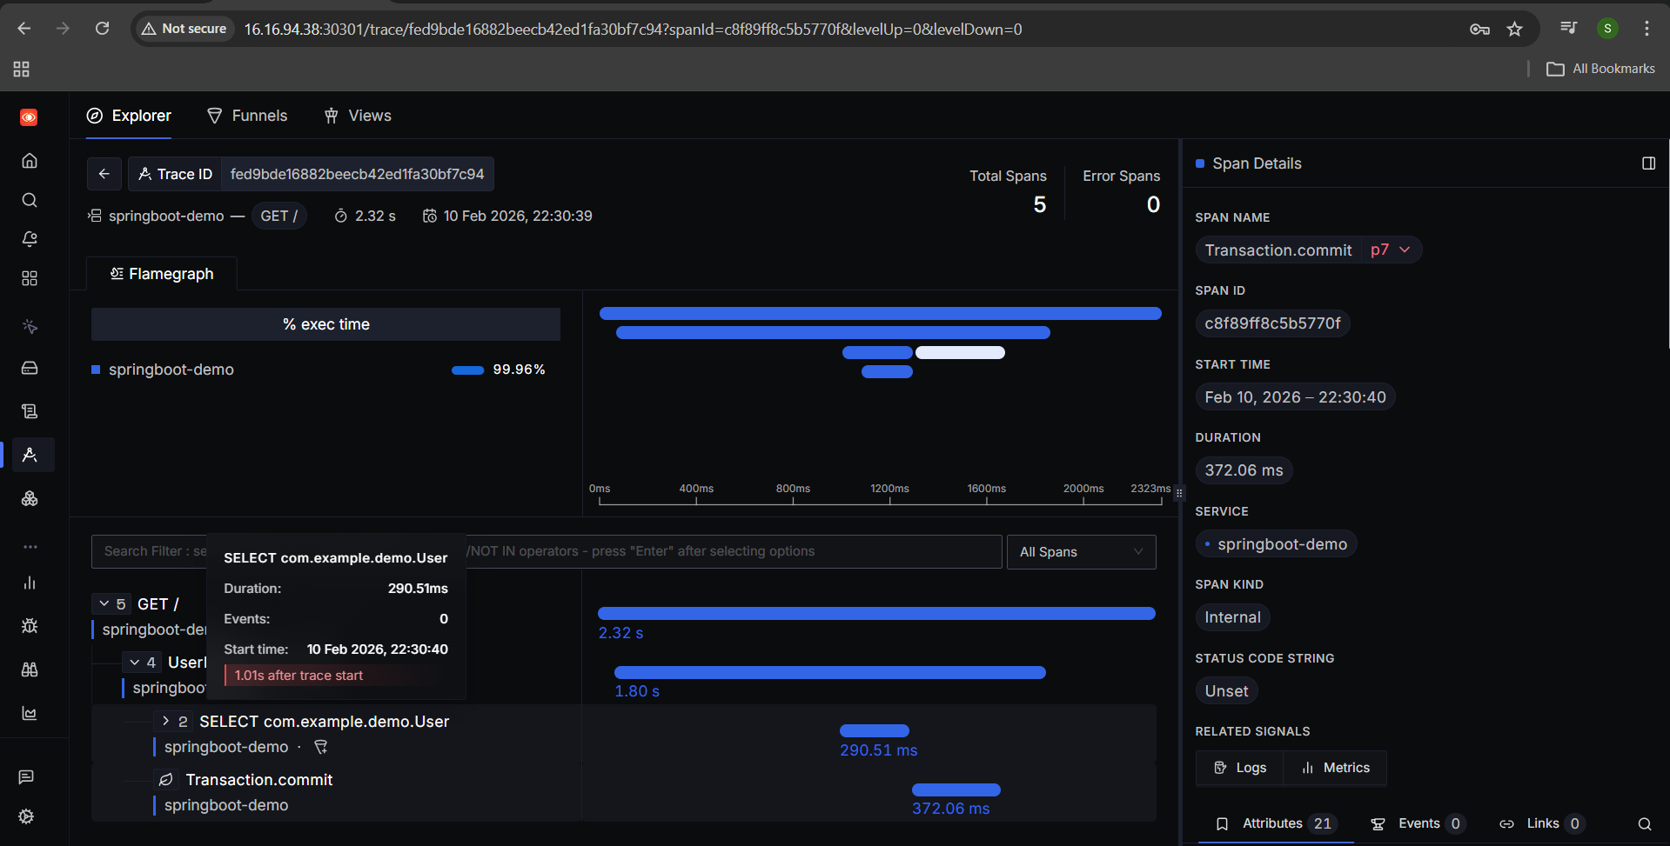

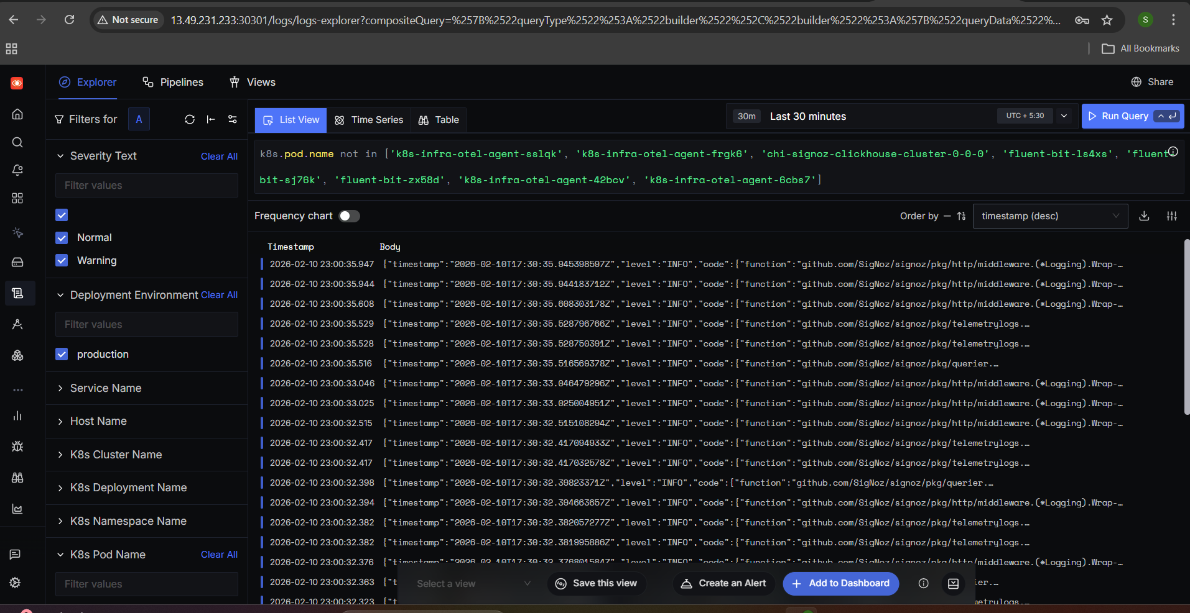

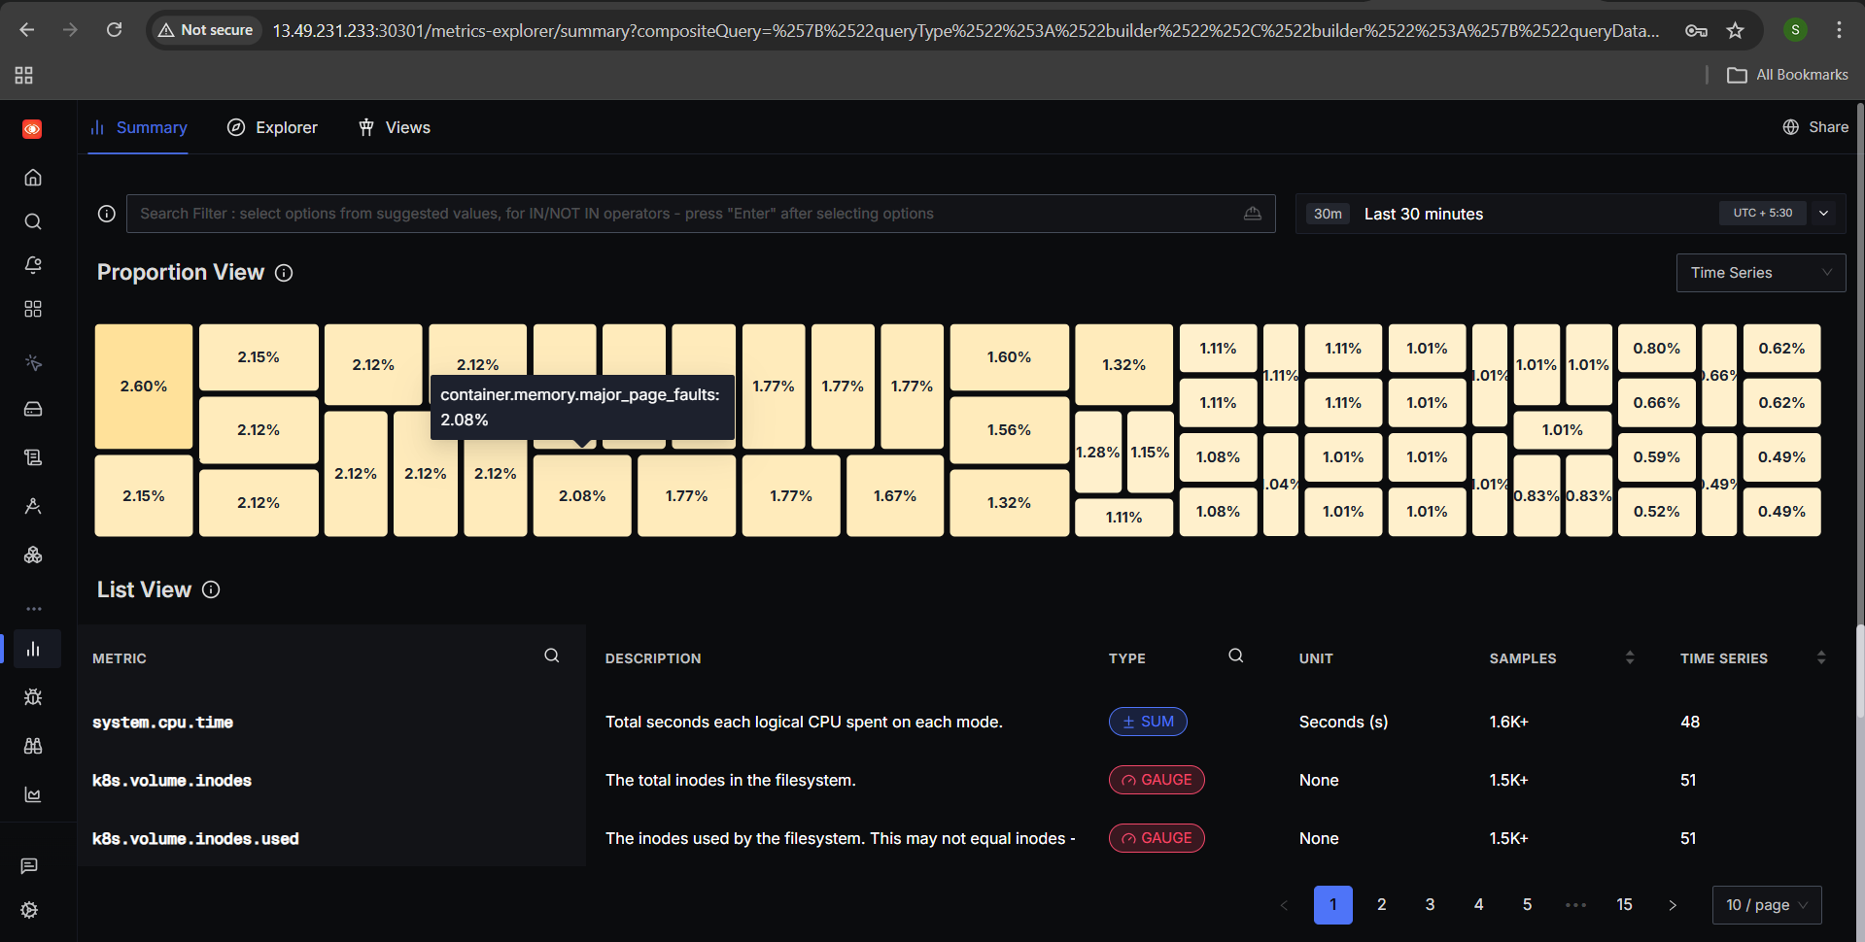

✅ Prerequisites Checklist (verify first)
Run these from master node or from a machine that has kubeconfig access.
1️⃣ Kubernetes version
kubectl version --short
✔ Must be v1.22+

2️⃣ Nodes should be Ready
kubectl get nodes
Expected:
master Ready
worker1 Ready
worker2 Ready

3️⃣ Helm (very important)
helm version
✔ Helm >= 3.8
If not installed:
curl https://raw.githubusercontent.com/helm/helm/main/scripts/get-helm-3 | bash

4️⃣ StorageClass (CRITICAL ❗)
SigNoz needs persistent storage (ClickHouse).
Check:
kubectl get storageclass
Case A: You see something like
NAME PROVISIONER
local-path rancher.io/local-path
or
standard kubernetes.io/no-provisioner
➡ Good, continue.
Case B: No storageclass
Tell me – we’ll create local-path-provisioner.

🏗️ Step 1: Create namespace for SigNoz
kubectl create namespace signoz
(Keeping it separate = easier debugging)

📦 Step 2: Add SigNoz Helm repo
helm repo add signoz https://charts.signoz.io
helm repo update

📝 Step 3: Create values.yaml
This is VERY IMPORTANT – don’t skip.
Create file:
nano values.yaml
Paste this (minimal + safe for kubeadm):
global:
storageClass: local-path

clickhouse:
installCustomStorageClass: true
persistence:
size: 50Gi

zookeeper:
persistence:
size: 10Gi
🔍 Explanation:
- storageClass: uses your cluster’s StorageClass
- ClickHouse needs big disk
- Zookeeper needs stable disk
👉 If your storageClass name is not local-path, replace it.

🚀 Step 4: Install SigNoz
helm install signoz signoz/signoz \
--namespace signoz \
--create-namespace \
--wait \
--timeout 1h \
-f values.yaml
⏳ This may take 5–15 minutes (ClickHouse is heavy).

🔍 Step 5: Watch pods (important)
In another terminal:
kubectl get pods -n signoz -w

[ec2-user@k8s-master signoz]$ cat signoz-nodeport.yaml
apiVersion: v1
kind: Service
metadata:
name: signoz-nodeport
namespace: signoz
spec:
type: NodePort
selector:
app.kubernetes.io/component: signoz
app.kubernetes.io/instance: signoz
app.kubernetes.io/name: signoz
ports:
- name: ui
port: 8080
targetPort: 8080
nodePort: 30301 # You can change this if needed
[ec2-user@k8s-master signoz]$

🧠 What K8s-Infra does (simple view)
Kubernetes Cluster
├── kubelet / nodes
├── pods / containers
├── logs
└── cluster metadata
↓
K8s-Infra (Helm)
↓
SigNoz Otel Collector
↓
SigNoz UI
This is separate from the SigNoz backend you already installed.

✅ Step 1: Get SigNoz Collector endpoint (VERY IMPORTANT)
Run:
kubectl get svc -n signoz signoz-otel-collector
You’ll see something like:
NAME TYPE CLUSTER-IP PORT(S)
signoz-otel-collector ClusterIP 10.96.123.45 4317/TCP,4318/TCP
👉 Your endpoint will be:
signoz-otel-collector.signoz.svc.cluster.local:4317
We’ll use this in override-values.yaml.

📝 Step 2: Create override-values.yaml
nano override-values.yaml
Paste this 👇 (safe & correct for kubeadm):
global:
cloud: others
clusterName: kubeadm-cluster
deploymentEnvironment: production

otelCollectorEndpoint: signoz-otel-collector.signoz.svc.cluster.local:4317
otelInsecure: true

presets:
otlpExporter:
enabled: true
loggingExporter:
enabled: false
🔍 Explain like you’re 5
- cloud: others → non-EKS / non-GKE
- clusterName → how cluster shows in SigNoz UI
- otelCollectorEndpoint → where data is sent
- otelInsecure: true → no TLS (internal cluster traffic)

🚀 Step 3: Install K8s-Infra
helm install k8s-infra signoz/k8s-infra \
--namespace signoz \
-f override-values.yaml
💡 We use the same namespace as SigNoz — simpler networking.

👀 Step 4: Verify pods
kubectl get pods -n signoz
You should now see new pods, like:
k8s-infra-otel-agent-xxxxx
k8s-infra-otel-collector-xxxxx
If any pod is not Running:
kubectl logs <pod-name> -n signoz

