**Features and Functionality Explained**

**Login Module:**

**Pre-Requisitions:**

1. User details with roles will be in DB.
2. User will not be having multiple roles.
3. Every User will have their credentials.

* User can login into the system using their credential.
* System will redirect the user to landing page according to their role.

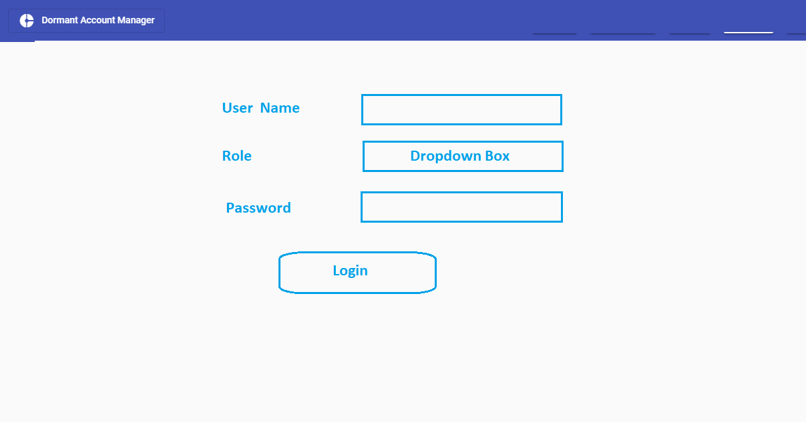

**File Import Module:** Business will receive the file and support role can import the file and upload the data into system. File will have the details of dormant accounts which include below fields-

1. Account Holder Name
2. Account Number
3. Contact Number
4. Email ID
5. Last Transaction date

**Ticket Module:**

* Ticket will have four states-

1. Initiated: Ticket will be assigned to User.
2. User Response: Ticket is pending with Account Holder. And this state will have the history of customer feedback linked.
3. Pending For Approval: Ticket is pending for approval with admin and will have the history of Admin feedback linked.
4. Closure: Ticket is closed.

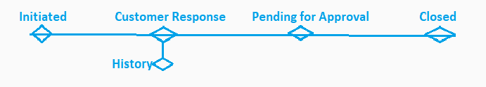

**Support Role Module:** Below are the listed features for support.

* 1. User will have access to import file module.
  2. User can access the dormant accounts assigned to him and unassigned dormant accounts.
  3. User can assign the unassigned dormant account to himself by clicking Assign to Me Button. On assigning to himself a Ticket will generated and a Progress Bar will get created for the dormant account with Ticket is in initiated state.
  4. User can View the Progress Bar and get the feedback (pre-defined responses) from account holder and log it into the system. Once the user will contact the account holder and will Save or Submit.

**Save Response:** If ticket is in initiated state and User save the Response, State will get changed to User Response and the feedback will get saved into the system.

**Submit Response:** If ticket is in initiated state and User Submits the Response, system will save the response in system and change the state to User Response. Immediately after that System will change the state to Pending for Approval.

* 1. User can view his/her activities on Log screen.
  2. User will get the notifications of activity to do under bell icon i.e. call to customer to get response

Support Landing Page (Dashboard):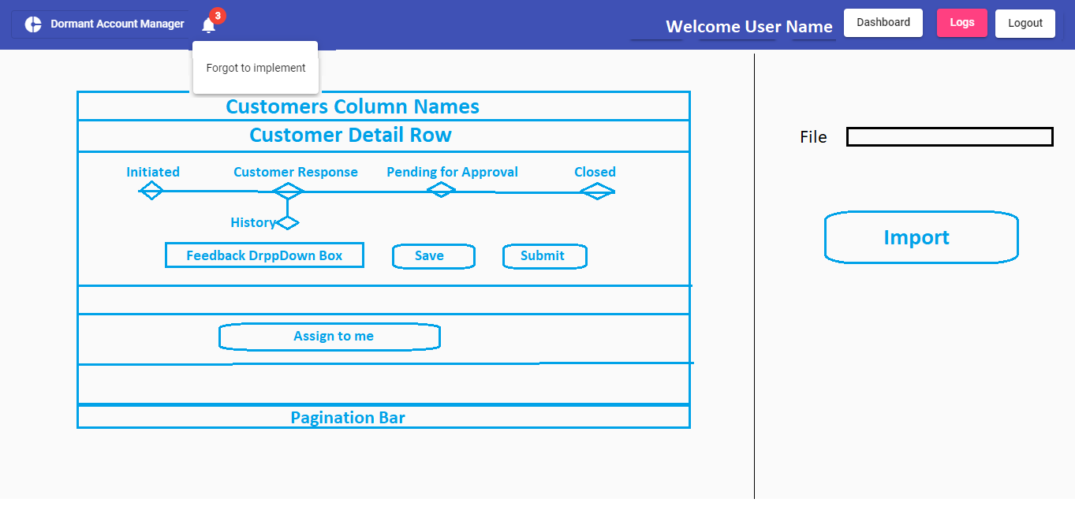

Support Logs Page: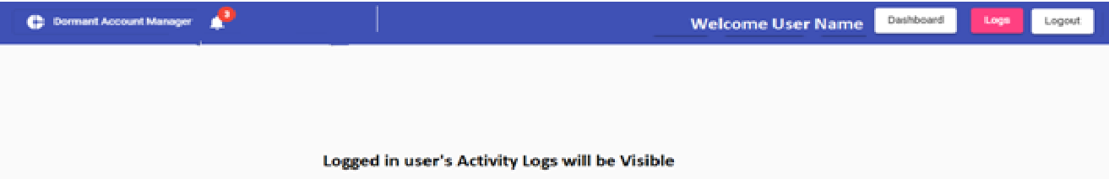

**Admin Role Module:** Below are the listed features for Admin Role-

* 1. User can view the dormant account List of all Customers with Progress Bar under All dormant account List Tab.
  2. User can access the dormant account List of Customers who are Pending for Approval under Pending for Approval List.

**Approve Request:** User can approve the Ticket and log the feedback, on approval system will change the state of ticket to Closure state.

**Reject Request:** User can reject the ticket and log the feedback, on rejection system will change the state to User response again.

* 1. User can View the activity of all users under Activity Tab.

All Dormant Account List: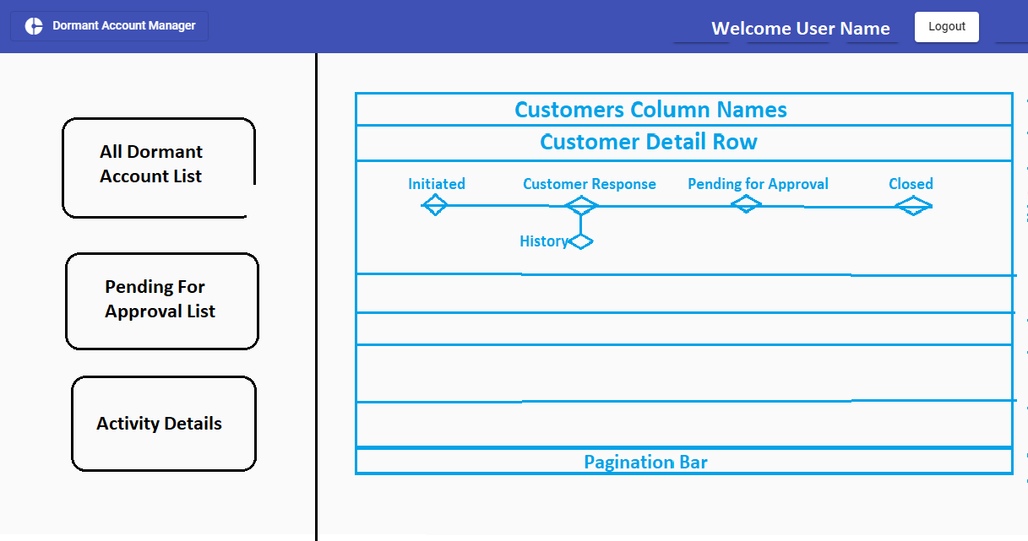

Pending For Approval List Tab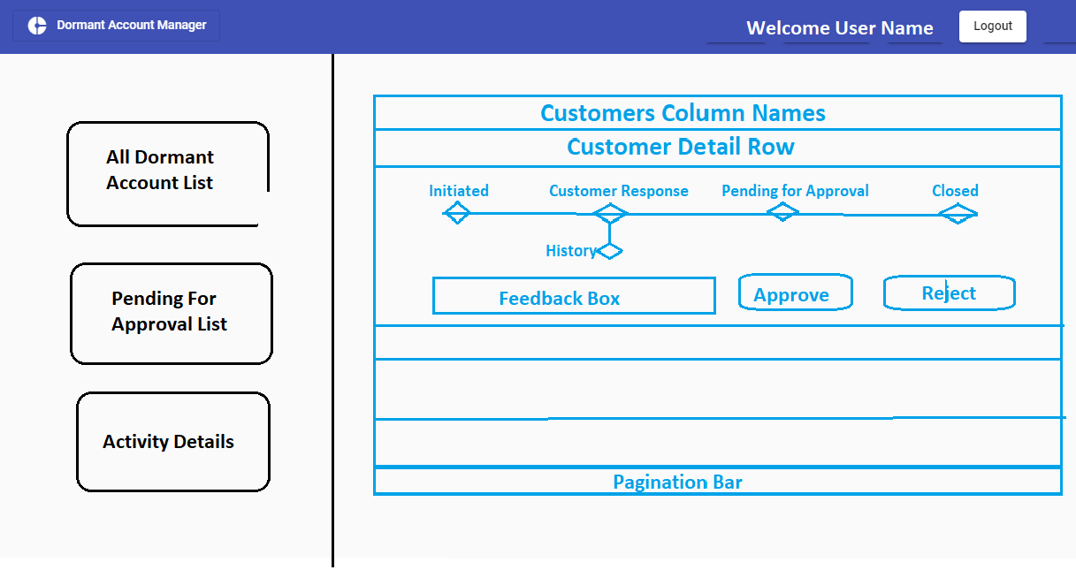

Activity Details Tab:

