PRISM (Precise & Repeated In vivo Subcellular Microscopy)
connects molecular dynamics to biological function in intact organisms

From molecules to behavior: the need for in vivo molecular measurement
Biological function spans orders of magnitude in space and time, from molecular interactions to organism-level behavior. Understanding how molecular-scale changes produce system-level outcomes therefore requires measuring molecules in their native functional context. The bacterial flagellar motor illustrates this principle. The motor spins continuously, yet its protein components are subject to ongoing synthesis and degradation. This raises a basic mechanistic question: how are the molecular components of a functioning machine maintained over time? Quantitative fluorescence imaging of motor units provided a key insight. These measurements showed that torque-generating proteins exchange continuously with a larger, diffusible membrane pool while the motor runs¹.
For larger organisms, this same maintenance problem must be solved across many spatial scales. In memory and learning, behavioral change is thought to be implemented through synaptic plasticity²: learning modifies circuit function by changing the strength of specific synapses³. Synaptic strength, in turn, is determined in part by the number of postsynaptic AMPA-type glutamate receptors⁴. These receptors, like motor proteins, are molecular components that turnover on timescales far shorter⁵ than the persistence of the function they support. This raises an analogous question: how are changes in synaptic strength implemented and maintained when their molecular substrates are continuously replaced?
We currently lack the tools needed to test such questions. This would require extending to synapses the level of access to protein dynamics that has made it possible to resolve mechanisms in the bacterial flagellar motor. Closing this gap will require coordinated innovation in labeling, imaging, and quantitative interpretation in intact animals. I have experience developing methods across these fronts and will integrate these approaches to enable direct measurement of synaptic protein dynamics during learning in vivo.
Specifically, one proposed mechanism is that synapses maintain their strength by exchanging AMPA receptors with a shared membrane pool. Evidence supporting this model comes from reduced preparations such as cultured neurons, where AMPA receptors were observed diffusing along the dendritic membrane and become locally stabilized at synapses during plasticity. In this diffusion-and-capture framework⁶, synapses draw receptors from a large, shared membrane pool supplied by ongoing synthesis in the soma. Indirect evidence suggests that these dynamics contribute to learning in vivo, as blocking AMPA receptor diffusion along the membrane prevents learning-induced synaptic strengthening⁷. A direct consequence of this model is that lateral diffusion equilibrates local receptor accumulations, enforcing smooth spatial variation in receptor turnover.
This was not the case in vivo. I was recently able to show that stable boundaries exist across hippocampal and cortical layers over days using DELTA⁸, a novel method my colleagues and I developed for measuring synaptic protein turnover in behaving animals. This organization both rules out a large, shared surface pool and exposes a deeper gap: we do not know how receptor numbers are regulated locally, how plasticity is distributed across synapse populations, or how these distributions evolve during learning. These results also show that experimental context shapes molecular mechanisms. This extends beyond learning: development, immune responses, and tissue repair all unfold in living systems where molecular dynamics must be measured repeatedly over time. Without such measurements in vivo, predictions derived from reduced preparations remain untested and central mechanisms remain inaccessible across many fields of biology.
The measurement gap: sensitivity × repetition × living tissue
Resolving this problem requires sufficient resolution, longitudinal access, and in vivo compatibility—requirements not met by any existing approach (Table 1). For example, current two-photon microscopes enabled longitudinal access in living animals^{9,10} but are diffraction-limited¹¹, such that both the predicted synapse-level changes and the separation between neighboring synapses—particularly along the axial (z) dimension—fall below their resolvable spatial scale. Fixed-tissue methods^{12,13} can achieve high resolution but require fixation, precluding longitudinal access. Single-molecule localization microscopy (SMLM)¹⁴ provides resolution and longitudinal access but cannot be easily applied in vivo in a repetitive manner because its reliance on prolonged camera-based acquisitions of isolated emitters breaks down in scattering, moving tissue.
Method | Spatial Resolution | Longitudinal access | in vivo compatibility
Two-photon microscopy | Insufficient | Yes | Yes
Fixation-based methods | Sufficient | No | No
SMLM: Single-molecule localization microscopy | Sufficient | Yes | No
PRISM: Precise & Repeated In vivo Subcellular Microscopy | Sufficient | Yes | Yes
Table 1. Comparison of imaging approaches across the three requirements.
This gap is technical, not conceptual. In living tissue, scattering, motion, and background heterogeneity act together on fluorescence signals as they are generated, collected, and interpreted. Because these constraints shape all three aspects simultaneously, achieving molecularly interpretable measurements in vivo requires that signal generation, signal collection, and quantitative interpretation be addressed as a coupled problem rather than independently. Meeting this requirement motivates PRISM (Precise & Repeated In vivo Subcellular Microscopy), an integrated platform I have designed to achieve molecular sensitivity, repeated measurement, and in vivo compatibility simultaneously. PRISM organizes solutions to signal generation, collection, and interpretation into three interdependent components—HaloTag-based labeling of endogenous proteins, fast two-photon microscopy with online motion correction, and quantification anchored by in-sample molecular standards. Together, these components enable precise, repeated molecular measurement in vivo (Table 2; Figure 1).
# | Innovation | What it enables
(i) | HaloTag knock-in labeling of endogenous proteins | Enables fluorescence measurements to be related directly to native protein abundance
(ii) | Photoactivatable HaloTag ligand dyes in vivo | Enables controlled emitter activation for molecular counting and quantitative measurements
(iii) | Spontaneously blinking HaloTag ligand dyes in vivo | Enables fluctuation-based super-resolution imaging
(iv) | In tissue standards | Anchors fluorescence measurements to known molecular references within the same optical environment as the tissue
(v) | Blinking-based calibration (combination of iii and iv) | Enables robust conversion of fluorescence signals into molecular numbers in heterogeneous in vivo conditions by separating dynamic calibration signals from static background fluorescence
(vi) | Fast two-photon imaging with real-time 3D motion correction | Enables repeated subcellular measurements at depth in behaving animals while preserving their spatial alignment
Table 2. PRISM innovations and what each enables.
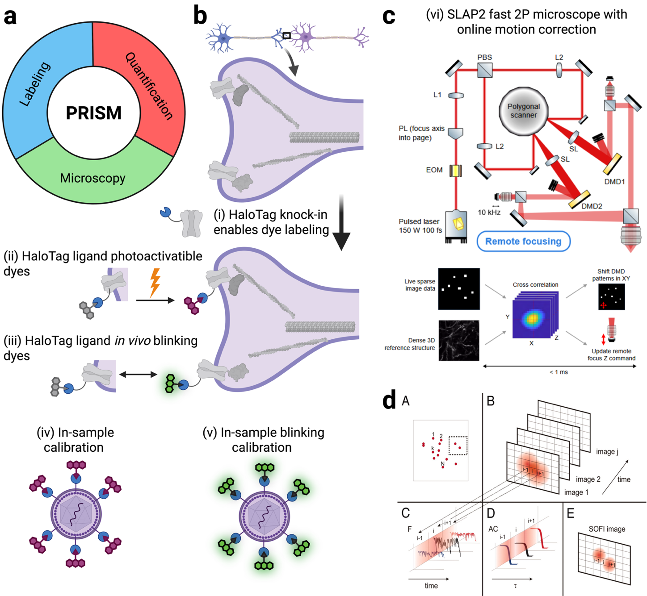
Figure 1 - PRISM innovations. a. PRISM is an integrated platform offering innovations in labeling, quantification and microscopy. b. PRISM innovations and what they enable - see also Table 2. c. SLAP2 (Scanned Line Arbitrary Projection 2P microscope). Adapted from He et al.¹⁵. Top: Optical path with 2 independently steered planes at up to kHz frame rates. The path includes a combination of a polygonal scanner, Digital Micromirror Device (DMD), and remote focusing¹⁶. Bottom: Online 3D motion correction possible at <1ms latency due to the fast DMD and remote focusing response times. He et al. report under 150 nm residual motion when imaging at 200 Hz in vivo. d. Principle of SOFI (Super-resolution Optical Fluctuation Imaging). Adapted from Dertinger et al.¹⁷ (A) Emitters in the object plane exhibit independent fluorescence intermittency. (B) Their signals are blurred by the system point spread function (PSF), preventing resolution of closely spaced emitters. (C) Fluorescence fluctuations are recorded over time at each pixel. (D) SOFI computes pixel-wise second-order or higher-order correlations of these fluctuations. (E) These yield an image with an effective PSF raised to the power of the correlation order and improving resolution by a factor that is the root of the correlation order. For 2nd order SOFI the improvement is $\sqrt{2.}$

PRISM components and innovations
Labeling must enable specific, stoichiometric tagging of endogenous proteins in vivo. PRISM will use knock-in animals that provide a one-to-one covalent handle for synthetic dyes via the HaloTag protein¹⁸. This makes the labeling layer chemigenetic: the animal provides specificity and stoichiometry, while dye chemistry can be upgraded without generating new lines. The Lavis laboratory has developed Janelia Fluor HaloTag ligands¹⁹ with substantially improved brightness and photostability²⁰, directly increasing photon budget and thus localization precision²¹. These dyes now exist in complementary photoactivatable²² and spontaneously blinking variants²³, providing two independent routes to the same molecular quantities. Photoactivatable dyes enable controlled activation for molecular counting²⁴, while blinking dyes enable super-resolution through stochastic switching and localization below the diffraction limit¹⁷ (Figure 2). Having both modes reduces technical risk and allows cross-validation when both can be applied in vivo. Bringing both photoactivation and spontaneous blinking into quantitative in vivo imaging has not yet been achieved and is a central innovation of this proposal. These labeling approaches make molecules visible. Next, quantification must make their fluorescence interpretable as numbers in living tissue.
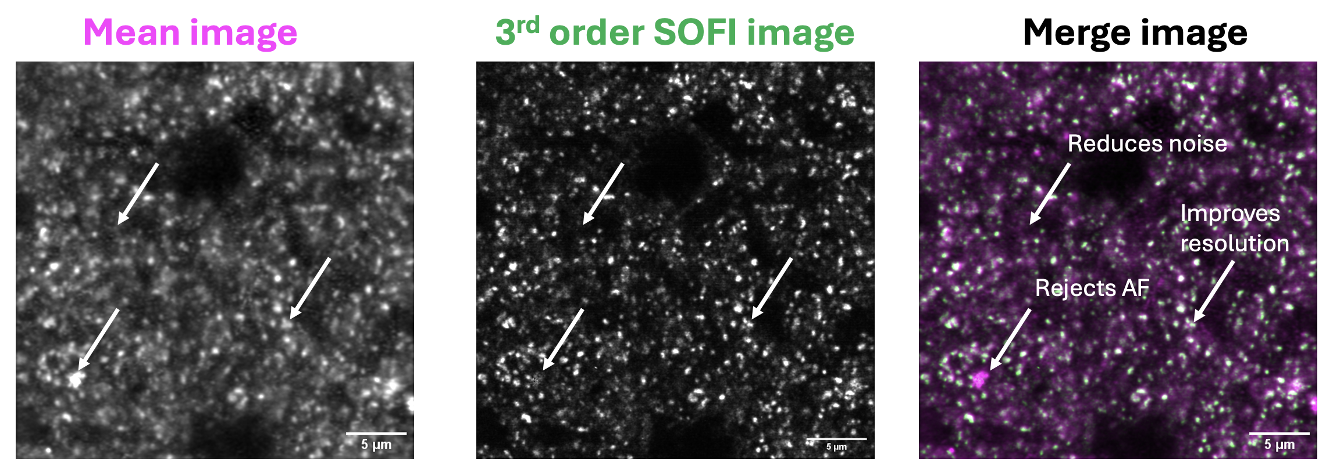
Figure 2 | Fluctuation-based imaging provides super-resolution and signal-to-noise enhancement in brain tissue. Fixed thick brain slice from a GluA2–HaloTag knock-in animal, imaged in physiological buffer. Spontaneously blinking JF635b–HaloTag ligand dyes were recorded using fast confocal Airyscan imaging, with 2,000 frames acquired from the same field of view at 30Hz for a total of ~1min of acquisition. Left: Mean intensity image, in which punctate synaptic AMPA receptors are blurred and partially obscured by background fluorescence. Middle: Third-order SOFI image computed from the same data, exploiting temporal intensity fluctuations to suppress static background like autofluorescence (AF) and achieve super-resolution relative to the diffraction-limited mean image. Right: Overlay of mean (magenta) and SOFI (green) images, illustrating both improved spatial separation of synapses and enhanced signal-to-noise through rejection of non-fluctuating background. Scale bar, 5 µm.
Quantification is essential whenever biological change is encoded in molecular copy number rather than the presence or absence of a protein. In the brain, synaptic plasticity produces changes on the order of tens of percent per synapse²⁵, while learning can drive larger cumulative shifts distributed across synapse populations²⁶ over seconds to days. Because synaptic weights follow lognormal distributions²⁷, understanding how learning reshapes circuit function requires molecular measurements at individual synapses with comparable precision across time. To accurately estimate changes in synapses, measurements must be calibrated and comparable across sessions; otherwise, drift in labeling, optics, or detection can masquerade as biology.
PRISM anchors fluorescence measurements to molecular quantities using in-sample standards with known HaloTag stoichiometry, such as virus capsids²⁸ or DNA origami²⁹, enabling fluorescence signals to be quantitatively interpreted. In vivo, however, scattering and heterogeneous background confound intensity-based quantification by breaking the correspondence between measured fluorescence and underlying molecular abundance. PRISM therefore reads calibration standards through dye blinking: temporal modulation is absent from static background, allowing calibration signals to be isolated from autofluorescence and other non-fluctuating contributions within the same tissue volume. Together, stoichiometric standards and advanced analysis of blinking-based readouts^{30–32} express fluorescence as molecular counts with confidence intervals across repeated imaging sessions. PRISM enables direct measurement of how synaptic strength is redistributed during learning: whether plasticity is sparse or dense, whether changes are symmetric or asymmetric across inputs, and whether individual synapses undergo stable consolidation or ongoing molecular turnover despite stable behavior.
Microscopy determines whether molecular mechanisms can be measured repeatedly in intact systems where scattering reduces signal with depth and physiological motion continuously displaces tissue during acquisition. Overcoming these challenges in intact organisms requires stabilized imaging at depth that maintains both spatial locations and the temporal structure of fluorescence signals. In awake mice, like other in vivo preparations, behavioral and physiological motion produces displacements far larger than the subcellular structures on timescales that overlap the temporal dynamics used for quantitative molecular readouts such as blinking dyes. To calculate these temporal statistics, online motion correction needs to be implemented during acquisition³³. Because online stabilization is a closed-loop problem that requires motion to be both detected and corrected on comparable timescales, acquisition speed and actuator responsiveness become key constraints. PRISM will build on Janelia’s SLAP2 line-projection two-photon microscopy platform, which combines kilohertz-rate acquisition³⁴ with actuators capable of responding on the same timescale, enabling real-time correction of physiological motion at depth. PRISM also includes a complementary fast confocal acquisition path that provides a linear-excitation regime to de-risk blinking photophysics under nonlinear excitation. Together, these advances define PRISM’s microscopy innovation (Figure 1): the integration of excitation well-suited to imaging deep into live samples, online motion stabilization, and acquisition schemes optimized for repeated molecular measurement across time.

Past work and motivation
My motivation to develop PRISM comes from pursuing how animals learn at the molecular level, where answering biological questions in behaving animals repeatedly drove me to develop new measurement capabilities. When I first came to Janelia, I asked how learning and decision-making are reflected in dendritic integration during behavior, and how task-related variables are organized within dendritic arbors. To address that question, I co-developed a custom high-resolution two-photon microscope to image calcium activity in dendrites during a tactile decision task in mice³⁵. I developed cross-day registration and motion correction algorithms in behaving animals, achieving stable subcellular measurements across days. This stability enabled us to show that task-related variables are represented by distance-dependent correlations along dendrites, with correlation structure significantly affected by dendritic branch points. This points to a postsynaptic plasticity mechanism in this behavior.
A key constraint emerged from this work: subcellular imaging in behaving animals requires early commitment to a specific brain region and, within it, a particular subcellular compartment such as cortical lamina. These decisions are currently made without molecular readouts of where plasticity is most pronounced in the brain. To address this gap, I developed DELTA, a method that provides brain-wide maps of synaptic protein turnover to guide targeted in vivo experiments⁸. The method uses HaloTag knock-in animals and Janelia Fluor dyes, the same labeling system as PRISM. DELTA revealed stable spatial structure in synaptic receptor lifetimes across hippocampal and cortical layers over days, present in both animals that learned and animals that did not. This organization is inconsistent with a free diffusion-and-capture model that predicts a shared surface pool and spatially uniform lifetimes⁶. It also revealed localized learning-induced plasticity in CA1 region of the hippocampus with laminar differences in magnitude that would guide PRISM experiments with unprecedented spatial resolution.
Driving application: receptor counting during reversal learning
Together, these results establish where synaptic plasticity is most pronounced in the intact brain and rule out models in which AMPA receptors freely exchange across synapses, but they leave unresolved how receptor numbers are adjusted at individual synapses during learning. Addressing this question requires tracking the same synapses repeatedly while plasticity is driven in defined directions by behavior. I will track AMPA receptor numbers at individual synapses during associative operant reversal learning, using this paradigm to drive platform development. Reversal learning imposes a defined switch in stimulus–reward contingencies, engaging synaptic strengthening for newly rewarded associations and weakening/extinction processes for previously rewarded ones over days—an ideal structure for validating longitudinal molecular tracking.

Broader impact: calibrated molecular imaging beyond synapses
PRISM is broadly applicable to questions beyond synaptic biology, wherever biological change is encoded in molecular abundance and unfolds over time in intact tissue. Examples include receptor trafficking in addiction-related circuits, transcription factor dynamics during development, and antibody binding during immune responses. Across these domains, distinguishing measurement artifacts from temporal dynamics requires precise, repeated, in vivo molecular measurement. PRISM enables fluorescence to transition from a qualitative indicator to a calibrated molecular measurement with defined precision.
PRISM, like DELTA, is conceived as a Janelia project: a platform I will drive and develop within an environment that supports deep technical integration and long-term tool building. The core components of PRISM—labeling, microscopy, and quantification—are each feasible and internally coherent, but their impact and rate of evolution are amplified when developed in close collaboration with others having complementary expertise.
At Janelia, continued advances in fluorophore chemistry in the Lavis laboratory provide a direct path to brighter, more photostable, and functionally diverse dyes that can be incorporated into PRISM as they emerge. T3's Infrastructure for in vivo administration and characterization enables systematic evaluation of dye performance under physiological conditions. New microscope architectures developed in the Shroff laboratory, together with ongoing exploration of excitation regimes compatible with living tissue by Wong-Campos, offer opportunities to push acquisition speed, stability, and depth beyond current limits. Quantitative analysis approaches for super-resolution^{14,36} and fluctuation-based imaging, including recent AI tools developed in the Turaga laboratory²⁴, enable increasingly rigorous conversion of optical signals into molecular measurements.
My experience developing and disseminating DELTA within this environment—including adoption by six independent laboratories and hands-on transfer through the Janelia Visiting Scientist program—demonstrates how such collaborations function as force multipliers. They allow a platform to mature more rapidly, reach a higher performance ceiling, and be adopted more broadly than would be possible in other institutions. PRISM is designed to follow this same trajectory.
Success is defined first by PRISM enabling me to make routine, repeated molecular quantification over time. In neuroscience, this will reveal key mechanisms of synaptic plasticity in intact, functioning circuits—bringing the kind of mechanistic insight that came from observing the flagellar motor in its native context. In five to ten years, I expect PRISM’s impact to extend far beyond neuroscience, revealing mechanisms across fields such as developmental biology, immunology, and cancer biology, where repeated molecular measurements in intact systems remain out of reach.

