# Getting Started

The following daigram shows the major components involved in the system.

## Spry Client SDK

Spry Client SDK takes care of the

* Fetching patient details from Spry Interoperable Bridge(supports AthenaHealth) using CareQuality Framework
* Real-time patient monitoring for patients

## Spry Clinical Interface

Using the Spry Clinical Interface, a user i.e. therapist can create customized exercise programs for the patient.

It also facilitates access to assessment reports from patients.

## Spry Cloud

Spry Cloud provides APIs for creating customized assessment programs and real-time patient monitoring using cutting-edge machine learning algorithms.

Spry Cloud uses its proprietary interoperable EHR bridge to fetch and send patient data with other EHRs. Currently supported EHRs include Athena, EPIC, and Cerner.

Build intelligence into your apps using Spry RTM SDKs



JS SDK Overview

## Introduction

Spry RTM developer platform is a core part of our mission to empower organizations to grow better. Our APIs are designed to enable teams of any shape or size to build robust integrations that help them customize and get the most value out of remote computer vision assessments.

All Spry SDKs and APIs are designed to have a predictable structure.

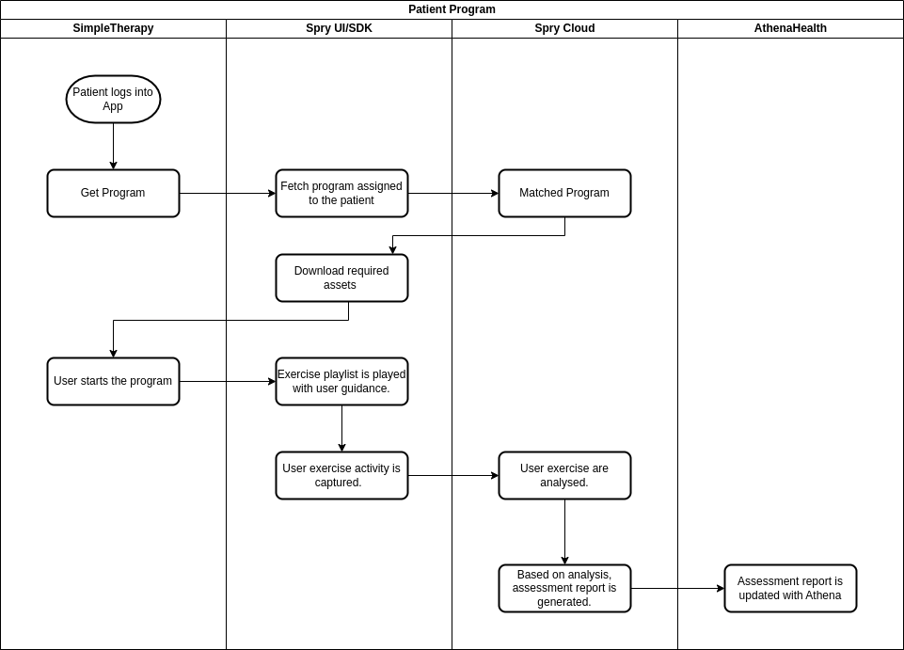

The above flow presents how the patient/user will adhere to the prescribed programs. Once prescribed exercises are done, their assessment is available via API and is also synced with AthenaHealth using Spry Interoperability Bridge.

The details for assessment reports is available in API Document

The below flow presents how the therapists will add a custom exercise program to the patient.

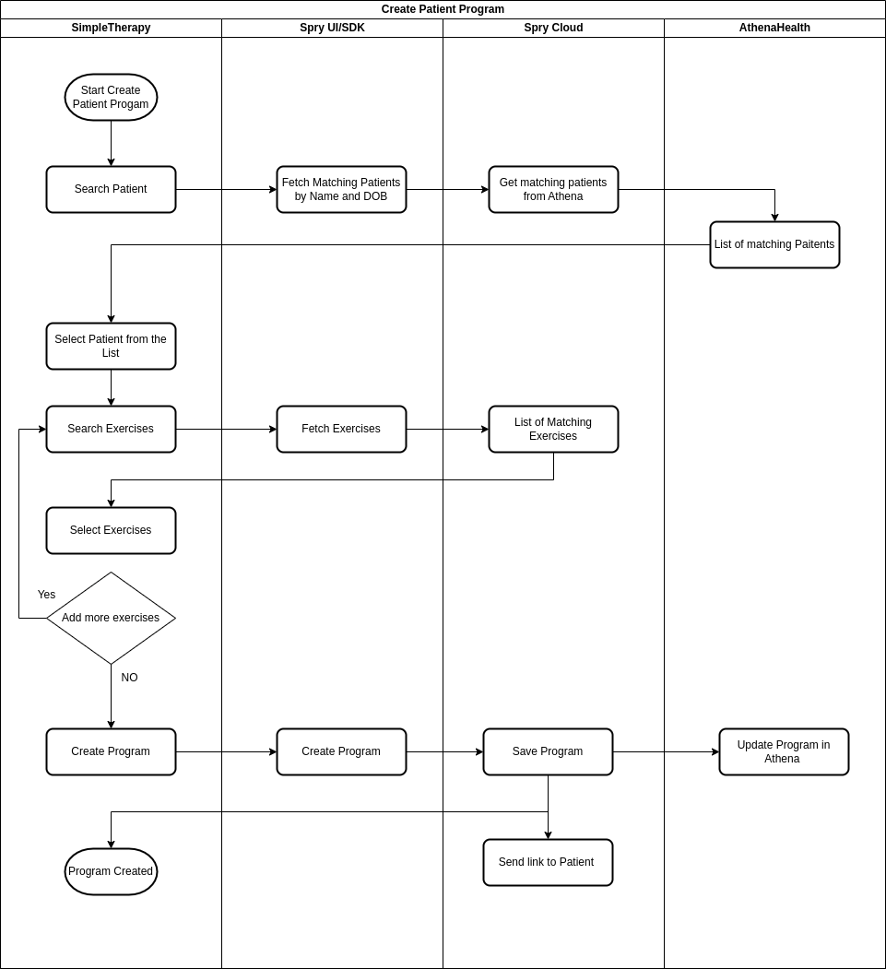

The following steps are involved in creating a customized exercise program

1. User (i.e. Therapist) searches for the patient using Name and Date of Birth
2. Spry SDK will return a list of matching patients.
3. User selects the patient.
4. User proceeds to create a customized program for the patient.
5. User searches for exercises and adds them to the program.
6. User selects the repetition, duration, and frequency for each exercise.
7. The created program is sent to AthenaHealth using Spry Interoperable Bridge.
8. The patient is notified about the program via email/SMS/push notification.