Student Name: Sagar Patidar
Registraion Number : 11804732
Course Code : CSE316 OPERATING SYSTEM

Que1: Write a multi-threaded C program that gives readers priority over writers concerning a
shared (global) variable. Essentially, if any readers are waiting, then they have priority over
writer threads -- writers can only write when there are no readers. This program should
adhere to the following constraints:
Multiple readers/writers must be supported (5 of each is fine)
Readers must read the shared variable X number of times
Writers must write the shared variable X number of times
Readers must print:
The value read
The number of readers present when value is read
Writers must print:
The written value
The number of readers present were when value is written (should be 0)
Before a reader/writer attempts to access the shared variable it should wait some random
amount of time
Note: This will help ensure that reads and writes do not occur all at once
Use pthreads, mutexes, and condition variables to synchronize access to the shared variable

CODE:
#include<stdio.h> //standard input and output
#include<pthread.h> //multithreading purpose //all header files to be required
#include<stdlib.h> //general purpose standard library
#include<unistd.h> //standard symbolic constraints
#include <time.h> //time and datefunction
#include <string.h> //string manipulation

pthread_mutex_t writ, mutex;
int Shared_Variable;
int count = 0;

void *ToWrite(void *arg){
pthread_mutex_lock(&writ);
int n = rand() % 8;
int d = ((int)arg);
printf("@@@@@@@@@@@@@@@@@@@@@@@@@@@@@@@@@@@@@@@@@@@@@@@@@@@@@@@@@@@@@@@\n\n");
printf("Wait some time WRITER%d \n", d);
sleep(n);
printf("No. of time WRITER%d want to write:\n", d);
int t;
scanf("%d", &t);
printf(" WRITER%d is writing...ADDITION...\n", d);
int j=0;
while(j<t){
printf("Give %dth INTEGER value to write:\n", (j+1));
int u;
scanf("%d", &u);
Shared_Variable = Shared_Variable + u;
j++;
}

printf("UPDATED value of Shared variable = %d \n", Shared_Variable);
printf("Number of WRITER present at current time = %d\n", count);

printf("@@@@@@@@@@@@@@@@@@@@@@@@@@@@@@@@@@@@@@@@@@@@@@@@@@@@@@@@@@@@@@@@@@\n");
pthread_mutex_unlock(&writ);
}

void *ToRead(void *arg){

pthread_mutex_lock(&mutex);
count++;
if(count==1)
{
pthread_mutex_lock(&writ); //writer is denied now
}
pthread_mutex_unlock(&mutex);

int n = rand() % 8;
int d = ((int)arg);
printf("@@@@@@@@@@@@@@@@@@@@@@@@@@@@@@@@@@@@@@@@@@@@@@@@@@@@@@@@@@@@@@@\n\n");
printf("wait some time READER%d \n", d);
sleep(n);
printf("No. of time READER%d want to read:\n", d);
int t;
scanf("%d", &t);
printf("Now READER%d is reading....\n", d);
int j;
while(j<t){
printf("READER%d READING the Shared_Variable = %d\n", d, Shared_Variable);
j++;
}
printf("Number of Readers present = %d\n", count);
pthread_mutex_lock(&mutex);
count--;
if(count==0)
{
pthread_mutex_unlock(&writ);//may be writer come
}
pthread_mutex_unlock(&mutex);
}

int main()
{
printf("ENTRY OF MAIN PROGRAM STARTS HERE \n"); //main flow of program from here...
printf("Provide a initial interger value for shared global variable for read and write:- \n");
scanf("%d", &Shared_Variable); //taking global variable value from user
printf("#############################################################################\n");

printf(" PROVIDE A TOTAl NUMBER OF WRITER....:\n");
int writer;
scanf("%d", &writer); //writer description
if(writer<0)
{
printf("Enterred invalid no. of writer.You intered negative number\n");
printf("Program is exiting....\n");
exit(0);
}
else if(writer == 0)
{
printf("No WRITER is choosed.Select atlest one writer\n");
printf(" thread will not be created of writer\n");
exit(0);
}
else
{
printf(" Generating of threads....\n");
}
int i=1;
while(i<writer+1)
{
printf("writer number is ->WRITER%d\n",i);
i++;

}

printf(" PROVIDE A TOTAl NUMBER OF READER....:\n");
int reader;
scanf("%d", &reader);
if(reader<0)
{
printf("Enterred invalid no. of reader.You intered negative number\n");
printf("Program is exiting....\n");
exit(0);
}
else if(reader == 0)
{
printf("No Reader is choosed.Select atlest one\n");
printf(" thread will not be created of READER\n");
exit(0);
}
else
{
printf(" Generating of threads of READER....\n");
}
int j=1;
while(j<reader+1)
{
printf("Reader number is ->READER%d\n",j);//Reader description.......
j++;

}

printf("@@@@@@@@@@@@@@@@@@@@@@@@@@@@@@@@@@@@@@@@@@@@@@@@@@@@@@@@@@@@@@@@@@@@@@@@@\n");

int k=pthread_mutex_init(&mutex, NULL); //initilation of mutex..
if(k==0)
{
printf("MUTEX is initilised succesfully\n");
}
else
{
printf("MUTEX is not initilised succesfully\n");
}

int l=pthread_mutex_init(&writ, NULL); //initilation of write

if(l==0)
{
printf("WRITE MUTEX is initilised succesfully\n");
}
else
{
printf("WRITE MUTEX is not initilised succesfully\n");
}

pthread_t WR1[writer];
pthread_t RD1[reader];

printf("#################################################################################\n");
int m=0;
if(writer>0 && reader>0)
{
for(m=0; m<writer; m++)
{
pthread_create(&WR1[m], NULL, &ToWrite, (int *)m);
}
for(m=0; m<reader; m++)
{
pthread_create(&RD1[m], NULL, &ToRead, (int *)m);
}
for(m=0; m<writer; m++)
{
pthread_join(WR1[m], NULL);
}

for(m=0; m<reader; m++)
{
pthread_join(RD1[m], NULL);
}
}
pthread_mutex_destroy(&mutex);
pthread_mutex_destroy(&writ);

printf("@@@@@@@@@@@@@@@@@@@@@@@@@.....THREAD JOINED NOW......@@@@@@@@@@@@@@@@@@@@@@@\n");
printf("SHARED VARIABLE VALUE AFTER READ WRITE OPERATION= %d\n",Shared_Variable);
return 0;

}

1.Explain the problem in terms of operating system concept? (Max 200 word)
Description:
The problem is to design a Thread synchronization of thread via help of mutux and multithreading concept. Threads are popular way to improve application through parallelism. For example, in a browser, multiple tabs can be different threads. MS word uses multiple threads, one thread to format the text, other thread to process inputs, etc. The readers-writers problem is us ed to manage synchronization so that there are no problems with the object data. For example - If two readers access the object at the same time there is no problem. However if two writers or a reader and writer access the object at the same time, there may be problems. To solve this situation, a writer should get exclusive access to an object i.e. when a writer is accessing the object, no reader or writer may access it. However, multiple readers can access the object at the same time. If a writer wants to access the object, wait operation is performed on write. After that no other writer can access the object. When a writer is done writing into the object, signal operation is performed on write. This problem based on providing security and integrity of shared and global variable.

2.Write the algorithm for proposed solution of the assigned problem.
Algorithm:

1.define the Readers and Writers and constraints,
a.define global data and variable.
2. create mutux variable and write for read and write threads.
3.for write wait(wrt);
Write into it…
Signal(wrt);

4. for read :
wait (mutex);
count ++;
if (count == 1)
wait (wrt);
signal(mutex);
.
. READ THE OBJECT
.
wait(mutex);
count --;
if (count == 0)
signal (wrt);
signal(mutex);
a) Run the write thread.
b) Till the time it completes, process the read thread.
c)print the final shared variable.
// Out of loop
5. for read

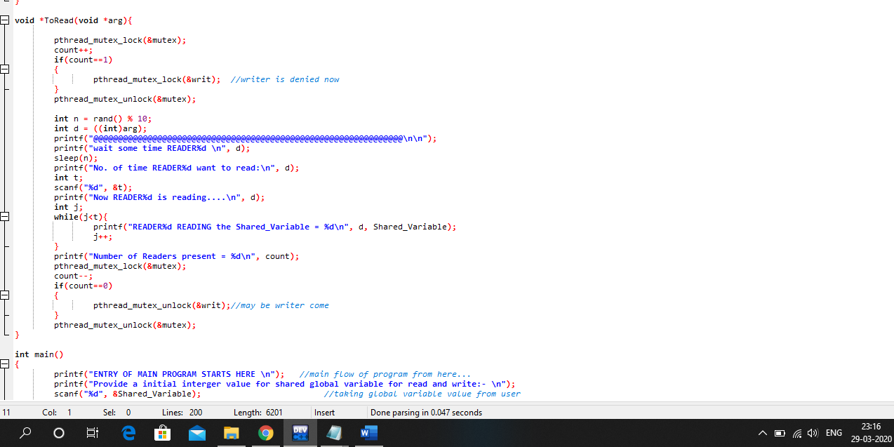

6. To write:
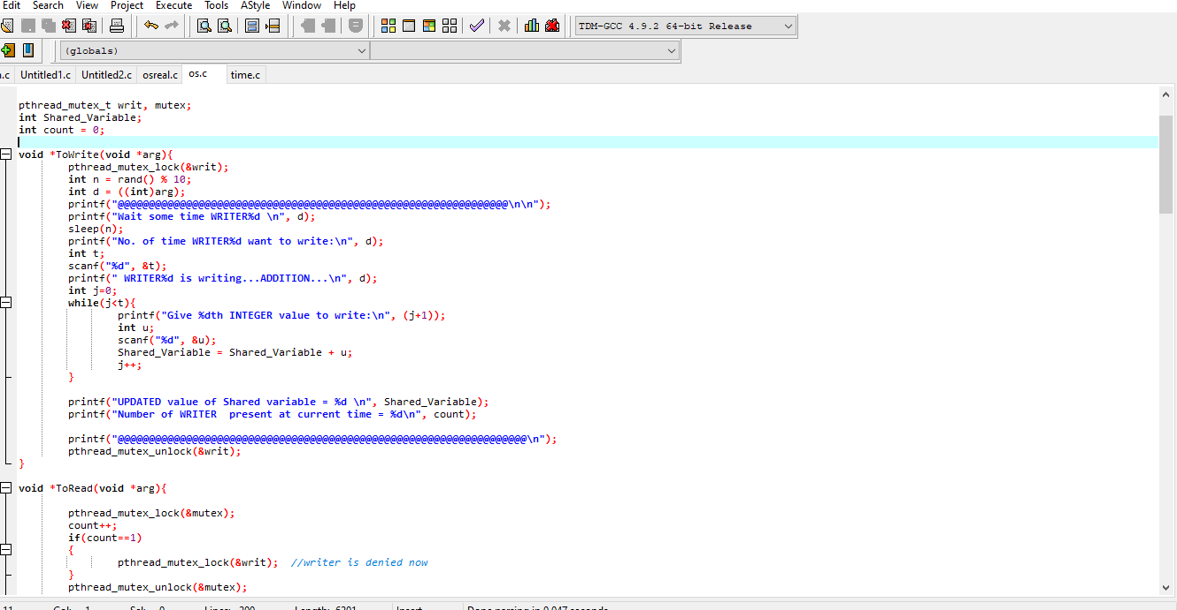

3.Calculate complexity of implemented algorithm.
Description (purpose of use):
1) for read or mutux function: O(n)
2) for write or wrt function: O(n)
3) Main Function:
a) Loop for taking INPUT from user and displaying OUTPUT: O(n)
b) Loop for creating threads): O (n ^2)
c) For Calling 2 functions: each having O(n) complexity
Overall Complexity: O (n^2)

4.Explain all the constraints given in the problem. Attach the code snippet of the implemented constraint.
Code snippet:
1. The comstrains that reader and writer are greater than 1 and not negative.when thread is writing shared variable then reader must be zero.and read and write both are not occur at same time.and also provde some random time between read and write threads to not happen at a same time.also provide some random time.

void *ToRead(void *arg){

pthread_mutex_lock(&mutex);
count++;
if(count==1)
{
pthread_mutex_lock(&writ); //writer is denied now
}
pthread_mutex_unlock(&mutex);

int n = rand() % 8;
int d = ((int)arg);
printf("@@@@@@@@@@@@@@@@@@@@@@@@@@@@@@@@@@@@@@@@@@@@@@@@@@@@@@@@@@@@@@@\n\n");
printf("wait some time READER%d \n", d);
sleep(n);
printf("No. of time READER%d want to read:\n", d);
int t;
scanf("%d", &t);
printf("Now READER%d is reading....\n", d);
int j;
while(j<t){
printf("READER%d READING the Shared_Variable = %d\n", d, Shared_Variable);
j++;
}
printf("Number of Readers present = %d\n", count);
pthread_mutex_lock(&mutex);
count--;
if(count==0)
{
pthread_mutex_unlock(&writ);//may be writer come
}
pthread_mutex_unlock(&mutex);
}

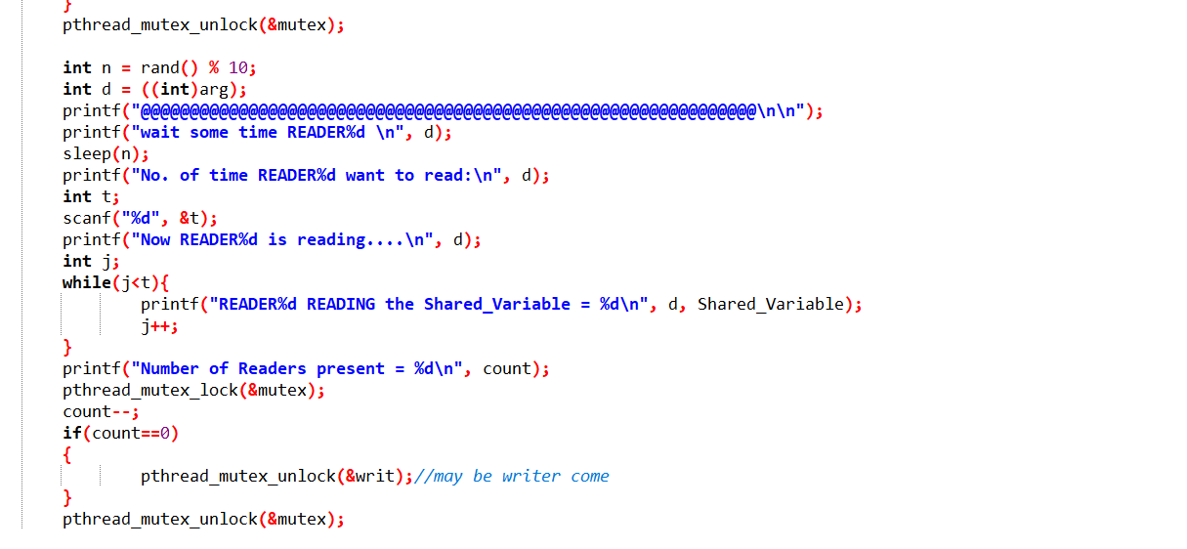

5. Explain the boundary conditions of the implemented code.
Description:
Reader and Writer can’t be negative since negative reader and writing has no meaning. Therefore, care has been taken in the code if such conditions occur and both are greater than 0. Code for the same is:
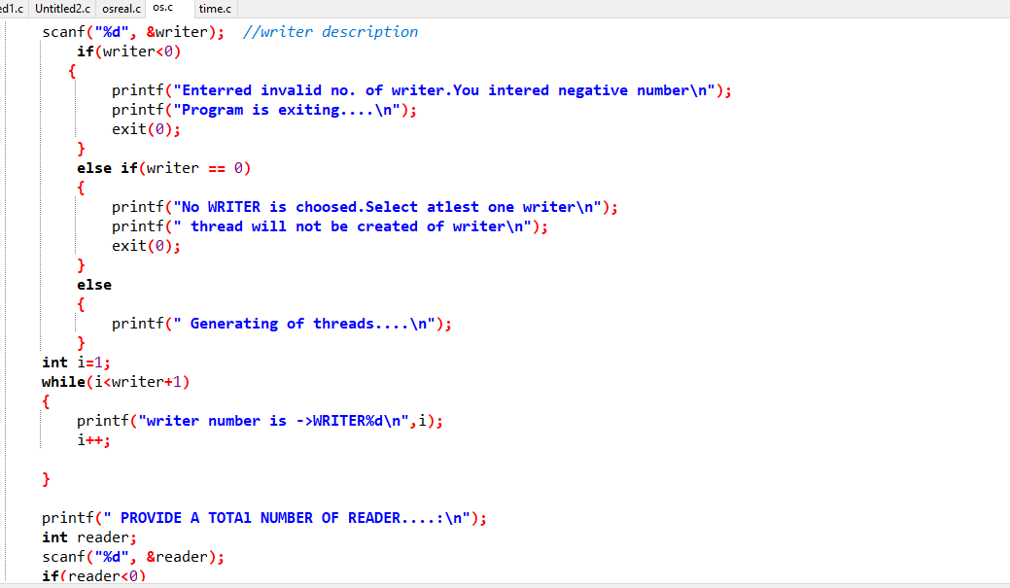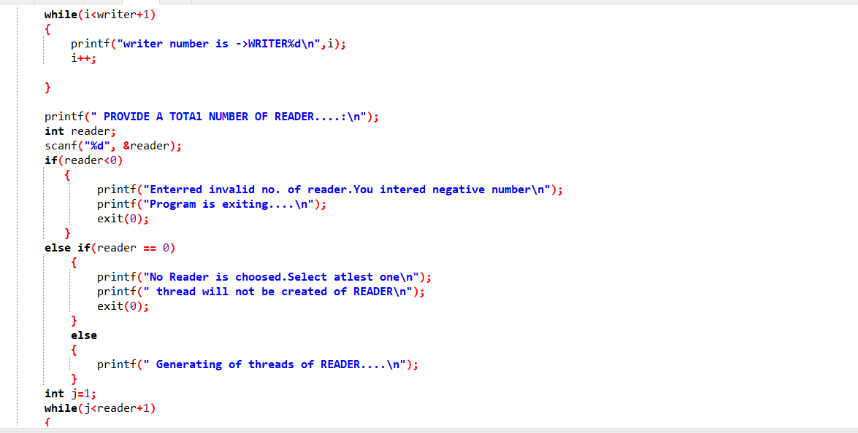

6.Explain all the test cases applied on the solution of assigned problem.
Description:
1.Both reader and writer equal to 0.
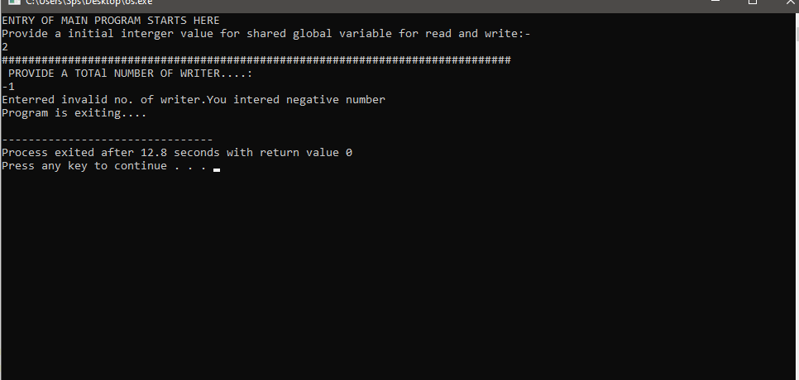
2.Both reader and writer equal to negative or one of them is negative.
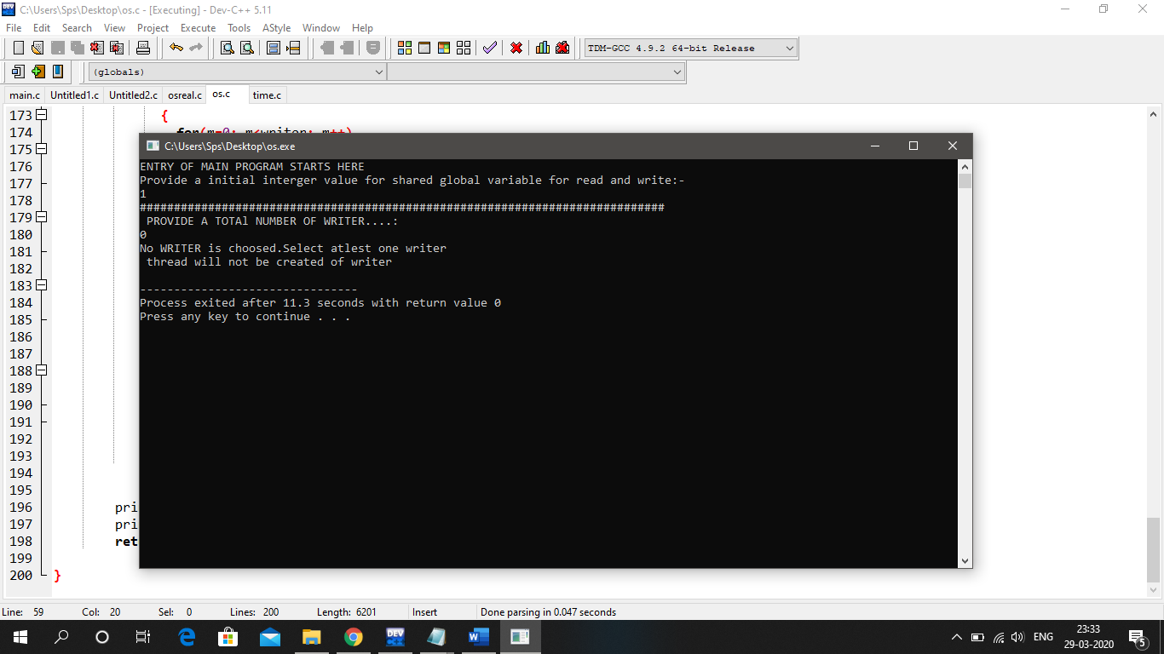

3.Both reader and writer grater than zero.
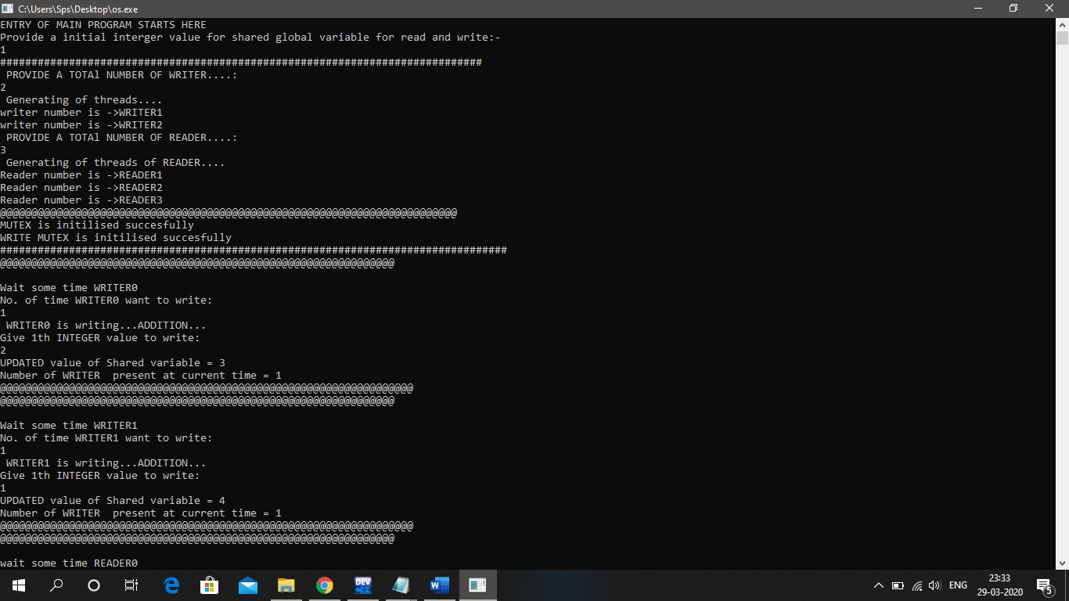

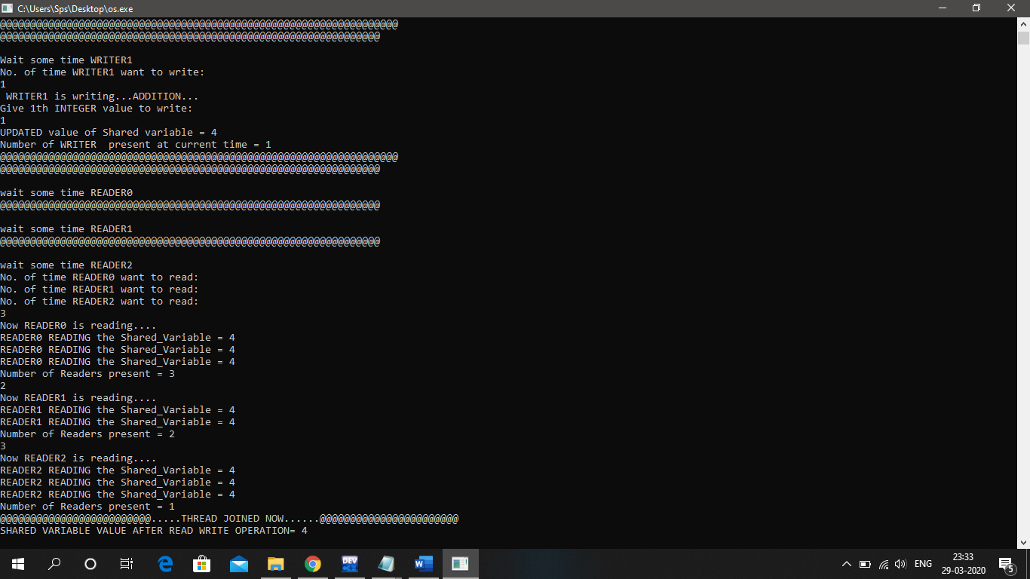

7.Have you made minimum 5 revisions of solution on GitHub?
Yes, I made atleast 5 revisions (commits) of solution on GitHub.
GitHub Link: https://github.com/sps1432/sps_osstimulation

