An alarm for host related to memory utilization

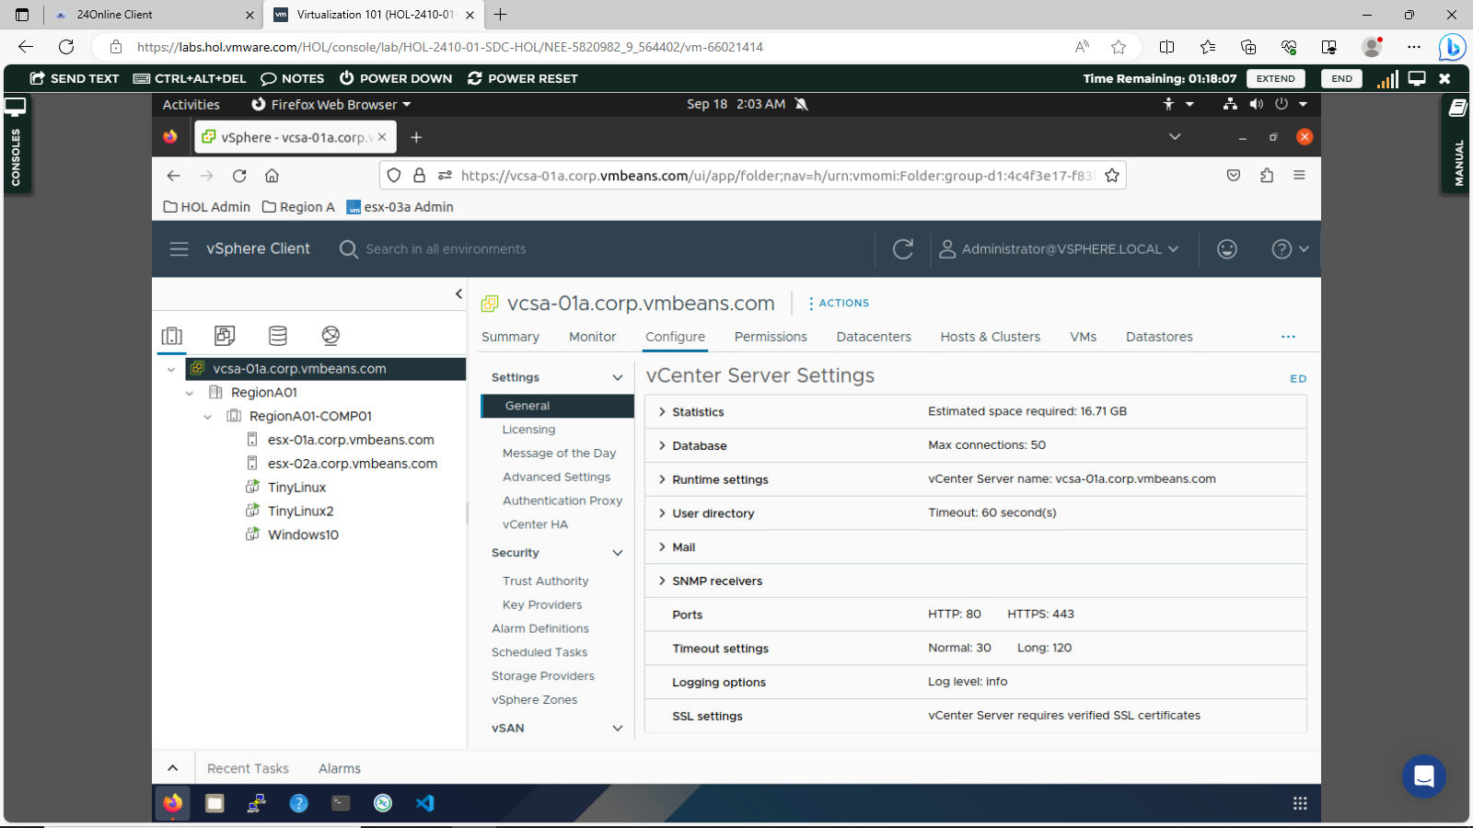
1 – select configure option, then choose alarm definitions.

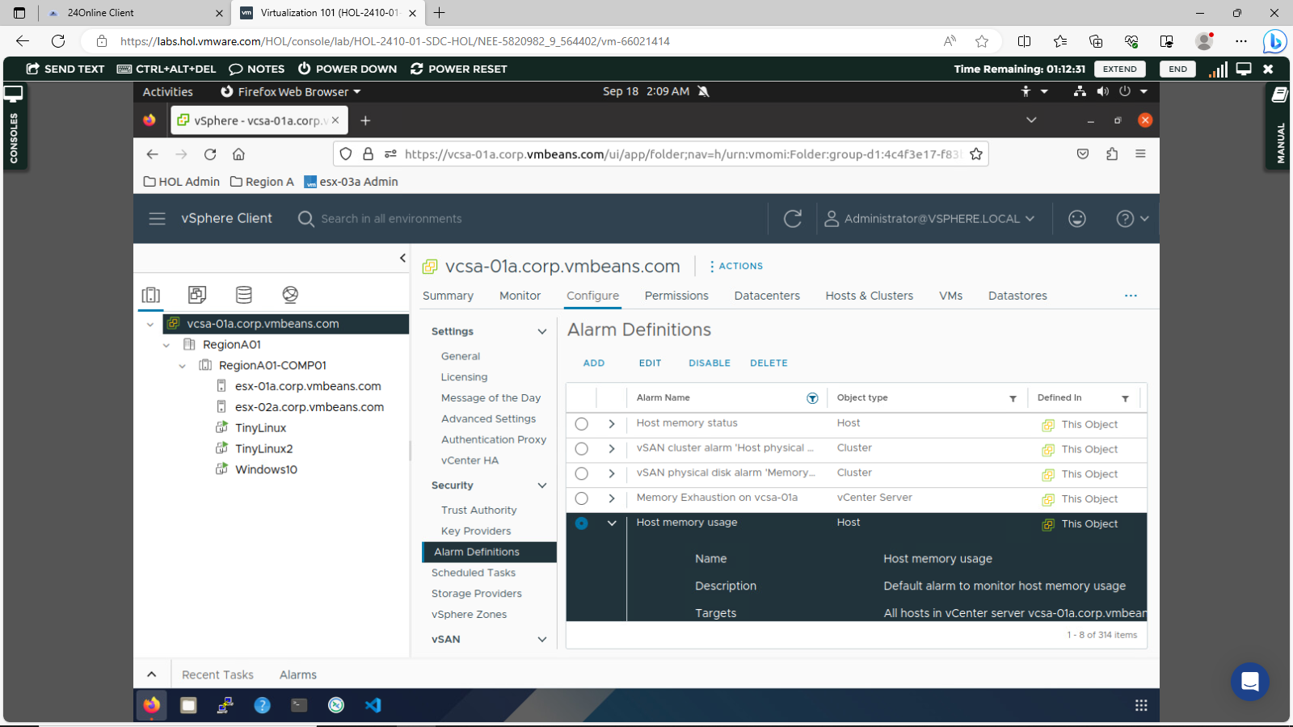
2 – selected host memory usage and choosed add option for new alarm creation.

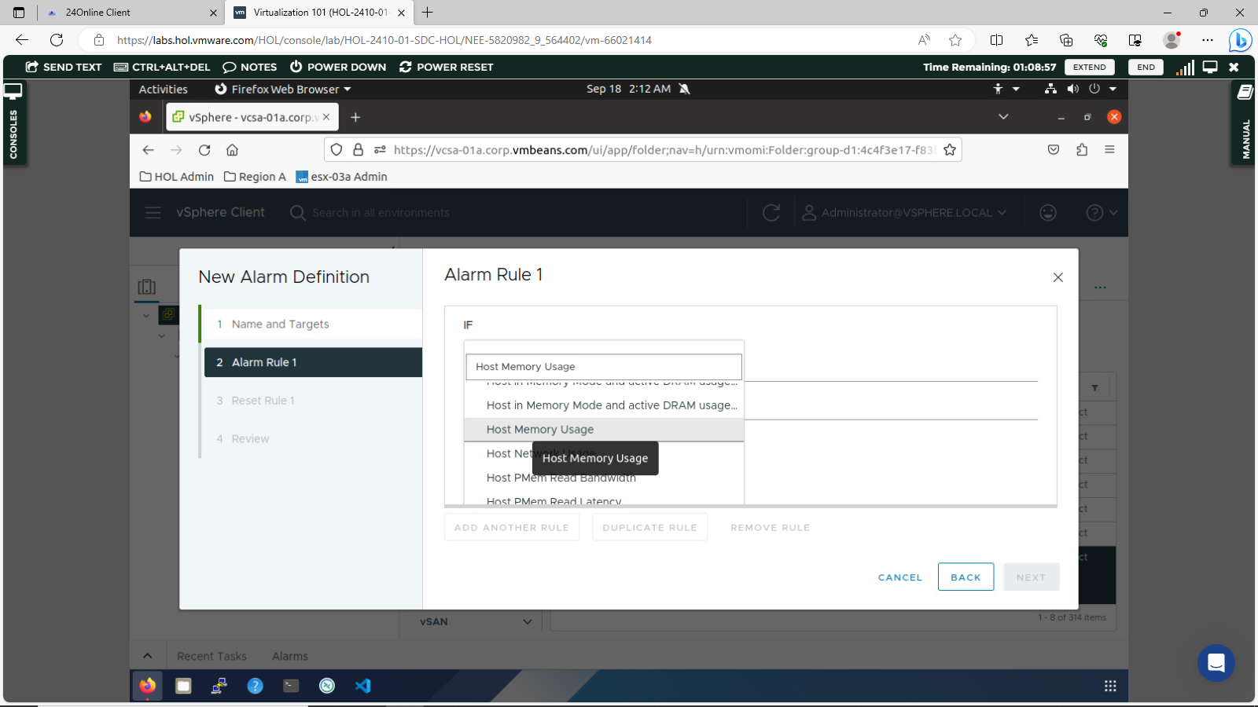

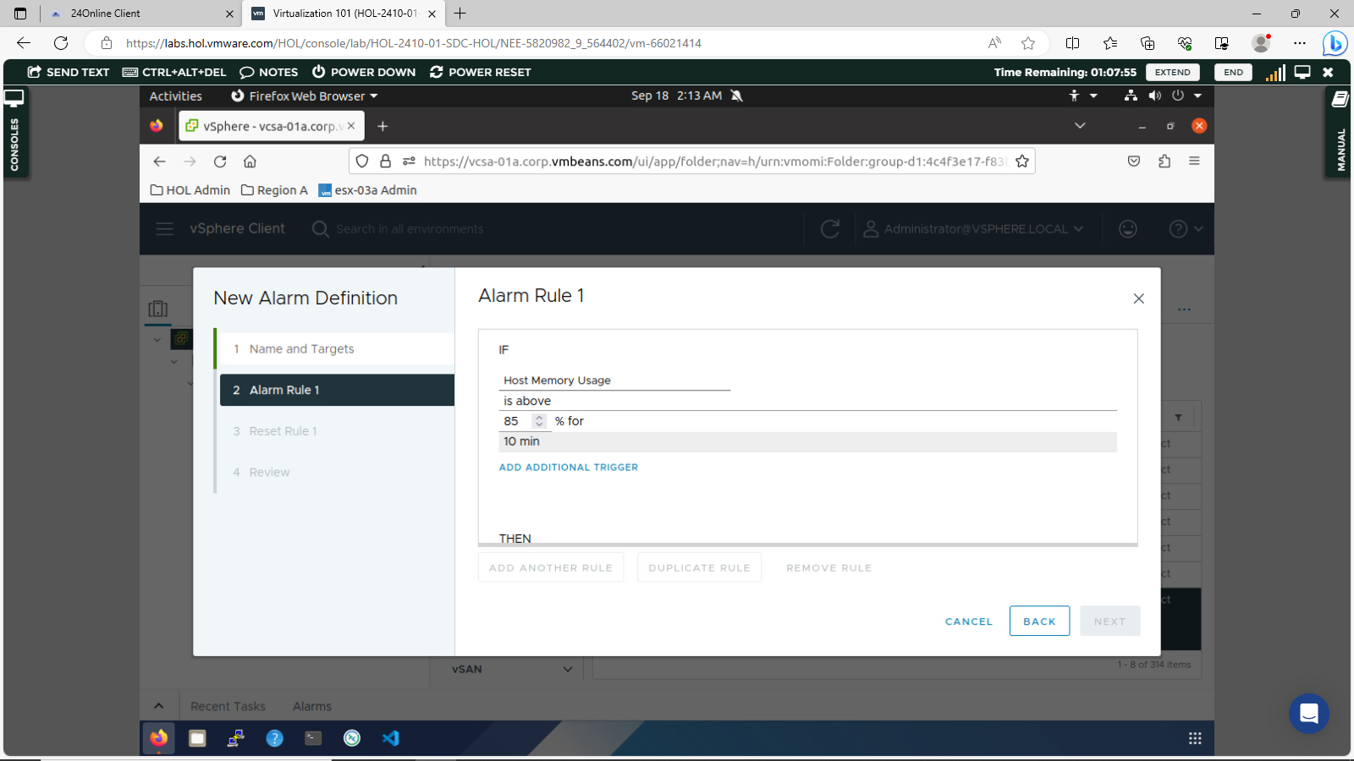
3 – Entered name as alarm1 and choosed alarm rule as host
memory usage.
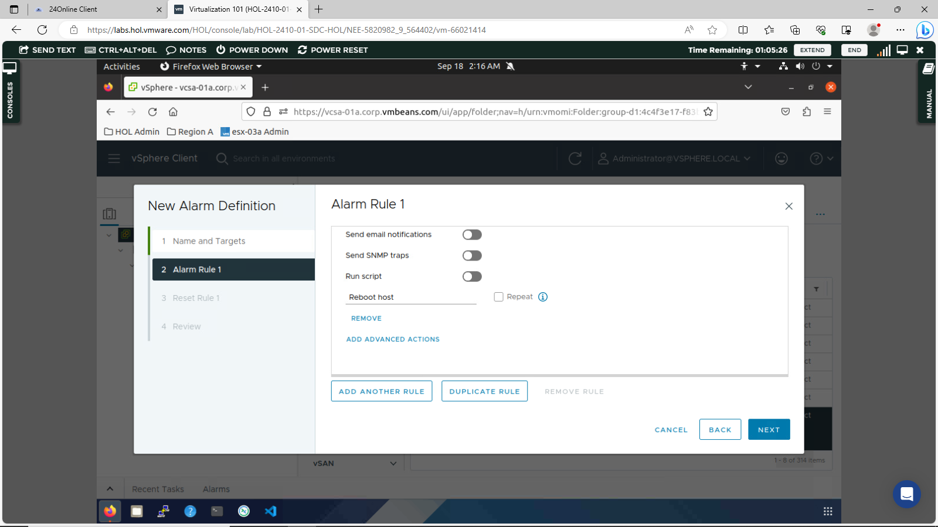

4 – Selected advanced rule as reboot host.

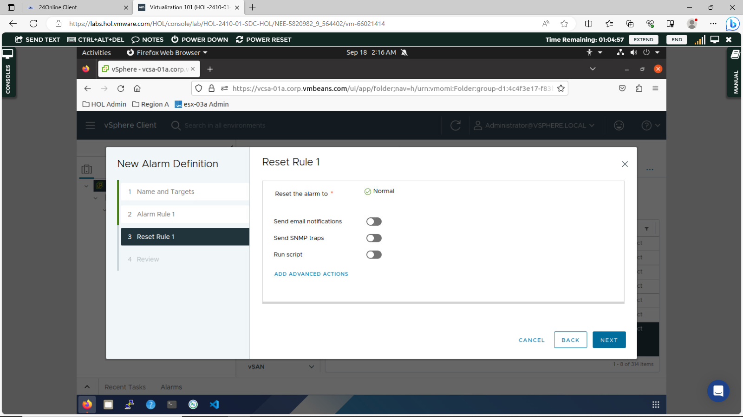
5 – clicked on next and gone to review tab, then clicked next.
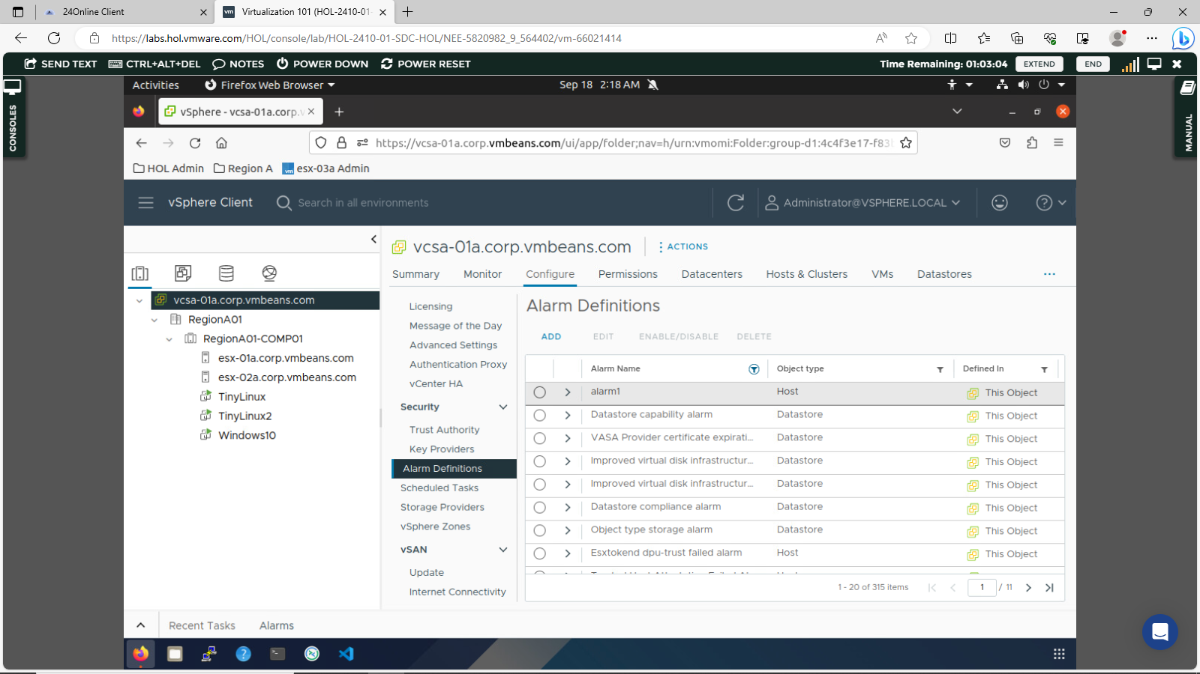
6 – alarm1 is now created.

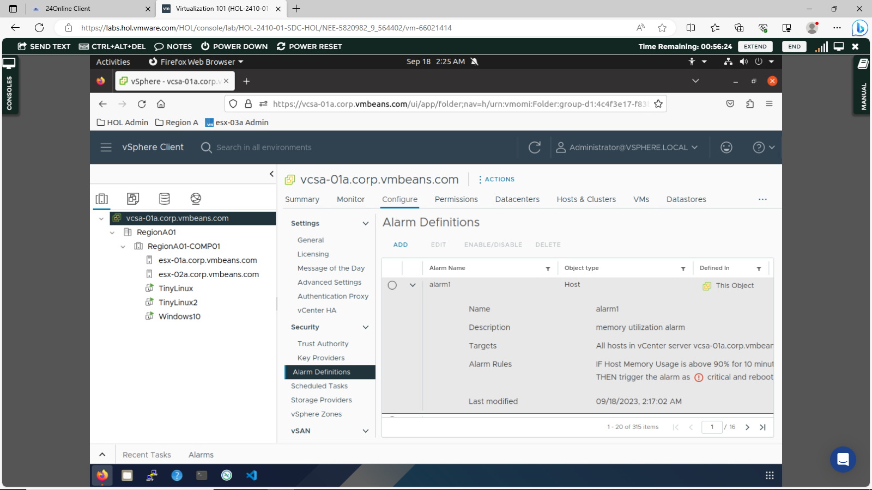
6 – Selected configure option and searched alarm1 and by clicking it
we can see details.

