# Enabling DRS & HA in HOL:

1. Open Virtualization 101 lab in HOL.

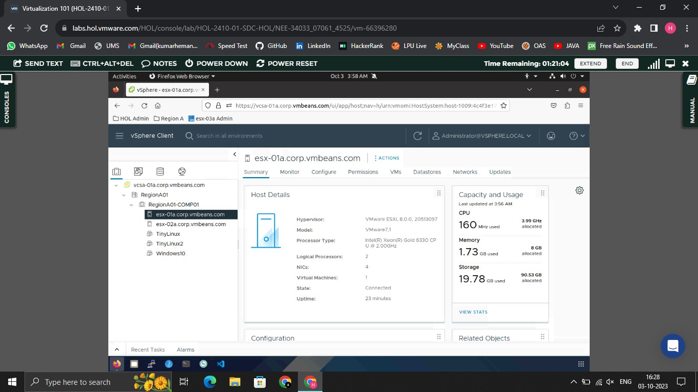

1. Then go to RegionAO1-COMPO1.

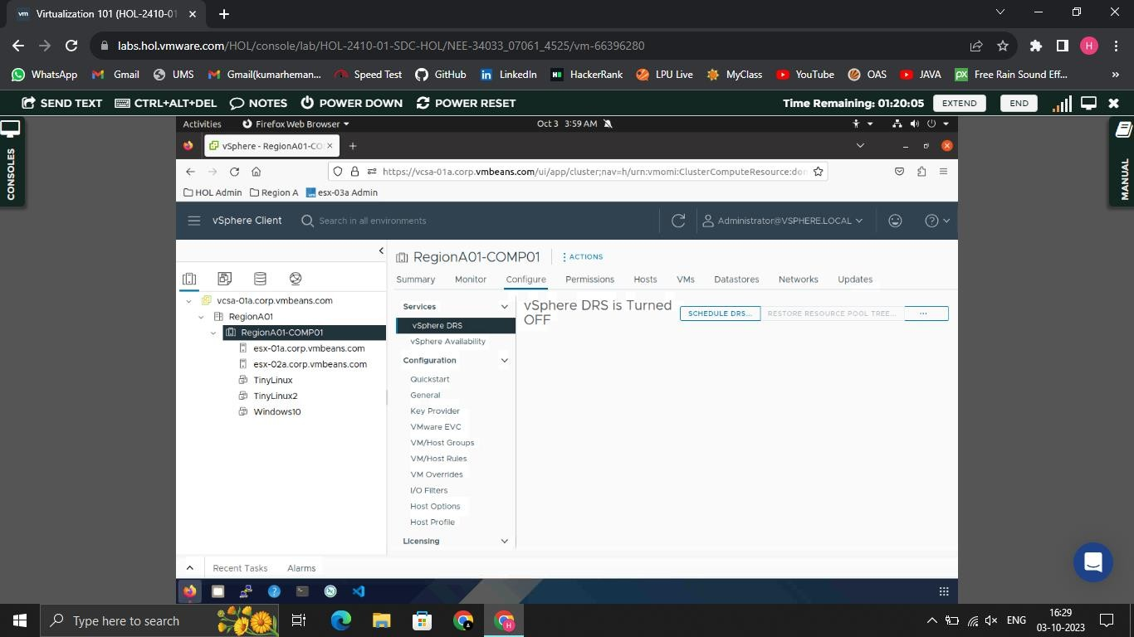

1. Then Click on Configure.



1. In vSphere DRS, Click on Options which are the form of (…), Then click on Option Edit.

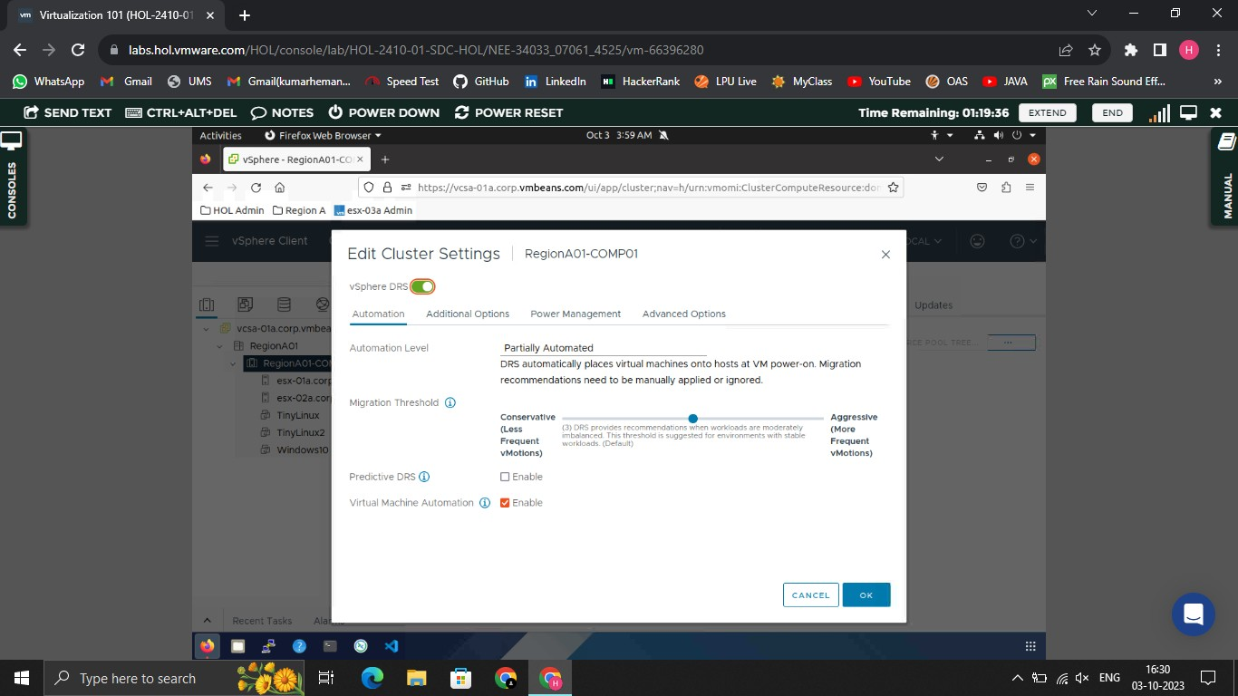

1. There after Enable vSphere DRS and Ok to save.

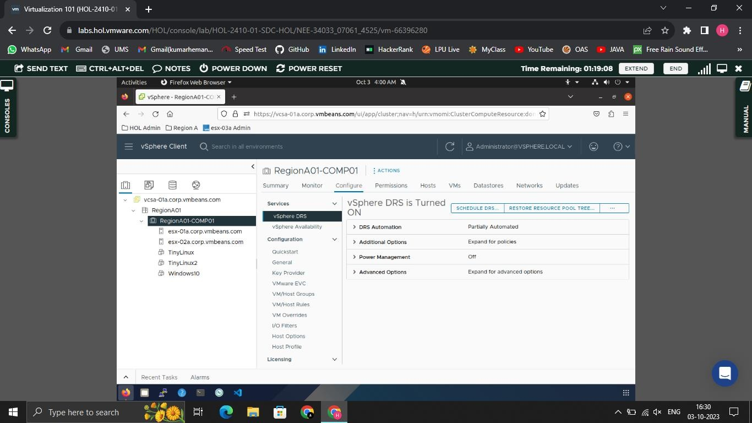

Hence, DRS is enabled.

# For HA…

1. Same in Configure tab, In services goto vSphere Aailability.

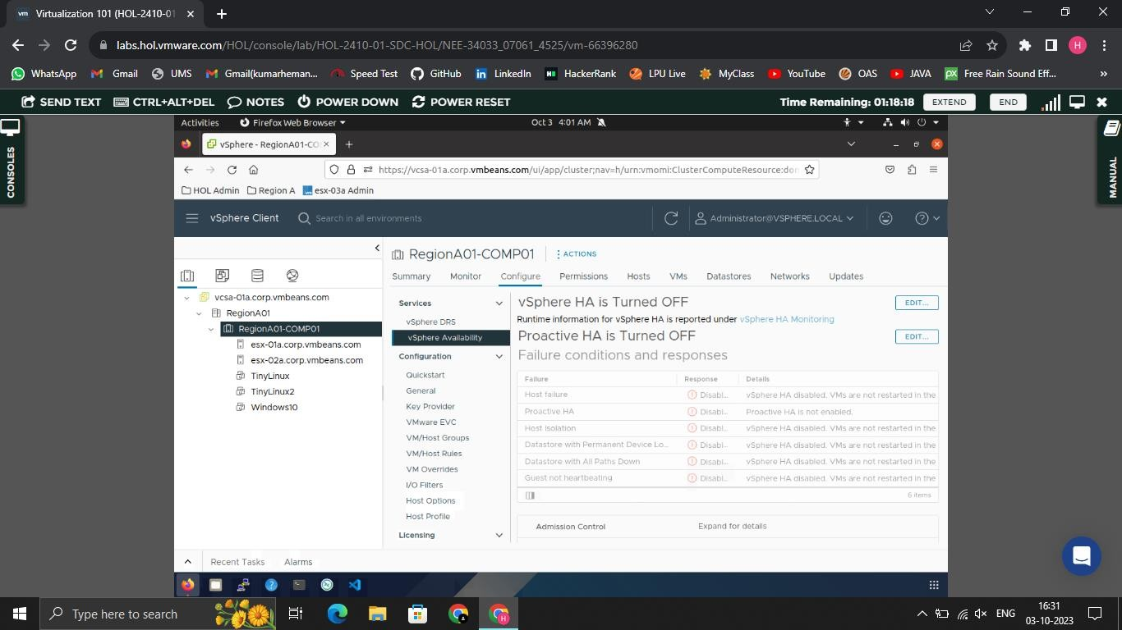

1. There will be visibility of vSphere HA is turned OFF. Click on edit to configure it. And Enable vSphere HA, Ok to save.

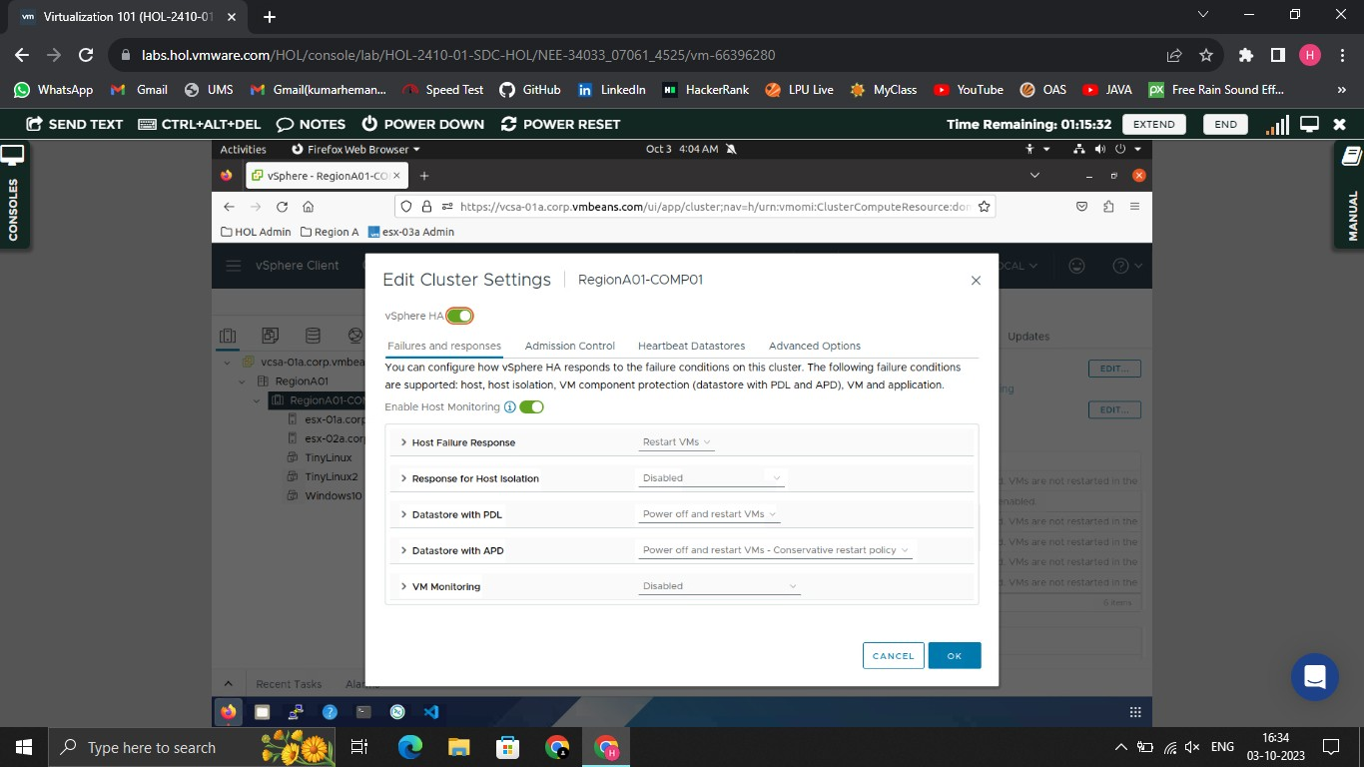

1. Then enable Proactive HA too…Ok to save

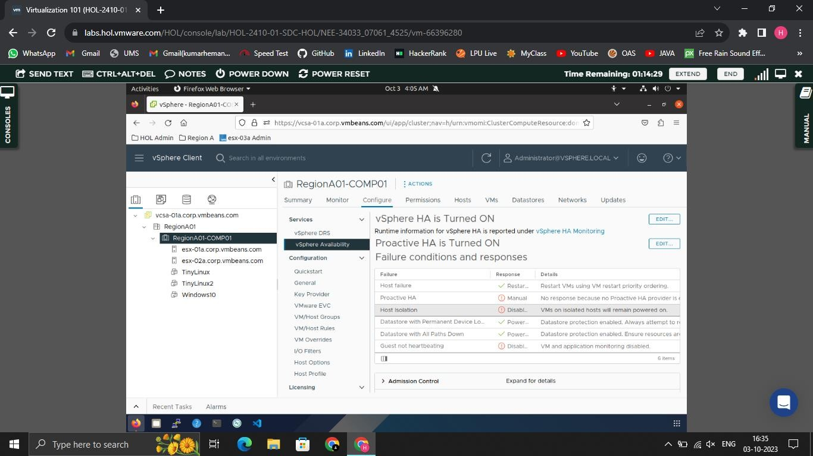

→ Hence, DRS & HA are enabled.