# Order of test data measurements

1. Reference
2. Blank dark background
3. Eucalyptus #1
4. Eucalyptus #2
5. Nb #1
6. Nb #2
7. Wheat #1
8. Wheat #2

## Other notes

* SVC has a default overlap correction – this can be disabled, hence the two file imports
* ASD 4 skipped either reference or dark background blank

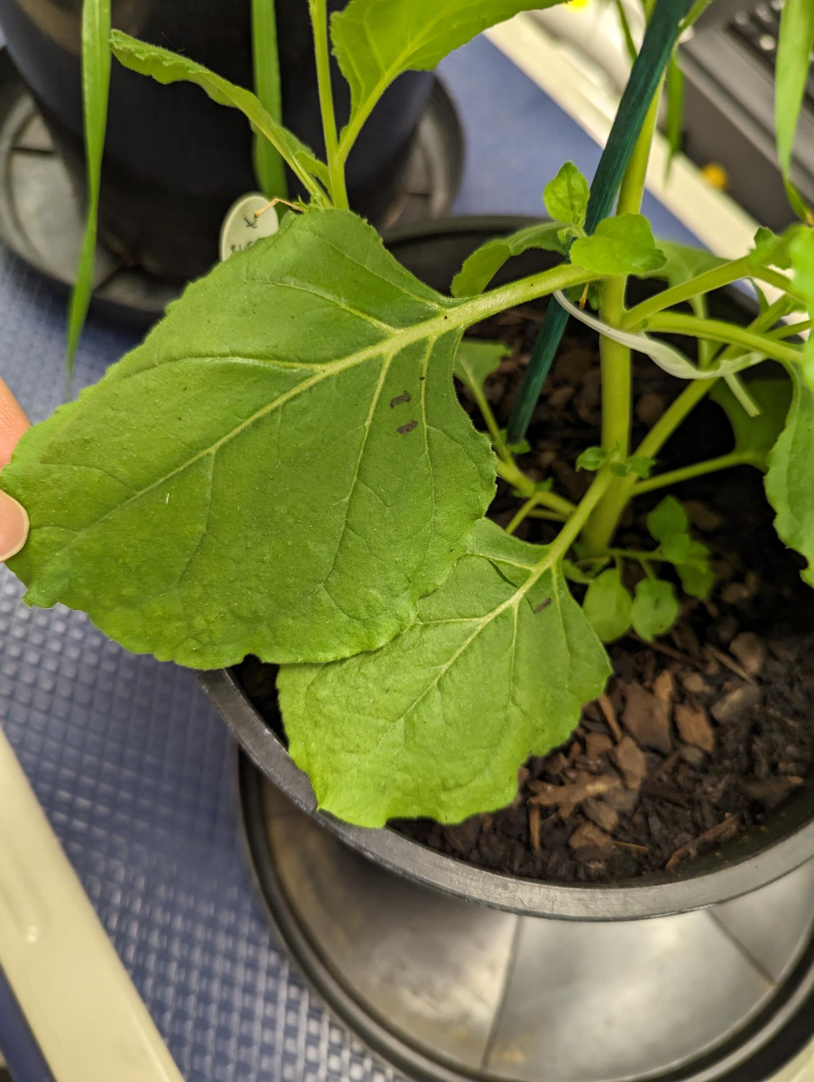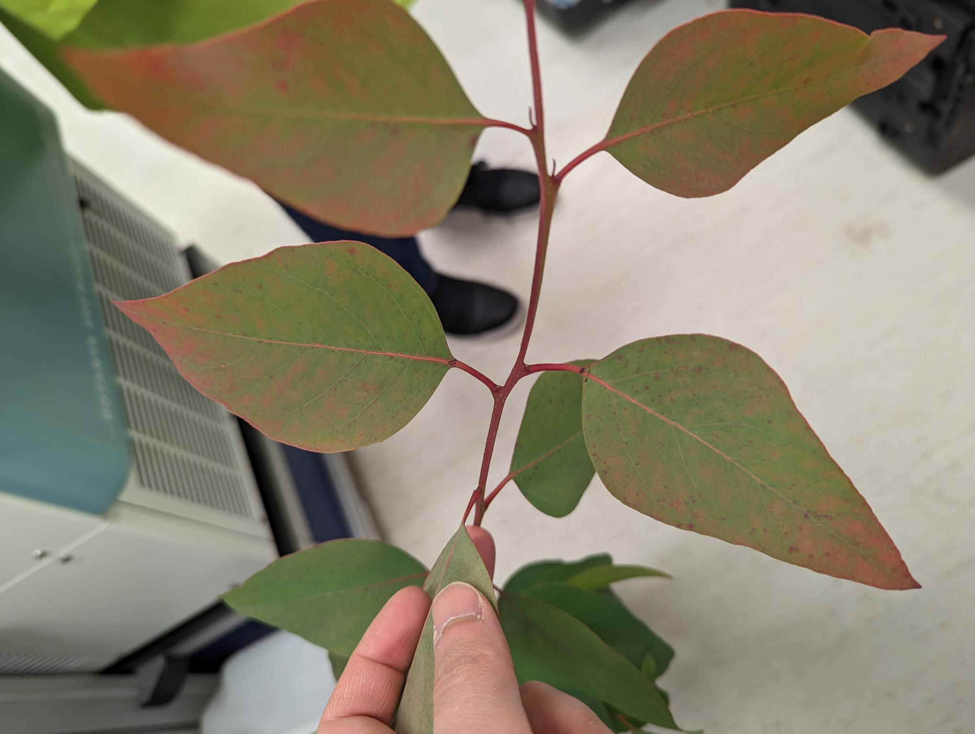

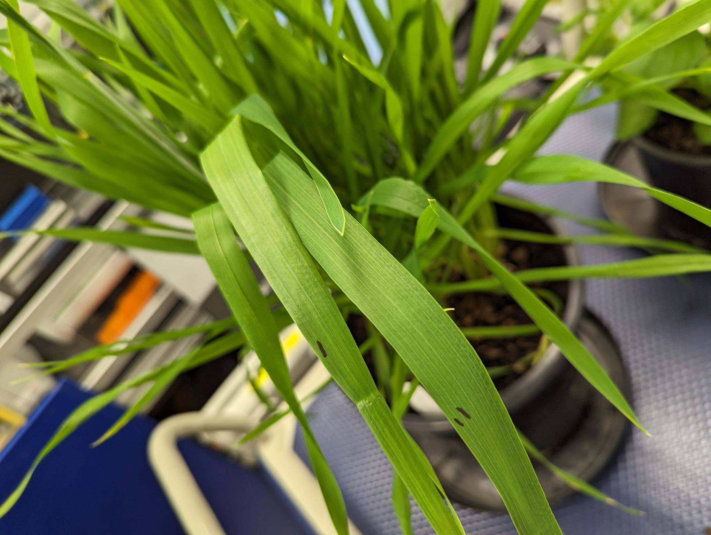

Data export options for ASDs

