# Enablon Assignment

## What is the URL of the application under test?

<https://todomvc.com/examples/angular2/>

## What framework has been chosen for test automation?

* I have used Cypress framework for automating test scenarios that a user might do on the todos application.
* I have used Cucumber plugin for writing the scenarios in Gherkin syntax; so that the tests are readable by everyone (including business stakeholders). These features can be found in the directory.
* For generating an html report another dependency called “multiple-cucumber-html-reporter” is used in the project. Please refer package.json for details.

## Where can I read the positive and negative test scenarios?

In the todo.feature file located at “..EnablonAssignment\cypress\integration”

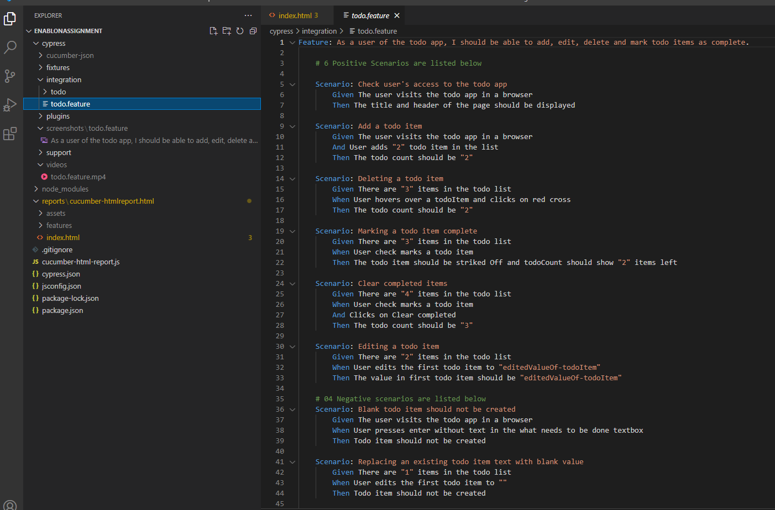

## How can I run the automated tests on my local machine/desktop?

**Step1**: Enter following command in the terminal/command prompt at any suitable directory of your choice (for example Desktop)

“git clone <https://github.com/spsaurabhpandey/EnablonAssignment.git>”

**Step2**: A new folder will be created on desktop(if you chose desktop in step1) called “EnablonAssignment”.

**Step3**: Open this folder in code editor of your choice. I used Visual Studio Code. This can be done in multiple ways. One of the way is to open the visual studio code and then select the folder via “File>Open Folder”.

**Step4**: Click on “Terminal>New Terminal” in Visual studio code and then enter following command in the terminal.

“**npm install**”

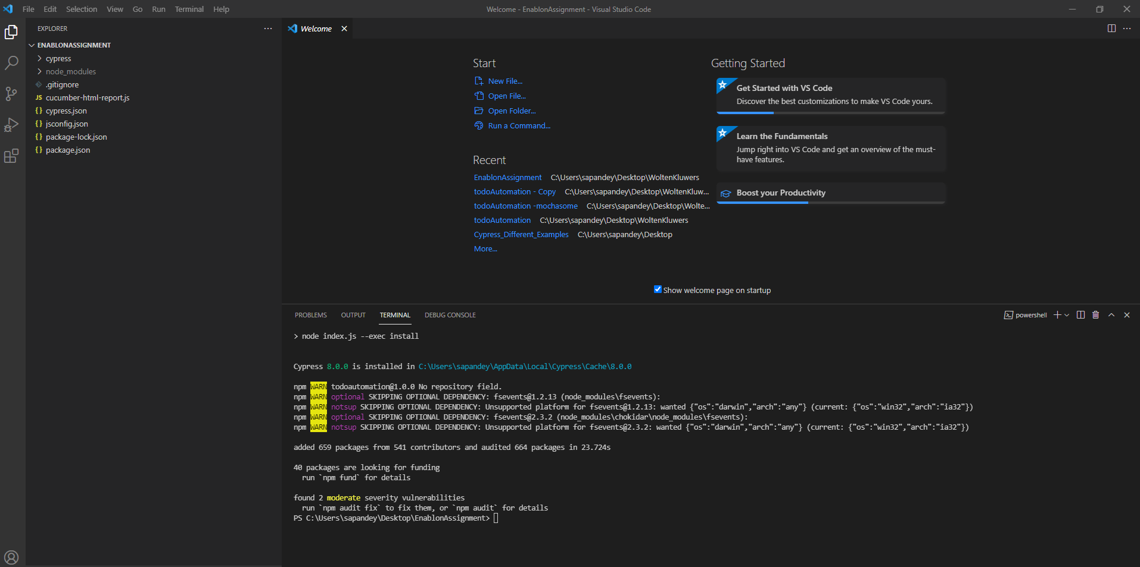

Execute following command “npm audit fix”, in case you get a message saying vulnerabilities found etc.

**Step5**: Execute command “**npm run test**” in the terminal. You should see a window pop by cypress, where you can select the browser of your choice (in the screenshot notice Chrome91).

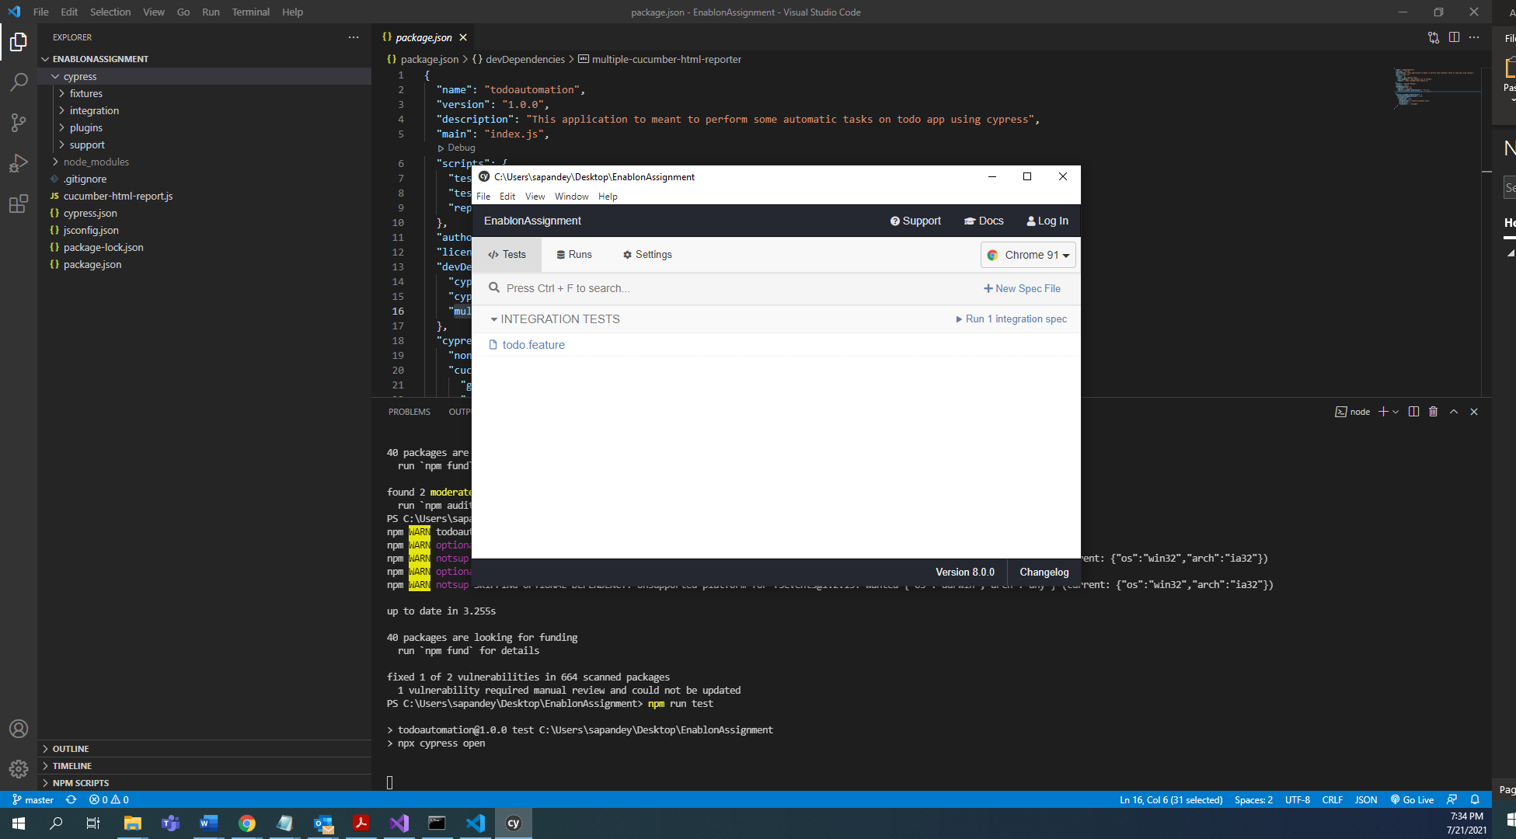

**Step6**: Click on the todo.feature and cypress will then control your chosen browser and start execution on the ten scenarios defined in todo.feature file.

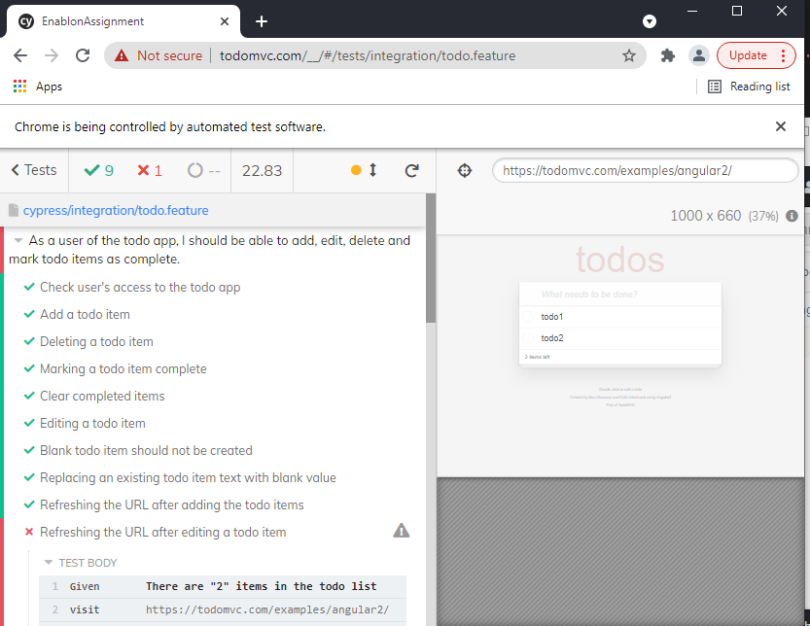

You would see that a total of 10 tests were executed and 09 were passed and one failed. This one failed scenario is automated on purpose to report a bug.

You can click on each step and see the Dom screenshot when the test was executed.

The test scenario : “refreshing the url after editing a todo item” is failing as we see it is a bug in the application, because when we add a todo and refersh the list displayed is same. But when we edit the item and refesh the page the edited value is not saved and is lost.

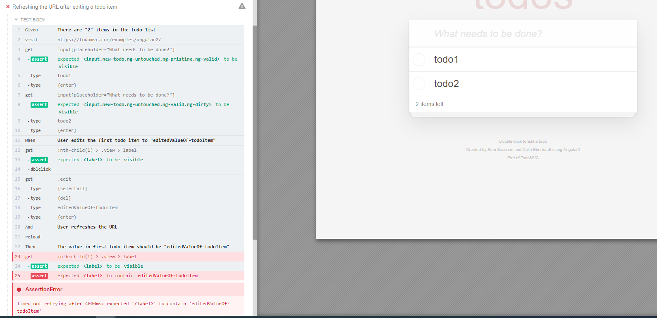

## How can I run the tests in chrome Headless mode?

**Step1**: Execute following command in terminal “npm run test-headless” and you should see following in terminal:

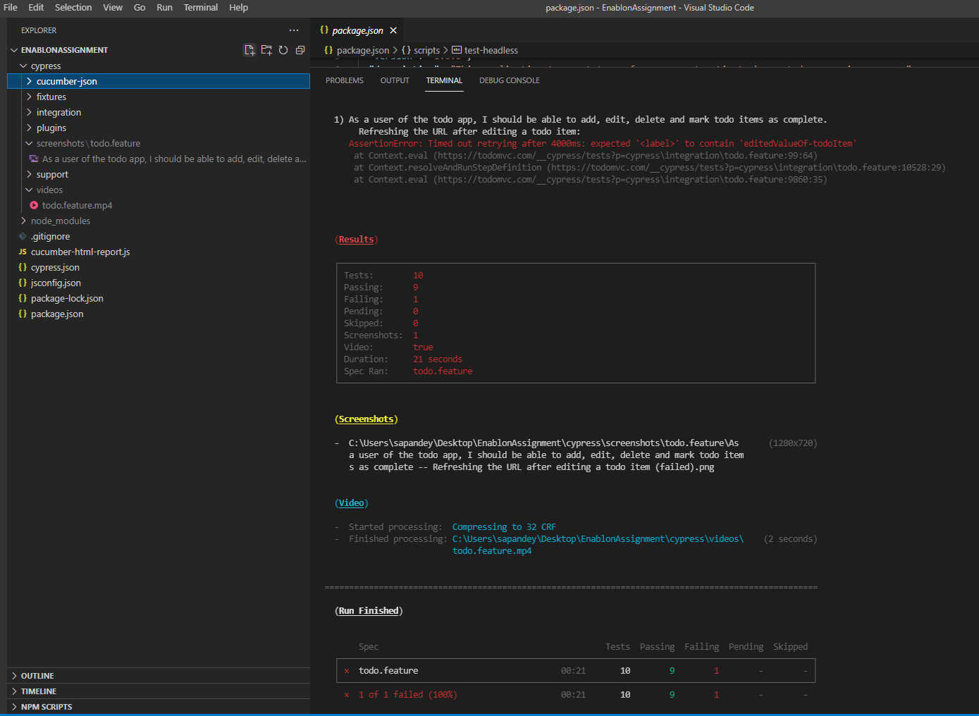

**Step2**: The video of the latest cypress run can be found at “**cypress/videos folder**”. Play this mp4 file to see the movie that shows DOM at each test step.

**Step3**: The screenshot of the failed step can be found at **cypress/screenshots/todo.feature**

## How can I generate an HTML report?

Execute the command “**npm run report**” in the terminal and you should see below message:

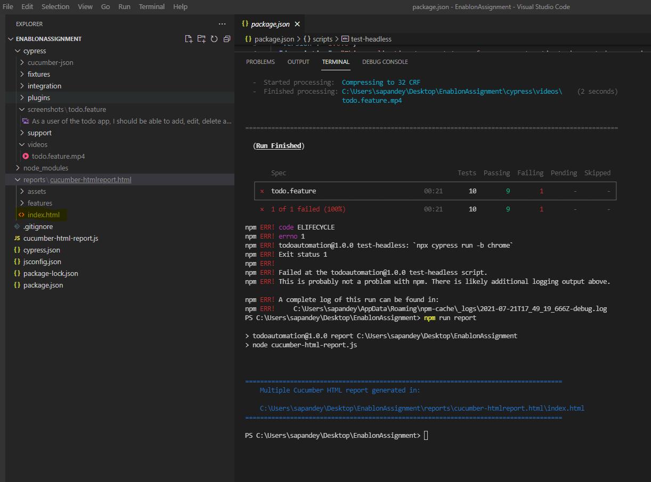

Open the file index.html in a browser and you should see following:

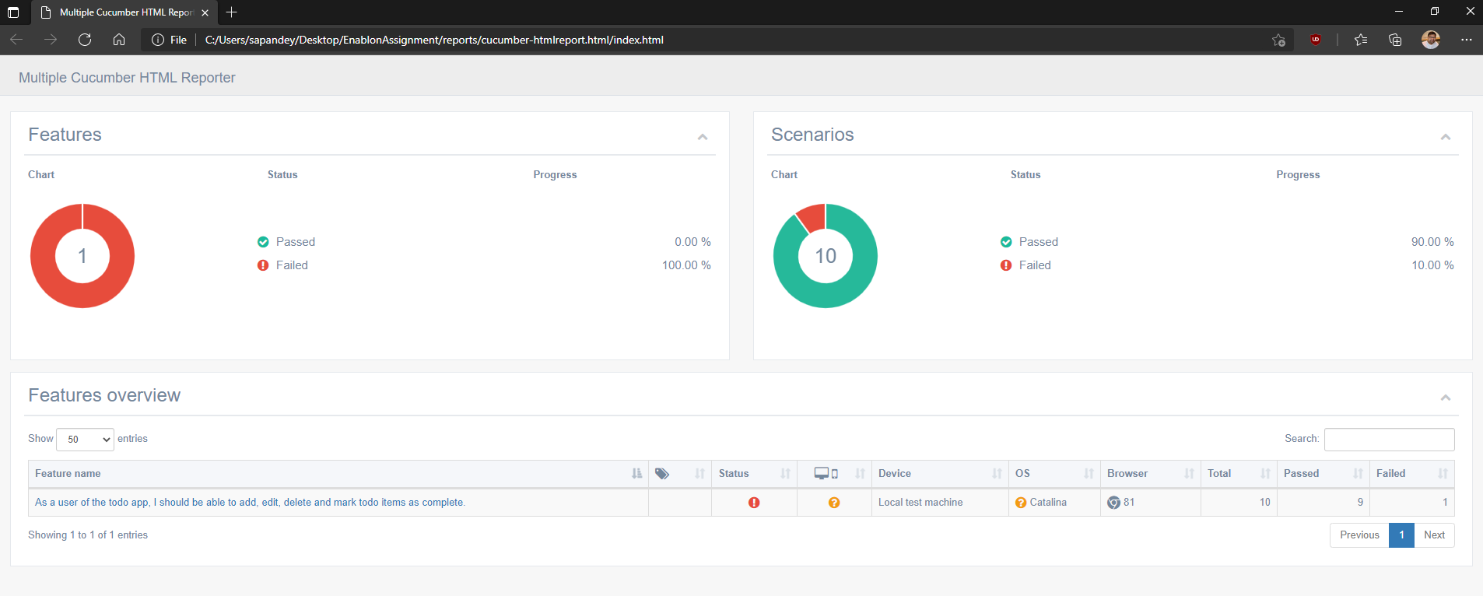

Click at a feature name “As a user of the todo app….” To see details of which scenarios passed and which failed in the feature.

