# Introduction:

Two test cases have been automated to test login functionality of the given application.

The automation test script can be found in the file attached below:



The text file clearly depicts

1. The Library used for scripting – Selenium2Library
2. The variables defined and their values.
3. Test cases (with their description and ROBOT Framework Keywords from Selenium2Library)

# Screenshots of RIDE IDE:

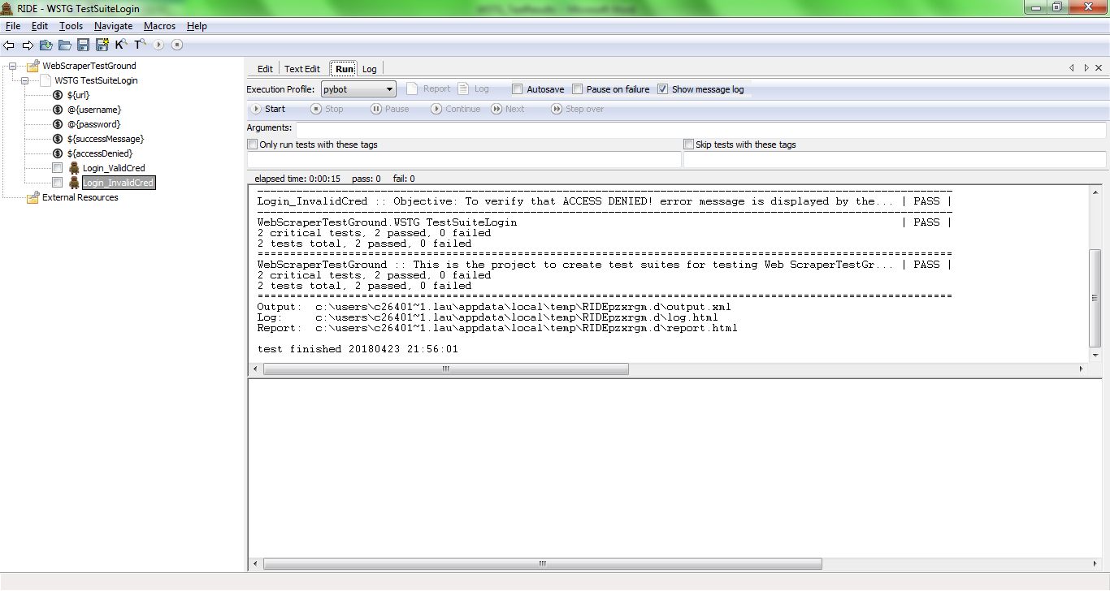

This the message received after successful test runs of both the test cases.

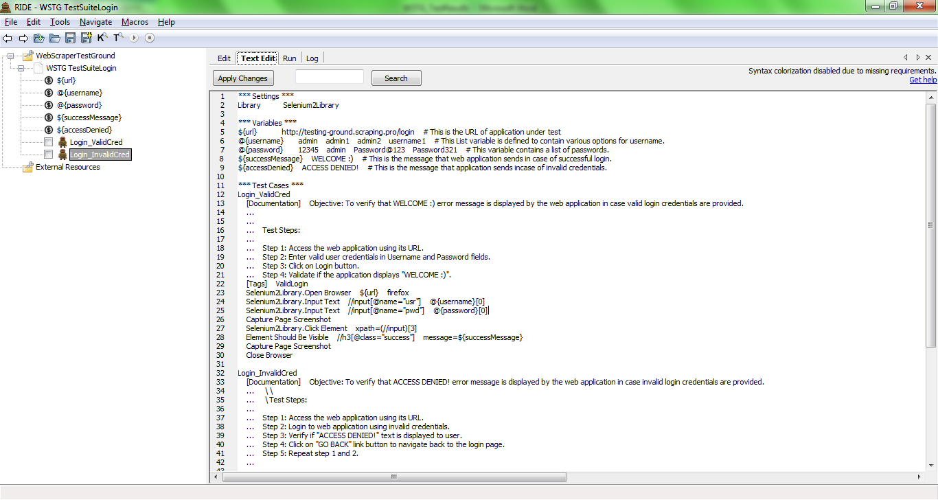

Above screenshots shows the text in RIDE tool. The content is same as in the file attached above.

# The report

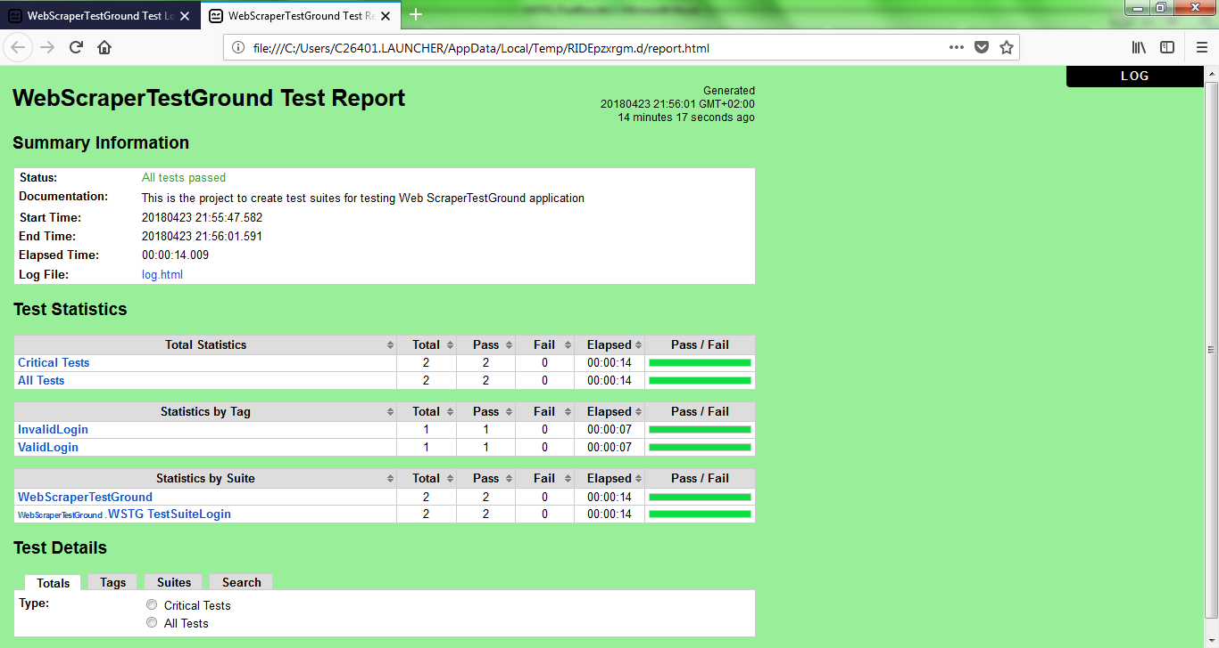

The report is green in colour which indicates that both the test cases were passed. If anyone of the test case is failed, the standard ROBOT framework produces a report in red colour.

The report gives a lot of details Start time End time, Statistics by Tags used in test case(tags are utilised for selective running of test cases)

We can also access LOG by clicking on top right corner.

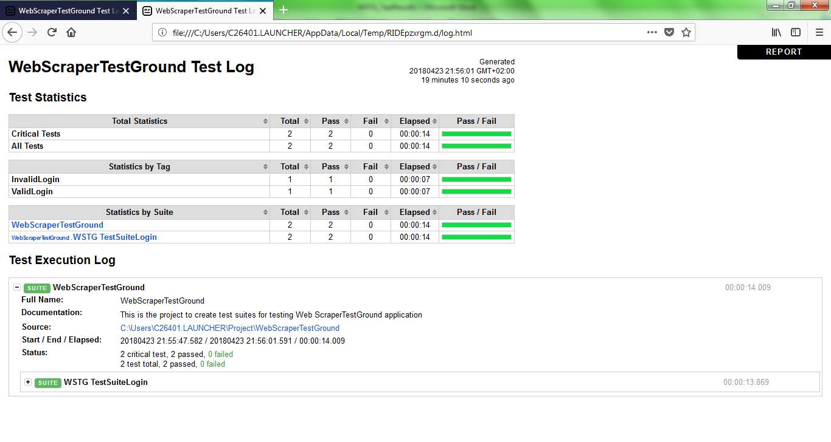

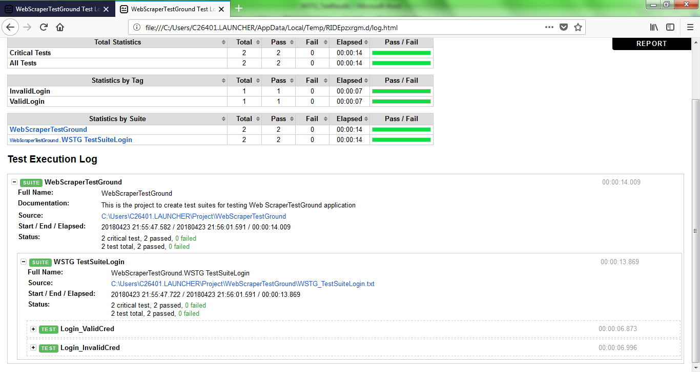

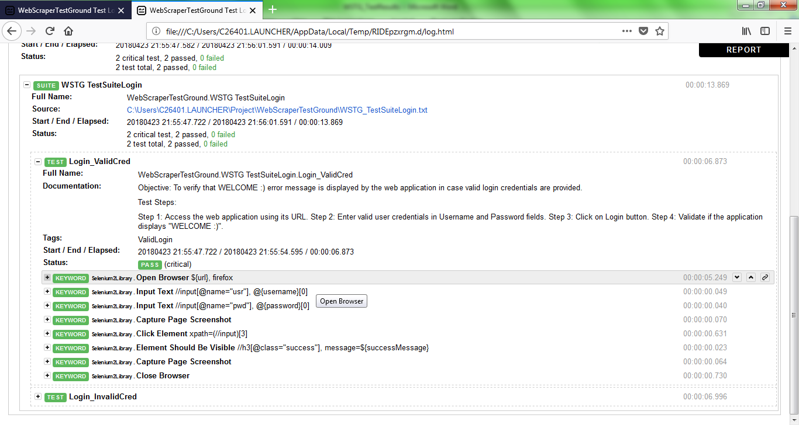

The log is used to see details per line of the automation script. The robot framework captures screenshots in case a step fails. But since in this test case I had given Exclusive command to capture screenshots. This log has screenshots in the steps where the keyword to capture screenshot was given:

