**CCNA - PROJECT -2**

# **OSPF - Open Shortest Path First**

* **REQUIREMNTS:**

**3-ROUTER**

**3-SWITCHES**

**9-PC**

* ASSIGN IP’S TO THE ROUTER’S

ROUTER-1 [10.0.0.0]

ROUTER 1—2 [40.0.0.0]

ROUTER -2 [20.0.0.0]

ROUTER 2---3 [50.0.0.0]

ROUTER-3 [30.0.0.0]

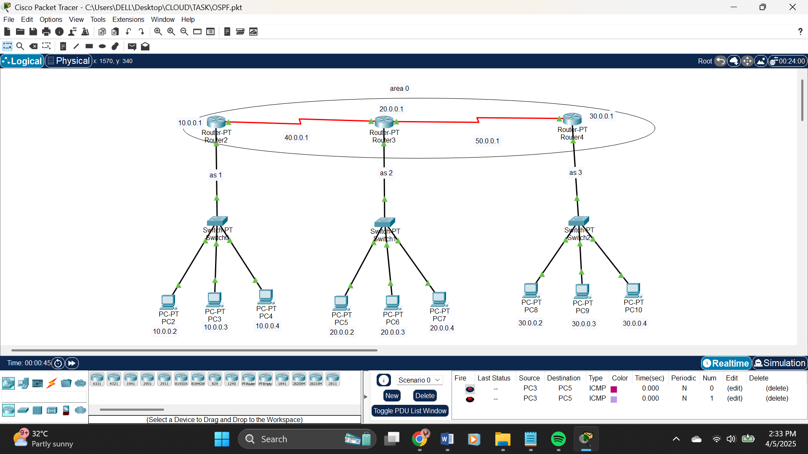

* ASSIGN IP TO THE PC’S

PC -> DESKTOP -> IP CONFIG -> STATIC

PC 2-4 [10.0.0.2-4]

PC 5-7 [20.0.0.2-4]

PC 8-10 [30.0.0.2-4]

MAKE IT THREE PART NAME AS [as 1 – 3].

* SCRIPT IS GIVEN IN THE TXT (NOTEPAD) FORMAT.

AFTER CONFIGURATION

PING PC TO PC

HERE I HAVE ATTACHED START PC9 to PC4 & PC5

TO PING THE DEVICE GOTO PC DESKTOP -> COMMAND PROMT

DATA SHARING IMG INSERTEDD IN BELOW:

