INDIA AIR QUALITY ANALYTICS
Data Analytics Project
Submitted by: SATYAM PRATAP
Python • Pandas • Matplotlib • Streamlit

1. Problem Statement
The objective of this project is to analyze air-quality records from five major Indian cities and convert daily AQI and pollutant data into clear summaries, trends and practical insights. The analysis focuses on city comparison, seasonal patterns, AQI categories and pollutant levels.

2. Dataset
The supplied ZIP contains separate CSV files for Bangalore, Chennai, Delhi, Hyderabad and Mumbai. After combining them, the working dataset contains 12,042 records and 9 core source fields: City, Date, AQI, PM2.5, PM10, NO2, SO2, CO and O3. The data covers 01 Jan 2018 to 31 Dec 2024.
The supplied README states that AQI values were sourced from the Central Pollution Control Board (CPCB), while pollutant concentrations were mathematically estimated from AQI-to-pollutant relationships. Consequently, pollutant values are treated as estimated analytical variables in this project.

3. Objectives
- Collect and combine the five city CSV files.
- Check the data for missing, duplicate, invalid and negative values.
- Classify AQI into six analytical categories.
- Calculate totals, counts, averages, medians, minimums and maximums.
- Compare air-quality patterns across cities and time.
- Create charts to communicate the results.
- Use the results to form practical monitoring and planning recommendations.
- Provide an interactive Streamlit dashboard.

4. Tools and Technologies
Python, Pandas, NumPy, Matplotlib, Streamlit, CSV and Microsoft Word.

5. Data Cleaning and Validation
Validation Check | Result
Combined records | 12,042
Duplicate rows | 0
Missing AQI values in supplied data | 1
Missing AQI after treatment | 0
Invalid dates | 0
Negative AQI/pollutant values | 0
All-empty source columns removed | Delhi/Hyderabad extra unnamed columns
The supplied data contained one missing AQI value in the Chennai file. For the analysis dataset, that value was filled using the mean AQI of the same city and an AQI_Missing_Original flag was retained so the treatment is transparent. Completely empty unnamed columns were removed because they contained no data.

6. Key Performance Indicators
KPI | Value
Total records | 12,042
Average AQI | 107.58
Median AQI | 83.00
Maximum AQI | 494
Minimum AQI | 19
Cities | 5
Date range | 2018-01-01 to 2024-12-31

7. City Analysis
City | Records | Average AQI | Median AQI | Min AQI | Max AQI | Avg PM2.5 | Avg PM10
Delhi | 2191 | 208.29 | 190.0 | 41.0 | 494.0 | 114.56 | 224.95
Mumbai | 2188 | 106.78 | 90.0 | 25.0 | 381.0 | 58.73 | 115.33
Hyderabad | 2556 | 85.4 | 82.0 | 19.0 | 193.0 | 46.97 | 92.23
Chennai | 2551 | 77.34 | 69.0 | 24.0 | 288.0 | 42.52 | 83.49
Bangalore | 2556 | 74.32 | 69.0 | 24.0 | 206.0 | 40.88 | 80.27
Delhi has the highest average AQI in the combined dataset at 208.29. Bangalore has the lowest average at 74.32. Delhi's average AQI is substantially higher than the other four cities in this dataset.

8. AQI Category Analysis
AQI Category | Records | Percentage
Good | 1540 | 12.79
Satisfactory | 6103 | 50.68
Moderate | 3189 | 26.48
Poor | 713 | 5.92
Very Poor | 381 | 3.16
Severe | 116 | 0.96
The category distribution shows that Satisfactory and Moderate records form the largest portions of the combined dataset. Delhi contains the largest concentration of Poor, Very Poor and Severe observations.

9. Time Trend Analysis
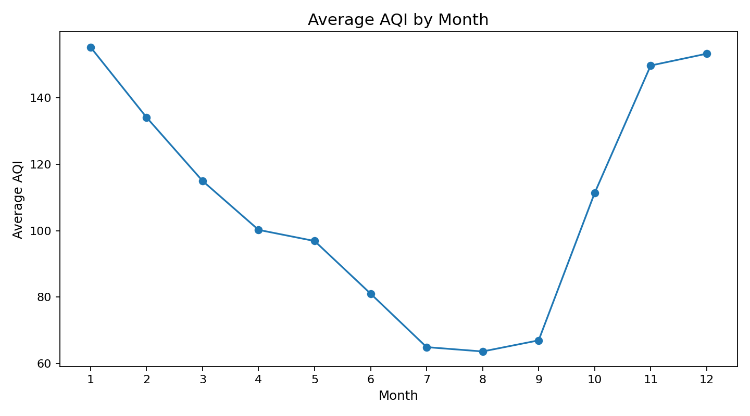
Figure 1: Average AQI by month
Across all five cities, January has the highest average AQI (155.25) and August has the lowest (63.65). The pattern indicates higher AQI levels during the late-year and winter months in this dataset, with lower average levels during the monsoon/summer portion of the year.
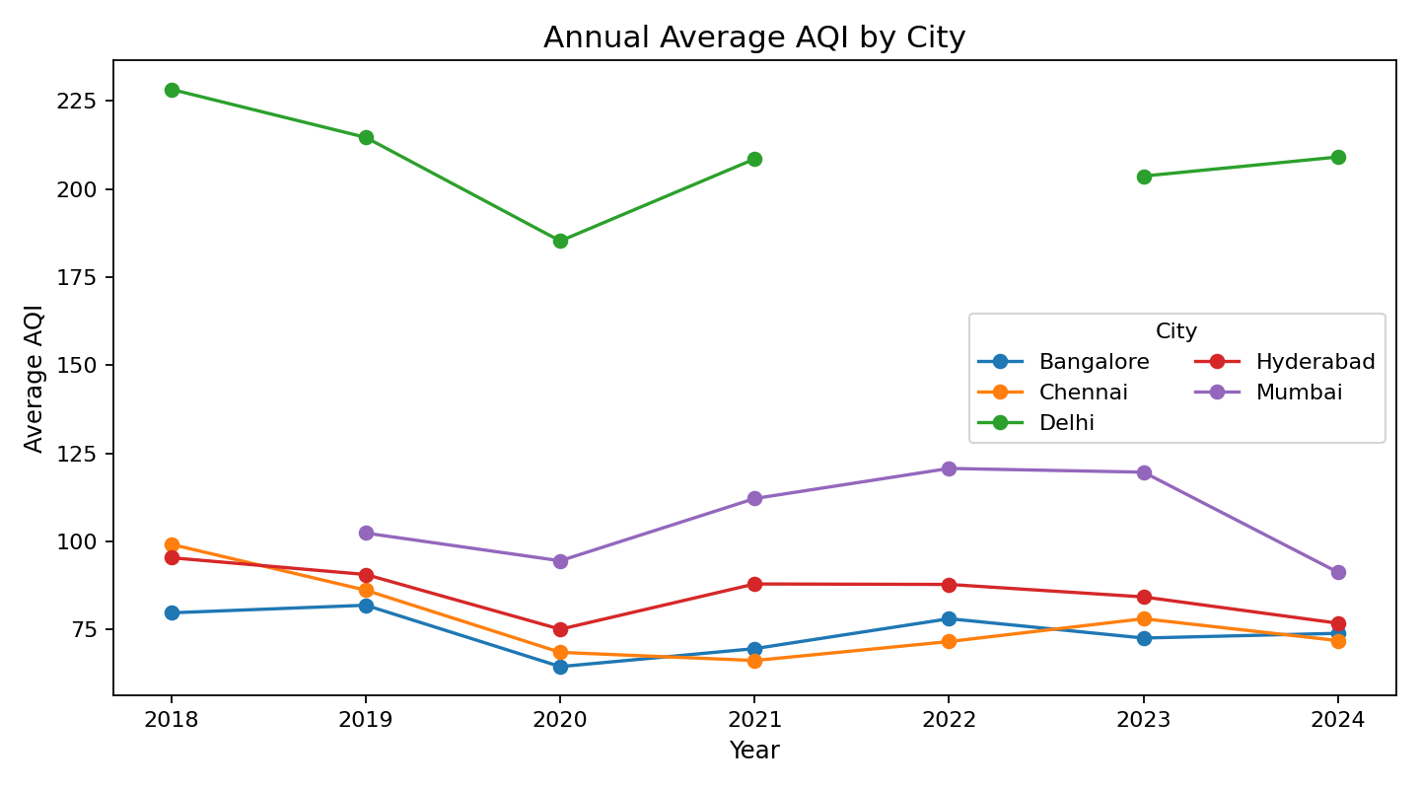
Figure 2: Annual average AQI by city

10. Pollutant Analysis
Pollutant | Average Dataset Level
SO2 | 122.64
PM10 | 116.18
O3 | 102.2
NO2 | 89.29
PM2.5 | 59.17
CO | 1.13
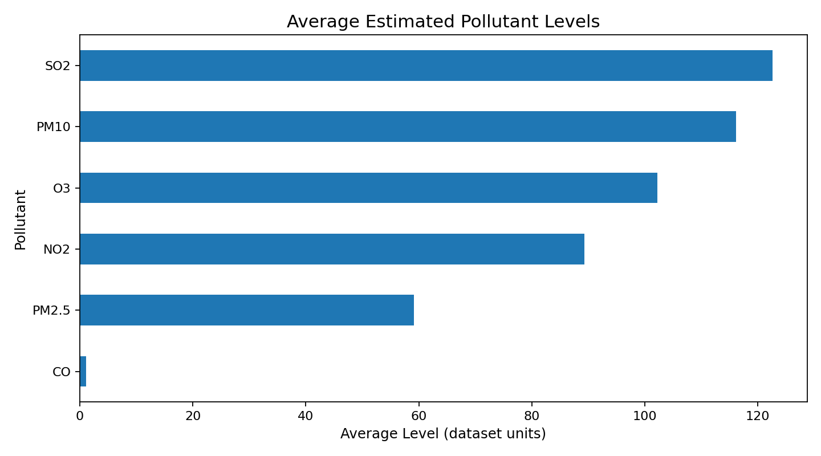
Figure 3: Average estimated pollutant levels
The pollutant values should be interpreted carefully. The dataset README explicitly states that these concentrations were estimated mathematically from AQI relationships. Therefore, the analysis uses them for descriptive comparison and does not claim that their correlations prove independent causal effects.

11. Five Key Observations
- Delhi has the highest average AQI among the five cities at 208.29.
- Bangalore has the lowest average AQI among the five cities at 74.32.
- January has the highest average AQI across the combined dataset (155.25), while August has the lowest (63.65).
- The combined dataset contains 1,210 records with AQI above 200, which are concentrated strongly in Delhi.
- Satisfactory AQI is the largest category with 6,103 records, followed by Moderate with 3,189.

12. Practical Insights
- City-level air-quality patterns are not uniform, so monitoring and resource planning should consider local conditions rather than using one city average for all locations.
- The strong seasonal pattern suggests that monthly and seasonal monitoring can help identify periods when AQI levels tend to rise and when additional preparedness may be useful.
- Delhi stands out in this dataset with a much higher average AQI and a much larger share of Poor, Very Poor and Severe records.
- The category distribution provides an easy way for a dashboard user to move from raw AQI numbers to an understandable performance summary.
- Because the pollutant concentrations are estimated from AQI relationships, independent sensor data should be used before drawing causal conclusions about individual pollutants.

13. Recommendations
- Use city-specific monitoring dashboards so decision-makers can compare local AQI patterns over time.
- Pay particular attention to the months with higher historical AQI in this dataset when planning monitoring capacity and public communication.
- Investigate the causes of high-AQI periods using independent station-level pollutant and meteorological data.
- Use the dashboard filters to inspect individual cities and date ranges instead of relying only on the combined average.
- For future analysis, integrate verified station-level pollutant measurements to complement the estimated pollutant fields.

14. Streamlit Frontend
The Streamlit application provides an interactive dashboard with city, date and AQI-category filters. It includes KPI cards, city comparison, monthly and annual trends, pollutant summaries, correlation display, data-quality checks, raw-data preview and CSV download.

15. Conclusion
This project demonstrates how a real-world environmental dataset can be converted into an interactive data analytics application. The combined five-city dataset contains 12,042 records and reveals clear differences between cities and months. The dashboard makes these patterns easier to explore, while the report documents the cleaning, validation, analysis and interpretation steps.

16. Project Files
- app.py
- analysis.py
- data/raw/ (original supplied city CSV files)
- data/india_air_quality_12042_rows.csv
- report_images/ (analysis charts)
- requirements.txt
- README.md
- run_app.bat
- Project_Report.docx

