AI Usage DISCLOSURE FORM

1. Team Details
Team Name: Fantastic 4
Project / Product Name: Streaming Live RAG
Organization / Institution (if any): SRM University / SRM Institute of Science & Technology
Submission Date: 30 September 2026

2. AI Usage Declaration
Did your team use any Artificial Intelligence (AI) in developing this project? Yes
AI tools, primarily Claude Code, were used during the development of the project for coding assistance, debugging, documentation, testing, and development support. The team provided the requirements and project direction, reviewed the outputs, tested the implementation, and finalized the submitted system. AI is not required as an external runtime service for the submitted prototype; the system operates using its implemented retrieval and grounding pipeline.

3. Purpose of AI Usage ( Brief Details)
Idea generation / brainstorming Yes — architecture and implementation planning assistance.
Code generation or assistance Yes — coding assistance and implementation support.
UI / UX design Yes — dashboard/UI implementation assistance.
Content creation Yes — documentation and presentation assistance.
Data analysis Yes — benchmark and evaluation analysis assistance.
Testing / debugging Yes — testing, debugging and issue analysis assistance.
Other Yes — development and submission preparation assistance.

4. Feature Origin Classification ( Please add/delete based on the number of the feature)
1. Feature Name: System Architecture & Retrieval Pipeline
Self-Generated/AI-Generated/Both: Both
Description: Claude Code was used to assist with architecture and implementation of the streaming RAG pipeline, retrieval controller, hybrid retrieval and evidence processing. The team provided requirements, reviewed the implementation and validated it through testing.

2. Feature Name: Streaming, Multi-Intent & Refinement
Self-Generated/AI-Generated/Both: Both
Description: AI assistance was used for implementation of streaming retrieval, multi-intent decomposition, session refinement and retrieval suppression. The team tested the features against the project requirements and finalized the implementation.

3. Feature Name: Grounding, Evaluation & Testing
Self-Generated/AI-Generated/Both: Both
Description: AI assistance was used for grounding validation, benchmark scripts, testing and debugging. The team reviewed the evaluation methodology, ran the tests and validated the final results.

4. Feature Name: Dashboard, Documentation & Presentation
Self-Generated/AI-Generated/Both: Both
Description: AI assistance was used for dashboard implementation, documentation, demo preparation and presentation content. The team reviewed and finalized the material for submission.

5. Ethical & Compliance Confirmation
AI usage complies with guidelines and policies. Yes
No proprietary or copyrighted data misused. I Agree

6. Declaration & Sign-Off
Name of Team Representative: Sneh Prasad
Role: Team Lead
Signature: 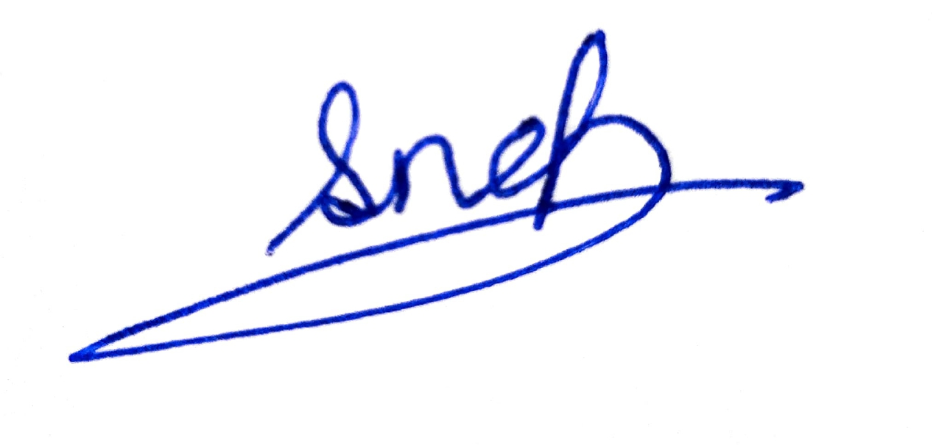
Date: 30 September 2026

