Prepared for CHAMS ecosystem websites
Detailed Digital Presence, SEO, AEO, SMO and 90-Day Growth Audit Report
Reviewed domains: chamsglobal.com, ksrtcbusbranding.com, letsplayoutdoors.in, misbahsalam.com
Audit date: 6 July 2026
This version expands the earlier proposal into a deeper working audit. It includes page-level structural findings, content and technical observations, answer-engine opportunities, social funnel recommendations, business implications, implementation priorities, and a more granular action plan.
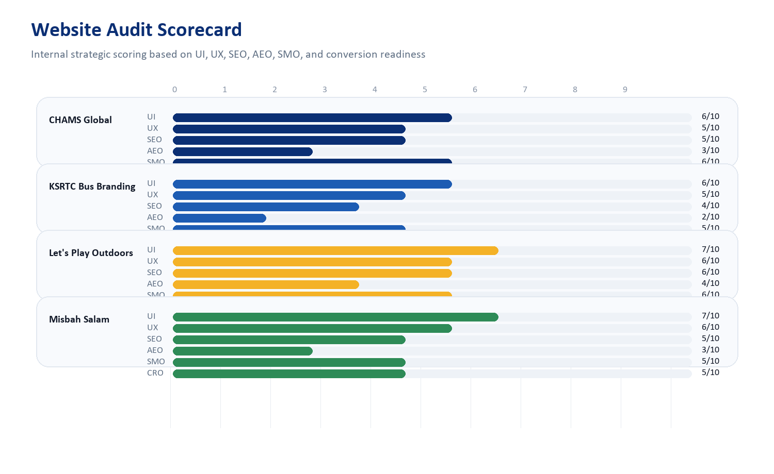

1. Executive Summary
The CHAMS ecosystem already has the ingredients for meaningful digital growth: a master agency brand, a niche transit-media property, a scalable OOH marketplace, and a founder-led authority site. The issue is not the absence of market fit. The issue is that the digital assets are not yet behaving like a coordinated commercial system.
At the moment, each site has some strengths, but the ecosystem loses momentum because of inconsistent metadata quality, incomplete schema, weak AEO structuring, uneven conversion architecture, fragmented proof, and limited cross-domain strategy. When fixed, these sites can support each other: CHAMS can close trust gaps, KSRTC can win niche intent, Let’s Play Outdoors can scale organic acquisition, and Misbah Salam can strengthen authority and thought leadership.
Top conclusions:
- CHAMS Global should become the ecosystem’s main authority, proof, and conversion hub.
- KSRTC Bus Branding should be treated as a specialized commercial landing ecosystem, not just a brochure website.
- Let’s Play Outdoors has the strongest SEO and marketplace upside, especially for category, city, and format-driven discovery.
- Misbah Salam can become the founder-expert layer that lifts trust and answer-engine relevance across the entire group.
- The first 90 days should prioritize technical cleanup, stronger commercial page architecture, schema, FAQ structures, content clustering, and analytics discipline.
2. Audit Methodology
- Live homepage and selected internal-page review performed on 6 July 2026.
- Search-result and indexed-footprint checks using branded and `site:`-based query review.
- Technical checks included titles, meta descriptions, canonical signals, H1 presence, robots/sitemap availability, structured data presence, and selected directory/index exposure.
- Page-level sampling included service pages, blog listings, contact pages, FAQ pages, and gallery pages where available.
- Commercial interpretation focused on lead generation, trust transfer, conversion readiness, and long-term organic growth potential.
3. Ecosystem Role Mapping
Site | Role | Primary purpose | Business outcome
CHAMS Global | Master brand | Authority, services, trust, case studies | Premium B2B service enquiries
KSRTC Bus Branding | Niche acquisition site | Transit-media demand capture | Focused commercial leads
Let's Play Outdoors | Marketplace growth engine | Inventory discovery and category SEO | Scalable lead flow and assisted bookings
Misbah Salam | Founder authority site | Thought leadership and trust transfer | Consulting and halo-brand value
The strongest future state is not four separate websites competing for attention. It is one ecosystem where each domain has a clear job and passes trust and intent to the others.
4. Scorecard Overview

Site | UI | UX | SEO | AEO | SMO | CRO
CHAMS Global | 6 | 5 | 5 | 3 | 6 | 5
KSRTC Bus Branding | 6 | 5 | 4 | 2 | 5 | 6
Let's Play Outdoors | 7 | 6 | 6 | 4 | 6 | 7
Misbah Salam | 7 | 6 | 5 | 3 | 5 | 5

5. CHAMS Global
https://chamsglobal.com/
Strategic role: Master corporate brand, service authority hub, and trust-transfer layer for the ecosystem.
Well-positioned brand platform with decent breadth, but the site needs stronger proof architecture, cleaner metadata consistency, and better answer-engine formatting.
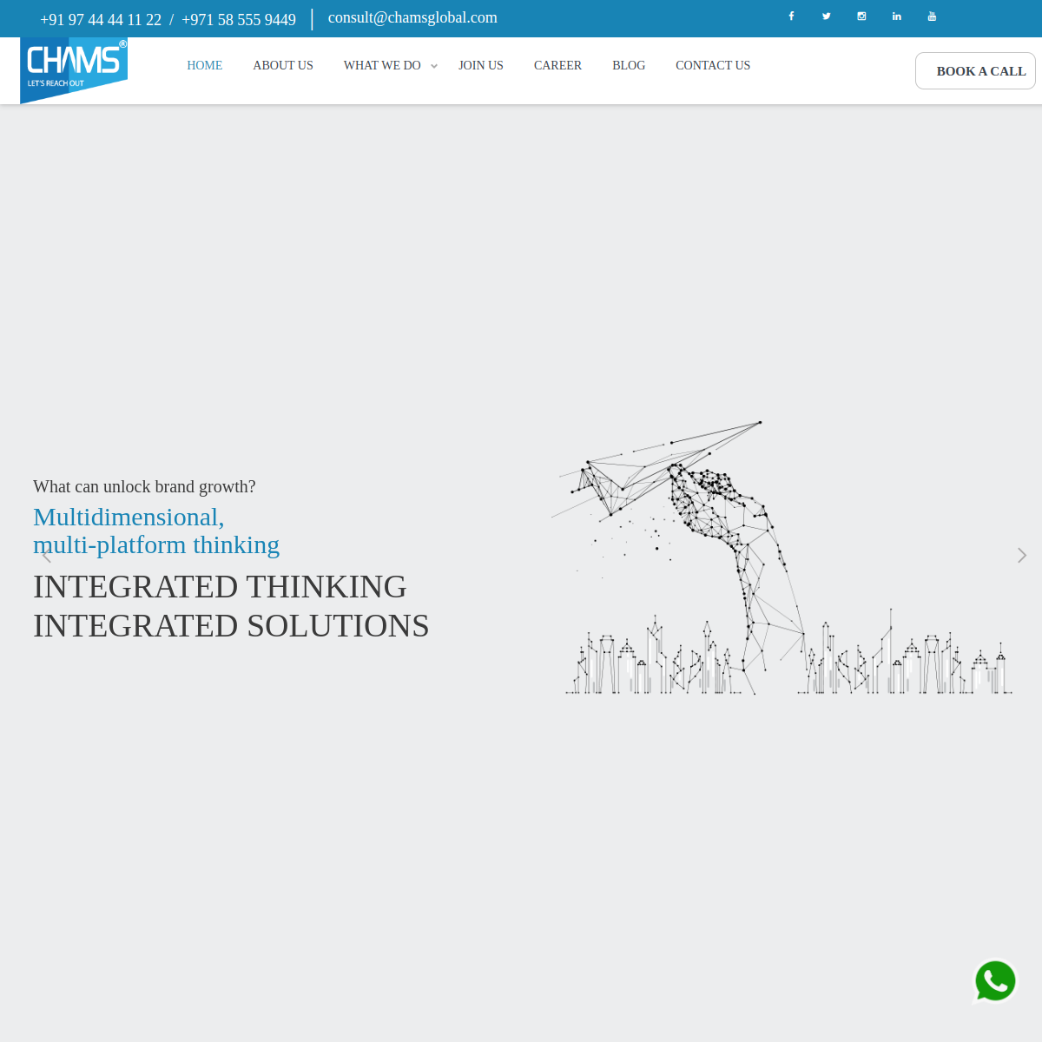
Strengths
- Broad service coverage and clear agency positioning across Kerala and GCC-oriented markets.
- Blog and service landing pages create a usable SEO foundation.
- The brand already has enough authority signals to become the ecosystem’s main conversion and case-study hub.
UI / UX Review
- The homepage looks credible but the hero is visually light on proof and heavy on generic positioning language.
- The journey from awareness to trust to conversion is not sequenced tightly enough. Visitors see services, but outcomes, case studies, and reasons to believe are underplayed.
- The site would benefit from clearer service page hierarchy, stronger internal CTA logic, and more obvious lead capture modules.
Technical and Structural Findings
Observation | Why it matters
Homepage canonical points to `https://www.chamsglobal.com/` while the reviewed domain resolved at `https://chamsglobal.com/`. | Canonical normalization should be cleaned up to reduce ambiguity around the preferred host.
Homepage had no visible Open Graph title, description, or image in the metadata review. | Social sharing previews are weaker than they should be, reducing click-through from WhatsApp, LinkedIn, and other social surfaces.
Homepage schema detection surfaced `BreadcrumbList` only. | The site is underusing structured data such as Organization, LocalBusiness, Service, FAQ, Person, and WebSite schema.
Sample page `digital-marketing-agency-in-dubai` showed duplicate H1 presence. | Heading hierarchy should be tightened so pages present one primary entity/topic cleanly.
The sitemap returned 60 URLs and several keyword-targeted service pages. | Good foundation, but content quality, uniqueness, and interlinking need strategic consolidation.
Sample Page Review
Page sample | Observed title / signal | Evidence | Interpretation
Homepage | Branding Agency in Kochi | Marketing Agency in Kerala | 4 H1s detected | Too many H1s on the homepage can dilute topical clarity.
About | Top Advertising Agency in Kerala | Chamsglobal | 2 H1s | Multiple H1s again suggest structural cleanup is needed.
Blog | Updated Marketing Blogs by the Top Media Agency in Kerala | 4455 words | Good depth, but editorial structure and topic clustering can be stronger.
Branding page | Branding Agency in Kochi | Best Advertising Agency in Kochi | 736 words | Service landing page has useful depth and can be further upgraded for local intent.
SMM page | Social Media Marketing | Digital Marketing Agency in Kochi | 1289 words | Strong opportunity to reformat into problem-solution-result-FAQ sections for AEO.
SEO Analysis
- The domain already ranks/indexes for multiple service terms, which is valuable.
- Metadata is present on many pages, but social metadata and schema are incomplete.
- The site needs page-type discipline: homepage, service page, location page, case study, blog article, and founder page should follow clearer templates.
- Local intent pages like branding and marketing in Kochi/Kerala are promising, but should link more strongly to proof assets and enquiry intent.
AEO Analysis
- The site is not yet shaped for answer engines. Many pages read like marketing copy rather than answer-ready expert content.
- There are few obvious FAQ structures, comparison blocks, pricing guidance, or process explainers on key pages.
- AEO opportunity is especially strong around strategic topics such as branding, agency selection, marketing planning, OOH, and digital strategy.
SMO Analysis
- Social links exist, but some are low-quality destinations like a generic Twitter home link or admin-style LinkedIn endpoints.
- The site should be supported by a stronger loop: case study snippet -> social proof -> landing page -> enquiry form.
- CHAMS is the natural home for polished case-study cards and expert founder clips.
Business Potential
- Highest value as the ecosystem’s authority and conversion hub.
- Can attract premium B2B clients if proof, trust, and strategic messaging become more concrete.
- Should become the main case-study destination feeding leads into CHAMS, KSRTC, and Let’s Play Outdoors offers.
Priority Actions
- Rebuild homepage above-the-fold with clearer offer segmentation, proof badges, and CTA logic.
- Add Organization, LocalBusiness, Service, FAQ, and WebSite schema across priority templates.
- Create better case-study, testimonial, and founder-thought-leadership modules.
- Normalize canonical and host handling across www vs non-www.
Keyword / Topic Opportunities
- branding agency in Kochi
- marketing agency in Kerala
- digital marketing agency in Dubai
- advertising agency in Kerala
- brand promotion agency in Kochi

6. KSRTC Bus Branding
https://www.ksrtcbusbranding.com/
Strategic role: Specialized niche acquisition property for transit-media and bus-branding intent.
Commercially attractive niche site with clear offer visibility, but its technical hygiene and information architecture need significant strengthening.
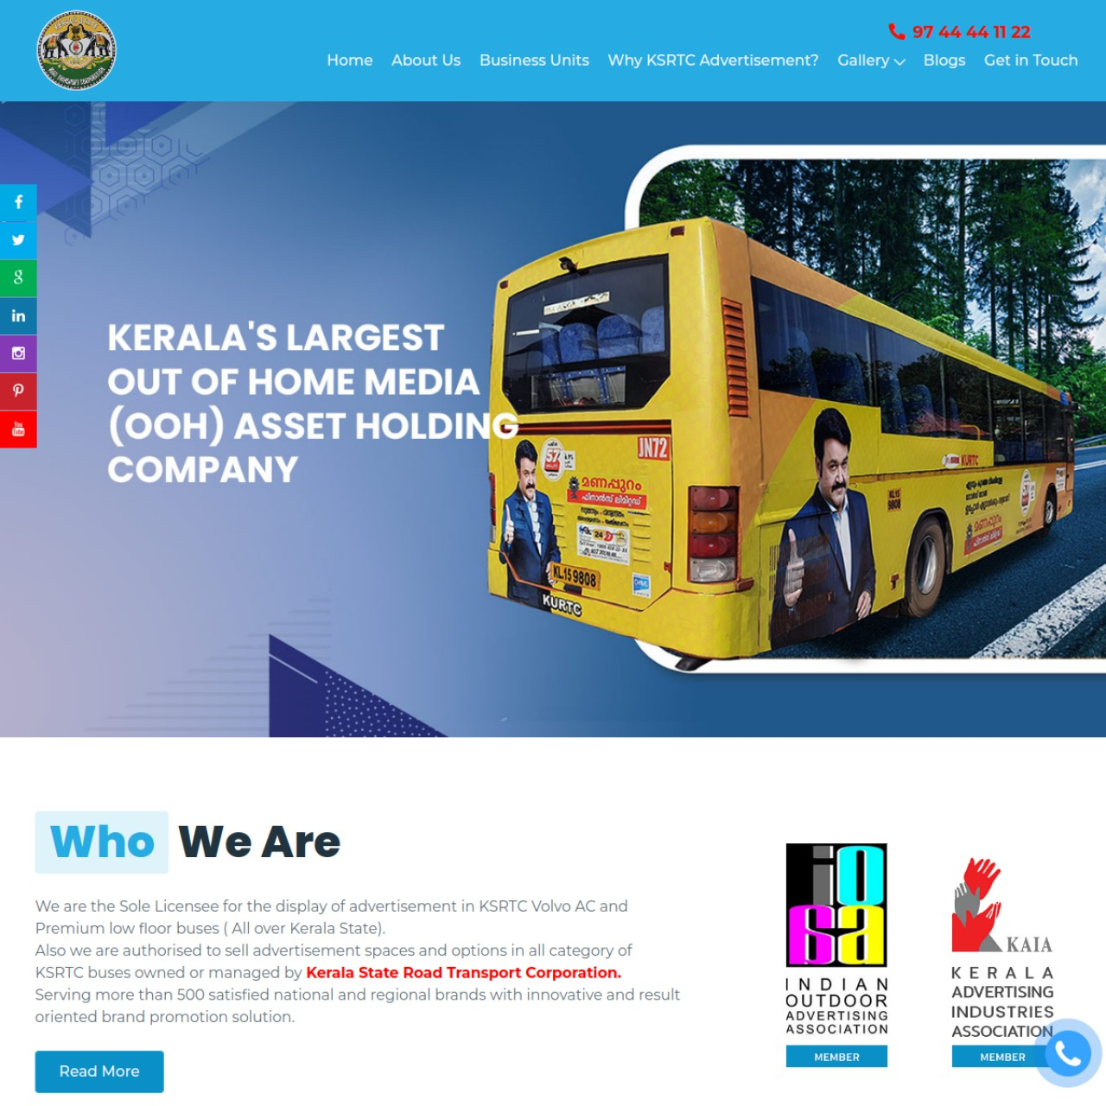
Strengths
- The homepage communicates the offer clearly and quickly.
- The site is focused on a specific niche with real purchase intent.
- Gallery-led assets are useful trust builders when properly optimized.
UI / UX Review
- The visual proposition is strong, but the site feels older and less polished than the opportunity deserves.
- The first impression is product-clear, but conversion UX is not modernized enough for a high-value B2B enquiry journey.
- There is room for stronger quote-request framing, inventory explanation, route coverage detail, and campaign process guidance.
Technical and Structural Findings
Observation | Why it matters
Homepage returned no H1 during review. | A missing H1 on the main page weakens topical clarity for search engines and screen readers.
Both `/` and `/index.php` were live and indexable with the same title and content. | This creates duplication risk and should be canonicalized or redirected.
No homepage JSON-LD schema was detected. | The site is missing key opportunities for Organization, Service, FAQ, VideoObject, and Breadcrumb schema.
`/admin/`, `/admin/uploads/`, and `/admin/uploads/gallery/` were publicly reachable. | This is a trust, SEO, and operational hygiene issue. Sensitive or irrelevant directories should not be publicly indexable.
Robots file appears template-generated. | Robots and indexing policy should be reviewed as part of a proper technical SEO cleanup.
Sample Page Review
Page sample | Observed title / signal | Evidence | Interpretation
Homepage | KSRTC Bus Branding | KSRTC Bus Advertising Agency in Kerala | 0 H1 | Important structural SEO issue on the main page.
About | KSRTC Advertising Agency Kerala | Bus Branding | 594 words | Solid trust page, but could be modernized and strengthened with proof.
Advantages | Low Cost Bus Advertising | Ad On Bus Cost | 307 words | Good commercial-intent page that can be expanded with FAQs and pricing logic.
Gallery pages | Volvo / Low Floor / KSRTC Gallery | 134 to 137 words | Useful for trust, but image alt text, captions, and internal links should be stronger.
Video gallery | Transit Advertising Videos | indexed snippet visible | Can support richer SERP visibility if VideoObject schema is added.
SEO Analysis
- This site has niche-keyword relevance and can become a strong local-search performer for transit-media queries.
- It needs better content depth on buying questions: cost, route coverage, ad sizes, booking process, timelines, creative support, and reporting.
- Page duplication and public-directory exposure reduce technical quality.
- Gallery and video assets can support richer search results if properly structured.
AEO Analysis
- The site currently says what it offers, but not in a way that answer engines can reuse easily.
- It should contain FAQ and explainer blocks such as: What is KSRTC bus branding, how much does it cost, where are the routes, what is the campaign duration, what creatives work best, and how to measure ROI.
- This site is an ideal candidate for concise commercial-answer content because the niche is narrow and buyer questions are predictable.
SMO Analysis
- The business has visual media assets that should perform well on Instagram, YouTube Shorts, LinkedIn, and WhatsApp circulation.
- Needs more campaign stories, route visibility clips, mockup-to-live transformations, and client success explanations.
Business Potential
- Very strong short-term lead potential because the offer is specific and commercially meaningful.
- With stronger conversion paths and page trust, this site can become a consistent niche lead source.
Priority Actions
- Fix homepage H1 and duplication between `/` and `/index.php`.
- Review and secure public admin/upload paths.
- Add Service, FAQ, Organization, Breadcrumb, and VideoObject schema.
- Create commercial landing pages for pricing, route coverage, and campaign process.
Keyword / Topic Opportunities
- KSRTC bus branding
- bus advertising agency in Kerala
- transit advertising Kerala
- bus branding cost Kerala
- Volvo bus advertising Kerala

7. Let's Play Outdoors
https://letsplayoutdoors.in/
Strategic role: Marketplace-scale lead engine and inventory discovery platform for OOH/DOOH products.
The strongest long-term growth asset in the group, with real inventory-led SEO potential, but it needs cleaner index discipline and better landing-page architecture.
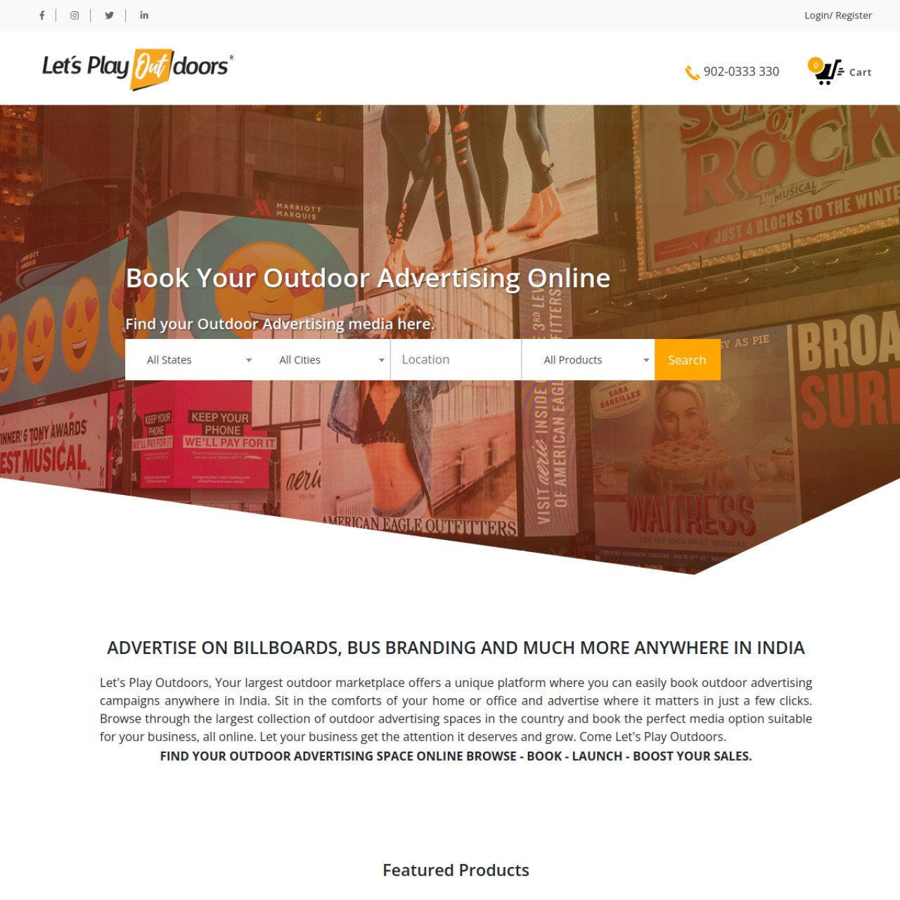
Strengths
- The search-first marketplace concept is commercially strong and scalable.
- Homepage intent is clear and the platform is differentiated from a normal agency site.
- Open Graph setup is stronger here than on the other reviewed sites.
UI / UX Review
- The homepage communicates an online-booking proposition effectively.
- The search interface is useful, but the page still feels broad and somewhat directory-like.
- It needs stronger category access, trust modules, featured collections, and conversion framing to reduce decision friction.
Technical and Structural Findings
Observation | Why it matters
Homepage canonical points to `/home` rather than the root URL. | Canonical setup should be reviewed so the preferred public URL structure is consistent.
Contact page returned 0 detected H1s and only ~79 words. | Important utility pages need stronger content and proper structural headings.
Blog listing page returned 0 H1s. | Blog index pages should still carry proper structural signals.
FAQ page returned 0 H1s. | A core answer-engine page should have explicit heading structure.
At least two sample URLs from search/sitemap review returned empty metadata or zero-word-like output. | Potential thin/empty pages should be repaired, redirected, or removed from indexation.
Sample Page Review
Page sample | Observed title / signal | Evidence | Interpretation
Homepage /home | Outdoor Advertising Agencies | Hoarding Companies | Kochi, Kerala | 785 words | Healthy core page, but category entry and trust hierarchy can improve.
About us | About Us - Outdoor Advertising Agencies | search result visible | Good positioning page and worth expanding for entity clarity.
Blog listing | Blog | Lets play outdoors | 208 words, 0 H1 | Index page needs structural cleanup.
FAQ | FAQ | 519 words, 0 H1 | Good foundation for AEO if restructured and schematized.
OOH article | Walking Billboards – How It Can Change Your Advertising Game | 743 words | Useful content pattern for long-tail SEO.
SEO Analysis
- This domain has the biggest programmatic and category-SEO upside of the group.
- Its sitemap footprint is large enough to support a serious content and category strategy.
- Index quality must be tightened so empty or broken pages do not dilute the site.
- City pages, format pages, product pages, and pricing-guidance pages can create durable search traffic.
AEO Analysis
- The domain is well-suited to answer-intent content because buyers often ask repeated questions about OOH formats, city availability, costs, lead times, and suitability by objective.
- FAQ exists, which is a positive sign, but it should be restructured into explicit question-answer modules and enhanced with FAQ schema.
- Comparison pages such as billboard vs bus branding vs DOOH vs roadshow vehicle can perform well for AI summaries and commercial search.
SMO Analysis
- This brand is inherently visual and can generate strong social assets from inventory highlights and city/location-based showcases.
- Social content should send traffic to themed landing pages rather than only to the homepage.
Business Potential
- Highest long-term traffic and scale potential in the ecosystem.
- Can become the top-of-funnel engine for both direct bookings and assisted-sales leads.
Priority Actions
- Fix index quality on empty or thin pages.
- Create stronger category, city, and format landing pages.
- Restructure FAQ and buying guides for AEO.
- Improve contact, blog, and FAQ template H1 hierarchy.
Keyword / Topic Opportunities
- outdoor advertising in Kerala
- OOH advertising marketplace India
- billboard advertising Kerala
- bus branding Kerala
- DOOH advertising India

8. Misbah Salam
https://misbahsalam.com/
Strategic role: Founder-led authority layer that can improve trust, thought leadership, and entity relevance for the wider group.
Strong personal-brand asset with high authority upside, but it needs content discipline, better metadata differentiation, and clearer consulting-package conversion design.
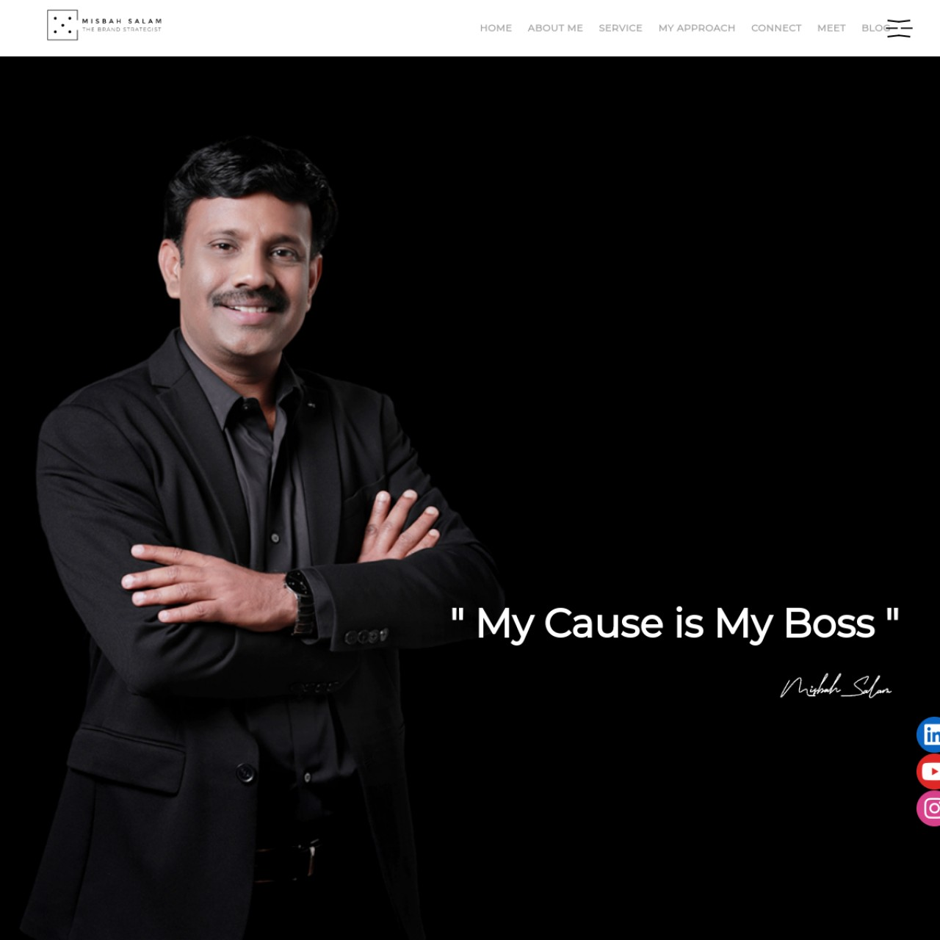
Strengths
- Visually premium and personality-led.
- Founder expertise gives the ecosystem a human trust anchor.
- Blog-led thought leadership can support both direct consulting and halo-brand visibility.
UI / UX Review
- The homepage look is premium, but text formatting and spacing issues reduce perceived polish.
- The offer architecture is not yet clear enough for consulting-package conversion.
- There should be clearer service pillars, speaking/consulting positioning, and proof-led pathways.
Technical and Structural Findings
Observation | Why it matters
Homepage had no visible Open Graph title/description/image in the metadata review. | Social share previews are underpowered.
No homepage JSON-LD schema was detected. | Missing opportunities for Person, Organization, Article, Breadcrumb, FAQ, and WebSite schema.
Service page returned 0 detected H1s. | Service pages need stronger heading hierarchy.
Blog listing page shared the same generic title pattern as the service page. | Metadata differentiation across page types is weak and should be improved.
Search snippets visibly revealed awkward spacing and acrostic-style formatting on the homepage biography block. | Copy presentation and page output need editorial tightening for credibility.
Sample Page Review
Page sample | Observed title / signal | Evidence | Interpretation
Homepage | Misbah Salam: Strategic Marketing Expert and Branding Specialist... | 1 H1 | Strong main entity, but formatting quality needs improvement.
Service | Misbah Salam: Marketing Specialist, Branding, Ads, Strategy... | 0 H1 | Page title too generic and likely reused across multiple pages.
Blog | Misbah Salam: Marketing Specialist, Branding, Ads, Strategy... | 0 H1 | Blog index should not share generic metadata with service pages.
Role of a Brand Marketing Specialist | Indexed article snippet visible | Published ~5 months ago | Good authority-content direction that can be expanded into clusters.
SEO Analysis
- The site has real thought-leadership potential, especially around brand strategy, consulting, startup guidance, and leadership positioning.
- Metadata differentiation is weak on important templates.
- The site should build topic clusters, not just isolated blog posts.
AEO Analysis
- This is the best candidate in the ecosystem for expert-answer content, glossary-style explainers, and founder insights.
- AEO growth can come from questions like what a brand strategist does, when a business needs rebranding, how to build brand positioning, and how marketing differs across B2B vs B2C.
SMO Analysis
- Ideal for LinkedIn-first authority, then repurposed to Shorts, Reels, and quote graphics.
- Needs stronger clip-to-site routing and recurring editorial themes.
Business Potential
- Can materially improve trust transfer to all other websites in the ecosystem.
- Can also become a standalone consulting and speaking lead engine if packaging improves.
Priority Actions
- Fix metadata differentiation and heading hierarchy across page templates.
- Rewrite and polish homepage/service copy for premium credibility.
- Build founder-led authority pages, consulting packages, and expert FAQs.
- Add Person, Article, FAQ, and Organization schema.
Keyword / Topic Opportunities
- brand strategist in Kerala
- marketing consultant in Kochi
- business strategist Kerala
- brand consultant for startups
- marketing strategy consultant India

9. Cross-Site Technical Issues
- Open Graph coverage is incomplete or missing on several reviewed sites, weakening social share CTR and message control.
- Structured data usage is inconsistent and generally underdeveloped across the ecosystem.
- Important pages on KSRTC, Let’s Play Outdoors, and Misbah Salam showed missing H1s during sampling.
- KSRTC has both `/` and `/index.php` live, indicating canonical/duplication cleanup is needed.
- Let’s Play Outdoors showed evidence of thin or empty indexed URLs, which can dilute search quality if not cleaned.
- Misbah Salam has weak metadata differentiation across page types.
- KSRTC public admin/upload path accessibility should be reviewed immediately from both SEO and operational trust standpoints.
10. Content Architecture Recommendations
Recommended content model by domain:
Site | Content priority | Primary purpose
CHAMS Global | Service pages, case studies, founder insights, proof pages | Authority and conversion
KSRTC Bus Branding | Buying guides, route coverage pages, FAQ, pricing explainers, campaign showcases | High-intent conversion capture
Let's Play Outdoors | Category pages, city pages, format pages, comparisons, FAQs, inventory explainers | Scalable organic acquisition
Misbah Salam | Expert articles, founder FAQs, consulting package pages, interviews, opinion essays | Entity authority and trust transfer
Suggested cluster themes:
- Agency selection: how to choose a branding or marketing partner.
- OOH buying education: bus branding, billboards, DOOH, roadshow vehicles, and retail activations.
- Commercial intent: cost, duration, city availability, ROI expectations, timelines, and creative requirements.
- Founder authority: strategy frameworks, brand positioning, business growth, and market-behavior insights.
11. AEO and Schema Roadmap
- Create FAQ blocks on every priority commercial page and implement FAQ schema where appropriate.
- Use Organization / LocalBusiness schema for CHAMS and Let’s Play Outdoors, and relevant Service schema for commercial service pages.
- Add Person schema and Article schema to Misbah Salam to strengthen expert identity.
- Add VideoObject schema to KSRTC video content and relevant gallery/video assets where technically feasible.
- Introduce answer-ready structures: question headings, concise definitions, comparison tables, process sections, and summary bullets.
12. SMO and Authority Strategy
- CHAMS Global: publish polished case-study snippets, proof-led carousels, and consulting/strategy clips.
- KSRTC Bus Branding: push vehicle walkthroughs, route-coverage reels, before/after wraps, and campaign launch visuals.
- Let's Play Outdoors: publish city-wise inventory highlights, product-format explainers, and advertiser-use-case content.
- Misbah Salam: prioritize LinkedIn-led founder authority, then repurpose to Instagram Reels and YouTube Shorts.
- All social campaigns should point to dedicated landing pages, not only to the homepage.
13. Measurement Framework
- Track leads by source, landing page, domain, and campaign theme.
- Separate raw enquiries from qualified enquiries and booked calls.
- Measure top commercial pages for scroll depth, CTA clicks, and form submissions.
- Track branded vs non-branded search growth and the contribution of each site.
- Review lead quality monthly and feed learnings back into content and page design.
14. Detailed 90-Day Execution Plan
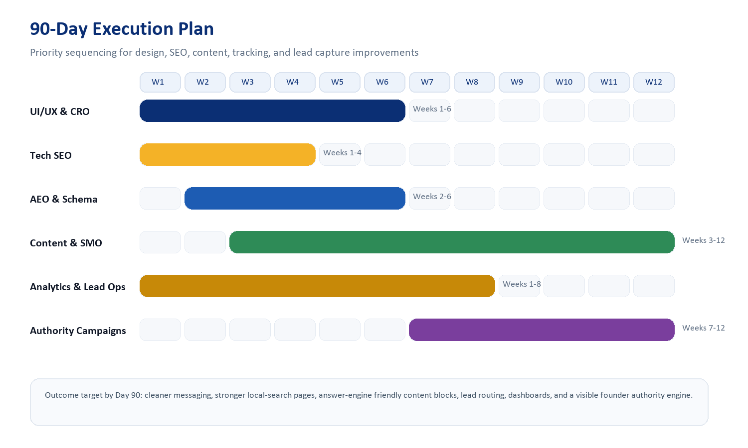
Phase 1: Days 1-30
- Fix metadata gaps, H1 issues, canonical inconsistencies, and index-quality problems.
- Review KSRTC directory exposure and clean search/index rules where required.
- Tighten homepage messaging and CTA logic on CHAMS, KSRTC, and Misbah Salam.
- Set analytics, event tracking, and domain-level KPI reporting.
Phase 2: Days 31-60
- Deploy schema across core templates.
- Build FAQ, process, pricing-guidance, and category-support content.
- Launch improved service and landing-page architecture for CHAMS and KSRTC.
- Clean and enrich Let’s Play Outdoors category and buying-flow pages.
Phase 3: Days 61-90
- Publish founder-led authority content and cross-link it intelligently into the service ecosystem.
- Expand long-tail content clusters and internal linking.
- Push social proof assets and campaign-driven landing pages.
- Review enquiry quality and refine pages based on actual commercial behavior.
15. Deliverables Matrix
Workstream | Planned outputs
Technical SEO | Meta cleanup, H1 cleanup, canonical review, sitemap/index discipline, schema deployment
UI/UX | Homepage refinement, stronger CTA paths, proof blocks, service-page hierarchy
AEO | FAQs, answer sections, comparison content, process explainers
Content | Keyword clusters, authority articles, niche buying guides, location/category pages
SMO | Social-message architecture, clip routing, campaign visuals, landing-page pairings
Analytics | Lead tracking, source breakdown, CTA events, commercial dashboards
16. Commercial Proposal
Kerala market signals reviewed on 6 July 2026 suggest a wide spread: budget providers commonly quote lower monthly SEO and social packages, while more established agencies price higher. Public pricing references reviewed during this audit included SEO in the roughly ₹5,000 to ₹15,000 monthly range on the low-to-mid side, social media packages starting around ₹10,000 monthly, broader Kerala SEO ranges around ₹8,000 to ₹40,000 monthly, and business website builds around ₹15,000 to ₹40,000 one time. Based on that local context, the earlier proposal has been reduced to a more affordable range.
Plan | Scope | Fee | Positioning
Starter | Technical cleanup + basic conversion improvements | ₹1.20L | Best if budget is tight and priority is fixing the core issues
Growth | Recommended full 90-day audit execution plan | ₹1.80L | Best balance of SEO, AEO, UX, content, and commercial impact
Authority | Growth plan plus deeper content and authority rollout | ₹2.60L | Best for faster brand consolidation and bigger traffic upside
Optional post-90-day retainer: ₹25,000 to ₹55,000 per month depending on content volume, reporting, and continuous optimization scope.
17. ROI Perspective
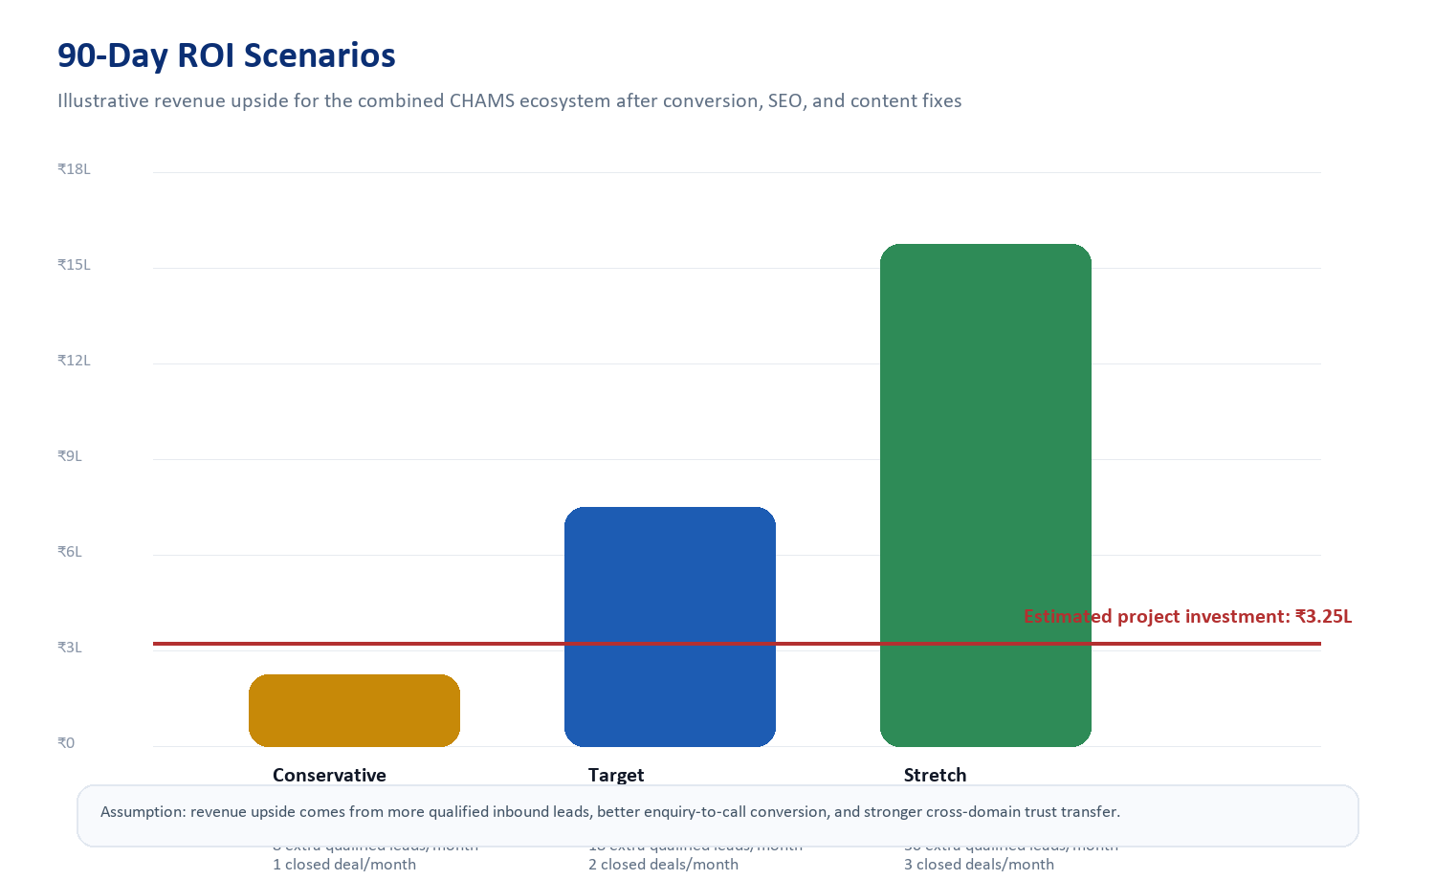
- The ROI case becomes attractive if the ecosystem produces even 1 to 2 additional quality closures per month after optimization.
- KSRTC and CHAMS appear especially capable of converting improved trust and enquiry quality into meaningful revenue uplift.
- Let’s Play Outdoors offers the biggest medium-term upside because it can accumulate traffic through category and inventory SEO.
- Misbah Salam strengthens the quality of inbound trust, which can indirectly improve conversion across all brands.
18. Final Recommendation
The best commercial move is not to redesign everything at once. It is to execute a disciplined 90-day growth sprint that first fixes structural weaknesses, then strengthens answer-ready and conversion-ready content, and finally compounds authority through better proof, social routing, and founder-led thought leadership. In practical terms, the Growth plan is the most sensible option for this ecosystem.
19. Source Notes
- Primary domains reviewed: https://chamsglobal.com/, https://www.ksrtcbusbranding.com/, https://letsplayoutdoors.in/, https://misbahsalam.com/.
- Internal-page samples were selected from sitemap outputs and visible live pages on 6 July 2026.
- Search-footprint checks used visible branded and `site:` query results available at review time.
- Technical findings are based on observable frontend signals and should be complemented by server-side access if a full implementation sprint begins.

