Prepared for CHAMS ecosystem websites
Digital Presence, SEO, AEO, SMO and 90-Day Growth Proposal
Audit date: 6 July 2026 | Websites reviewed: chamsglobal.com, ksrtcbusbranding.com, letsplayoutdoors.in, misbahsalam.com
This proposal evaluates the live user experience, search readiness, social positioning, answer engine readiness, and near-term business potential of the four websites, then outlines an affordable 90-day plan to improve visibility, enquiries, and brand authority.
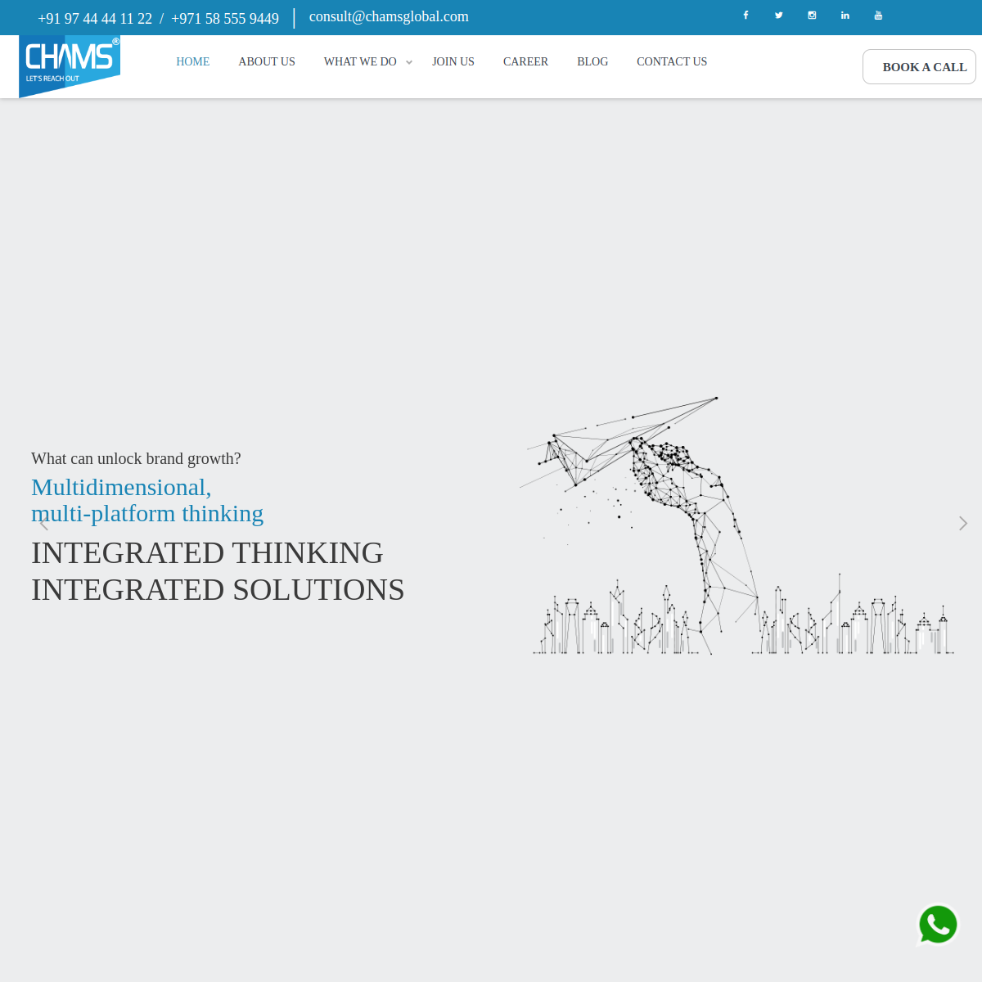
Prepared as a practical improvement plan for the Indian market, balancing brand quality with affordable execution.

1. Executive Summary
The four websites already form a useful digital ecosystem: CHAMS Global is the master brand, KSRTC Bus Branding is a high-intent niche offer, Let’s Play Outdoors has strong marketplace upside, and Misbah Salam can become the authority-led trust engine. The main problem is not the lack of intent. It is fragmentation. The sites are not yet working together as a unified demand-generation system.
Across the ecosystem, the strongest opportunities are better lead capture, stronger service-page clarity, structured schema for answer engines, tighter on-page copy, improved cross-linking, and a more deliberate social-content funnel. The biggest risks are technical inconsistency, weak Open Graph setup, limited answer-engine formatting, and public directory exposure on the KSRTC domain.
Overall strategic read:
- CHAMS Global should become the authority and case-study hub.
- KSRTC Bus Branding should be optimized as a high-conversion niche landing system.
- Let’s Play Outdoors should be scaled as the searchable inventory and lead-routing engine.
- Misbah Salam should be developed as the founder-expert layer that strengthens trust across all sites.
2. Scorecard Snapshot
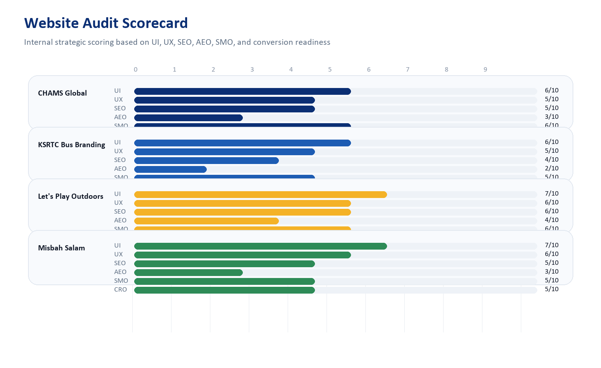
Scores are internal audit scores out of 10 and are meant to guide priority, not to mimic third-party tools.
Website | UI | UX | SEO | AEO | SMO | CRO
CHAMS Global | 6 | 5 | 5 | 3 | 6 | 5
KSRTC Bus Branding | 6 | 5 | 4 | 2 | 5 | 6
Let's Play Outdoors | 7 | 6 | 6 | 4 | 6 | 7
Misbah Salam | 7 | 6 | 5 | 3 | 5 | 5
Interpretation: Let’s Play Outdoors has the strongest scale upside, CHAMS Global is the best authority hub candidate, KSRTC Bus Branding has the clearest niche intent, and Misbah Salam can strengthen trust and thought leadership across the group.

3. CHAMS Global
https://chamsglobal.com/
Strong master-brand positioning with blog content, social links, and multi-market messaging, but discovery and conversion are below potential.

UI/UX Findings
- Clean corporate look and good top-level service positioning.
- Hero area is text-heavy and low on immediate proof, resulting in slower message absorption.
- Primary CTA exists, but case studies, outcomes, and lead-capture points are not prominent enough.
SEO Findings
- Title and meta description are present, but Open Graph tags are missing.
- Canonical points to `https://www.chamsglobal.com/` while the live site resolves on non-www, which can dilute canonical clarity.
- Only `BreadcrumbList` schema was detected; no strong Organization, Service, FAQ, or Review schema.
AEO Findings
- Limited structured content for answer engines to summarize.
- No obvious FAQ or expert-answer blocks on the homepage.
- Service pages need clearer problem-solution-result formatting.
SMO Findings
- Active social links are present, but some links are weak quality, including a generic Twitter home link and LinkedIn admin/feed style link.
- Needs stronger social proof blocks, campaign reels, and case snippets.
Business Potential
- Best positioned to become the authority hub for the whole ecosystem.
- Can generate higher-value B2B enquiries through case-study SEO, founder content, and stronger service landing pages.

4. KSRTC Bus Branding
https://www.ksrtcbusbranding.com/
Niche-led offer with strong category relevance and visual product clarity, but technically under-optimized and trust hygiene needs work.
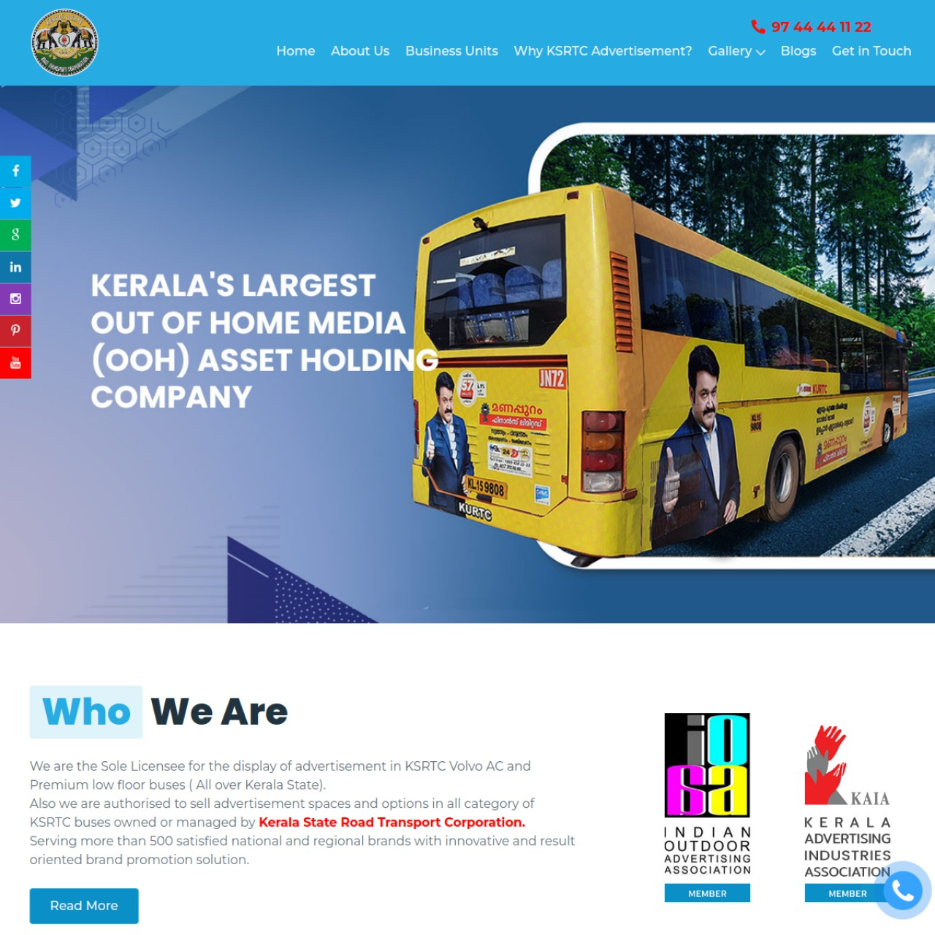
UI/UX Findings
- Clear product-market fit: visitors immediately understand bus branding as the offer.
- Strong visual asset, but the page architecture feels dated and heavy.
- Quote form exists, which is good, but the trust and proof sequence can be improved.
SEO Findings
- Meta title and description exist, but no H1 was detected on the homepage.
- No JSON-LD schema detected.
- Public admin and upload directories are indexable, which is both an SEO and trust risk.
AEO Findings
- No FAQ, pricing explainer, route coverage explainer, or campaign-format answer blocks on the homepage.
- No schema to help AI systems understand the business as a specialized service provider.
SMO Findings
- Social profile links exist across multiple platforms.
- Needs campaign walkthroughs, bus route clips, client success stories, and before/after creative posts.
Business Potential
- High lead intent because the niche is specific and commercially valuable.
- Could rank and convert well for regional OOH and transit-media queries with better landing pages and stronger proof.

5. Let's Play Outdoors
https://letsplayoutdoors.in/
Most scalable digital product concept among the four sites, with inventory-led search opportunity and transaction-style UX direction.
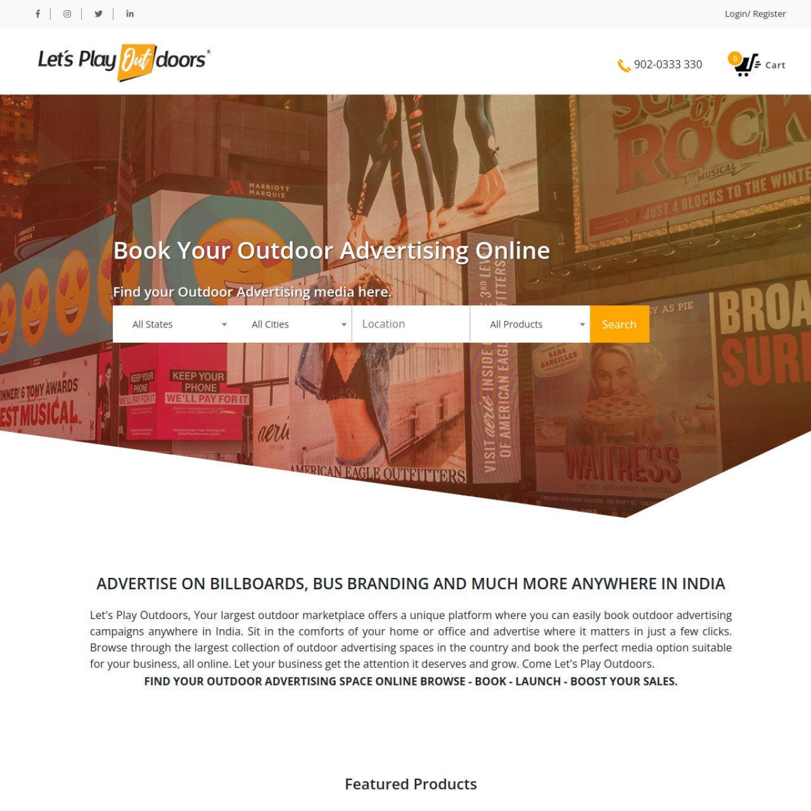
UI/UX Findings
- Clear marketplace proposition with searchable inventory behavior.
- Hero communicates intent well, but the experience can feel broad and directory-like.
- Needs sharper category entry points, trust markers, and conversion shortcuts.
SEO Findings
- Good title, meta description, Open Graph title/description/image, and basic Organization schema.
- Canonical currently points to `/home` instead of the root, which should be normalized.
- Large sitemap footprint creates strong programmatic SEO potential if category pages are optimized.
AEO Findings
- FAQ exists on the domain, which is a good foundation.
- Needs buyer-intent explainers such as pricing, city-wise inventory, format comparison, and booking workflow content.
SMO Findings
- Brand has recognizable identity and multi-platform presence.
- Could perform well with inventory snapshots, campaign wins, new-city launches, and UGC-style outdoor showcases.
Business Potential
- Biggest long-term upside as a searchable OOH marketplace.
- With category SEO and lead-routing, it can become the acquisition engine for the entire group.

6. Misbah Salam
https://misbahsalam.com/
Strong founder-brand asset with personal authority potential, but content quality control and conversion framing need tightening.
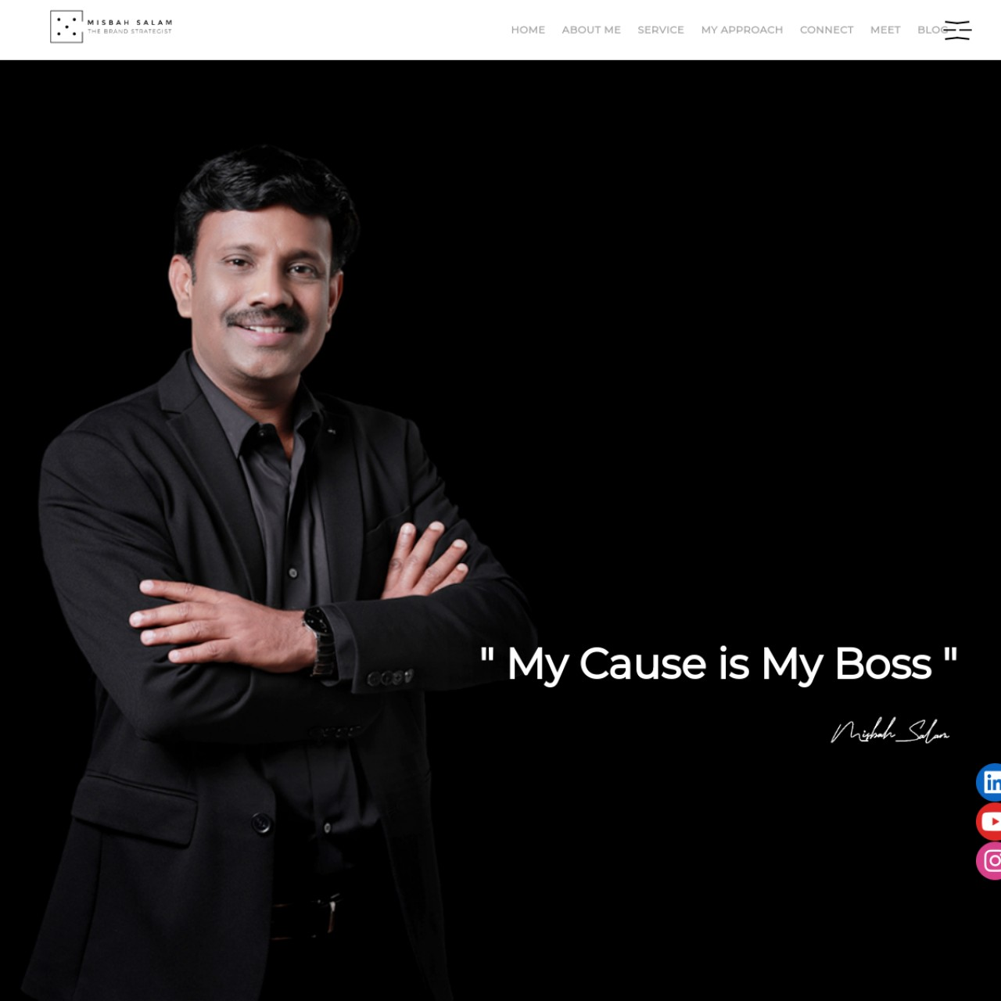
UI/UX Findings
- Premium, minimal visual style with a strong personal-brand hero.
- Several text-spacing and copy-formatting issues reduce polish and credibility.
- Service and value proposition need clearer consulting packages and proof blocks.
SEO Findings
- Meta title and description exist, but Open Graph tags and schema are missing.
- Blog presence supports authority building, yet stronger topic clustering is needed.
- Needs better entity reinforcement around strategist, consultant, speaker, and mentor intents.
AEO Findings
- Good candidate for author-led answer engine visibility through expert articles, interviews, FAQs, and topical glossaries.
- Current homepage lacks structured expert-answer formatting.
SMO Findings
- Good visual face for LinkedIn, YouTube Shorts, and Instagram thought leadership.
- Needs a more consistent publishing cadence and stronger clip-to-site funnel.
Business Potential
- Can become the trust amplifier for the whole ecosystem.
- Founder-led authority content can improve both direct consulting leads and corporate brand lift.

7. Cross-Domain Strategic Findings
- The four websites should behave like one commercial ecosystem, but today the cross-domain funnel is weak and inconsistent.
- Open Graph coverage is incomplete, which reduces social sharing quality and click-through potential.
- Structured data is too thin for answer engines. CHAMS shows only BreadcrumbList, Let’s Play Outdoors shows Organization schema, and the other two sites showed none on the homepage.
- Security and trust hygiene need improvement. Standard hardening headers were not detected across the sites, and the KSRTC domain exposes public admin upload directories.
- Copy polish is uneven. Misbah Salam especially needs tighter editing because visible spacing and formatting issues reduce premium perception.
- There is blog and social activity in the ecosystem, which means the growth foundation exists. The missing layer is prioritization, repackaging, and consistent authority signaling.
8. 90-Day Plan
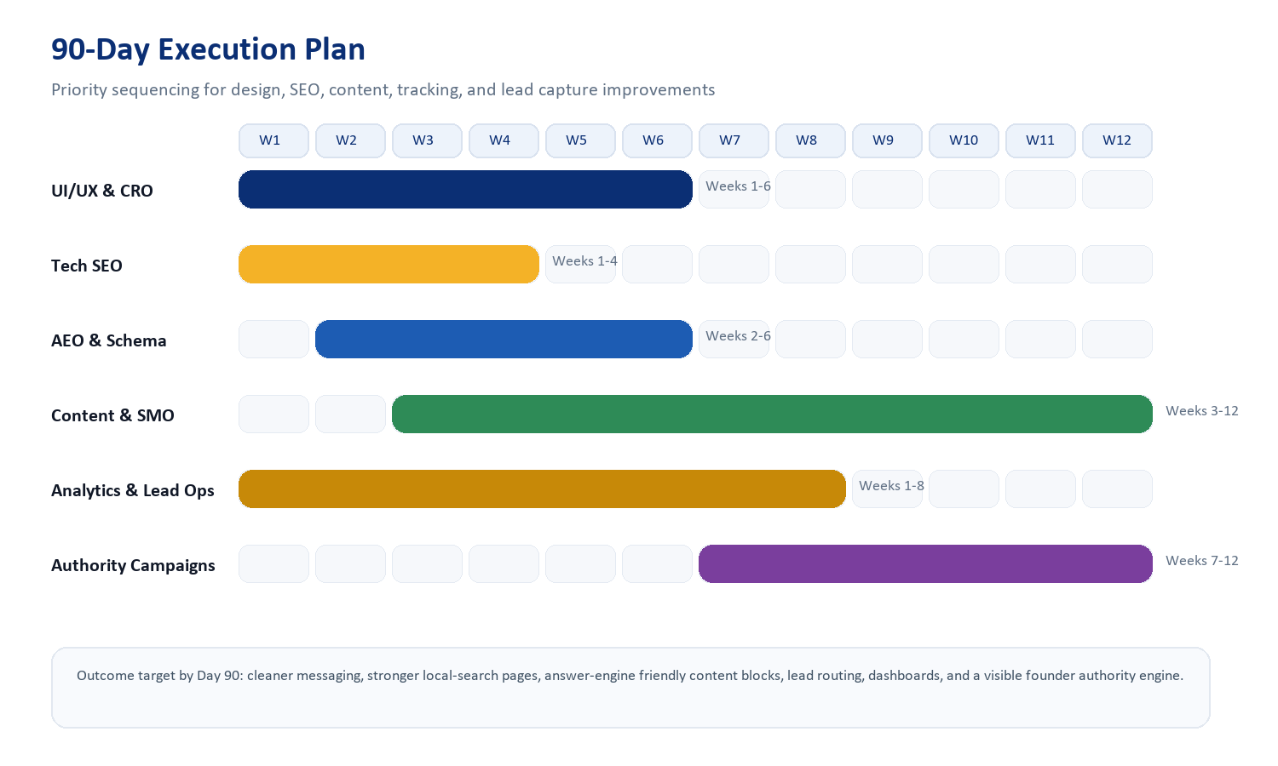
Recommended sprint structure:
- Days 1-30: fix technical hygiene, improve page structure, clean copy, set analytics, normalize canonicals, add stronger CTA placements, and block exposed directories from search where required.
- Days 31-60: add schema, FAQ blocks, service landing pages, local SEO pages, case-study modules, and social proof. Launch founder-led authority content and niche landing enhancements.
- Days 61-90: expand content clusters, strengthen cross-linking, push SMO campaigns, publish video snippets and case stories, measure enquiry quality, and refine pages based on actual lead behavior.
9. KPI Targets for the First 90 Days
- 25% to 60% lift in qualified enquiries across the ecosystem, depending on traffic quality and sales follow-up.
- Improved social click quality through better Open Graph assets and more campaign-specific landing pages.
- Increase in local search visibility for agency, outdoor advertising, bus branding, strategist, consultant, and city-intent keywords.
- Better answer-engine pickup through FAQs, entity reinforcement, author content, and service-result formatting.
- A stronger trust narrative through case studies, founder visibility, testimonial framing, and clearer contact pathways.
10. Commercial Proposal
Affordable Indian-market pricing options for the combined four-site ecosystem:
Plan | Best for | Included focus | 90-day fee | Expected outcome
Starter | Fix the basics fast | UI clean-up, technical SEO fixes, CTA improvements, analytics, social asset cleanup | ₹2.25L | Better credibility and stronger enquiry readiness
Growth | Recommended | Everything in Starter plus schema, landing pages, content clustering, SMO plan, authority pages, dashboarding | ₹3.25L | Best balance of visibility, conversion, and authority
Authority | Aggressive brand push | Everything in Growth plus deeper content production, founder campaign rollout, extra city/category pages, CRO testing | ₹4.75L | Faster growth and stronger category ownership
Suggested execution model:
- One-time 90-day sprint fee from the table above.
- Optional content and growth retainer after Day 90: ₹45,000 to ₹90,000 per month depending on deliverable volume.
- Paid ads, influencer spends, video shoots, and major redevelopment costs are best treated as separate line items.
11. ROI Estimate
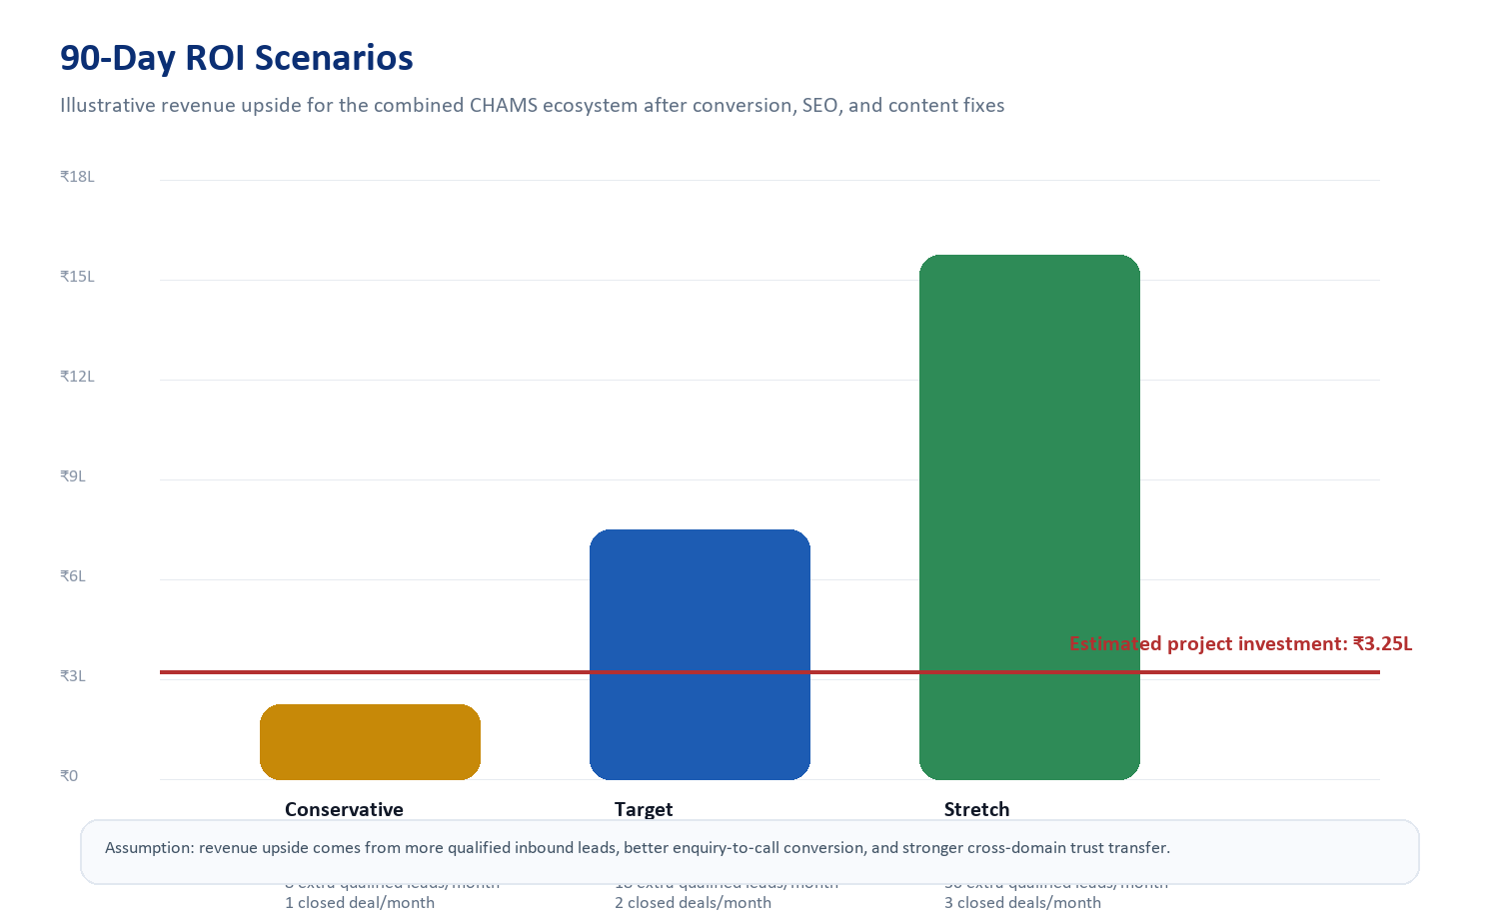
The recommended Growth plan at ₹3.25L is commercially reasonable if the ecosystem turns even a modest increase in qualified inbound traffic into 1 to 2 additional monthly closures. Because CHAMS and KSRTC appear to sell higher-value services, ROI can become attractive quickly once lead quality and trust improve.
Illustrative assumptions behind the chart:
- Conservative case assumes one additional closed deal per month after lead quality improves.
- Target case assumes two additional closed deals per month from better enquiry volume and conversion.
- Stretch case assumes the ecosystem starts compounding through founder authority, niche landing pages, and marketplace SEO.
12. Immediate Recommendations
- Fix technical hygiene first: canonical normalization, OG tags, H1 hierarchy, schema, and security/search exposure issues.
- Rebuild the conversion narrative next: stronger proof, clearer offers, more visible CTAs, and better contact flows.
- Publish answer-engine friendly content blocks: FAQs, pricing explainers, process pages, city/category pages, and expert commentary.
- Use Misbah Salam as the authority bridge between brand strategy and service delivery across the ecosystem.
- Treat Let’s Play Outdoors as the long-term scalable acquisition engine and CHAMS Global as the central trust and case-study hub.
13. Sources and Audit Notes
- Live site review conducted on 6 July 2026.
- Primary sources: https://chamsglobal.com/, https://www.ksrtcbusbranding.com/, https://letsplayoutdoors.in/, https://misbahsalam.com/.
- Technical checks included homepage metadata, canonical tags, robots/sitemap availability, schema detection, social-link presence, H1/H2 structure, and crawl/index exposure signals.
- Search-footprint observations included indexed pages, blog presence, and directly visible search-result snippets.
- ROI projections are strategic estimates and should be refined further using actual baseline traffic, close rates, and average deal value.

Prepared by Codex as a practical proposal document for stakeholder review.

