Sentiment Analysis for correlating AT&T Retails Store performance – Empirical Study on Twitter, Yelp and Google reviews.

Aditya Purandare, Swapnil Phulse, Alok Satpathy, Mohammad Atif Tahir

20th October 2016

# Introduction

The year 2016 expects certain insurgency around in what capacity can online networking information be expended in an enhanced way to relate with particular business needs. On the off chance that we think in 2015, we watched parcel of concentration on "Sophistication", "Customization" and "Innovation" inside the web-based social networking space, and it will probably observe the improvements around these territories in 2016 too, alongside the extra focus on "Collaboration", "Integration" and "Automation" to give superior personalized products, services and experiences across industries.

[Figure: Survey about expenditures to customer retention and over the years]

It is imperative that renowned corporations like AT&T jump the social media analytics bandwagon. This competition aimed at harnessing Big data to unravel information about customer sentiments as captured in either structured/unstructured way. This report intends to describe our basic understanding through literature-review, our overall solution design and initial insights obtained from exploratory data analysis.

# Literature Review

## Sentiment analysis and opinion mapping –Katrekar Ashish. 2009

The authors in this paper mention how feelings of others have a critical impact in our daily decision-making process. These choices extend from purchasing an item, for example, an advanced mobile phone to making speculations to picking a school—all choices that influence different parts of our day by day life. Before the Web, individuals would look for feelings on items and administrations from sources, for example, companions, relatives, or shopper reports. In any case, in the Internet era, it is much simpler to gather assorted assessments from various individuals around the globe. Individuals hope to audit destinations (e.g., CNET, Epinions.com), e-business destinations (e.g., Amazon, eBay), online conclusion locales (e.g., TripAdvisor, Rotten Tomatoes, Yelp) and social media (e.g., Facebook, Twitter) to get criticism on how a specific item or administration might be seen in the advertise.

## Big Data Stream Analytics for Near Real-Time Sentiment Analysis - Otto K. M. Cheng, Raymond Lau

The main theoretical contributions of our research include the design and development of a novel big data stream analytics framework, named BDSASA for the near real-time analysis of consumer sentiments. Another main contribution of this paper is the illustration of a probabilistic inferential language model for analyzing the sentiments embedded in an evolving big data stream generated from online social media. The business implication of the author’s research is that business managers and product designers can apply the proposed big data stream analytics framework to more effectively analyze and predict consumers’ preferences about products and services. Accordingly, they can take proactive business strategies to streamline the marketing or product design operations.

# Business problem and motivation

In a worldwide commercial center, where consistent development and client contact is fundamental, AT&T must explore the scene of customary call focuses, retail location collaborations, and now, online presence. As mentioned in case, 500 million tweets are posted in the Twitter universe daily. These tweets go from associations between companions to purchaser protestations. True to its mission " connect people with their world, everywhere they live, work and play … and do it better than anyone else ", AT&T has decided to use data over the plethora of online websites.

# Data description & methodology

## Data Collection

By using API collectors intended to gather data from varied sources, in its native form, we have gathered raw tweets, yelp and google reviews. It helped us capture general sentiments associated with this excerpts that capture customer response.

**Milestone # 1 - First part for framework for second round**

**Expanding the search to Include Products and Services**

Collecting all social media reviews about AT&T products and frequencies in Dallas. Taking AT&T store locator as reference and after looking up the social media website likes google reviews, twitter and yelp. We decided to drill down to 11 AT&T corporate store locations and 7 authorized retail stores which are prominent in the Dallas areas and have considerable number of reviews on social media website. The number of authorized retail stores is not same as the corporate stores due to the absence of reviews for many authorized dealer store. The store locations list is given below.

Corporate Retail Stores

|  |  |  |  |  |
| --- | --- | --- | --- | --- |
| **Store**  **Address** | **Store Alias** | **Store Web Business Id (For Twitter and Yelp)** | **Geolocation(For twitter)** | **Zip**  **Code** |
| 208 S Akard Street, Ste 110, Dallas, | Dallas 1 | at-and-t-dallas-6 | 32.779555, -96.8009703 | TX 75202 |
| 3329 Oak Lawn Avenue Dallas | Dallas 2 | at-and-t-dallas-13 | 32.8111091,-96.8092962 | TX 75219 |
| 5616 Lemmon Ave Dallas | Dallas 3 | at-and-t-dallas-17 | 32.8293128,-96.8272358 | TX 75209 |
| 8687 N Central Expressway Suite 2340 | Dallas 4 | at-and-t-dallas-7 | 32.8685017,-96.7757012 | TX 75225 |
| 1152 North Buckner Blvd | Dallas 5 | at-and-t-dallas-9 | 32.8342578,-96.7045404 | TX 75218 |
| 9100 N Central Expressway Suite 105 | Dallas 6 | at-and-t-dallas | 32.8740567,-96.771404 | TX 75231 |
| 5959 Royal Lane Dallas | Dallas 7 | at-and-t-dallas-16 | 32.8957338,-96.8079243 | TX 75230 |
| 7800 N. Macarthur Boulevard Suite 150 | Dallas 8 | at-and-t-irving-2 | 32.913273, -96.958064 | TX 75075 |
| 701 N Central Expy Plano, TX 75075 | Dallas 9 | at-and-t-plano-6 | 33.009892, -96.709061 | TX 75063 |
| 5100 Beltline Road Ste. 1032 | Dallas 10 | at-and-t-addison-2 | 32.953929, -96.821254 | TX 75254 |
| 13710 Dallas Parkway Suite I | Dallas 11 | at-and-t-dallas-5 | 32.934372, -96.820672 | TX 75240 |

**Authorized Retail Stores**

|  |  |  |  |  |
| --- | --- | --- | --- | --- |
| **Store**  **Address** | **Store Alias** | **Store Web Business Id (For Twitter and Yelp)** | **Geolocation(For twitter)** | **Zip**  **Code** |
| 5618 E Mockingbird Lane  Dallas, TX 75206" | Dallas 12 | at-and-t-dallas-6 | 32.779555, -96.8009703 | TX 75202 |
| 6417 Hillcrest Ave Dallas, TX 75205" | Dallas 13 | at-and-t-dallas-13 | 32.8111091,-96.8092962 | TX 75219 |
| 5567 W Lovers Ln  Dallas, TX 75209 | Dallas 14 | at-and-t-dallas-17 | 32.8293128,-96.8272358 | TX 75209 |
| 5521 Greenville Ave  Dallas, TX 75206 | Dallas 15 | at-and-t-dallas-7 | 32.8685017,-96.7757012 | TX 75225 |
| 5960 W Northwest Hwy  Dallas, TX 75225 | Dallas 16 | at-and-t-dallas-9 | 32.8342578,-96.7045404 | TX 75218 |
| 1530 S Buckner Blvd Dallas, TX 75217 | Dallas 17 | at-and-t-dallas | 32.8740567,-96.771404 | TX 75231 |
| 2160 N Coit Rd Ste 141 Richardson, TX 75080 | Dallas 18 | at-and-t-dallas-16 | 32.8957338,-96.8079243 | TX 75230 |

**Geolocation**

Since one of the important factors during the case study was store location. Different social media store location in different ways, for twitter the geolocation is in latitude, longitudes coordinates. It becomes necessary to extract geolocation information from a tweet. Moreover, it is not easy to track the store location from twitter. Approximation based on nearest store has to be done to determine the score. In case of google and yelp, the reviews are categorized by store location. But, during the analysis, there should be unified standard. Hence, the geolocation coordinates are the criteria for the location of stores to collect the reviews from different social media platforms.

For products and services different methods had to applied to platforms get the customer satisfaction.

*Twitter*

Data collection will happen through the twitter API (<https://api.twitter.com/1.1/search/tweets.json>")

Data will be fetched in json format and it will be converted to .csv format for keeping the data in common format for facilitating the use of Hadoop distributed File System (HDFS). From the perspective of making the application future proof and scalable.

Below table shows the individual search strings used to come up with the final search query for twitter

|  |  |  |
| --- | --- | --- |
| Product | Search String Web link | Service |
| Uverse | https://twitter.com/search?q=AT%26T%20uverse%20service&src=typd - U-versegood service | Uverse General Service |
| https://twitter.com/search?q=att%20uverse%20satisfied | Product Satisfaction |
| https://twitter.com/search?q=att%20uverse%20installed | Product Installation |
| https://twitter.com/search?q=att%20uverse%20technician%20dispatched | Technician Dispatch |
| DIRECTV | https://twitter.com/search?q=directtv%20product%20installation&src=typd | Product Installation |
| https://twitter.com/search?q=att%20directtv%20technician%20dispatched | Technician Dispatch |
| https://twitter.com/search?q=%20directv%20satisfied&src=typd | Product Satisfaction |

The search queries for other products like mobile and ATT Fiber has been done in similar manner as aforementioned above.In case of twitter, the search queries had to expanded to include AT&T Products like Uverse, DIRECTV, Fiber and Mobile. The search query used for twitter is listed below.

queries = ['att%20OR%20attcares%20OR%20uverse%20OR%20attfiber%20OR%20directv%20OR%20directvservice']

The search query is passed to the REST API call passes to twitter to fetch the tweets.

*Yelp*

In case of yelp AT&T products have been listed as separate business. So, there was no need to write search queries for products. For instance, Uverse has a separate business page on yelp. For Dallas and adjoining areas.

|  |  |
| --- | --- |
| Product | Yelp Product Page |
| Uverse | https://www.yelp.com/biz/at-and-t-u-verse-dallas-ft-worth |
| DIRECTV | https://www.yelp.com/biz/directv-dallas-5?osq=directv |

*Google*

The search queries in case of google were similar to that of twitter. The reviews already retrieved from different store locations was parsed in order to get the required products and services.

product_dict = {"uverse":"uverse","attfiber":"fiber", "fiber":"fiber","directv":"directv", "directvservice":"directv"}

The product dictionary aforementioned is used to get the relevant products and services from google.The application for data collection has been abstracted is such a way that the api key and other configurations are handled well from a config.ini file.

Base.py - Contains the base script which loads the config for twitter. It also contains the fetch feeds method, which is called by app.py for filtering on the basis of search query.

App.py - Search query strings and called to fetch_twitter methods is done in the script. Query strings are critical for Twitter due to the fact that only customer satisfaction and product experience data should be filtered.

Out of all of the places online that you can review a business, only two places spring to mind for many consumers: Yelp and Google. Both of them are powerhouses with a long history in the business. Both of them are influential. Yelp has a lot of power online. Aside from its community, it’s still the #1 place users go to search for reviews. The yelp-api is used for fetching the reviews, the architecture is similar to that of twitter. The main difference is reviews are being fetched using the yelp business-id. Yelp API supports search by keyword via "term" parameter and filter by category via category filter.

Google Places API was used to obtain the reviews by leveraging the business-id from yelp.

A code snippet is shown below which shows how google is leveraging the retail stores fetched during review collection from yelp API.

yelp_results = yelp_instance.Search(location='US', term="google", category_filter="AT&T")  
data = []  
**for** business **in** yelp_results.businesses:  
 places = google_instance.text_search(  
 business.id,business,name  
 lat_lng={  
 'lat': business.location.coordinate['latitude'],  
 'lng': business.location.coordinate['longitude']  
 }  
 )  
  
 att_stores = {}  
 **for** place **in** places.places:  
 place.get_details()  
 company.update(place.details)  
  
 data.append(att_stores)

# Data Preprocessing

# Preprocessing is needed to eliminate text noises [4]. It should be performed before text classification process, especially for text that has many non-standard text spelling words [6]. The preprocessing techniques applied in this research are as follows:

# 1) Remove Duplicates

# 2)HTML Parsing - URL, RT, punctuation mark, and special character removal

**4.2 Sentiment analysis**

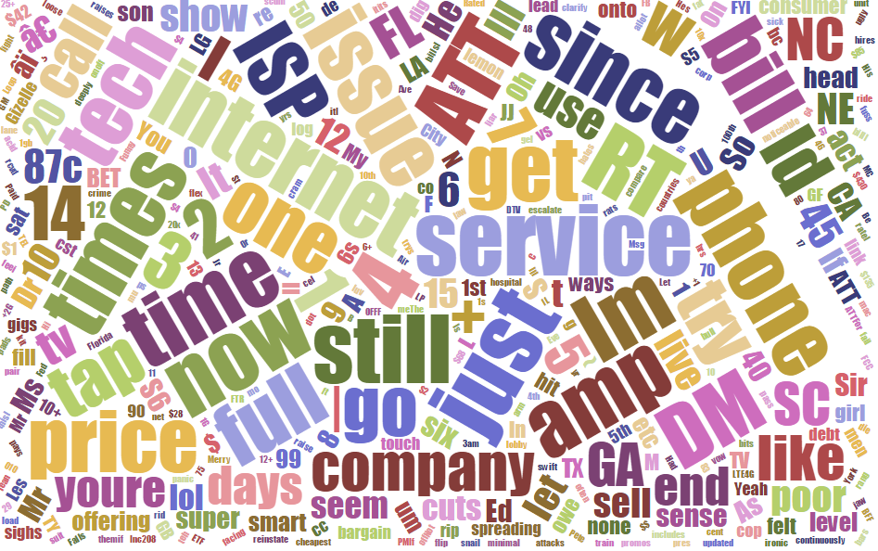

This, we believe to be the most crucial stage, lying at the heart of the application to derive sentiments through the use of API and Hive processing. Capturing sentiment scores from reviews and rendering a relational database-like appearance through HQL, it should be able to provide answers to most social media presence related issues. We did the sentiment analysis processing for each platform through a different python script, since there is difference in the way each platforms gives review related data.

The key factors for analyzing the sentiment was mainly the text of the review, along with geolocation of the user. Individual words and short sequences of words (n-grams) and comparing them with a probability model. It can also detect negations in phrases, i.e, the phrase "not bad" will be classified as positive despite having two individual words with a negative sentiment.  
  
AlchemyAPI's sentiment analysis algorithm looks for words that carry a positive or negative connotation then figures out which person, place or thing they are referring to. It also understands negations (i.e. "this car is good" vs. "this car is not good") and modifiers (i.e. "this car is good" vs. "this car is really good").

Sentiment Analysis Example for some tokens found in review :

|  |  |  |
| --- | --- | --- |
| Analyzed Item | Target | Sentiment |
| AT &T | Entity | Mixed |
| Quick Service | Keyword | Positive |
| Slow Response | Keyword | Negative |
| ATT Cares | Entity | Positive |
| Happy Customer | Keyword | Positive |
| Customer love | Keyword | Positive |
| Bad Service | Keyword | Negative |

**MileStone # 2 - Second part for framework for second round**

Key factors outside of social media that can affect customer sentiment and rate them based on influence/ effect on customer sentiment

Launch date of products

|  |  |
| --- | --- |
| Product | Date |
| Uverse | Launched in 2007 around Dallas (originally June 06 in SanAntonio) mid-2012, U-verse TV had 4.1 million customers, U-verse Voice 2.6 million, and U-Verse High Speed Internet 6.5 million. |
| Directv | Originally launched in 1994. Taken over by ATT in 2015. As of the quarter (Q3) ended September 30, 2012, DirecTV U.S. had 19.981 million subscribers |
| ATT Fiber | Launched in 2014 in Dallas |

Derived columns, definition and examples

|  |  |
| --- | --- |
| Derived Column Name | Definition |
| Effective Novelty | Calculated as (Prod_Age-Rev_Age)/Prod_Age |
| Customer Tendency | If(score[4,5] ->0,8,score[0,1] ->0,8) for Google,Yelp, Twitter respectively |
| Source Credibility | Yelp > Google > Twitter 3>2>1 |
| Source Perception Index | How much customers value this source Google=Twitter > Yelp -2>1 |

4.5 Methodology

**Architecture**

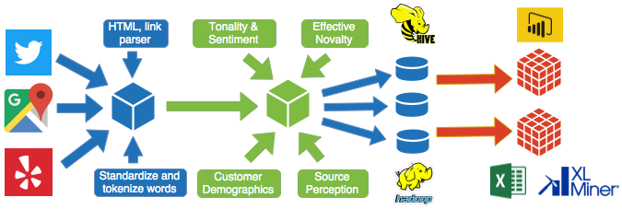

# Above diagram shows the architecture foe the big data pipeline.

Data Ingestion

The Data collection, sentiment analysis and external factors have been aforementioned under Milestone 1 & 2. After the products and services features have been extracted using the features transformation. Sentiment Analysis will be calculated using APIs.

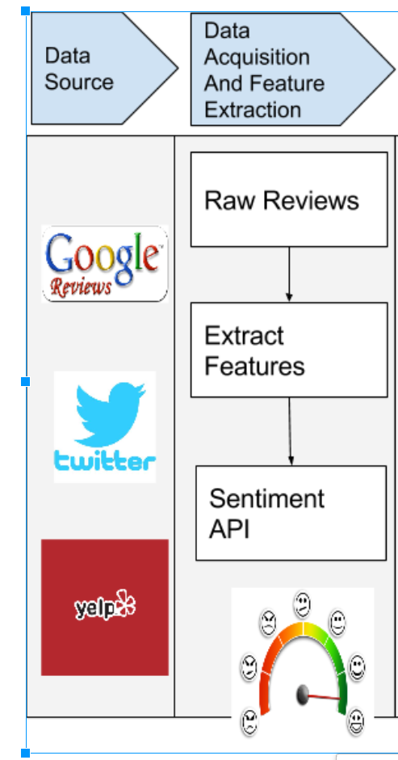

Data Transformation and Processing

During transformation additional derived columns will be added to account for the external factors for the social media sentiments.

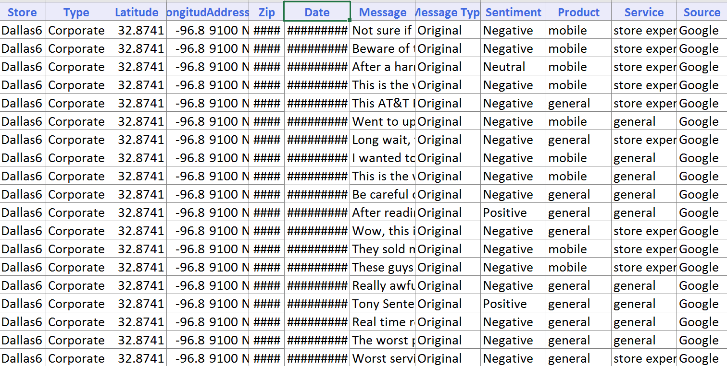

# The above image shows the sample data snippet using the data collection and feature transformation for product and services.

# 

# The above image shows the snippet of derived columns using external factors which affect customer satisfaction and sentiment analysis.

# 5. Data exploration

# 

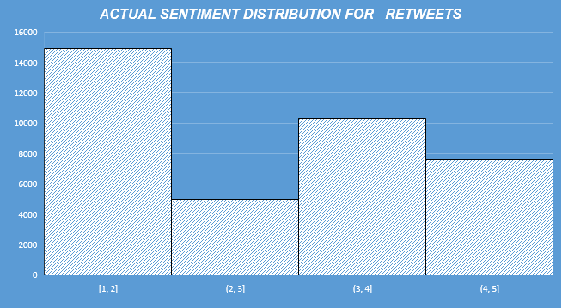

# 

# 

# 6. Data warehousing

One of the biggest challenges in this project has been data consolidation. We figured a better way enabling dynamicity and operational flexibility (treating this to be a real-world project, which it is) would be through a data-warehouse. A dedicated ETL layer, built with a future vision would be an added advantage over an ad-hoc database solution.

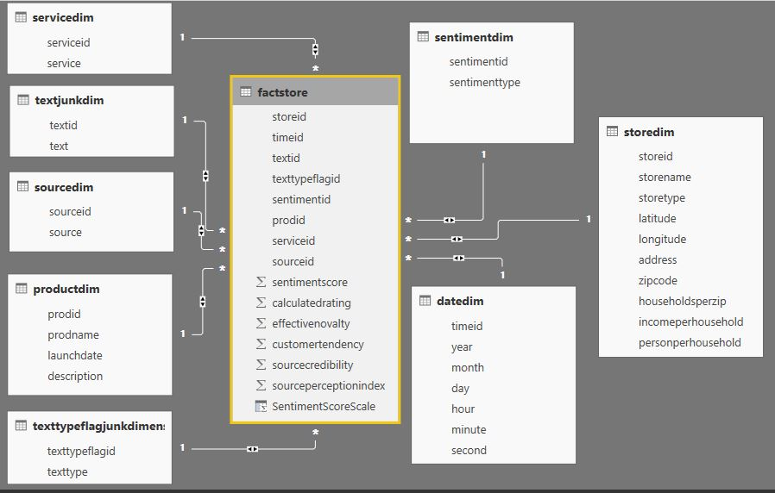

**Figure - Data model for Big Data Warehouse**

**HIVE queries used to create the above mentioned data warehouse in Hive**

**SOCIALMEDIA – CSV**

create table SocialMedia (StoreName string, StoreType string, Latitude string, Longitude string, Address string, Zipcode string, CreatedAt string, Text string, TextType string, SentimentType string, SentimentScore string, Product string, Service string, CalculatedRating int, Source string, EffectiveNovalty string, HouseholdsPerZip string, IncomePerHousehold string, PersonPerHousehold string, CustomerTendency string, SourceCredibility string, SourcePerceptionIndex string)

ROW FORMAT DELIMITED

FIELDS TERMINATED BY '\t'

LINES TERMINATED BY '\n'

STORED AS TEXTFILE;

load data local inpath '/socialmedia.csv' overwrite into table social media;

**PRODUCTS – CSV**

create table products (ProdName string, LaunchDate string, Description string)

ROW FORMAT DELIMITED

FIELDS TERMINATED BY '\t'

LINES TERMINATED BY '\n'

STORED AS TEXTFILE;

load data local inpath '/products.csv' overwrite into table products;

**DEMOGRAPHICS – CSV**

Create table Demographics (ZipCode string, CurrentPopulation string, Population2010 string, HouseholdsPerZIP string, AverageHouseValue string, AverageIncomePerHousehold string, PersonsPerHousehold string, WhitePopulation string, BlackPopulation string, HispanicPopulation string, AsianPopulation string, AmericanIndianPopulation string, HawaiianPopulation string, OtherPopulation string, MalePopulation string, FemalePopulation string, MedianAge string, MaleMedianAge string, FemaleMedianAge string)

ROW FORMAT DELIMITED

FIELDS TERMINATED BY '\t'

LINES TERMINATED BY '\n'

STORED AS TEXTFILE;

load data local inpath '/demographics.csv' overwrite into table demographics;

**STORE DIMENSION**

create table StoreDim (StoreID int, StoreName string, StoreType string, Latitude string, Longitude string, Address string, Zipcode string, HouseholdsPerZip string, IncomePerHousehold string, PersonPerHousehold string)

ROW FORMAT DELIMITED

FIELDS TERMINATED BY '\t'

LINES TERMINATED BY '\n'

STORED AS TEXTFILE;

insert into StoreDim select distinct rank() over (order by StoreName asc) as StoreID, StoreName, StoreType, Latitude, Longitude, Address, Zipcode, HouseholdsPerZip, IncomePerHousehold, PersonPerHousehold from socialmedia;

**PRODUCT DIMENSION**

create table ProductDim (ProdID int, ProdName string, LaunchDate string, Description string)

ROW FORMAT DELIMITED

FIELDS TERMINATED BY '\t'

LINES TERMINATED BY '\n'

STORED AS TEXTFILE;

insert into productdim select distinct rank() over (order by ProdName asc) as ProdID, ProdName, LaunchDate, Description from products;

**SERVICE DIMENSION**

create table ServiceDim (ServiceID int, Service string)

ROW FORMAT DELIMITED

FIELDS TERMINATED BY '\t'

LINES TERMINATED BY '\n'

STORED AS TEXTFILE;

insert into servicedim select distinct rank() over (order by Service asc) as ServiceID, Service from socialmedia;

insert into texttypeflagjunkdimension select distinct rank() over (order by TextType asc) as TextTypeFlagID, TextType from socialmedia;

**STORE FACT:**

create table FactStore (StoreId int, TimeId int, TextID int, TextTypeFlagID int, SentimentID int, ProdID int, ServiceID int, SourceID int, SentimentScore float, CalculatedRating float, EffectiveNovalty float, CustomerTendency float, SourceCredibility float, SourcePerceptionIndex float)

ROW FORMAT DELIMITED

FIELDS TERMINATED BY '\t'

LINES TERMINATED BY '\n'

STORED AS TEXTFILE;

insert into FactStore

select st.storeid as StoreId,

d.timeid as TimeId,

td.textid as TextID,

ttf.TextTypeFlagID as TextTypeFlagID,

snd.sentimentid as SentimentID,

pd.prodid as ProdID,

srd.serviceid as ServiceID,

sod.sourceid as SourceID,

m.SentimentScore as SentimentScore,

m.rating as CalculatedRating,

m.EffectiveNovalty as EffectiveNovalty,

m.CustomerTendency as CustomerTendency,

m.SourceCredibility as SourceCredibility,

m.SourcePerceptionIndex as SourcePerceptionIndex

from socialmedia m inner join

storedim st on m.storename=st.storename inner join

datedim d on unix_timestamp(concat(d.year, '-', d.month, '-', d.day, ' ', d.hour, ':', d.minute, ':', d.second))=unix_timestamp(concat(substr(m.createdat,1,4), '-', substr(m.createdat,6,2), '-', substr(m.createdat,9,2), ' ', split(split(m.createdat,’ ’)[1],’:’)[0], ':', split(split(m.createdat,’ ’)[1],’:’)[1], ':', split(split(m.createdat,’ ’)[1],’:’)[2])) inner join

textjunkdim td on m.text=td.text inner join

texttypeflagjunkdimension ttf on m.texttype=ttf.texttype inner join

sentimentdim snd on m.SentimentType=snd.SentimentType inner join

productdim pd on m.Product=pd.ProdName inner join

servicedim srd on m.Service=srd.Service inner join

sourcedim sod on m.Source=sod.Source;

# 7. Results

**Milestone # 3 – Visuals leveraging the data warehouse to gain actionable insights**

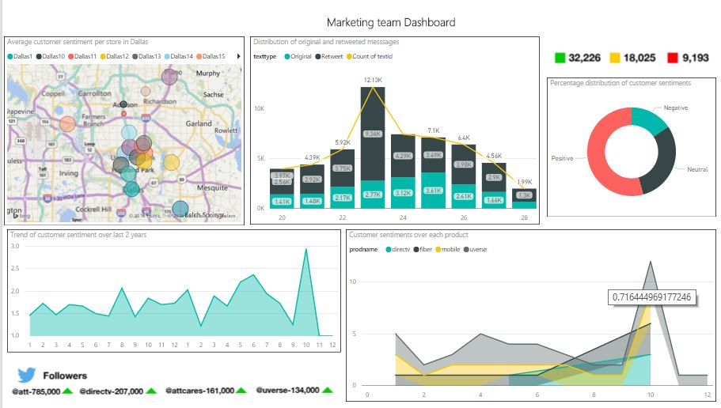

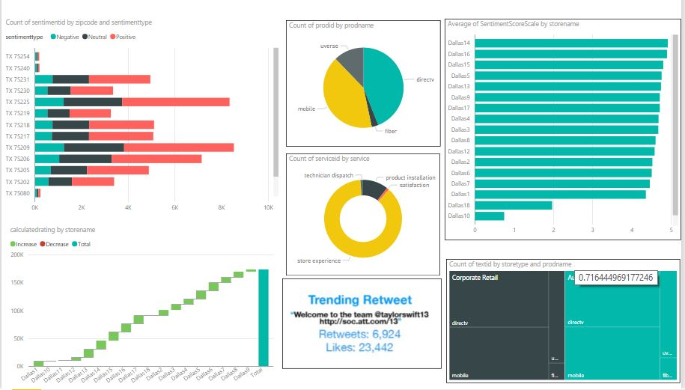

8. Conclusion and Recommendations

**Milestone # 4 – Recommendations for AT&T to improve customer service**

* Ensure correct sampling rate

Having the right sample for the products and services should be a priority. AT&T has improved its customer satisfaction using ATT cares account on twitters. But, there can be chances on significant improvement by considering the yelp reviews as well for its products and services.

* Complex customer reviews that talk about two different products

This is a follow-up based on the aforementioned importance of Yelp. The reviews are very detailed for products listed on yelp. AT&T should leverage the sentiment analysis done and continuously monitor the sentiment to improve the customer service

* Different languages like Spanish, Chinese and Japanese in tweets

Spanish language was widely used in tweets. Having multilingual support while processing text will go a long way in accommodating the sentiments of reviews from different languages. This somehow ties with the demographic factor effecting the sentiment.

* Customer Satisfaction Management System

A smart system to detect the hikes and spikes in the sentiment. So, that special care can be done on the top of customer care that is being done. A message can be sent to customer care executive’s inbox for responding to the customers in a timely manner.