**MLP/BP: A worked example**

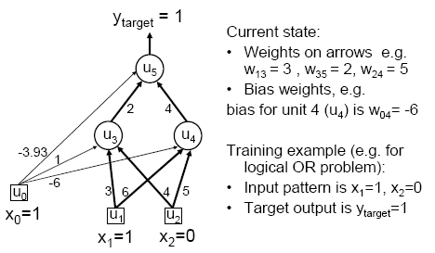

**Worked example: Forward Pass**

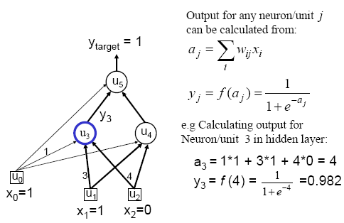



**Worked example: Backward Pass**

**Worked example: Update Weights Using Generalized Delta Rule (BP)**



**Similarly for the all weights wij:**

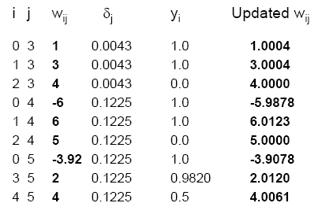

**Verification that it works**

