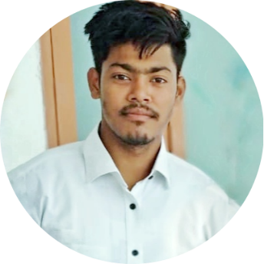

[www.github.com/spsyco](https://github.com/spsyco)

[www.linkedin.com/in/spsyco](https://www.linkedin.com/in/spsyco/)

salman0786.nav@gmail.com

D-98, Bawana, New Delhi-110039

+917827015254

**Salman**

**EDUCATION**

[spsyco.blogspot.com](https://spsyco.blogspot.com/)

INFOMATION TECHNOLOGY · STUDENT

**Wordpress Developer (Freelancer)**

**PROJECTS (GitHub)**

**CERTIFICATIONS**

**TRAININGS**

**OBJECTIVE**

I seek challenging opportunities where I can fully use my skills for the success of the organization.

**GBSS School Bawana**

**XII (76.4%)**

**Sathyabama University**

**BTECH (8.91 CGPA)**

**2017 - 2021**

**2015 - 2016**

**2013 - 2014**

**GBSS School Bawana**

**XII (7.0 CGPA)**

**Data Science With Python | Jan 2020**

**Edufabrica Pvt Ltd**

The Five Days Winter Camp focuses on covering basic to intermediate levels of respective technologies that are part of the training program. after that they provided Certication 1. MTA 2. Edufabrica

**Python Programming With AI | Dec 2018**

**What After College**

The Five Days Winter Camp focuses on covering basic to intermediate levels of respective technologies that are part of the training program after that they provided 1. MTA 2. WAC Certication

**SKILLS**

**EXPERIENCE**

**Profit Pay Management LLC | 2018 -2019**

* Worked for the Company PPM LLC for creating and designing the stylish and cool website.
* Collected and responded to user feedback through iterative improvements to site structure and content.

**SCHOLARSHIPS**

* 2017 Anbu Foundation Scholarship, SIST Chennai
* 2009 Best Student Scholarship, NIF Bawana
* 2008 Merit Student scholarship, M.C.D Pre Boys School
* 2007 Merit Student scholarship, M.C.D Pre Boys School
* Personal Assistant
* Home Prices Prediction
* Movie Recommender
* Customer Leave the Bank
* [Microsoft Technology Associate: Introduction to](http://verify.certiport.com/SQXq-uSHL) [Programming using Python](http://verify.certiport.com/SQXq-uSHL)
* [Applied Data Science with Python](https://www.coursera.org/account/accomplishments/specialization/certificate/B6QVWK22FA8U)
* [Google IT Automation with Python](https://www.coursera.org/account/accomplishments/specialization/certificate/SYVC3ZMHZDYD)
* [Introduction to Data Studio](https://analytics.google.com/analytics/academy/certificate/gOpTlwalSRyGg_NyWZ-juQ)

**AWARDS and ACHEIVEMENTS**

* Best Student Awards by NIF
* Internal Smart India Hackathon
* [Earners of the Microsoft Technology Associate(MTA)](https://www.youracclaim.com/users/mr-salman.af05a575/badges)

**HOBBIES**

Debugger

Cloud Services

Automation

Wordpress

Data Science