
- Call for Participation -
- 14th International Conference on Information Security Practice and Experience -
Tokyo, Japan | 25-27 Sep, 2018
Contact: ispec2018-info@ml.cc.tsukuba.ac.jp

The 14th International Conference on Information Security Practice and Experience (ISPEC 2018) will be held in Tokyo in September 2018. The ISPEC conference is an established forum that brings together researchers and practitioners to provide a confluence of new information security technologies, including their applications and their integration with IT systems in various vertical sectors.

Invited Talks
Professor CHOW Sherman  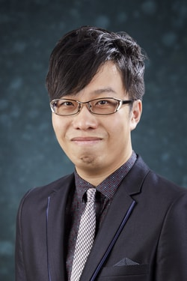  The Chinese University of Hong Kong  Title: Password-Hardening Services | Professor Robert Deng    Singapore Management University  Title: A User Centric and Layered Approach to Mobile Security | Professor Shin’ichiro Matsuo  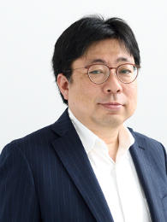  Georgetown University  Title: Era of Elusiveness in Security and Privacy
Professor Kui Ren    Zhejiang University  Title: Attributing Pictures to Smartphones via Camera Fingerprinting | Professor Mark Ryan    University of Birmingham  Title: Security of machine learning









Registration Free：
Registration Fee (in Japanese Yen) | [Early] By 6 August 2018 (23:59 JST) | [Late] After 6 August 2018 (23:59 JST)
Full Registration | 65,000 yen | 80,000 yen
Student Registration | 65,000 yen | 65,000 yen

Conference Organization:
Honored Chair
Eiji Okamoto, University of Tsukuba, Japan

General Co-Chairs
Kazumasa Omote, University of Tsukuba, Japan
Jiageng Chen, Central China Normal University, China

Program Co-Chairs
Chunhua Su, University of Aizu, Japan
Hiroaki Kikuchi, Meiji University, Japan

Conference Venue:
ISPEC 2018 will be held at Tokyo Campus, University of Tsukuba, Myogadani St., Tokyo. Tokyo Campus of University of Tsukuba is located near Myogadani Station of Tokyo Metro Marunouchi Line.

Sponsored by:
Hitachi, Ltd.
Mitsubishi Electric Corporation
TOSHIBA Corporation
Huawei Technologies Co., Ltd.
ANDISEC, Ltd.

Supported by:
ISEC of IEICE, Japan
CSEC of IPSJ (Special Interest Group on Computer Security of Information Processing Society of Japan)

