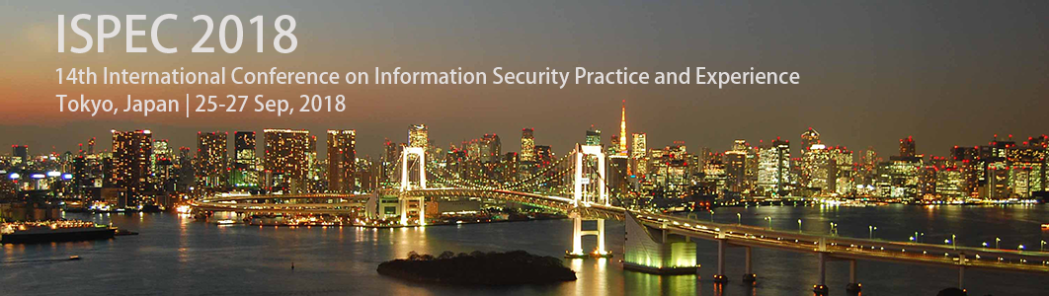

**- Call for Participation -**

**- 14th International Conference on Information Security Practice and Experience -**

**Tokyo, Japan | 25-27 Sep, 2018**

Contact: ispec2018-info@ml.cc.tsukuba.ac.jp

**The 14th International Conference on Information Security Practice and Experience** (ISPEC 2018) will be held in Tokyo in September 2018. The **ISPEC** conference is an established forum that brings together researchers and practitioners to provide a confluence of new information security technologies, including their applications and their integration with IT systems in various vertical sectors.

**Invited Talks**

|  |  |  |
| --- | --- | --- |
| Professor CHOW Sherman  http://www.risk.tsukuba.ac.jp/ispec2018/img/ShermanChow.jpg  The Chinese University of Hong Kong  Title: Password-Hardening Services | Professor Robert Deng    Singapore Management University  Title: A User Centric and Layered Approach to Mobile Security | Professor Shin’ichiro Matsuo    Georgetown University  Title: Era of Elusiveness in Security and Privacy |
| Professor Kui Ren    Zhejiang University  Title: Attributing Pictures to Smartphones via Camera Fingerprinting | Professor Mark Ryan    University of Birmingham  Title: Security of machine learning |  |

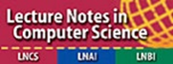



 

**Registration Free：**

|  |  |  |
| --- | --- | --- |
| **Registration Fee (in Japanese Yen)** | **[Early] By 6 August 2018 (23:59 JST)** | **[Late] After 6 August 2018 (23:59 JST)** |
| Full Registration | 65,000 yen | 80,000 yen |
| Student Registration | 65,000 yen | 65,000 yen |

**Conference Organization:**

**Honored Chair**

Eiji Okamoto, University of Tsukuba, Japan

**General Co-Chairs**

Kazumasa Omote, University of Tsukuba, Japan

Jiageng Chen, Central China Normal University, China

**Program Co-Chairs**

Chunhua Su, University of Aizu, Japan

Hiroaki Kikuchi, Meiji University, Japan

**Conference Venue:**

ISPEC 2018 will be held at Tokyo Campus, University of Tsukuba, Myogadani St., Tokyo. Tokyo Campus of University of Tsukuba is located near Myogadani Station of Tokyo Metro Marunouchi Line.

**Sponsored by:**

Hitachi, Ltd.

Mitsubishi Electric Corporation

TOSHIBA Corporation

Huawei Technologies Co., Ltd.

ANDISEC, Ltd.

**Supported by:**

ISEC of IEICE, Japan

CSEC of IPSJ (Special Interest Group on Computer Security of Information Processing Society of Japan)