***Name: Ngô Việt Tùng - ICT01-K63***

***ID: 20184326***

**Assignment 8.1:**

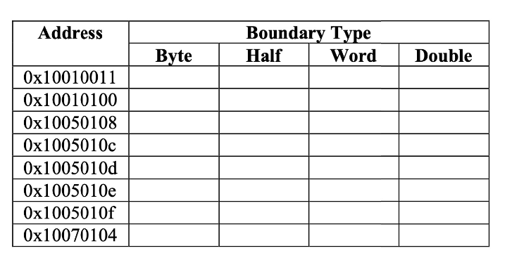

**Assignment 8.2:**

**Why do "la label" instructions always need to be translated into 2 lines of pseudo code?**

Answer: Because ***la*** instruction load the address, and the address is big 32-bit number, then it should be separate into 2 parts of 16 bit

Example:



The first pseudo code is load upper immediate (16-bit upper), and the second is load 16-bit lower.

**What about "lw label" instructions?**

That is pseudo instruction, and it also divided into 2 instruction:



**Explain the similarities and differences in how they are implemented in MARS:**

* la label contain 2 pseudo code to load 2 part : 16bit upper and lower
* lw label contain 1 pseudo code to allow the address of label to be stored, and a real operator to load the value.

**Assignment 8.3:**

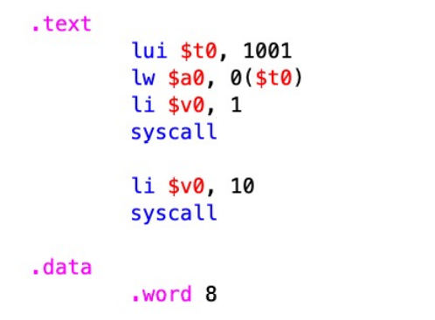

**-**Because 1001 here is decimal number , when it convert to hexa-decimal it is: 0x 03e9 , and load to $t0, then address of $t0 is 0x03e90000

This address is not in range of static data( from 0x10010000 – 0x10040000)

* Error.