**Rubric – CLC Mini-Project**

|  |  |  |
| --- | --- | --- |
| **Category** | **Comments** | **Score** |
| Explanation of the team’s solution to questions or challenges posed by mini-project. |  | /10% |
| Diagram, flowchart, or pseudo code . |  | /10% |
| Team and individual responsibilities are clearly articulated. |  | /10% |
| List of Java EE concepts, tools, and techniques used in this mini-project. |  | /10% |
| Correct use of English language and grammar in all project components. |  | /10% |
| Code submission to remote repository. |  | /10% |
| Code runs correctly and matches your flowchart/diagram. |  | /20% |
| Code Readability/Organization. |  | /10% |
| Specific requirements applying to this specific mini-project are implemented (i.e., Use of particular Java EE constructs, processes). |  | /10% |
| **TOTAL** |  | /100% |

Caleb Miller

20171112

CST-235

CLC Mini Project

**Question 1**

How can configuration settings of a bean be made persistent? Provide code examples. Substantiate your answer with code examples and screenshots of execution. Seek instructor guidance as needed.

**Answer 1**

The configuration setting can be made persistent by adding their components to a XML file. The IDE reads the file and writes the data for being a persistent file before reading it back with the needed persistence.

**Question 2**

What is the JavaBeans API? Provide a code example for its use. Substantiate your answer with code examples and screenshots of execution. Seek instructor guidance as needed.

**Answer 2**

The JavaBeans API and its implementation are contained in the java.beans package. In this package, most of the classes are meant to be used by a bean editor, a development environment for customizing and putting together beans to create an application.

References

OpenJDK. 2017. The JavaBeans API. Retrieved from http://openjdk.java.net/groups/swing/beans/index.html

**Screenshots**

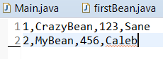

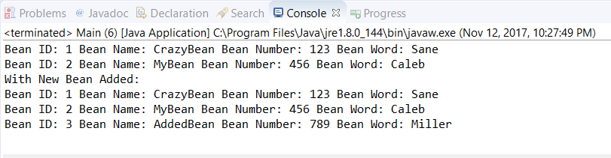

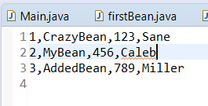

**Flow Chart for Persistence**

File

firstBean

fileReader

Main.java

Methods

**Flow Chart for JavaBeans API**

Event

Naming Method

Constructor

Methods

Event Listener

Bean Class

Main.java