**Rubric – CLC Mini-Project**

|  |  |  |
| --- | --- | --- |
| **Category** | **Comments** | **Score** |
| Explanation of the team’s solution to questions or challenges posed by mini-project. |  | /10% |
| Diagram, flowchart, or pseudo code . |  | /10% |
| Team and individual responsibilities are clearly articulated. |  | /10% |
| List of Java EE concepts, tools, and techniques used in this mini-project. |  | /10% |
| Correct use of English language and grammar in all project components. |  | /10% |
| Code submission to remote repository. |  | /10% |
| Code runs correctly and matches your flowchart/diagram. |  | /20% |
| Code Readability/Organization. |  | /10% |
| Specific requirements applying to this specific mini-project are implemented (i.e., Use of particular Java EE constructs, processes). |  | /10% |
| **TOTAL** |  | /100% |

Caleb Miller

20171203

CST-235

CLC Mini-Project

**Question 1**

What is the difference between JSF servlets and JSF applications? Explain using code examples. Substantiate your answer with code examples and screenshots of execution. Seek instructor guidance as needed.

JSF applications are dynamically generated webpages and are request driven where as the JSF servlets are code and predefined actions that talk between the server and client via web content. JSF servlets use HTML or XML files to communicate and connect with the java code.

**Question 2**

When and why would you need to configure JSF? Substantiate your answer with code examples and screenshots of execution. Seek instructor guidance as needed.

When accessing non-standard facets, library, and templates JSF needs to be configured. When adding extra features such as HTML or JavaScript, all that needs to be done is configuration.

**Files**

helloBean.java

DisBean.html

servlet.jsp

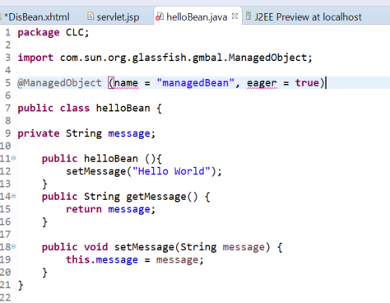

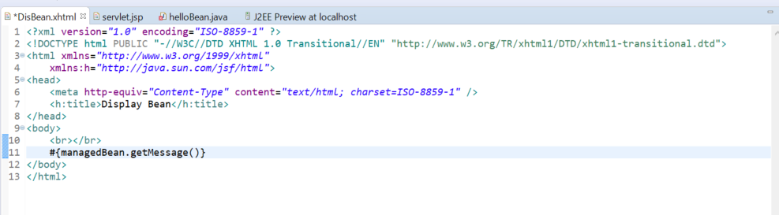

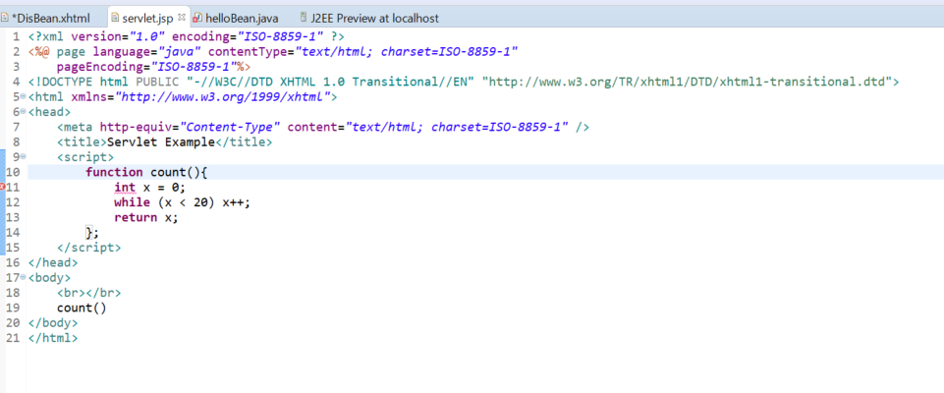

Not sure what is causing an error, maybe whatever is wrong with my @ManagedObject inside my bean, or the file path, but this is my result…

