Caleb Miller

20171112

CST-235

Short Assignment

To meet the requirement of the number of characters, number of words, and the sum of all numbers in a text document filled with information, I had to make a file reader (fileReader.java) which I found a form of one on Over Stack and modified it to fit my needs to find the above. The file (readThis.txt) is read by the fileReader and the output is printed out in the console. Then I made a JavaBean (theBean.java) to hold the getters and setters of the file reader. Finally, I made a Main.java to house my three System.out.println to achieve the following console output:

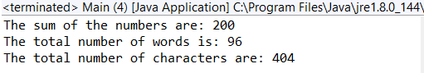

readThis.txt:

