Caleb Miller

20171119

CST-235

Short Assignment #3 JavaFX & EE

JavaFX is my favorite part about Java. In my JavaFX application, I used a BorderPane to display what we did in our other Short Assignment dealing with the size of a file given its length and resolution.

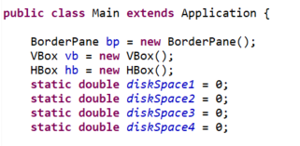

Inside this BorderPane I have a HBox and a VBox where a text field and a submit button is placed.

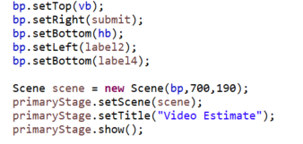

On top of the TextField I have a label1 to prompt the user what info needs to be submitted.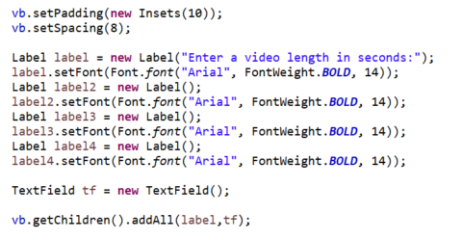

I have the JavaBean being accessed based on what the user inputs in the TextField.

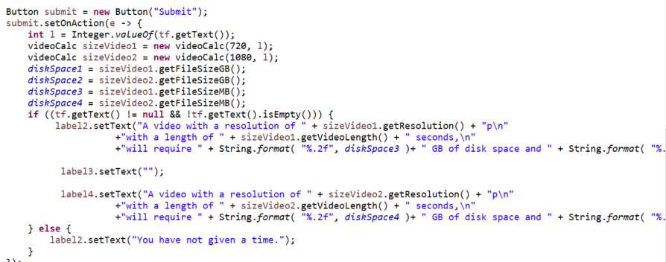

Endstate:

