**Interface naming scheme**

$$\underset{Immediate Assembly}{\underbrace{XX}}-\underset{Interface Number}{\underbrace{000}}-\underset{Interface Type}{\underbrace{XXX}}-\underset{Instances}{\underbrace{00}}$$

**Immediate Assembly**: Two-character abbreviation of the lowest-level assembly that the interface is within.

**Interface Number**: Three-digit number of the interface. Interfaces are numbered from left to right, top to bottom, and are numbered in increments of 10. Increments of 1 can be used a if a new interface is defined between two previously existing interfaces.

For example:

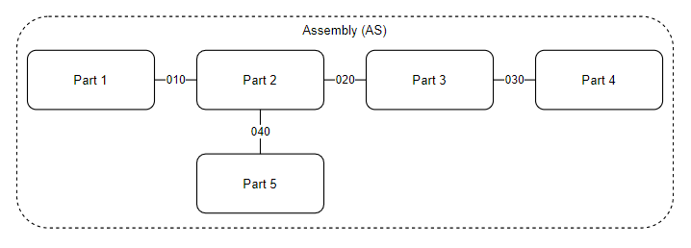

Note that the example would look like this if the interface between Parts 2 and 3 had not been defined until later in the design phase:

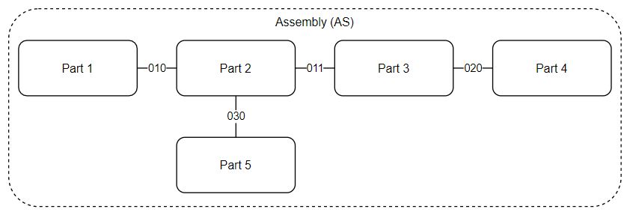

**Interface Type:** Three-character string that defines the type of interface.

$$\underset{Mechanical}{M} \underset{Electrical}{E} \underset{Software}{S}$$

If there is a mechanical component to the interface (ie. Bolt pattern, PCB footprint, etc), then the first character is an “M.” Otherwise, it is an “X”.

If there is an electrical component to the interface then the second character is an “E.” Otherwise, it is an “X”.

If there is a software component to the interface, then the third character is an “S.” Otherwise, it is an “X”.

**Instances** – Two-digit number which represents the number of identical interfaces. If there were 3 identical interfaces within the same assembly, then they can all have the same name, but that name should end with 03.