Fine-Tuning on Nebius Soperator
Scope: a reproducible, end-to-end proof of concept covering both exercises: multi-node training (Exercise 1) and base-vs-tuned inference comparison (Exercise 2).

Results at a glance
Model | Qwen3.6-35B-A3B (Mixture-of-Experts, 35B total / ~3B active)
Cluster | 2 nodes × 8 H200 on Nebius Soperator (Slurm on Kubernetes)
GPU utilization | 85-92% sustained across all 16 GPUs (target: >80%)
Training | full SFT, 3 epochs, completed in 51m33s, no out-of-memory errors
Tuned vs base | function-name accuracy 82→100%, arguments 76→94%, appropriate call/no-call 87→96%

Summary
This is a multi-node LLM fine-tuning workflow on Nebius Soperator (Slurm on Managed Kubernetes), built to show a PoC team how to train and serve a function-calling model on reserved GPU capacity. We fine-tuned Qwen3.6-35B-A3B (a 2026 open-weight Mixture-of-Experts (MoE) model: 256 experts, ~3B active of 35B, with hybrid Gated DeltaNet attention; already instruction-tuned) for function calling. Training used Megatron-SWIFT (ms-swift on a Megatron-Core backend) with full supervised fine-tuning and Expert Parallelism across 2 nodes × 8 H200 GPUs, the Qwen-team-recommended path for MoE that keeps GPUs busy where naive MoE training stalls at 10-20%. The data is the public hypervariance/function-calling-sharegpt corpus (~75k usable conversations) normalized through the tokenizer's chat template. The run completed in 51 minutes at 85-92% sustained GPU utilization (the assignment's >80% target), verified on the Nebius dashboard. We then served the base and fine-tuned models side-by-side with vLLM and evaluated them on a 23-case function-calling suite, where the fine-tuned model improved on every metric (detailed in Inference and Evaluation).

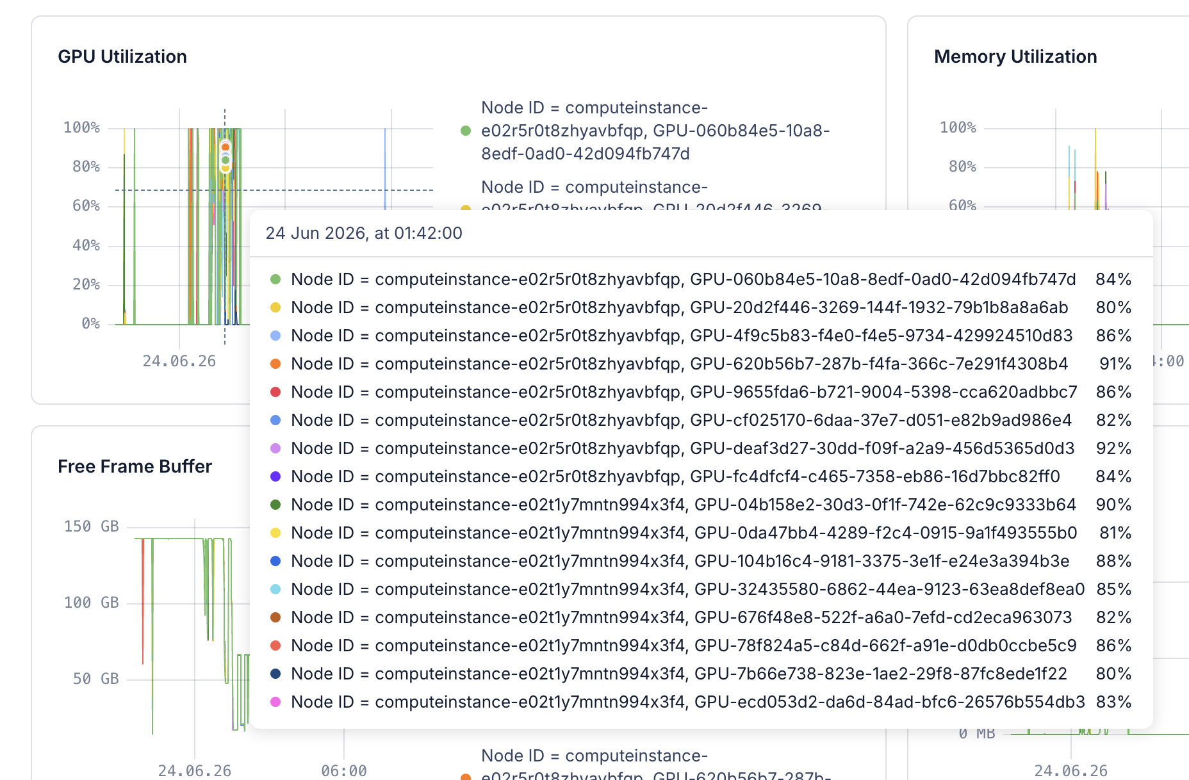

Background & Objective
The customer is a small (<20-person), VC-funded startup building process-automation products with AI agents, evaluating Nebius for a 512× H100, 6-month reservation and currently at the proof-of-concept stage. The PoC team is mostly ML engineers with limited cloud and infrastructure experience, so the example has to be reproducible and approachable rather than bespoke. The goal is an end-to-end, multi-node fine-tuning workflow for an open-source function-calling LLM on the allocated PoC capacity (2 nodes × 8 H200 GPUs, fabric eu-north2-a, shared SSD storage), using the GPUs efficiently (>80% utilization, verifiable on the Nebius console) and comparing the base and fine-tuned models. Scheduler, fine-tuning framework, storage, and dataset are left to the implementer; this report documents and justifies each of those choices.

Infrastructure
The cluster is provisioned with Terraform, forked from the official nebius-solution-library Soperator recipe. Soperator runs Slurm on top of Managed Kubernetes, so the team gets a familiar sbatch/squeue/sacct workflow without needing Kubernetes expertise while Nebius manages the control plane. The deployment is 2 worker nodes × 8 H200 (141 GB each) on the eu-north2-a InfiniBand fabric, with a single shared filesystem mounted at /data on every node holding code, the model, datasets, the container image, checkpoints, and logs. We keep everything on one shared filesystem rather than per-node local disk: every rank reads the same model weights and dataset and writes to one checkpoint path, and the container image is imported once and reused by both nodes without copying. The 1 TB SSD allocation holds the model (~67 GB), the image (~18 GB), and rolling checkpoints (~66 GB each, capped at two).
The container runtime is enroot via the Pyxis SPANK plugin (not Docker): jobs run with srun --container-image=..., and a single .sqsh image on the shared filesystem is reused by both nodes for a reproducible, drift-free environment. Before training we ran the built-in NCCL (NVIDIA Collective Communications Library) multi-node all-reduce check and measured ~475 GB/s bus bandwidth (target >300 GB/s), confirming the inter-node interconnect.

Model and Framework
Model: Qwen3.6-35B-A3B, a 2026 open-weight (Apache-2.0) Mixture-of-Experts model: 256 experts with top-8 routing (~3B active parameters of 35B total), 40 layers, and a hybrid attention stack that interleaves full attention with Gated DeltaNet (linear-attention) layers. It ships already instruction-tuned, so we do task-specialization rather than base alignment.
We chose MoE over a dense model partly out of necessity: no dense open-weight model above ~32B was released in 2026 (the field has moved to MoE), so a dense choice would have meant a year-old model (the newest comparable option, Qwen2.5-72B, is from 2024). MoE is also harder to train efficiently. Sparse top-k routing, expert load-balancing, and all-to-all expert communication are what make naive MoE training stall at 10-20% utilization, so keeping a sparse 35B MoE above 80% across two nodes is where most of the work went. That is the capability a customer reserving large GPU capacity needs to see on a current architecture rather than a legacy dense one.
Framework: Megatron-SWIFT (ms-swift on a Megatron-Core backend) with full supervised fine-tuning and Expert Parallelism. The Qwen team recommends it for MoE: it is roughly 10x faster than HuggingFace and DeepSpeed for MoE training and keeps GPU utilization high, where naive MoE training (e.g. DeepSpeed ZeRO-3 + LoRA) is reported to stall at 10-20% and has documented incompatibilities. We use full SFT rather than LoRA because LoRA on MoE with Expert Parallelism at this scale is undocumented and risks falling below the 80% utilization requirement; full SFT is the proven path to >80%.
Tool-call format. Qwen3.6 emits XML-style tool calls (<function=name><parameter=key>value</parameter></function>), so inference uses the vLLM qwen3_coder parser (not Hermes JSON). The tokenizer's apply_chat_template handles tool schemas and rendering; we never construct the XML by hand.

Dataset
The primary dataset is the public hypervariance/function-calling-sharegpt corpus (~87k examples, no access gate). It is in ShareGPT form (a single conversations column) with tool schemas embedded as free text in the system message, function calls wrapped in <functioncall> tags, and arguments that are sometimes double-stringified. A preparation script parses this inline: it extracts the JSON tool schemas, converts <functioncall> tags into structured tool_calls, handles the double-stringified arguments, maps roles, and drops unparseable examples (~75k survive). Every example is then rendered through tokenizer.apply_chat_template(..., enable_thinking=False) so the training signal matches what the model sees at inference, and split 96/4 into train/eval (a validation pass checks counts, JSON validity, and token statistics). With sequence packing to 8192 tokens, the ~75k short conversations compact into 4,558 train + 191 eval packed sequences (~8,131 tokens each). enable_thinking=False is kept throughout: it yields a simpler training signal, lower inference latency, and cleaner output for an automation integration.

Training
Training runs from the official ms-swift enroot image with tilelang baked in (see Engineering Challenges), invoked as megatron sft from a two-script pattern: an sbatch script sets MASTER_ADDR/NNODES, and an srun runner sets NODE_RANK per node (the separation avoids quoting issues and rank collisions).
The parallelism is pipeline=1, tensor=1, expert=8 (PP/TP/EP), which leaves a data-parallel size of 16. Expert Parallelism shards the 256 experts across 8 ranks; with no pipeline parallelism across nodes, both nodes run as full data-parallel replicas and stay busy (the only inter-node traffic is an overlappable gradient all-reduce plus the MoE all-to-all). The main configuration:
Setting | Value | Rationale
Parallelism | PP=1, TP=1, EP=8 (DP=16) | experts sharded within a node; no cross-node pipeline bubbles
Batch | micro 2, global 32 | enough compute per step to keep utilization >80%
Sequence | packing on, length 8192 | packs short conversations into full windows
Memory | full activation recompute, bf16 | fits the model + optimizer in 143 GB
Attention | flash | throughput
Optimization | lr 5e-6, cosine, 3 epochs | conservative for an already instruction-tuned model
Checkpoint | save_safetensors | written as a complete HuggingFace directory
We enable the MoE fusions (grouped_gemm, permute_fusion, shared_expert_overlap) for throughput. Because save_safetensors writes a standard HuggingFace checkpoint, serving needs no Megatron→HF export step.
The verified run completed in 51m33s, 426 steps, loss 0.20 → 0.13, eval loss 0.196, peak memory 113 / 143 GB per GPU (no out-of-memory errors). The final checkpoint (66 GB of safetensors) is directly loadable by vLLM.

GPU Utilization
The assignment's key metric is DCGM_FI_DEV_GPU_UTIL (from NVIDIA's Data Center GPU Manager): the fraction of time the GPU executes kernels. We sustained 85-92% across all 16 H200 GPUs (mean ≈ 85%) during steady-state training, above the >80% target. We measured utilization two ways that agree: live from the cluster with an overlapping step on the job's own allocation (srun --jobid=N --overlap ... nvidia-smi), and on the Nebius console dashboard (GPU-metrics view). A representative single sample of all 16 GPUs (8 per node) during steady-state training illustrates the balance:
node 0: 84 80 86 91 86 82 92 84
node 1: 90 81 88 85 82 86 80 83 (mean 85%)
Reaching this took two changes from the initial design. First, switching from pipeline parallelism (PP=2), which idled GPUs with cross-node pipeline bubbles (alternating 0%/100%, averaging ~73% or worse), to data-parallel PP=1 so both nodes compute continuously. Second, raising micro_batch_size from 1 to 2 so each GPU does enough compute per optimizer step to amortize the all-reduce and MoE all-to-all communication, which lifted utilization from 73% to 85%.

Inference and Evaluation
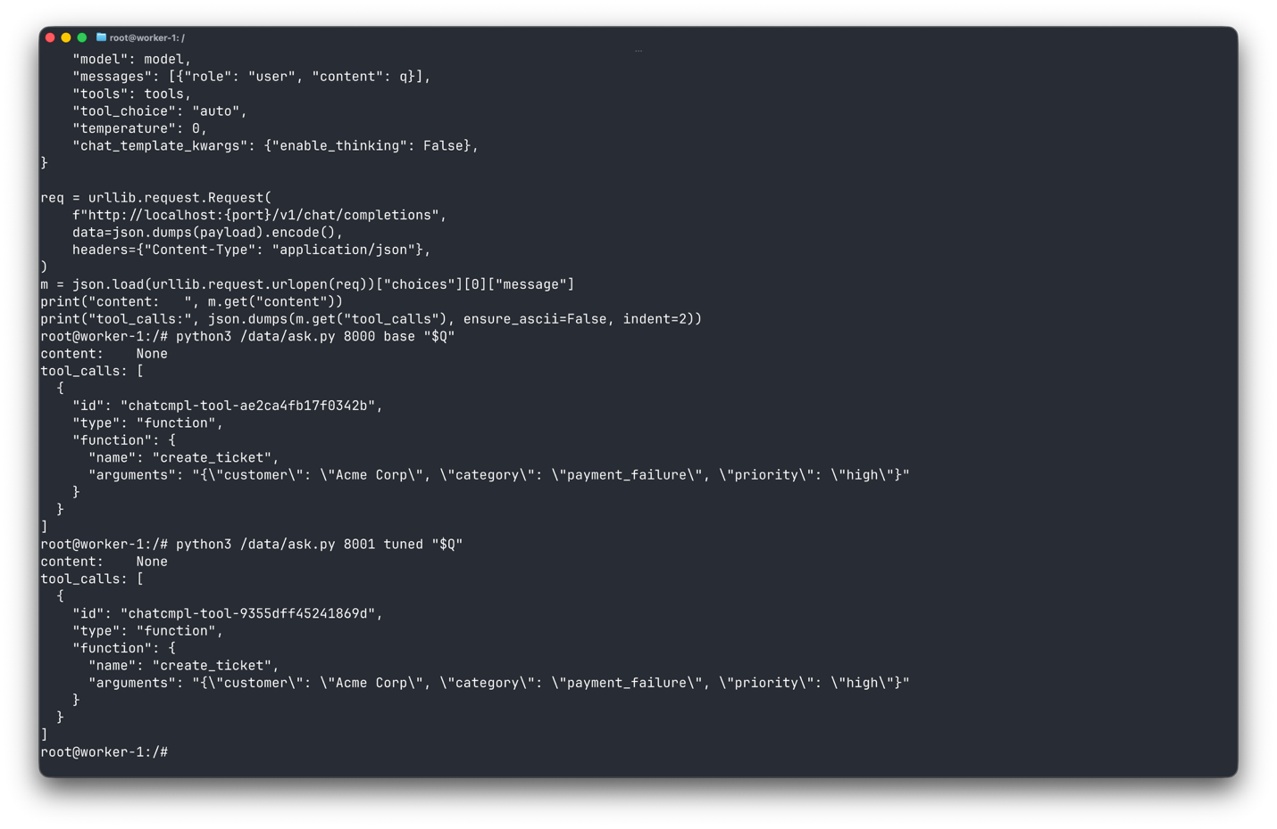
Both models are served with vLLM 0.23.0 (from the same image) at tensor-parallel size 2: 35B in bf16 (~70 GB) fits on 2 H200s, and TP=8 would only add communication overhead. A smoke test first confirmed that vLLM loads the hybrid Gated DeltaNet architecture and emits a parsed tool call via --tool-call-parser qwen3_coder. Both models run with thinking disabled (chat_template_kwargs={"enable_thinking": false} per request) to match training, so the two are compared under identical settings.
A comparison job stands up base (:8000) and tuned (:8001) on one node and runs a harness that sends the same 23 hand-written prompts to each model at temperature 0 (so the comparison is deterministic and reproducible), across six categories (single-tool, multi-argument, should-clarify, no-tool-needed, process-automation, ambiguous). It parses the returned tool calls and scores them, including executability against mock tool implementations. The fine-tuned model improves on every aggregate metric:
Metric | Base | Tuned | Δ
Appropriate call / no-call | 87.0% | 95.7% | +8.7
Function-name accuracy (call cases) | 82.4% | 100.0% | +17.6
Argument exact-match (call cases) | 76.5% | 94.1% | +17.6
Executable against mock tools | 65.2% | 78.3% | +13.1
Here appropriate counts the model correct when it calls a tool exactly when one is warranted and declines otherwise; call cases are the prompts where a tool call was expected; and executable means the predicted call runs against a mock implementation without error. Broken down by category (appropriate call/no-call rate), the gains concentrate where the base model was weakest, with no regressions except clarify:
Category | n | Base | Tuned
ambiguous | 2 | 0% | 100%
single_tool | 6 | 83% | 100%
multi_arg | 5 | 100% | 100%
no_tool | 3 | 100% | 100%
process_automation | 4 | 100% | 100%
clarify | 3 | 100% | 67%
The fine-tuned model now reliably translates ("good morning" → Japanese), resolves ambiguous asks (get_stock_price(TSLA); set_reminder instead of get_weather), and fills multi-argument process-automation calls (tickets, refunds, VM provisioning) correctly. The one regression is clarify (100% → 67%): function-calling SFT makes the model more eager to call a tool rather than ask for a missing argument. This is expected; the fix is to add more negative and clarification examples to the data mix.

Engineering Challenges
Several non-obvious issues each needed a real fix rather than a runtime patch:
- ms-swift 4.x [megatron] is not on PyPI. Every pip/uv install backtracked forever or pulled an incompatible torch (No module named 'torch.multiprocessing'). Fix: use the official ms-swift Docker image via enroot; it ships a consistent torch 2.11 / TransformerEngine / flash-attn / megatron-core / vLLM stack.
- Qwen3.6's Gated DeltaNet crashes on the first backward on Hopper. Its fla Triton kernel is numerically wrong on Triton ≥ 3.4 (the image has 3.6), so it hard-requires the tilelang backend. Fix: bake tilelang==0.1.9 into a derived image, pinned to the image's apache-tvm-ffi 0.1.9 (shared with vLLM) so nothing upgrades and FFI types don't double-register.
- Pipeline parallelism idled GPUs, and batch divisibility: with PP=1, the data parallel size is 16 (EP is orthogonal), so global_batch must be a multiple of micro_batch × 16, so micro_batch=2 ⇒ global_batch=32.
- vLLM 0.23.0 has no --chat-template-kwargs CLI flag (servers exit at arg-parse); thinking is disabled per request in the body instead.

Deliverables
The customer receives a self-contained repository:
- terraform/: the cluster definition (a forked Soperator recipe) to stand up an identical 2-node H200 environment.
- training/: the dataset pipeline (download, parse, validate) and the Slurm jobs for the one-time environment build and the multi-node training run.
- inference/: vLLM serving scripts for the base and tuned models, plus a small command-line client for ad-hoc tool-call queries.
- eval/: the 23-case test suite, mock tools, the comparison harness, and the saved results.

