TUTORIAL FILE

Following are the steps to run the software package:

1. Open MobaXterm and go to the folder containing the software codes using the command cd as shown below. QB is the main folder



1. Use the command make all to compile the program as shown below.

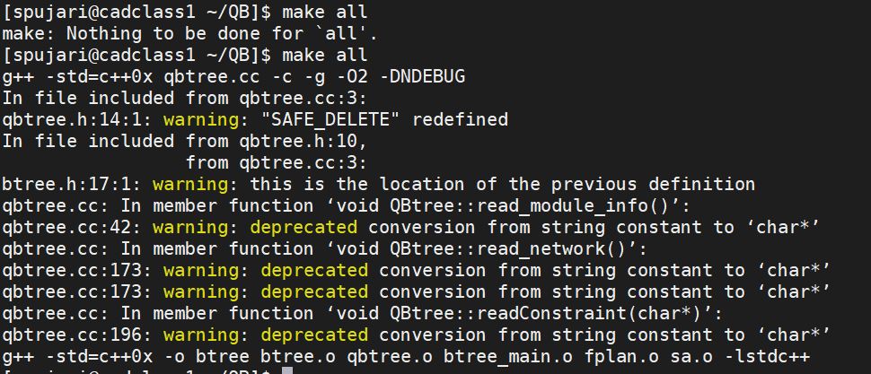

1. Run the program using the command “./btree (input file)”. We have two input files namely, apte and ami33.

An “apte” input file is given as parameter in the following image.



An “ami33” input file is given as parameter in the following image.



Following shows the output after the command given above for “apte” input file is executed. Output for “ami33” input file can be displayed in the similar way.

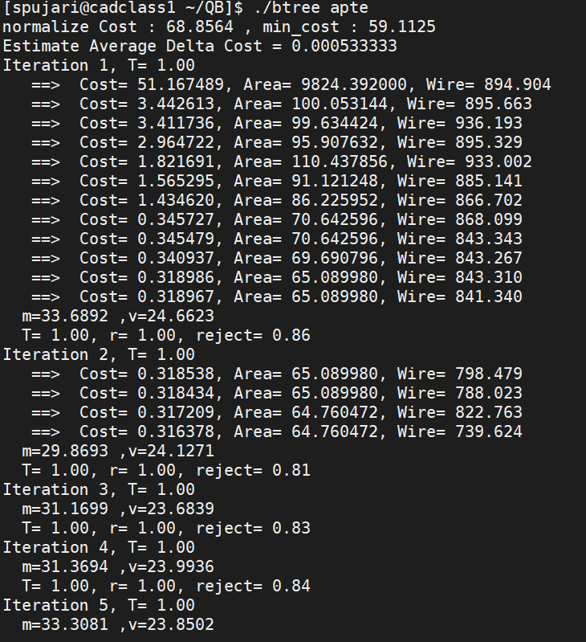

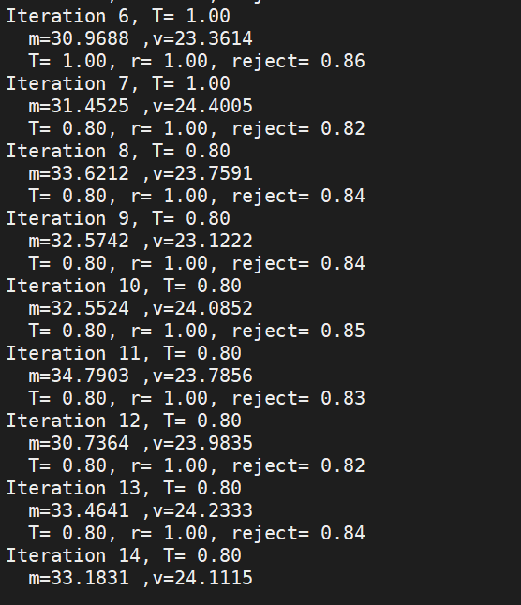

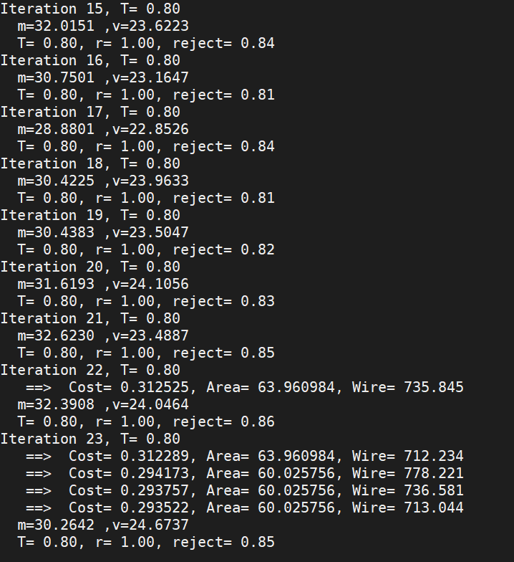

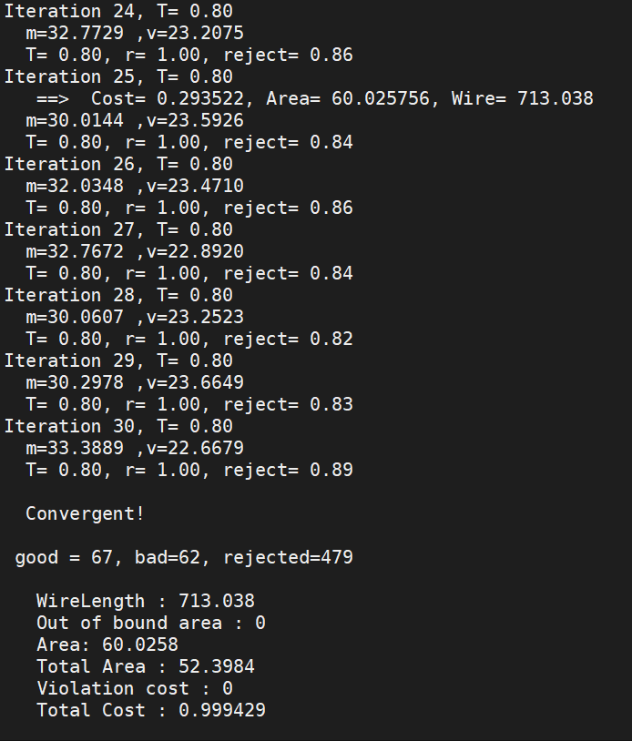

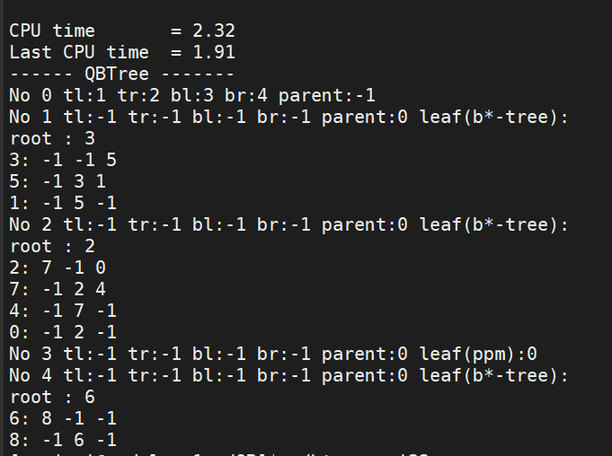

1. Click on the “apte.res” file or “ami33.res” from the side bar in the QB folder to view the outputs. These files contain the outputs generated every time step 3 is executed.

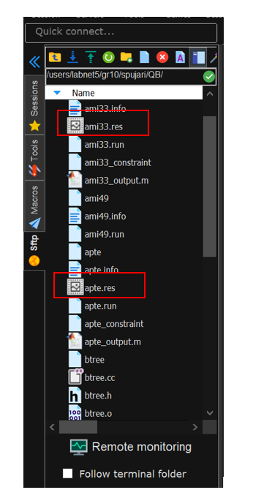

Following is the output shown in apte.res file after executing the command “./btree apte”.

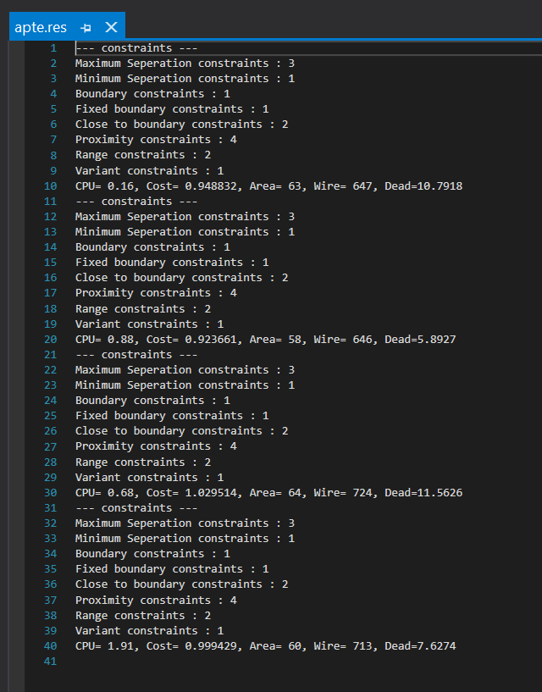

Following is the output shown in ami33.res file after executing the command “./btree ami33”.

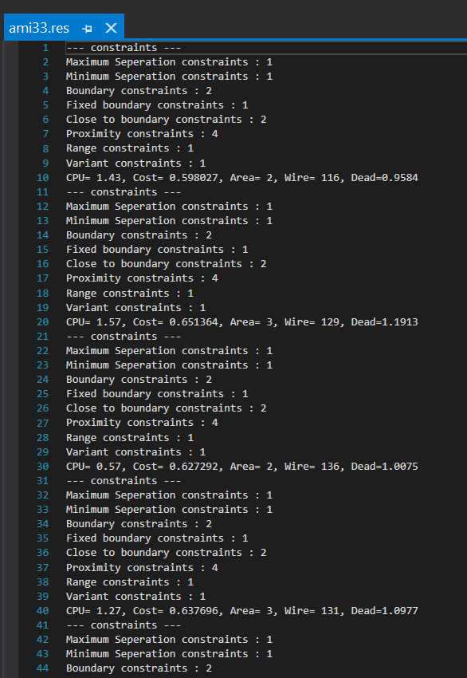

1. “apte_output.m” and “ami33_output.m” are the matlab files which provides the visual representation of the placement. Click on the apte_output.m or ami33_output.m file for the displaying the plots for the apte or ami33 input files, respectively.

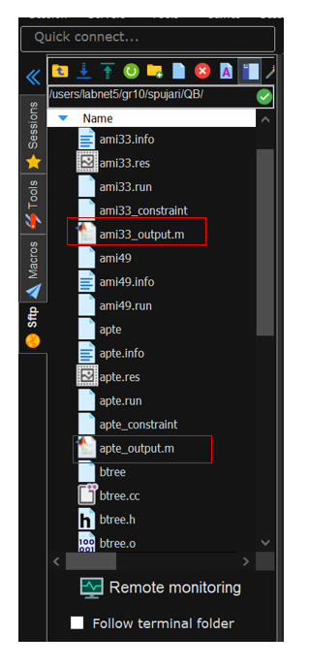

Following is the output generated for apte input file. The matlab file for apte input file is apte_output.m file.

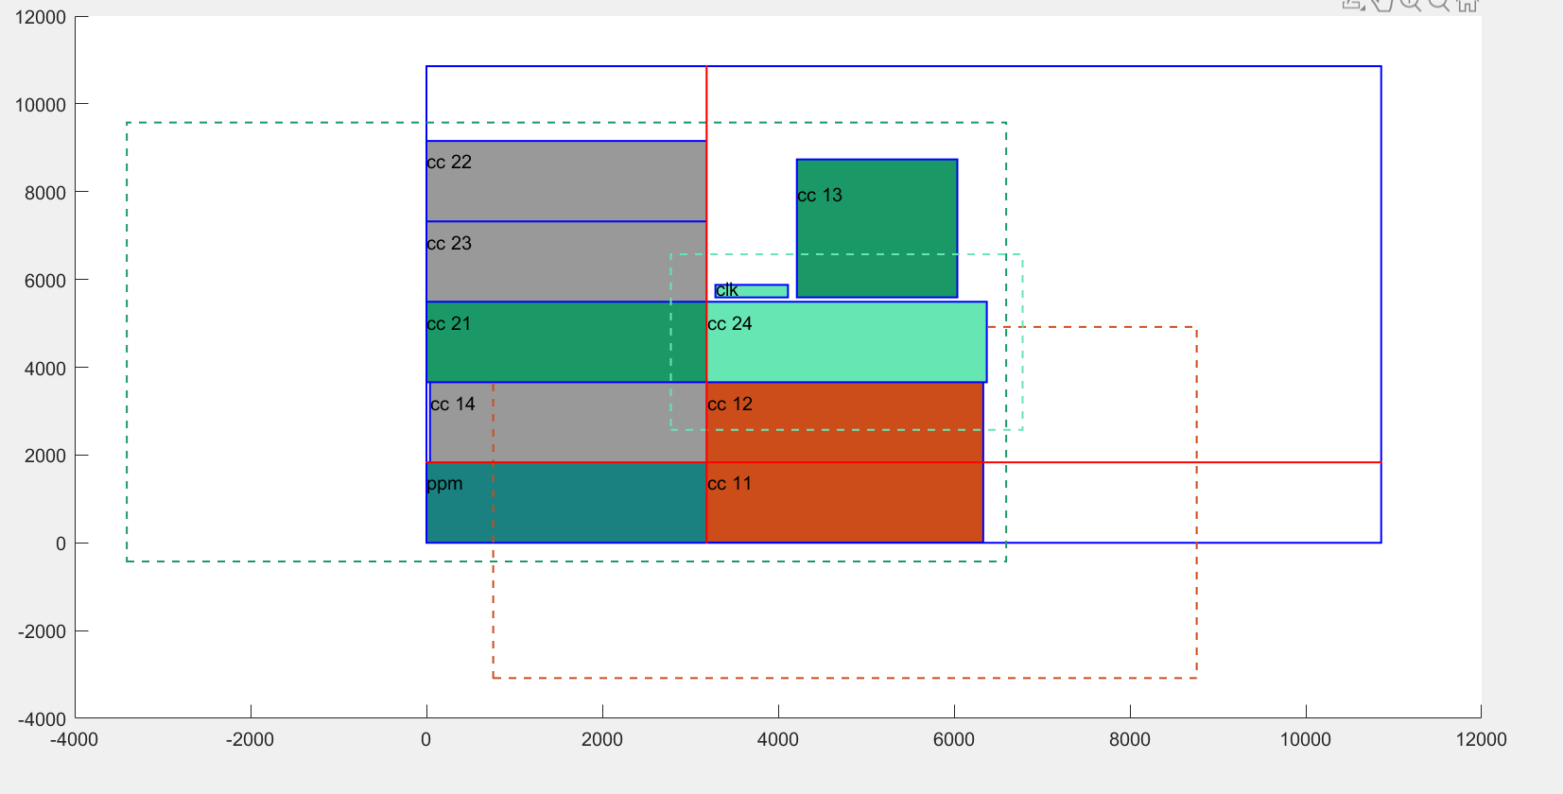

Following is the output generated for ami33 input file. The matlab file for ami33 input file is ami33_output.m file.

