Final Project
Image Classification

1.Approach:
1.1 Explanation of basic extractions:

Initially in the data set of images each image was of different dimensions,so I resized all the images to the shape 256X256 pixels. Using the bash command below :

for name in /path/to/train/*.JPG; do
convert -resize 256x256\! $name $name
done

*reference :http://caffe.berkeleyvision.org/gathered/examples/imagenet.html
During this process I have identified faulty images from the set and deleted them.

Then from the given train.csv file, I extracted a label for each image, the code for this has been written in the read_train.py file submitted. This will return a csv file which will have the image ids and lables of each image (example :”11422” ,”7”) .The labels of the faulty images identified have been removed from here.

Similarly I have extracted the image ids of test images by running the file test_name.py

1.2 Explanation of code logic used for final submission:

After having the data ready for processing we need to extract some features from each image.
So I have used hog technique to extract the features form images. So before that I resized the image to 224X224 (earlier tried with a 100X100 size images but log loss value is more ) to get optimum number of features and also I changed the image to gray format.
For this I was getting a total 0f 1568 features per image.
So I have a made a list of image features of each image according to indexing from the new_train11.csv file and the converted the list in to a ndarray this would be my X-train data.
Next I have taken all the labels according the same indexing i.e. from new_train11.csv and extract the Y_train.
Then the train data is split using train_test_split method to obtain cross validation data and training data.
Results:
After having the training and cross validation data I have used logistic regression for classification as it gives probabilistic predictions(initial idea was to use linear svm classifier) then I checked the score of labels predicted for the cross validation set against the original labels of the cross validation data.

Then the log_loss value was calculated for the predictions which came out to be 1.5629.(this was better when compared to other experiments)

So I have the my test data features which were obtained in a similar way as of train data, as an input to the classifier, whose probabilistic predictions have written into a csv file for submission.

1.3. Choice of HOG:

Initially there were two choices for feature extractions, SIFT and HOG. I searched for some papers on image classification using HOG and SIFT .
SIFT key points were good for correspondence problems as it is based on finding blobs in scale space.
HOG computes edge gradient of a whole image and find orientation of each pixel so that it can generate a histogram. It is done by dividing the image into smaller cells and summing up the gradients over every pixel with in each cell in an image.
In short, HOG is used to extract global feature whereas SIFT is used for extracting local features.
I also referred to a paper where the classification of image data was done by using HOG +PCA followed by SVM as classifier.

Usage of HOG:
We first divide the image into a large number of cells, then calculate the gradient or edge direction histogram of each pixel in all cells.
Here I have 8 bins or (8 orientations),here the histogram is constructed by dividing the image into multiple overlapping blocks of same size and quantizing the gradient direction of all pixels ino 8 directions.
For each block, its histogram is formed such that the occurrence for each direction represents the total gradient magnitude of the gradient along the direction and the histogram reflects the weighted gradient distribution inside each block. The HOG of each block is then normalized so the sum of elements of each block HOG is 1, and the HOG of the entire image is formed by concatenating the block HOGs.
Below is a sample of an images from our train set and its reconstruction using the HOG :

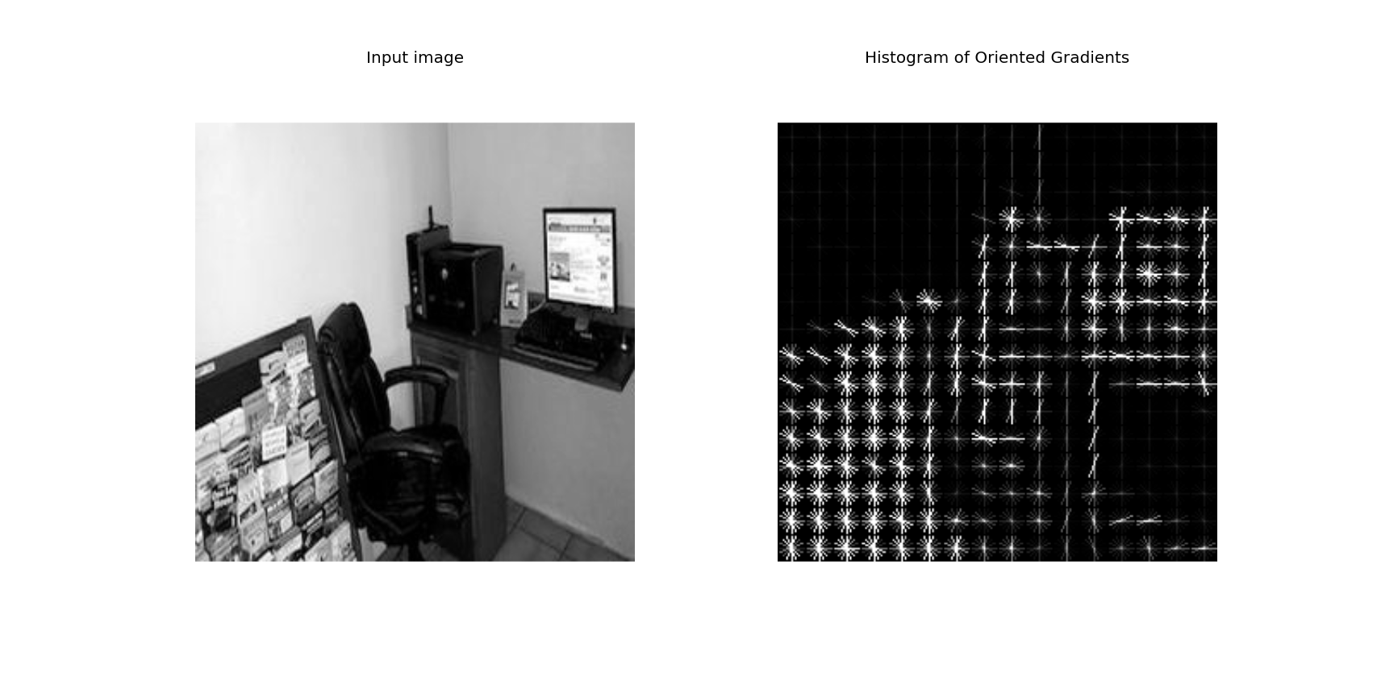

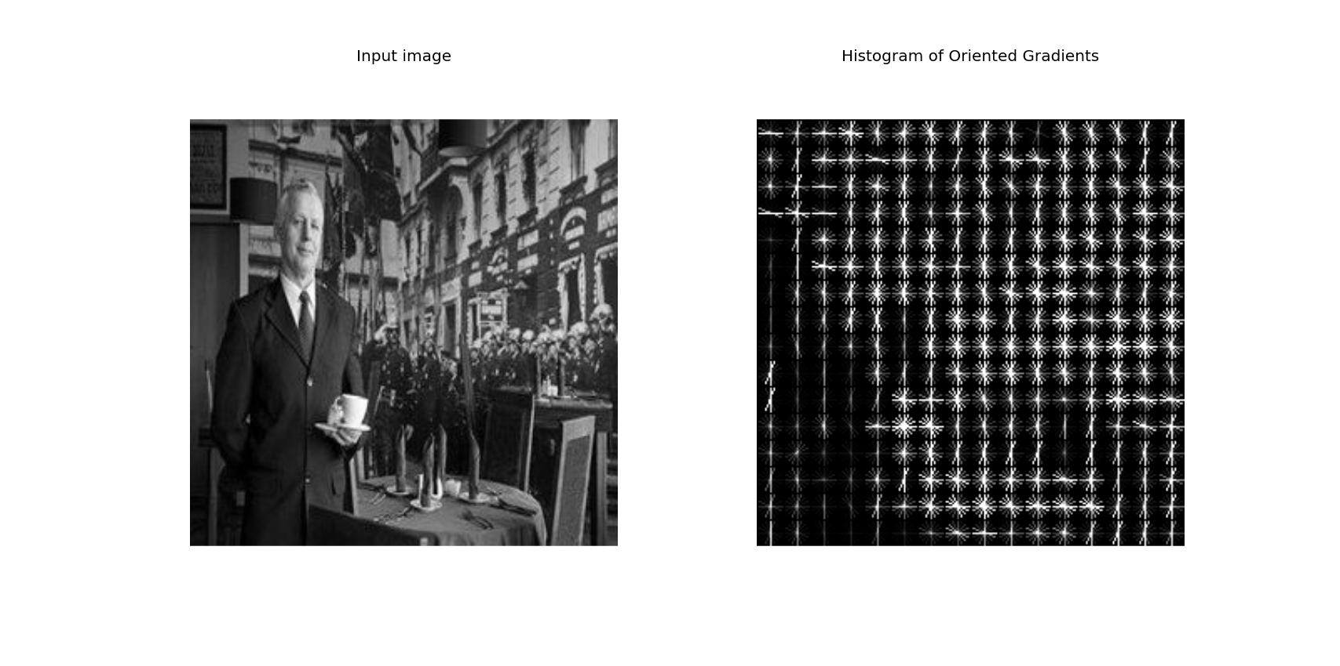
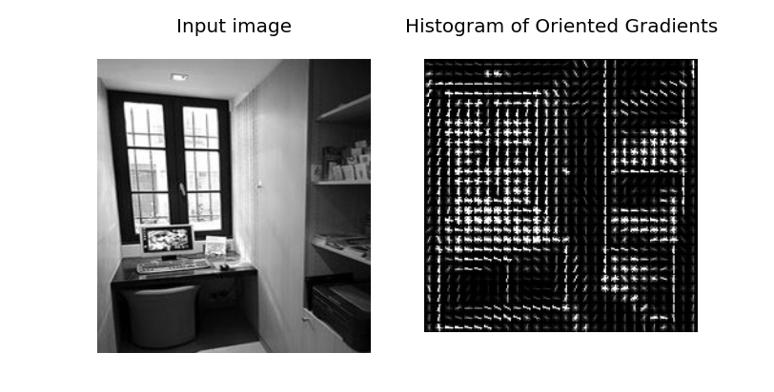

1.4 Choice of Classifier :
First choice of classifier was linear SVM classifier , using one vs rest classification technique as we have multiple labels for our training data. But this was yielding bad results and the computation time was also more, the major problem was it was giving as exact estimate of the result and not the probabilistic estimate. So the error was too high in the kaggle index it showed more than 20.

So I switched to several other classifiers which can give probabilistic estimate before moving to logistic regression .
So with logistic regression the training time was also less compared to svm and also the predicted values were more accurate.

