**SDM COLLEGE OF ENGINEERING & TECHNOLOGY,**

**DHARWAD – 580 002**



**MINI PROJECT - *II***

**ON**

**PREGNANCY GUIDE ANDROID APPLICATION**

Submitted in partial fulfillment of the requirements for the Award of Degree of

**BACHELOR OF ENGINEERING**

**IN**

**INFORMATION SCIENCE AND ENGINEERING**

Submitted by:

**NAME: SPURTHI JOSHI USN 2SD16IS050**

**NAME: SRI GOWRI USN 2SD16IS051**

**NAME: ANISHA SHETTY USN 2SD16IS005**

*Under the Guidance of:*

*Prof Varsha S J*

**Department of Information Science & Engineering**

**2018-2019**

**SDM COLLEGE OF ENGINEERING AND TECHNOLOGY,**

**DHARWAD-580002**

**(An autonomous Institution affiliated to VTU, Belagavi – 590018)**



**Department of Information Science and Engineering**

**CERTIFICATE**

This is to certify that the Mini Project work entitled “Pregnancy Guide Android Application” is a bonafied work carried out by Miss.Spurthi Joshi , Miss.Sri.Gowri and Miss.Anisha.Shetty bearing USN 2SD16IS050 , 2SD16IS051 and 2SD16IS005 respectively , for successfully completing the Mini Project for VI Semester B.E. Degree in Information Science and Engineering of SDM College of Engineering and Technology, Autonomous Institution under Visvesvaraya Technological University, Belagavi during the year 2018–2019. It is certified that all necessary suggestion indicated for internal assessment have been incorporated in the report deposited in the department library. The project work has been approved as it has successfully satisfied the academic requirements as prescribed for the Bachelor of Engineering Degree

|  |  |  |
| --- | --- | --- |
| **Signature of the Guide**  **Prof. Varsha S J** | **Signature of the HOD**  **Dr. J. D. Pujari** | **Signature of the Principal**  **Dr. S. B. Vanakudre** |

|  |  |  |
| --- | --- | --- |
|  | Examiner I | Examiner II |
| Signature with date: |  |  |
| Name: |  |  |

**ACKNOWLEGEMENT**

The successful completion of any task would be incomplete, without the mention of people who are responsible for the completion of this work.

First and foremost, we would like to express our sincere gratitude to our research supervisors who has in the literal sense, guided and supervised us. Their guidance deserves much more than the credit on the successful completion of our project and also for giving us an opportunity to implant our skills and for providing the required help and co-operation to complete the report. We are indebted with a deep sense of gratitude for the constant inspiration and valuable guidance throughout the work.

We are humbly thankful to Prof. J.D. Pujari, H.O.D., Dept of Information Science and Engineering for providing us a 24 hour internet access and high bandwidth round the clock.

Team members:

**Name USN**

Spurthi Joshi 2SD16IS050

Sri Gowri 2SD16IS051

Anisha Shetty 2SD16IS005

**ABSTRACT**

As the name specifies “PREGNANCY GUIDE” is an Android application developed for assisting the pregnant women during their pregnancy for healthy child development . **Pregnancy**, also known as **gestation**, is the time during which one or more offspring develops inside a woman. Prenatal care improves pregnancy outcomes. Prenatal care may include taking extra folic acid, avoiding drugs and alcohol, regular exercise, blood tests, and regular physical examinations.

This app tracks down week by week progress.It will guide you throughout the journey.The app has the features to calculate approximate due dates.The app guides you as to what vaccinations are to be taken and in which month,the proper balanced diet chart,the exercises to be followed through videos . Good maternal care will improve the child’s health and help the child build immunity . The follow up of exercises will help place the baby in the proper position .

Thus,this application is more efficient and has salient features.

**Contents**

|  |  |  |
| --- | --- | --- |
| Chapter No. | Chapter Name | Pg.no |
| 1. | Introduction   * 1. Introduction   2. Problem Statement   3. Objectives   4. Methodology   5. Limitations | 6  7  7  8  8 |
| 2. | Software Requirements  2.1 Software Requirements | 9 |
| 3. | Design And Implementation  3.1 Design  3.2 Implementation  3.3 Source Code  3.4 Result Analysis  3.5 Conclusion  3.6 Future Scope  3.7 References | 10  10  11  25  28  28  28 |

**Chapter 1**

**1.  INTRODUCTION**

**1.1 Introduction**

This Pregnancy Guide Android application is developed in favor of the pregnant women who need guidance throughout their pregnancy . It helps them in delivering a healthy baby.

This solution is developed for the parents, through this they can follow certain steps and keep themselves and their babies fit and healthy , all you need to do is to login as user and you can see the information of all the three trimesters with weekly schedule to be followed.

This application has come up with the solution which is more user friendly and more GUI oriented. We can guide the mothers-to-be , thus overcome the drawbacks .

**1.2 Problem Statement**

The development of Pregnancy Guide Application plans to cure the difficulties

 a)What should be the proper diet to be followed during pregnancy?

b)What are the exercises or workout routines that will help position the baby properly?

**1.3 Objectives**

The main objectives of this project work are that:

* Parents have access to this application on their phones.
* It is easy and efficient.
* This also will relieve the parents from visiting the gynecologist frequently .
* It helps the parents to track down week-by-week progress.
* Keeps the baby healthy.
* An appointment reminder system is implemented.

**1.4 Methodology**

APPLICATION

USER

Fig1.1 Module Design

This application includes four modules namely:

User module – Mothers to be.

**1.5 Limitations**

Some of the limitations of the proposed system are

1. The application does not give a clear idea about the development stages of the baby .
2. The application cannot cater to personal needs. It is rather generic. The details of users cannot be stored.

**Chapter 2**

**SOFTWARE REQUIREMENTS**

**2.1 Software Requirements**

The whole Project is built using Android Studio :

* + 1. Android Studio
* **Android Studio** is the officialintegrated development environment(IDE) for Google'sAndroid operating system, built on JetBrains' IntelliJ IDEA software and designed specifically for Android development.
* Gradle-based build support
* Android-specific refactoring and quick fixes
* Lint tools to catch performance, usability, version compatibility and other problems
* ProGuard integration and app-signing capabilities
* Template-based wizards to create common Android designs and components
* A rich layout editor that allows users to drag-and-drop UI components, option to preview layouts on multiple screen configurations
* Support for building Android Wear apps
* Built-in support for Google Cloud Platform, enabling integration with Firebase Cloud Messaging (Earlier 'Google Cloud Messaging') and Google App Engine

**Chapter** 3

**DESIGN** AND **IMPLEMENTATION**

**3.1 Design**

Enter date

Login

Due Date and List of Trimesters with respective information.

* 1. **Implementation**

**Algorithm:**

**Step 1:** Enter username and last period date

**Step 2:** Click on login button

**Step 3:** profile appears click on Get Started button

**Step 4:** Select required Trimester

**Step 5:** In the selected Trimester , click on Explore button of required week.

**Step 6:** View the Exercises ,Diet Chart ,Vaccination List

**Step 7:** Finally close the application.

**3.3 Source Code**

1.Login

package com.google.myapp.app1;

import android.content.Intent;

import android.support.v7.app.AppCompatActivity;

import android.os.Bundle;

import android.view.View;

import android.widget.Button;

import android.widget.EditText;

public class add extends AppCompatActivity {

private EditText email;

private Button login;

protected void onCreate(Bundle savedInstanceState) {

super.onCreate(savedInstanceState);

setContentView(R.layout.activity_add);

email = (EditText) findViewById(R.id.umail);

login = (Button) findViewById(R.id.ulogin);

login.setOnClickListener(new View.OnClickListener() {

@Override

public void onClick(View view) {

validate(email.getText().toString());

}

});

}

private void validate(String userName){

{

Intent intent = new Intent(add.this,secondactivity.class);

startActivity(intent);

}

}

}

2.Second Page

package com.google.myapp.app1;

import android.content.Intent;

import android.support.v7.app.AppCompatActivity;

import android.os.Bundle;

import android.view.View;

import android.widget.Button;

public class

secondactivity extends AppCompatActivity {

private Button startbtn;

@Override

protected void onCreate(Bundle savedInstanceState) {

super.onCreate(savedInstanceState);

setContentView(R.layout.activity_secondactivity);

startbtn = (Button) findViewById(R.id.start);

startbtn.setOnClickListener(new View.OnClickListener() {

@Override

public void onClick(View view) {

Intent intent = new Intent(secondactivity.this,trilist.class);

startActivity(intent);

}

});

}

}

3.Trimester Tabs

package com.google.myapp.app1;

import android.support.design.widget.TabLayout;

import android.support.design.widget.FloatingActionButton;

import android.support.design.widget.Snackbar;

import android.support.v7.app.AppCompatActivity;

import android.support.v7.widget.Toolbar;

import android.support.v4.app.Fragment;

import android.support.v4.app.FragmentManager;

import android.support.v4.app.FragmentPagerAdapter;

import android.support.v4.view.ViewPager;

import android.os.Bundle;

import android.view.LayoutInflater;

import android.view.Menu;

import android.view.MenuItem;

import android.view.View;

import android.view.ViewGroup;

import android.widget.TextView;

public class trilist extends AppCompatActivity {

/**

* The {@link android.support.v4.view.PagerAdapter} that will provide

* fragments for each of the sections. We use a

* {@link FragmentPagerAdapter} derivative, which will keep every

* loaded fragment in memory. If this becomes too memory intensive, it

* may be best to switch to a

* {@link android.support.v4.app.FragmentStatePagerAdapter}.

*/

private SectionsPagerAdapter mSectionsPagerAdapter;

/**

* The {@link ViewPager} that will host the section contents.

*/

private ViewPager mViewPager;

@Override

protected void onCreate(Bundle savedInstanceState) {

super.onCreate(savedInstanceState);

setContentView(R.layout.activity_trilist);

Toolbar toolbar = (Toolbar) findViewById(R.id.toolbar);

setSupportActionBar(toolbar);

// Create the adapter that will return a fragment for each of the three

// primary sections of the activity.

mSectionsPagerAdapter = new SectionsPagerAdapter(getSupportFragmentManager());

// Set up the ViewPager with the sections adapter.

mViewPager = (ViewPager) findViewById(R.id.container);

mViewPager.setAdapter(mSectionsPagerAdapter);

TabLayout tabLayout = (TabLayout) findViewById(R.id.tabs);

tabLayout.setupWithViewPager(mViewPager);

FloatingActionButton fab = (FloatingActionButton) findViewById(R.id.fab);

fab.setOnClickListener(new View.OnClickListener() {

@Override

public void onClick(View view) {

Snackbar.make(view, "Replace with your own action", Snackbar.LENGTH_LONG)

.setAction("Action", null).show();

}

});

}

@Override

public boolean onCreateOptionsMenu(Menu menu) {

// Inflate the menu; this adds items to the action bar if it is present.

getMenuInflater().inflate(R.menu.menu_trilist, menu);

return true;

}

@Override

public boolean onOptionsItemSelected(MenuItem item) {

// Handle action bar item clicks here. The action bar will

// automatically handle clicks on the Home/Up button, so long

// as you specify a parent activity in AndroidManifest.xml.

int id = item.getItemId();

//noinspection SimplifiableIfStatement

if (id == R.id.action_settings) {

return true;

}

return super.onOptionsItemSelected(item);

}

/**

* A placeholder fragment containing a simple view.

*/

//delete placeholder

/**

* A {@link FragmentPagerAdapter} that returns a fragment corresponding to

* one of the sections/tabs/pages.

*/

public class SectionsPagerAdapter extends FragmentPagerAdapter {

public SectionsPagerAdapter(FragmentManager fm) {

super(fm);

}

@Override

public Fragment getItem(int position) {

switch(position){

case 0:

tab1 t = new tab1();

return t;

case 1:

tab2 t2 = new tab2();

return t2;

case 2:

tab3 t3 = new tab3();

return t3;

default:

return null;

}

}

@Override

public int getCount() {

// Show 3 total pages.

return 3;

}

@Override

public CharSequence getPageTitle(int position) {

switch (position) {

case 0:

return "TRIMESTER 1";

case 1:

return "TRIMESTER 2";

case 2:

return "TRIMESTER 3";

}

return null;

}

}

}

TAB1,2,3:

package com.google.myapp.app1;

import android.content.Intent;

import android.support.design.widget.TabLayout;

import android.support.design.widget.FloatingActionButton;

import android.support.design.widget.Snackbar;

import android.support.v7.app.AppCompatActivity;

import android.support.v7.widget.Toolbar;

import android.support.v4.app.Fragment;

import android.support.v4.app.FragmentManager;

import android.support.v4.app.FragmentPagerAdapter;

import android.support.v4.view.ViewPager;

import android.os.Bundle;

import android.view.LayoutInflater;

import android.view.Menu;

import android.view.MenuItem;

import android.view.View;

import android.view.ViewGroup;

import android.widget.Button;

import android.widget.TextView;

import android.content.Intent;

import android.support.v7.app.AppCompatActivity;

import android.os.Bundle;

import android.view.View;

import android.widget.Button;

public class tab1 extends Fragment{

public View onCreateView(LayoutInflater inflater, ViewGroup container,

Bundle savedInstanceState) {

View rootView = inflater.inflate(R.layout.tab1, container, false);

//TextView textView = (TextView) rootView.findViewById(R.id.section_label);

//textView.setText(getString(R.string.section_format, getArguments().getInt(ARG_SECTION_NUMBER)));

return rootView;

}

}

1.tri list

package com.google.myapp.app1;

import android.content.Intent;

import android.support.v7.app.AppCompatActivity;

import android.os.Bundle;

import android.view.View;

import android.widget.Button;

public class trimesterlist extends AppCompatActivity {

private Button t1;

private Button t2;

private Button t3;

@Override

protected void onCreate(Bundle savedInstanceState) {

super.onCreate(savedInstanceState);

setContentView(R.layout.activity_trimesterlist);

t1 = (Button) findViewById(R.id.t1);

t2 = (Button) findViewById(R.id.t2);

t3 = (Button) findViewById(R.id.t3);

t1.setOnClickListener(new View.OnClickListener() {

@Override

public void onClick(View view) {

Intent intent = new Intent(trimesterlist.this,tri1.class);

startActivity(intent);

}

});

t2.setOnClickListener(new View.OnClickListener() {

@Override

public void onClick(View view) {

Intent intent = new Intent(trimesterlist.this,tri2.class);

startActivity(intent);

}

});

t3.setOnClickListener(new View.OnClickListener() {

@Override

public void onClick(View view) {

Intent intent = new Intent(trimesterlist.this,tri3.class);

startActivity(intent);

}

});

}

}

2.tri1

package com.google.myapp.app1;

import android.content.Intent;

import android.support.v7.app.AppCompatActivity;

import android.os.Bundle;

import android.view.View;

import android.widget.Button;

public class tri1 extends AppCompatActivity {

private Button d1;

private Button e1;

private Button v1;

@Override

protected void onCreate(Bundle savedInstanceState) {

super.onCreate(savedInstanceState);

setContentView(R.layout.activity_tri1);

d1 = (Button) findViewById(R.id.d1);

e1 = (Button) findViewById(R.id.e1);

v1 = (Button) findViewById(R.id.v1);

e1.setOnClickListener(new View.OnClickListener() {

@Override

public void onClick(View view) {

Intent intent = new Intent(tri1.this,fexe.class);

startActivity(intent);

}

});

d1.setOnClickListener(new View.OnClickListener() {

@Override

public void onClick(View view) {

Intent intent = new Intent(tri1.this,fdiet.class);

startActivity(intent);

}

});

v1.setOnClickListener(new View.OnClickListener() {

@Override

public void onClick(View view) {

Intent intent = new Intent(tri1.this,fvac.class);

startActivity(intent);

}

});

}

}

3.tri2

package com.google.myapp.app1;

import android.content.Intent;

import android.support.v7.app.AppCompatActivity;

import android.os.Bundle;

import android.view.View;

import android.widget.Button;

public class tri2 extends AppCompatActivity {

private Button d2;

private Button e2;

private Button v2;

@Override

protected void onCreate(Bundle savedInstanceState) {

super.onCreate(savedInstanceState);

setContentView(R.layout.activity_tri2);

d2 = (Button) findViewById(R.id.d2);

e2 = (Button) findViewById(R.id.e2);

v2 = (Button) findViewById(R.id.v2);

e2.setOnClickListener(new View.OnClickListener() {

@Override

public void onClick(View view) {

Intent intent = new Intent(tri2.this,sexe.class);

startActivity(intent);

}

});

d2.setOnClickListener(new View.OnClickListener() {

@Override

public void onClick(View view) {

Intent intent = new Intent(tri2.this,sdiet.class);

startActivity(intent);

}

});

v2.setOnClickListener(new View.OnClickListener() {

@Override

public void onClick(View view) {

Intent intent = new Intent(tri2.this,svac.class);

startActivity(intent);

}

});

}

}

4.tri3

package com.google.myapp.app1;

import android.content.Intent;

import android.support.v7.app.AppCompatActivity;

import android.os.Bundle;

import android.view.View;

import android.widget.Button;

public class tri3 extends AppCompatActivity {

private Button d3;

private Button e3;

private Button v3;

@Override

protected void onCreate(Bundle savedInstanceState) {

super.onCreate(savedInstanceState);

setContentView(R.layout.activity_tri3);

d3 = (Button) findViewById(R.id.d3);

e3 = (Button) findViewById(R.id.e3);

v3 = (Button) findViewById(R.id.v3);

e3.setOnClickListener(new View.OnClickListener() {

@Override

public void onClick(View view) {

Intent intent = new Intent(tri3.this,texe.class);

startActivity(intent);

}

});

d3.setOnClickListener(new View.OnClickListener() {

@Override

public void onClick(View view) {

Intent intent = new Intent(tri3.this,tdiet.class);

startActivity(intent);

}

});

v3.setOnClickListener(new View.OnClickListener() {

@Override

public void onClick(View view) {

Intent intent = new Intent(tri3.this,tvac.class);

startActivity(intent);

}

});

} }

XML files :

1.tri list

<?xml version="1.0" encoding="utf-8"?>

<RelativeLayout

xmlns:android="http://schemas.android.com/apk/res/android"

xmlns:app="http://schemas.android.com/apk/res-auto"

xmlns:tools="http://schemas.android.com/tools"

android:layout_width="match_parent"

android:layout_height="match_parent"

tools:context="com.google.myapp.app1.add">

<Button

android:id="@+id/t1"

android:layout_width="wrap_content"

android:layout_height="wrap_content"

android:text="Trimester 1"

tools:layout_editor_absoluteX="148dp"

tools:layout_editor_absoluteY="220dp"

android:layout_above="@+id/t2"

android:layout_alignLeft="@+id/t2"

android:layout_alignStart="@+id/t2"

android:layout_marginBottom="56dp" />

<Button

android:id="@+id/t2"

android:layout_width="wrap_content"

android:layout_height="wrap_content"

android:text="Trimester 2"

tools:layout_editor_absoluteX="148dp"

tools:layout_editor_absoluteY="323dp"

android:layout_above="@+id/t3"

android:layout_alignLeft="@+id/t3"

android:layout_alignStart="@+id/t3"

android:layout_marginBottom="44dp" />

<Button

android:id="@+id/t3"

android:layout_width="wrap_content"

android:layout_height="wrap_content"

android:text="Trimester 3"

tools:layout_editor_absoluteX="148dp"

tools:layout_editor_absoluteY="424dp"

android:layout_alignParentBottom="true"

android:layout_centerHorizontal="true"

android:layout_marginBottom="48dp" />

<ImageView

android:id="@+id/imageView2"

android:layout_width="wrap_content"

android:layout_height="wrap_content"

android:layout_centerHorizontal="true"

app:srcCompat="@drawable/tri"

android:layout_above="@+id/t1"

android:layout_alignParentTop="true" />

</RelativeLayout>

2.tri1,2,3

<?xml version="1.0" encoding="utf-8"?>

<RelativeLayout

xmlns:android="http://schemas.android.com/apk/res/android"

xmlns:app="http://schemas.android.com/apk/res-auto"

xmlns:tools="http://schemas.android.com/tools"

android:layout_width="match_parent"

android:layout_height="match_parent"

tools:context="com.google.myapp.app1.add">

<Button

android:id="@+id/e1"

android:layout_width="wrap_content"

android:layout_height="wrap_content"

android:text="EXERCISES"

tools:layout_editor_absoluteX="263dp"

tools:layout_editor_absoluteY="231dp"

android:layout_marginLeft="49dp"

android:layout_marginStart="49dp"

android:layout_marginTop="50dp"

android:layout_alignParentTop="true"

android:layout_alignParentLeft="true"

android:layout_alignParentStart="true" />

<Button

android:id="@+id/v1"

android:layout_width="wrap_content"

android:layout_height="wrap_content"

android:text="VACCINATIONS"

tools:layout_editor_absoluteX="43dp"

tools:layout_editor_absoluteY="403dp"

android:layout_marginBottom="56dp"

android:layout_alignParentBottom="true"

android:layout_alignLeft="@+id/e1"

android:layout_alignStart="@+id/e1" />

<Button

android:id="@+id/d1"

android:layout_width="wrap_content"

android:layout_height="wrap_content"

android:text="DIET PLAN"

tools:layout_editor_absoluteX="43dp"

tools:layout_editor_absoluteY="60dp"

android:layout_centerVertical="true"

android:layout_alignLeft="@+id/e1"

android:layout_alignStart="@+id/e1" />

<ImageView

android:id="@+id/imageView3"

android:layout_width="wrap_content"

android:layout_height="wrap_content"

app:srcCompat="@drawable/exe"

android:layout_toRightOf="@+id/v1"

android:layout_toEndOf="@+id/v1" />

<ImageView

android:id="@+id/imageView4"

android:layout_width="wrap_content"

android:layout_height="wrap_content"

app:srcCompat="@drawable/diet"

android:layout_alignParentRight="true"

android:layout_alignParentEnd="true"

android:layout_above="@+id/v1"

android:layout_toRightOf="@+id/v1"

android:layout_toEndOf="@+id/v1" />

<ImageView

android:id="@+id/imageView5"

android:layout_width="wrap_content"

android:layout_height="wrap_content"

app:srcCompat="@drawable/vac"

android:layout_alignParentBottom="true"

android:layout_toRightOf="@+id/v1"

android:layout_toEndOf="@+id/v1"

android:layout_alignTop="@+id/v1" />

</RelativeLayout>

3.diet

<?xml version="1.0" encoding="utf-8"?>

<android.support.constraint.ConstraintLayout xmlns:android="http://schemas.android.com/apk/res/android"

xmlns:app="http://schemas.android.com/apk/res-auto"

xmlns:tools="http://schemas.android.com/tools"

android:layout_width="match_parent"

android:layout_height="match_parent"

tools:context="com.google.myapp.app1.fdiet">

<TextView

android:id="@+id/textView2"

android:layout_width="wrap_content"

android:layout_height="wrap_content"

android:text="DIET CHART"

android:textSize="36sp"

tools:layout_editor_absoluteX="92dp"

tools:layout_editor_absoluteY="2dp" />

<ImageView

android:id="@+id/imageView14"

android:layout_width="wrap_content"

android:layout_height="wrap_content"

app:srcCompat="@drawable/ftridietplan"

tools:layout_editor_absoluteY="45dp"

tools:layout_editor_absoluteX="0dp" />

</android.support.constraint.ConstraintLayout>

4.vaccination

<?xml version="1.0" encoding="utf-8"?>

<android.support.constraint.ConstraintLayout xmlns:android="http://schemas.android.com/apk/res/android"

xmlns:app="http://schemas.android.com/apk/res-auto"

xmlns:tools="http://schemas.android.com/tools"

android:layout_width="match_parent"

android:layout_height="match_parent"

tools:context="com.google.myapp.app1.fvac">

<TextView

android:id="@+id/textView3"

android:layout_width="wrap_content"

android:layout_height="wrap_content"

android:text="VACCINATIONS"

android:textSize="36sp"

tools:layout_editor_absoluteX="53dp"

tools:layout_editor_absoluteY="40dp" />

<CheckBox

android:id="@+id/checkBox"

android:layout_width="277dp"

android:layout_height="106dp"

android:text="TT(Tetanus Toxoid)"

android:textSize="24sp"

tools:layout_editor_absoluteX="66dp"

tools:layout_editor_absoluteY="132dp" />

</android.support.constraint.ConstraintLayout>

* 1. **Result Analysis**

3.4.1.Login Page

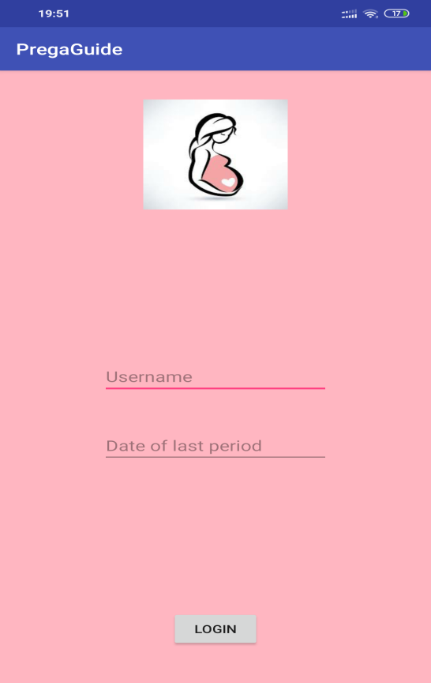

3.4.2.First Page

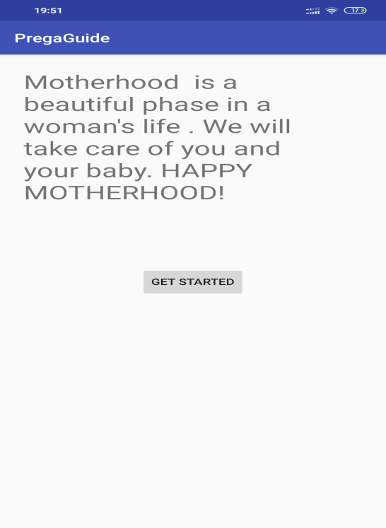

3.4.3.Trimester List Page

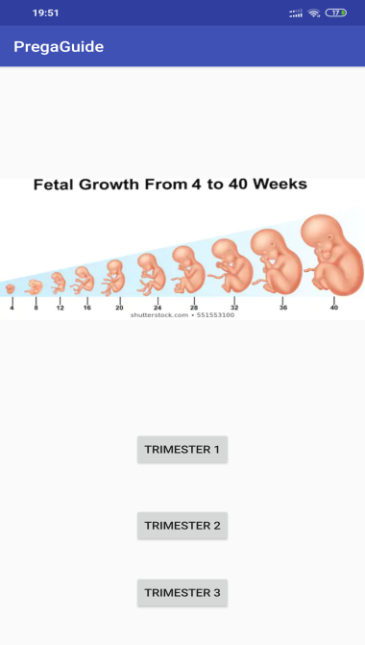

3.4.4.Trimesters Page

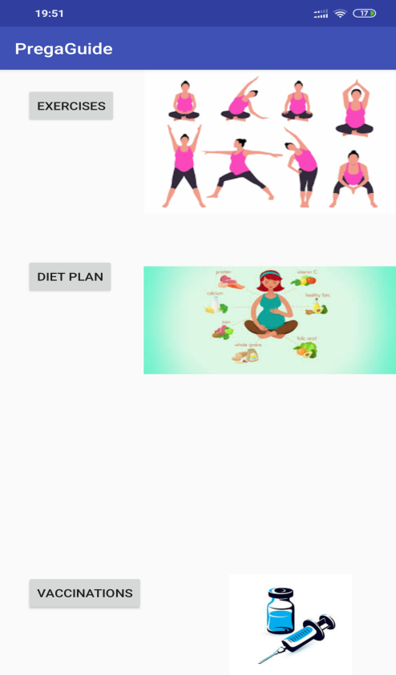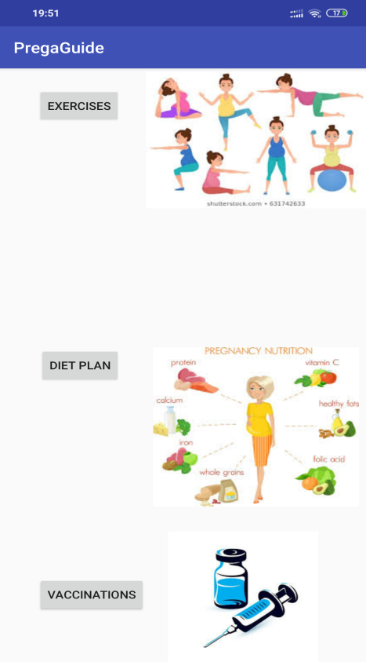

3.4.5.Diet Charts for 1st and 2nd Trimester

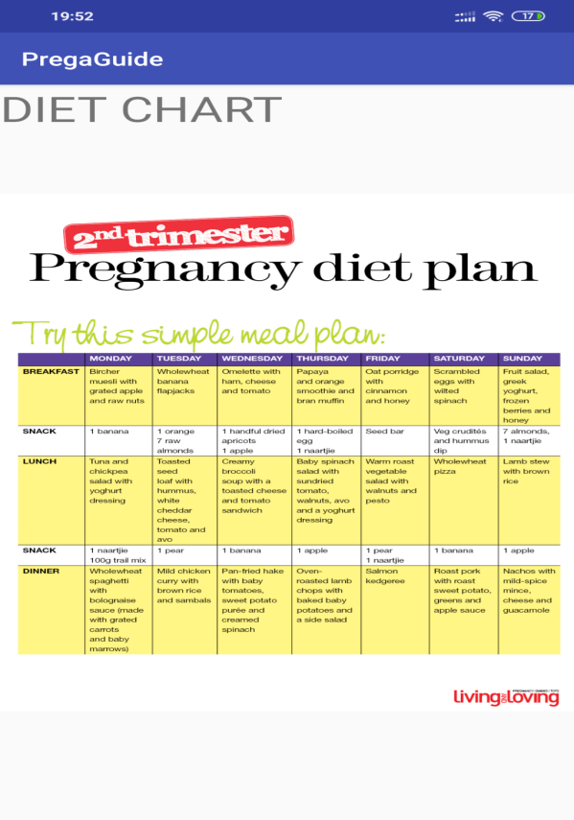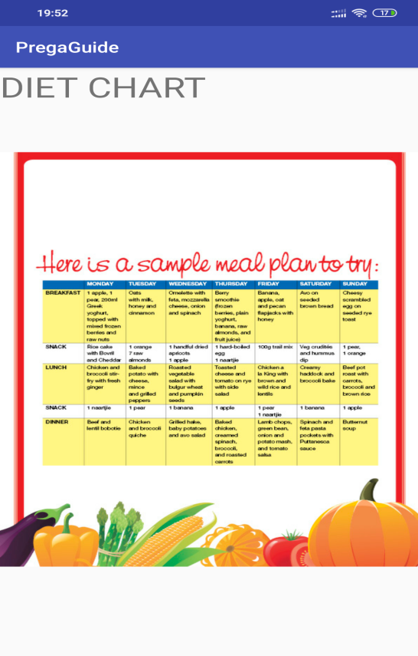

3.4.6.Vaccination Page

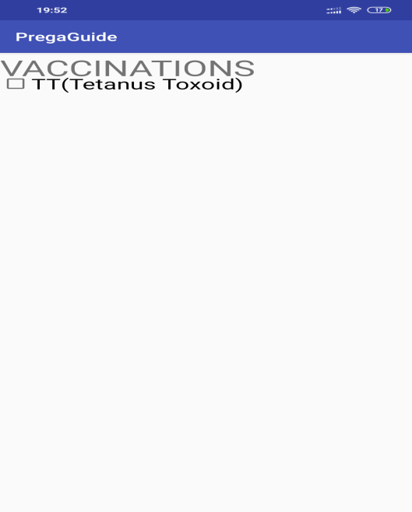

* 1. **Conclusion**
* Easily Accessible.
* Each user can view the information at any point of time.
  1. **Future Scope**
* The hospitals could collaborate and more informative user interface can be built.
* An online forum for the doctors to interact with the users can be made.
* Doctors can prescribe medicines online which will save time .
  1. **References**
* IEEE papers-

[1] W. Bian, A. I. Wang, A. Hartvoll Ruud, and

Z. Wan Zhen. Extending google android’s application

as an educational tool. In Third IEEE International

Conference on Digital Game and Intelligent Toy Enhanced Learning (DIGITEL), pages 23–30, 2010.

[2] M. Butler. Android: Changing the mobile landscape.

Pervasive Computing, IEEE, 10(1):4–7, 2011.

[3] T.-M. Grnli, J. Hansen, and G. Ghinea. Android vs

windows mobile vs java me. In 3rd International Conference on PErvasive Technologies Related to Assistive

Environments (PETRA), 2010.

[4] C. Hu and I. Neamtiu. Automating gui testing for

android applications. In 6th International Workshop

on Automation of Software Test (AST), pages 77–83,

2011.

[5] L. Jae Kyu and L. Jong Yeol. Android programming techniques for improving performance. In 3rd

International Conference on Awareness Science and

Technology (ICAST), pages 386–389, 2011.

* https://www.w3schools.com
* https://developer.android.com/studio/features