

DIGITAL TWIN FOR THE
AUGMENTED VDE TEST FACILITY
Software Design Document
Dynamics Engine Software and Visualization Software

1. Introduction
This document presents the software design for the Hardware-in-the-Loop (HIL) digital twin developed for the Augmented Vertical Docking Experiment (VDE) Test Facility. The sections that follow present the design through five complementary views: a system-level architecture, a component architecture, a class design, a sequence of operations, and a timing diagram of the external interactions, each shown as a figure with an accompanying explanation.
Figure 1: System-Level Architecture
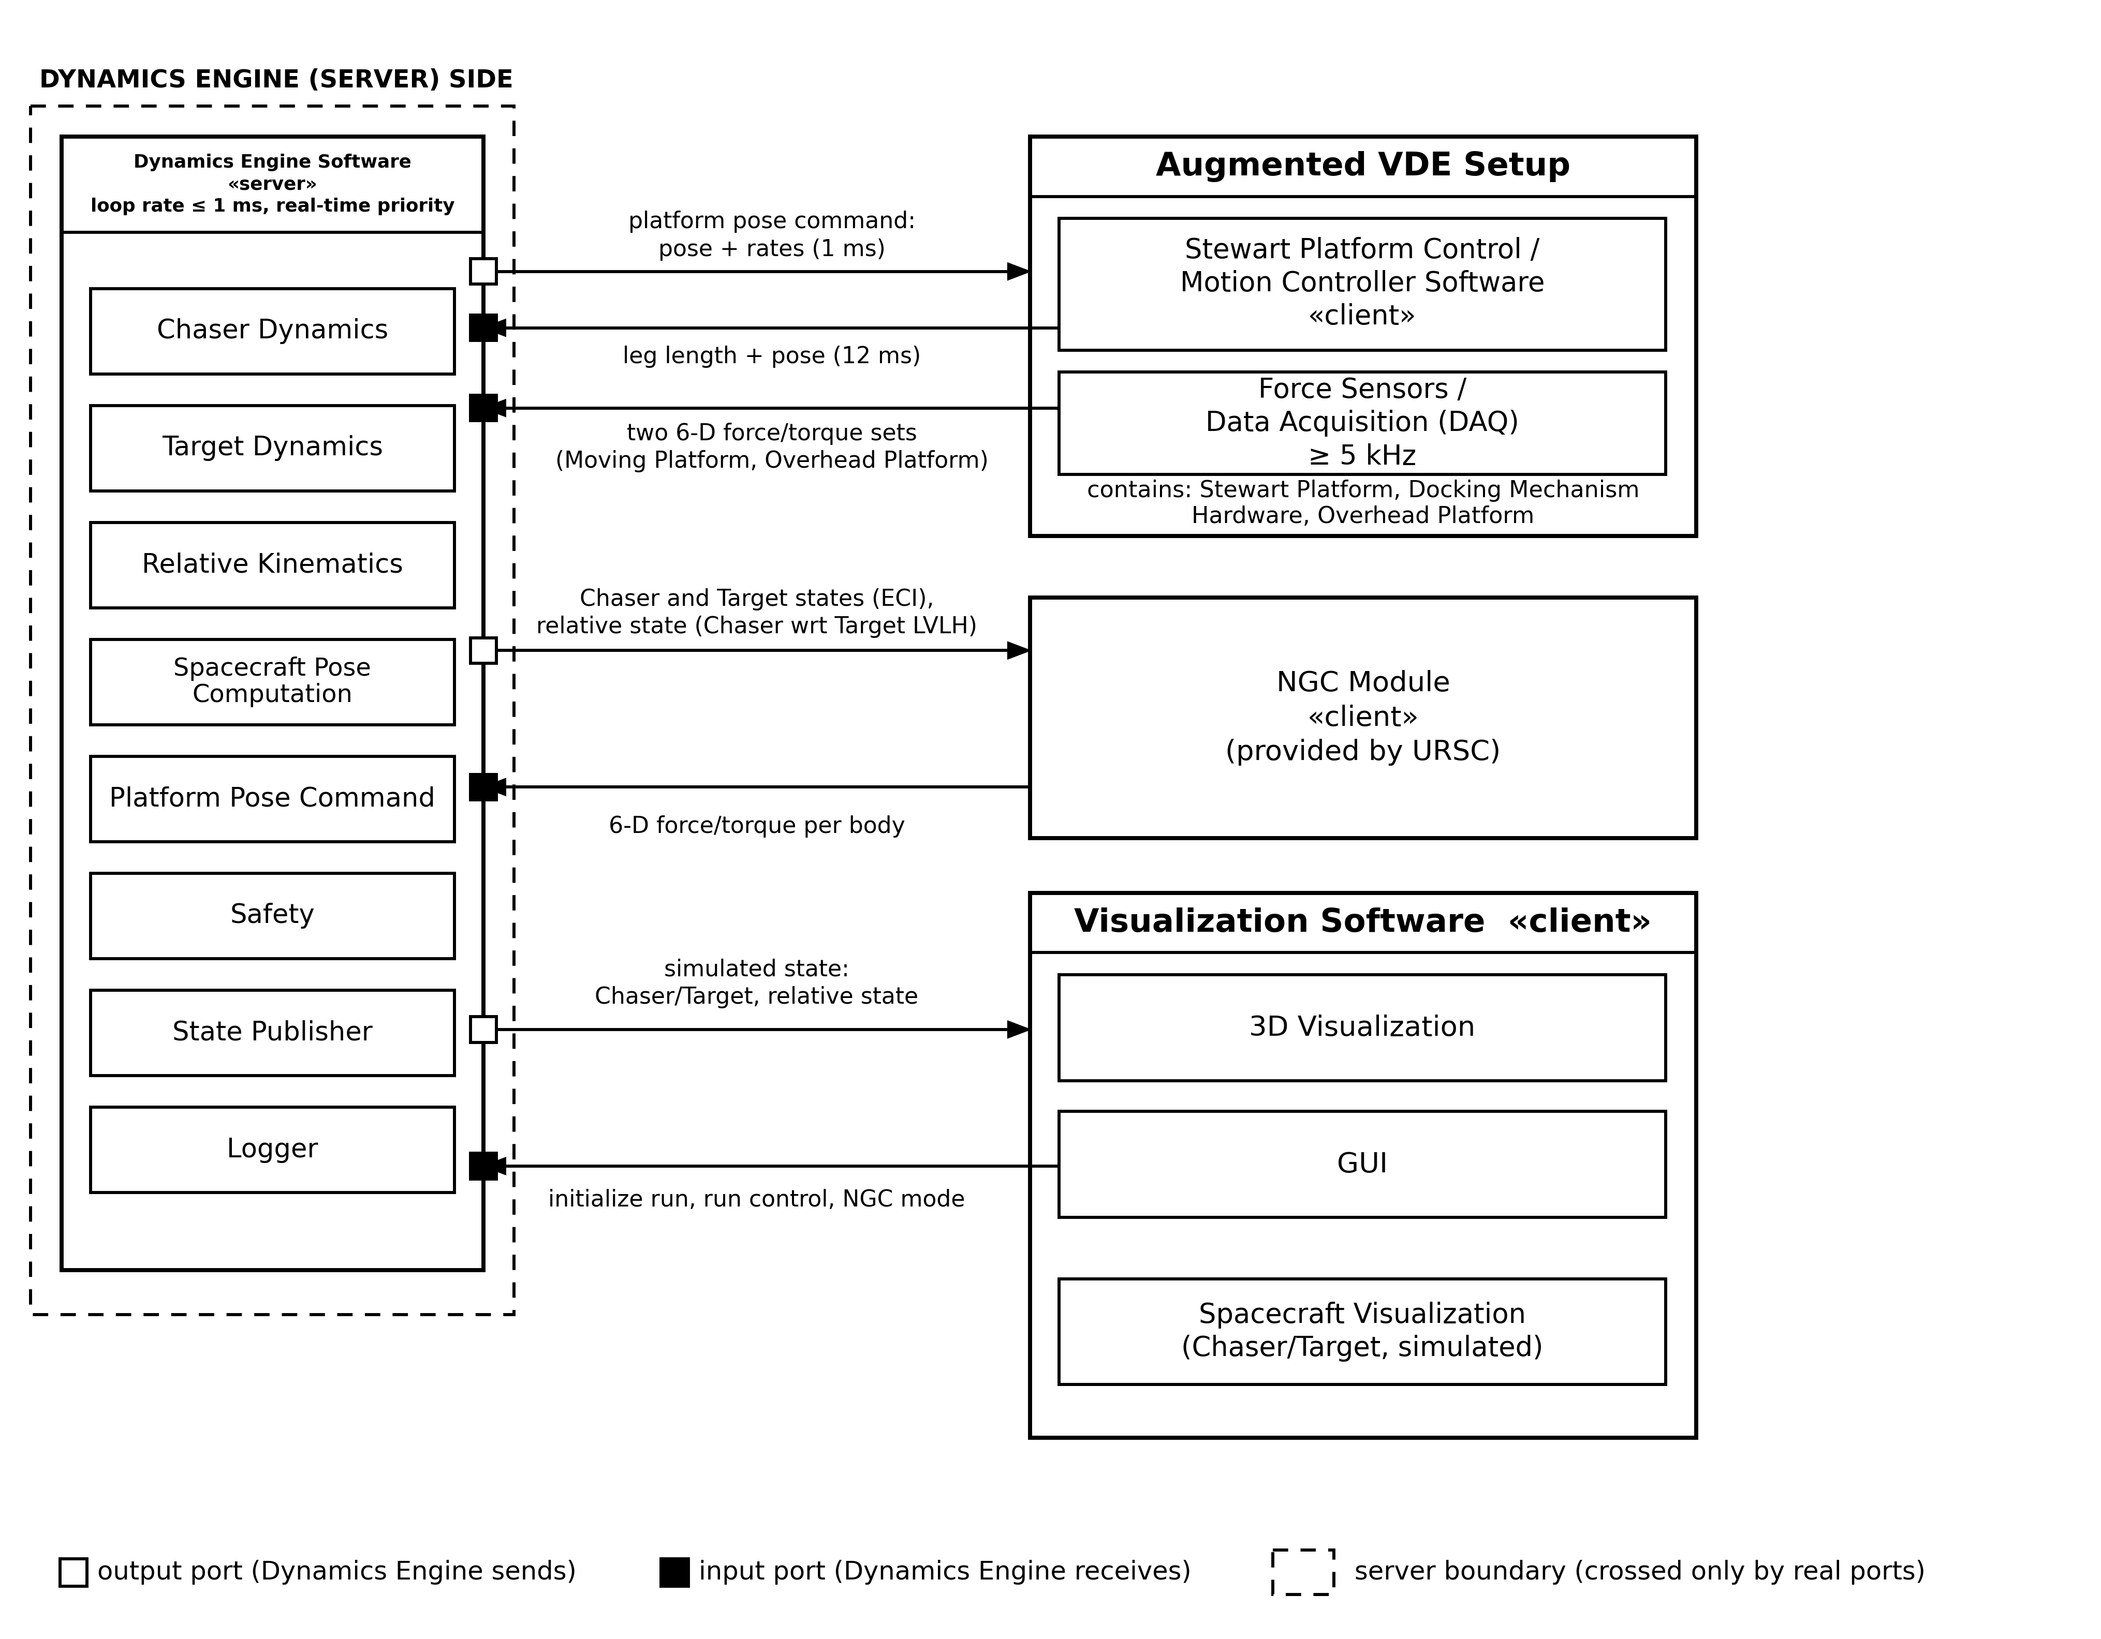
Client–server architecture of the Dynamics Engine Software. The NGC Module, the Augmented VDE Setup and the Visualization Software are all clients: each connects to the engine through its own pair of network ports, which cross the dashed server boundary.

2. System-Level Architecture
The Dynamics Engine Software is designed as a server (Figure 1). The NGC Module, the Augmented VDE Setup and the Visualization Software are all clients of the engine, and each connects to it through its own dedicated pair of network ports (white for data the engine sends, black for data the engine receives), so that a change on one side does not propagate to the others. The Visualization Software is deployed on the same workstation as the engine, in a separate thread, but it is treated exactly like the other two clients: it communicates with the engine only through its own port pair. Inside the engine, the Chaser and Target dynamics, relative kinematics, spacecraft pose computation, platform pose command, safety, state publishing and logging are separate modules.

2.1 Interface to the Augmented VDE Setup
The engine sends a platform pose command (relative position, orientation and rates) to the Stewart Platform Control / Motion Controller Software every 1 ms, and receives the leg lengths and platform pose from it every 12 ms. It also receives two six-dimensional force/torque sets (one each from the Moving Platform and the Overhead Platform) from the Force Sensors / DAQ at a rate of 5 kHz or higher.

2.2 Interface to the NGC Module
The engine sends the Chaser and Target states in the Earth-Centered Inertial (ECI) frame, together with the relative state of the Chaser with respect to the Target's local orbital frame, and receives a six-dimensional force/torque per body in return.

2.3 Interface to the Visualization Software
The Visualization Software connects to the Dynamics Engine in the same way as the NGC Module and the Augmented VDE Setup: as a client, through its own dedicated pair of network ports (Figure 1), so that the two are decoupled and run in separate threads. Two flows pass through this port pair. In one direction, the GUI sends the run initialization, run control and NGC-mode selection to the engine. In the other direction, the engine sends the live simulated state to the visualization and never waits for it, so that the visualization can never stall the 1 ms control loop. The 3D Visualization draws the newest state it has received, and a third, independent consumer, the Spacecraft Visualization, uses the same received state to render the Chaser and Target as simulated bodies in space; this path is one-way, with nothing fed back from it into the engine.
Figure 2: Component Architecture
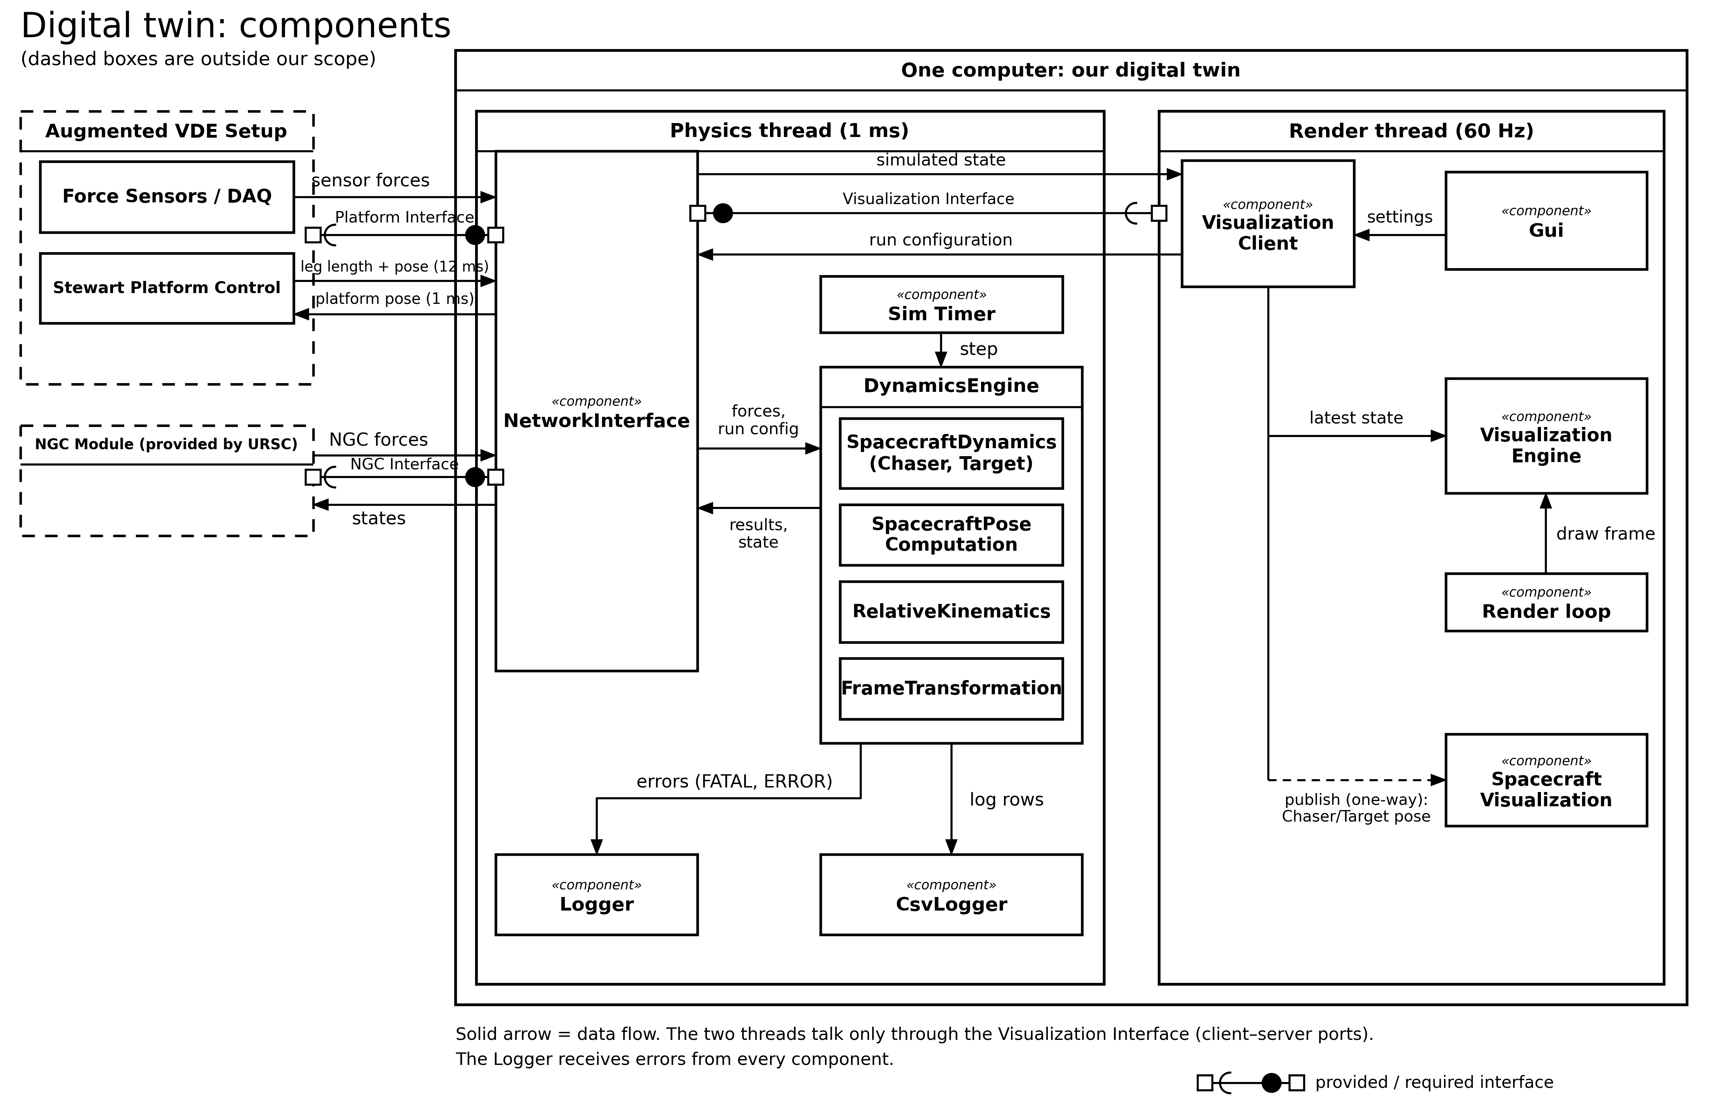
Deployment of the digital twin on a single computation workstation, showing the physics thread and the render thread. The Visualization Client in the render thread is a client of the NetworkInterface, linked through the Visualization Interface in the same way as the Augmented VDE Setup and the NGC Module. Provided and required interfaces are shown using standard ball-and-socket (lollipop/socket) notation, and each component carries the standard UML component icon.

3. Component Architecture
Both the Dynamics Engine Software and the Visualization Software are deployed on a single computation workstation, organized as two concurrent threads (Figure 2). This realizes the client–server interfaces of Figure 1 as concrete software components and data flows.

3.1 Physics Thread (1 ms)
The physics thread is driven by a Sim Timer and executes the DynamicsEngine once per cycle. The NetworkInterface component is the sole point of contact with the outside world: it receives sensor forces and the leg lengths and platform pose from the Augmented VDE Setup, force/torque values from the NGC Module and the run configuration from the Visualization Client, and it returns the computed relative state and platform pose and sends the simulated state to the Visualization Client. At start-up, the DynamicsEngine retrieves the run configuration (masses, orbit and separation) from the NetworkInterface, before the cyclic loop begins. Inside the engine, SpacecraftDynamics (instantiated once for the Chaser and once for the Target), SpacecraftPoseComputation, RelativeKinematics and FrameTransformation together perform the physics computation. Every processed cycle is logged to CsvLogger, and any error condition is reported to the Logger component.

3.2 Render Thread (60 Hz)
The render thread runs independently at 60 Hz, driven by its own render loop. The Gui component collects run settings from the operator at start-up and hands them to the VisualizationClient, which sends them to the engine through the Visualization Interface. The VisualizationClient also receives the simulated state sent by the engine and keeps the most recent one, without ever blocking the engine. The VisualizationEngine reads this most recent state to draw the 3D scene and its numerical overlay. A separate Spacecraft Visualization component receives the Chaser and Target pose from the VisualizationClient to render the Chaser and Target themselves as simulated bodies in space, independently of the Augmented VDE Setup; it only ever receives state, and never calls back into the engine.

3.3 Thread Coupling
The two threads communicate exclusively through the Visualization Interface, a client–server link built from a pair of network ports, in the same way as the NGC Module and the Augmented VDE Setup. The physics thread sends the newest state without waiting for the render thread, and the render thread keeps and draws the newest state it has received without waiting for the physics thread, so that neither thread can stall the other even though they run at different, independent rates.
Figure 3: Class Design
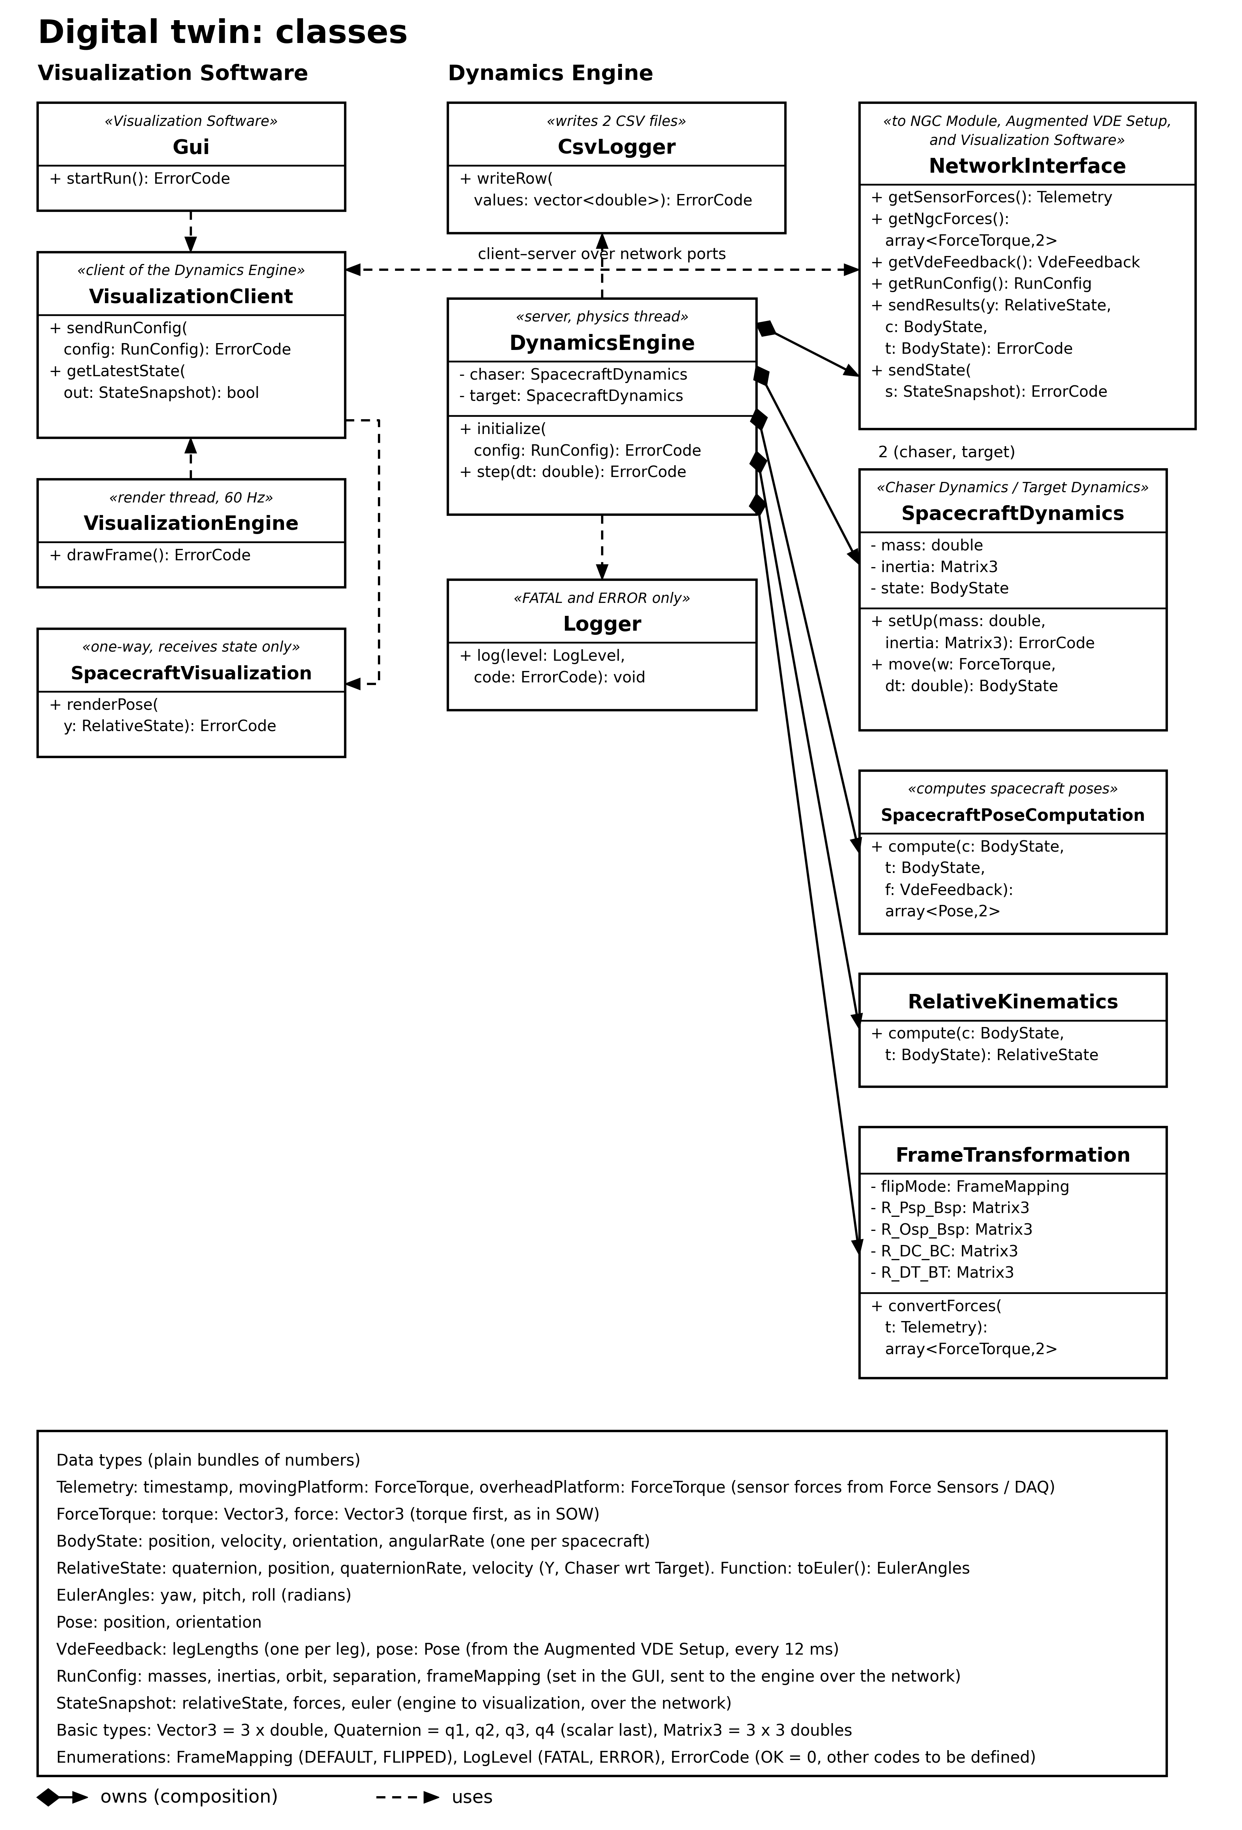
Classes of the Dynamics Engine and Visualization Software, grouped by responsibility, with composition (filled diamond) and usage (dashed arrow) relationships. The dashed double-headed arrow between the VisualizationClient and the NetworkInterface is the client–server link over network ports. Data types are summarized at the foot of the diagram.

4. Class Design
Figure 3 shows the classes inside the Dynamics Engine and Visualization Software. Each class shown here corresponds to one of the components in Figure 2, but in more detail, with its attributes, its methods, and the other classes it uses. The design deliberately keeps each class to a small, well-defined responsibility, and confines all interaction between the engine and the NGC Module, the Augmented VDE Setup and the Visualization Software to the NetworkInterface class (and, on the visualization side, to the VisualizationClient), so that the physics classes have no dependency on the transport mechanism.
Class | Responsibility
DynamicsEngine | Owns the Chaser and Target dynamics; coordinates one simulation step (initialize, step).
SpacecraftDynamics | Rigid-body propagation for a single spacecraft; instantiated once each for Chaser and Target.
RelativeKinematics | Computes the relative docking state (Chaser with respect to Target) from the two body states.
SpacecraftPoseComputation | Computes the Chaser and Target poses from their body states and the leg lengths and pose received from the Augmented VDE Setup.
FrameTransformation | Converts sensor force/torque readings into each spacecraft's body frame, using the explicit rotation matrices between the Stewart Platform, docking hardware, and body frames defined in the Annexure (Table 6).
NetworkInterface | Boundary to the NGC Module, the Augmented VDE Setup and the Visualization Software; the only class on the engine side that performs external I/O.
CsvLogger | Writes the two run logs (sensor telemetry and engine output) in CSV format.
Logger | Records FATAL and ERROR conditions raised by any component.
VisualizationClient | Client-side endpoint of the link to the Dynamics Engine: sends the run configuration to the engine and keeps the latest simulated state received from it, without blocking either side.
Gui | Collects run configuration and starts a run by handing the configuration to the VisualizationClient.
VisualizationEngine | Reads the latest received state from the VisualizationClient and renders the 3D scene and metrics overlay at 60 Hz.
SpacecraftVisualization | Receives the Chaser and Target pose from the VisualizationClient and renders them as simulated bodies in space; one-way only, with nothing fed back into the engine.

4.1 Data Types
The classes exchange plain data structures rather than passing primitive values individually. Telemetry and ForceTorque (a combined force-and-torque structure) together represent the sensor force/torque readings; BodyState represents one spacecraft's position, velocity, orientation and angular rate; RelativeState is the 14-element relative docking vector (position, velocity, and orientation as a quaternion with its rate) computed by RelativeKinematics; RunConfig carries the settings collected by the GUI at start-up and sent to the engine over the network; and StateSnapshot carries the simulated state from the engine to the visualization. Pose is a position and an orientation, and VdeFeedback carries the leg lengths and the measured platform pose received from the Augmented VDE Setup every 12 ms. All angles are expressed as quaternions internally and converted to yaw/pitch/roll (EulerAngles) only for display and logging.

4.2 Error Handling
Every method that can fail returns an ErrorCode. FATAL and ERROR conditions are reported to the Logger; a WARNING severity level is defined in the enumeration for future use but is not raised in the current design. The catalogue of specific error codes is finalized during detailed design.
Figure 4: Sequence of Operations
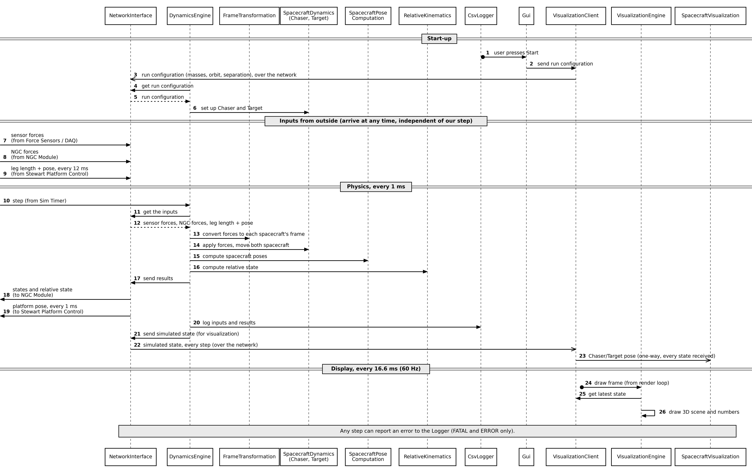
End-to-end message flow from start-up through one physics cycle (1 ms) and one display refresh (16.6 ms), expressed at the level of the classes in Figure 3.

5. Sequence of Operations
Figure 4 shows the run-time behaviour of the digital twin in four phases, corresponding to the four horizontal bands of the diagram: start-up, inputs from outside, the physics cycle, and the display refresh.

5.1 Start-Up (messages 1–6)
The operator starts a run from the GUI, which passes the run configuration (masses, initial orbit and separation) to the VisualizationClient (message 2). The VisualizationClient sends it over the network to the NetworkInterface (message 3), exactly as the NGC Module and the Augmented VDE Setup communicate with it. The DynamicsEngine retrieves it (messages 4–5) and initializes the Chaser and Target SpacecraftDynamics instances accordingly (message 6). Sensor telemetry, NGC force/torque values and, once every 12 ms, the leg lengths and platform pose from the Augmented VDE Setup may begin arriving at the NetworkInterface at any time after this point, independently of the engine's own timing (messages 7–9).

5.2 Physics Cycle, Every 1 ms (messages 10–23)
Each cycle, the DynamicsEngine retrieves the latest sensor forces, NGC forces and VDE leg lengths and pose from the NetworkInterface (messages 11–12), converts the forces into each spacecraft's body frame through FrameTransformation (13), applies them through SpacecraftDynamics to propagate both bodies (14), computes the spacecraft poses through SpacecraftPoseComputation (15), and computes the relative docking state through RelativeKinematics (16). The results are sent back out through the NetworkInterface (17): the current states to the NGC Module (18), and the platform pose command to the Stewart Platform Control (19), the latter at every step (1 ms). Every cycle is logged through CsvLogger (20). The engine also hands the latest computed state to the NetworkInterface (21), which sends it over the network to the VisualizationClient on every step without waiting for it (22); on receipt, the VisualizationClient makes the Chaser/Target pose available to the Spacecraft Visualization (23).

5.3 Display Refresh, Every 16.6 ms / 60 Hz (messages 24–26)
Independently of the physics cycle, the render loop periodically invokes the VisualizationEngine (24), which reads the latest state received by the VisualizationClient (25) and redraws the 3D scene together with its numerical overlay (26).

5.4 Error Reporting
Any step in either phase may raise a FATAL or ERROR condition, which is reported to the Logger; this path is shown once, at the foot of the diagram, rather than repeated at every message, for clarity.
Figure 5: Timing of External Interactions
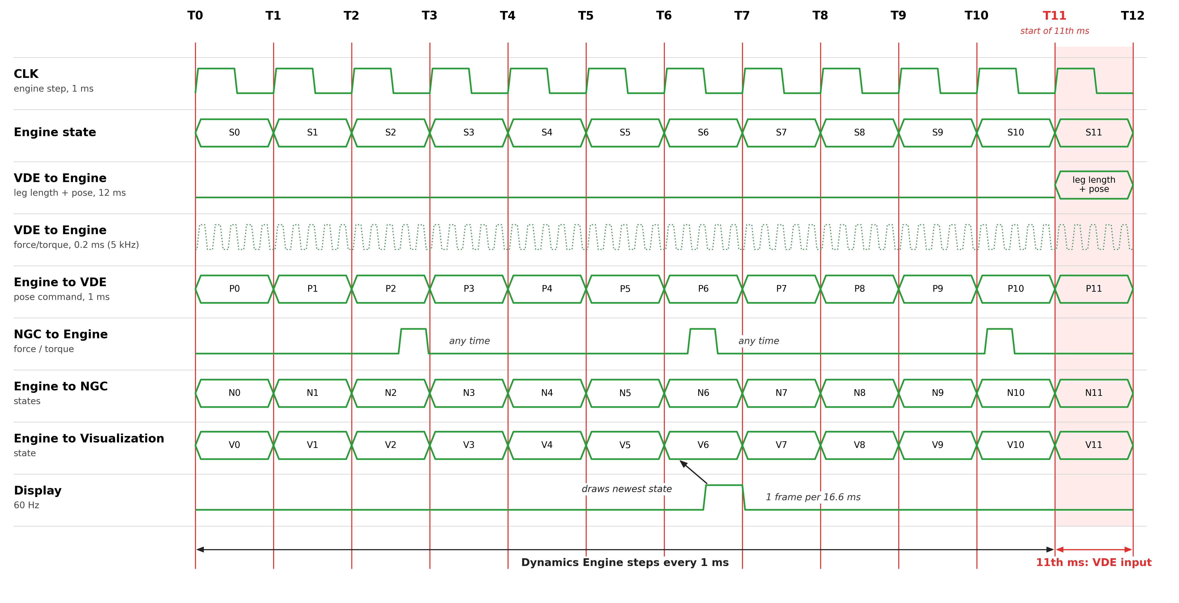
Timing of the Dynamics Engine's external interactions over one 12 ms window (T0 to T12).

6. Timing of External Interactions
Figure 5 shows when the Dynamics Engine exchanges data with the Augmented VDE Setup, the NGC Module and the Visualization Software over one 12 ms window, from T0 to T12. Unlike Figure 4, which shows the internal call sequence, it shows only the external interfaces of Figure 1 against a common time axis.

6.1 Dynamics Engine Step (every 1 ms)
The Sim Timer clock drives the DynamicsEngine: it takes one step at T0 and at every millisecond after that, so the window contains twelve steps. On each step the engine takes the newest input from each client, updates its state and sends its outputs.

6.2 Augmented VDE Setup
The Augmented VDE Setup sends the leg lengths and the platform pose once per 12 ms window, and the force/torque samples every 0.2 ms (5 kHz), shown as the dotted lane. The engine uses the newest force/torque sample at each step. In the other direction, the engine sends the platform pose command to the Stewart Platform Control at every step (1 ms).
Assumption: the VDE pose is required to be updated at least every 12 ms, so the leg lengths and pose are assumed to arrive during the 11th millisecond (T11 to T12), before the 12 ms window ends at T12. The engine uses them from the step at T12 onward, until the next update arrives.

6.3 NGC Module
The engine sends the spacecraft states and the relative state to the NGC Module at every step. The NGC Module returns a force/torque for each body whenever its own computation completes, independently of the engine clock; the engine uses the newest value at its next step.

6.4 Visualization Software
The engine sends the simulated state to the VisualizationClient at every step and never waits for it. The display redraws at 60 Hz, once every 16.6 ms, so at most one frame falls within a 12 ms window. Each frame draws the newest state the VisualizationClient has received.

