|  |
| --- |
|  |
| The Documentation |
| [Type the document subtitle] |
|  |
| **[Your Name]** |
| **[Pick the date]** |

[Type the abstract of the document here. The abstract is typically a short summary of the contents of the document. Type the abstract of the document here. The abstract is typically a short summary of the contents of the document.]

Table of Contents

[To update the table of contents, right click the message below and select Update Field (F9 on PC, ⌥⌘U on Mac).]

**No table of contents entries found.**

1. Pages
   1. Page Tree

Home  
 AmazonFrontPage  
 Today's Deal  
 Gift Cards  
 Treasure Truck  
 AmazonFrontyash

* 1. Home
     1. User Interface

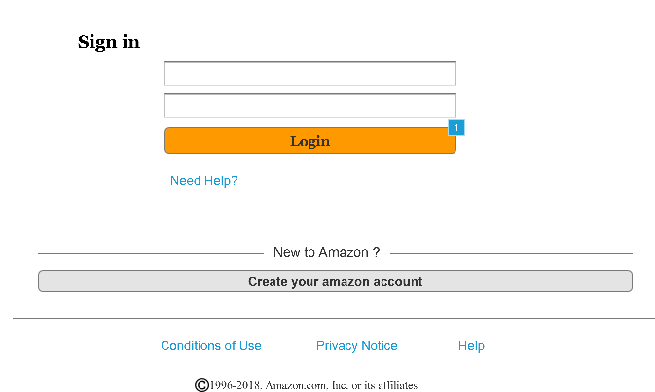

* + 1. Widget Table

| Footnote | Name | Interactions |
| --- | --- | --- |
| 1 | LoginButton | OnClick:  Case 1  (If text on EmailField equals "yash@gmail.com" and text on PasswordField equals "yash"):  Open AmazonFrontyash in Current Window  Case 2  (Else If True):  Show ErrorPanel |

* + 1. ErrorPanel
       1. State1
       2. User Interface



* 1. AmazonFrontPage
     1. User Interface

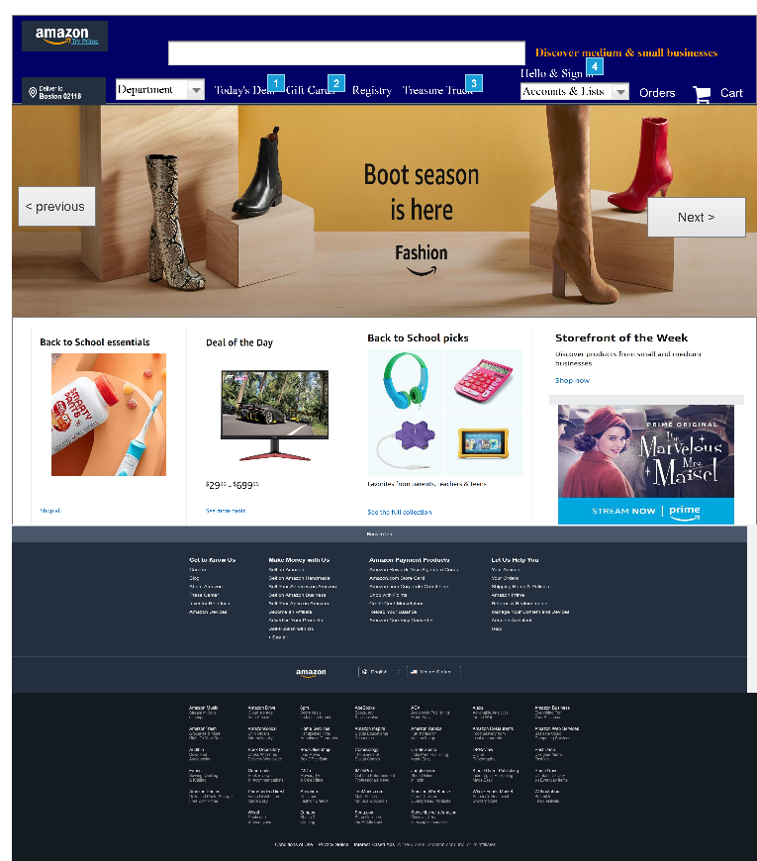

* + 1. Widget Table

| Footnote | Name | Interactions |
| --- | --- | --- |
| 1 |  | OnClick:  Case 1:  Open Today's Deal in Current Window |
| 2 |  | OnClick:  Case 1:  Open Gift Cards in Current Window |
| 3 |  | OnClick:  Case 1:  Open Treasure Truck in Current Window |
| 4 |  | OnClick:  Case 1:  Open Home in Current Window |

* + 1. image_carousel
       1. State1
       2. User Interface

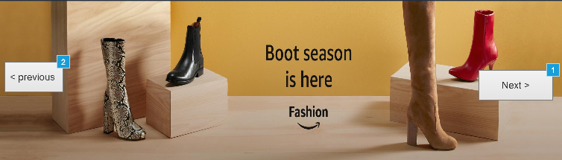

* + - 1. Widget Table

| Footnote | Name | Interactions |
| --- | --- | --- |
| 1 | next | OnClick:  Case 1:  Set image_carousel to Next wrap |
| 2 | previous | OnClick:  Case 1:  Set image_carousel to Previous wrap |

* + - 1. State2
      2. User Interface

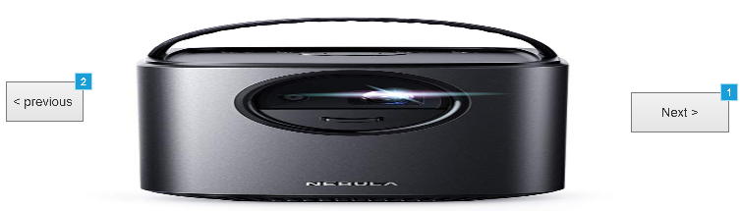

* + - 1. Widget Table

| Footnote | Name | Interactions |
| --- | --- | --- |
| 1 | next | OnClick:  Case 1:  Set image_carousel to Next wrap |
| 2 | previous | OnClick:  Case 1:  Set image_carousel to Previous wrap |

* + - 1. State3
      2. User Interface

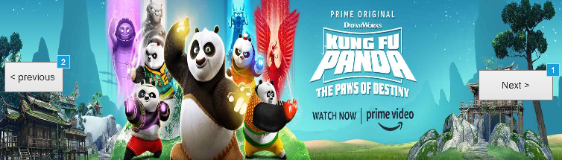

* + - 1. Widget Table

| Footnote | Name | Interactions |
| --- | --- | --- |
| 1 | next | OnClick:  Case 1:  Set image_carousel to Next wrap |
| 2 | previous | OnClick:  Case 1:  Set image_carousel to Previous wrap |

* 1. Today's Deal
     1. User Interface

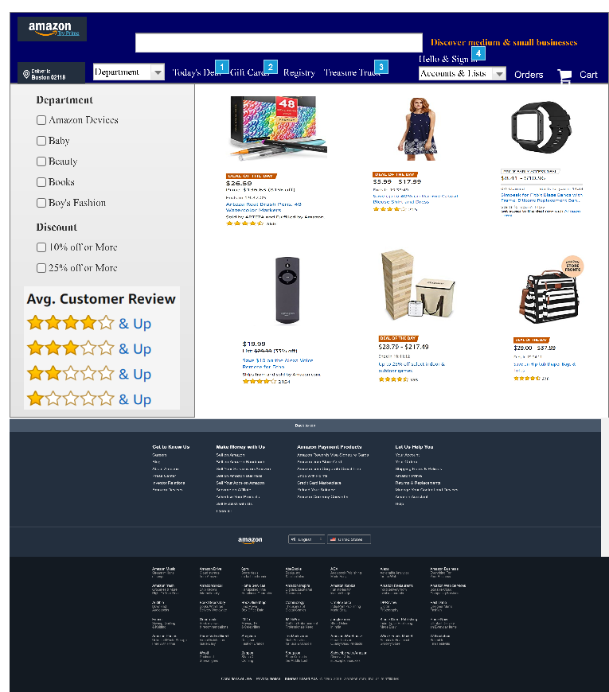

* + 1. Widget Table

| Footnote | Interactions |
| --- | --- |
| 1 | OnClick:  Case 1:  Open Today's Deal in Current Window |
| 2 | OnClick:  Case 1:  Open Gift Cards in Current Window |
| 3 | OnClick:  Case 1:  Open Treasure Truck in Current Window |
| 4 | OnClick:  Case 1:  Open Home in Current Window |

* 1. Gift Cards
     1. User Interface

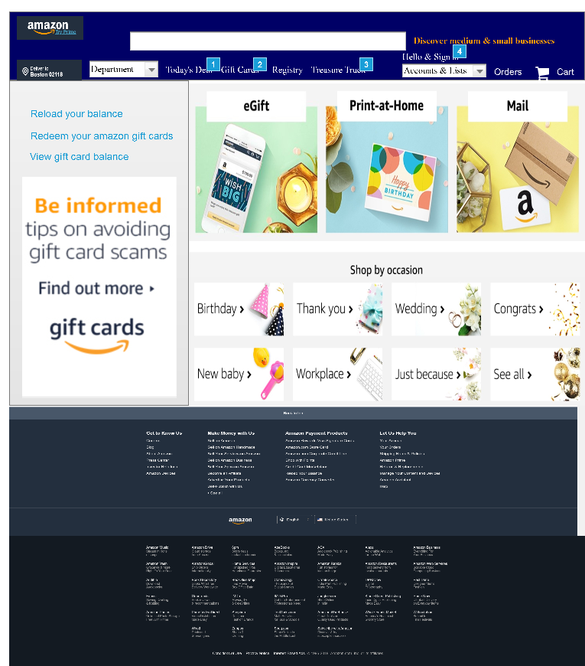

* + 1. Widget Table

| Footnote | Interactions |
| --- | --- |
| 1 | OnClick:  Case 1:  Open Today's Deal in Current Window |
| 2 | OnClick:  Case 1:  Open Gift Cards in Current Window |
| 3 | OnClick:  Case 1:  Open Treasure Truck in Current Window |
| 4 | OnClick:  Case 1:  Open Home in Current Window |

* 1. Treasure Truck
     1. User Interface

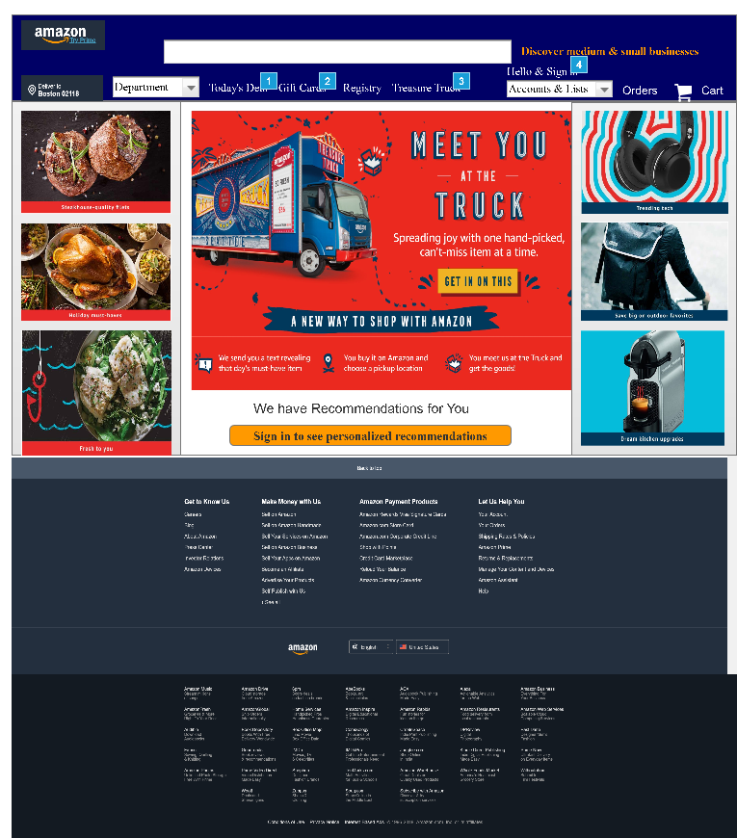

* + 1. Widget Table

| Footnote | Interactions |
| --- | --- |
| 1 | OnClick:  Case 1:  Open Today's Deal in Current Window |
| 2 | OnClick:  Case 1:  Open Gift Cards in Current Window |
| 3 | OnClick:  Case 1:  Open Treasure Truck in Current Window |
| 4 | OnClick:  Case 1:  Open Home in Current Window |

* 1. AmazonFrontyash
     1. User Interface

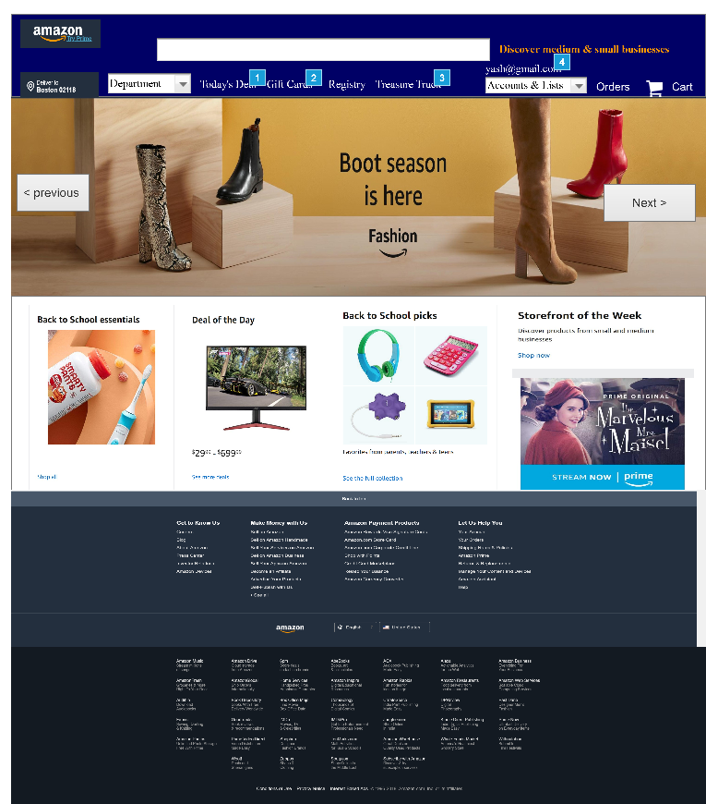

* + 1. Widget Table

| Footnote | Name | Interactions |
| --- | --- | --- |
| 1 |  | OnClick:  Case 1:  Open Today's Deal in Current Window |
| 2 |  | OnClick:  Case 1:  Open Gift Cards in Current Window |
| 3 |  | OnClick:  Case 1:  Open Treasure Truck in Current Window |
| 4 |  | OnClick:  Case 1:  Open Home in Current Window |

* + 1. image_carousel
       1. State1
       2. User Interface



* + - 1. Widget Table

| Footnote | Name | Interactions |
| --- | --- | --- |
| 1 | next | OnClick:  Case 1:  Set image_carousel to Next wrap |
| 2 | previous | OnClick:  Case 1:  Set image_carousel to Previous wrap |

* + - 1. State2
      2. User Interface



* + - 1. Widget Table

| Footnote | Name | Interactions |
| --- | --- | --- |
| 1 | next | OnClick:  Case 1:  Set image_carousel to Next wrap |
| 2 | previous | OnClick:  Case 1:  Set image_carousel to Previous wrap |

* + - 1. State3
      2. User Interface



* + - 1. Widget Table

| Footnote | Name | Interactions |
| --- | --- | --- |
| 1 | next | OnClick:  Case 1:  Set image_carousel to Next wrap |
| 2 | previous | OnClick:  Case 1:  Set image_carousel to Previous wrap |