**Activity 7: Troubleshoot a VPC**

Spurthy Mutturaj

Information Technology, Arizona State University

IFT 562: Cloud Security & Operations for IT

Daniel Wells

Sep 24, 2023

**Activity 7: Troubleshoot a VPC**

**Figure 1**

*A screenshot to confirm the flow logs were created.*

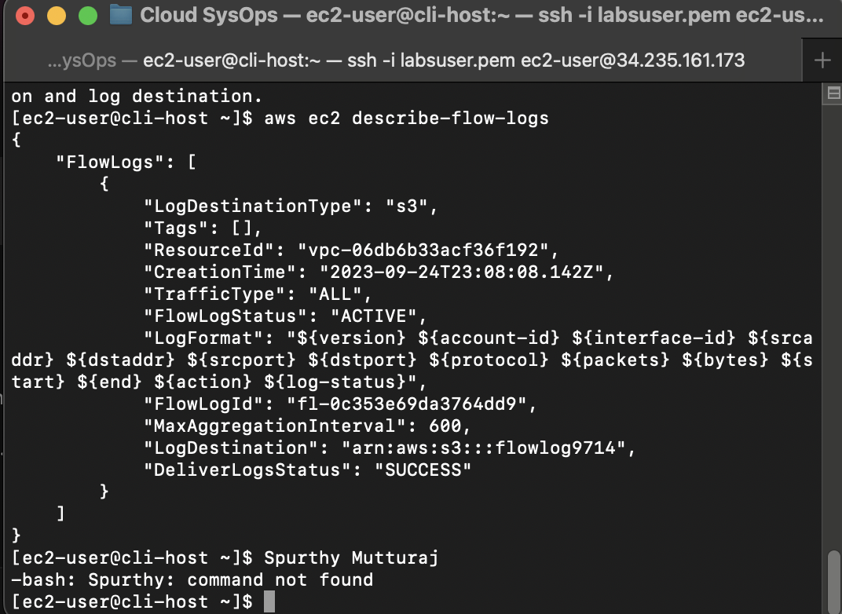

**Figure 2**

*Screenshot of command to show the EC2 instance - Web Server.*

*Note.* My name is typed in the first line (step 32).

**Figure 3**

*Screenshot of command to show the EC2 instance filtered results - Web Server.*

*Note.* Step 33.

**Figure 4**

*Screenshot of describe-network-interfaces command.*

