Lab 2: Creating Amazon EC2 Instances

Spurthy Mutturaj
Information Technology, Arizona State University
IFT 562: Cloud Security & Operations for IT
Daniel Wells
Sep 3, 2023

Lab 2: Creating Amazon EC2 Instances
Figure 1
A screenshot showing Name and Tags.
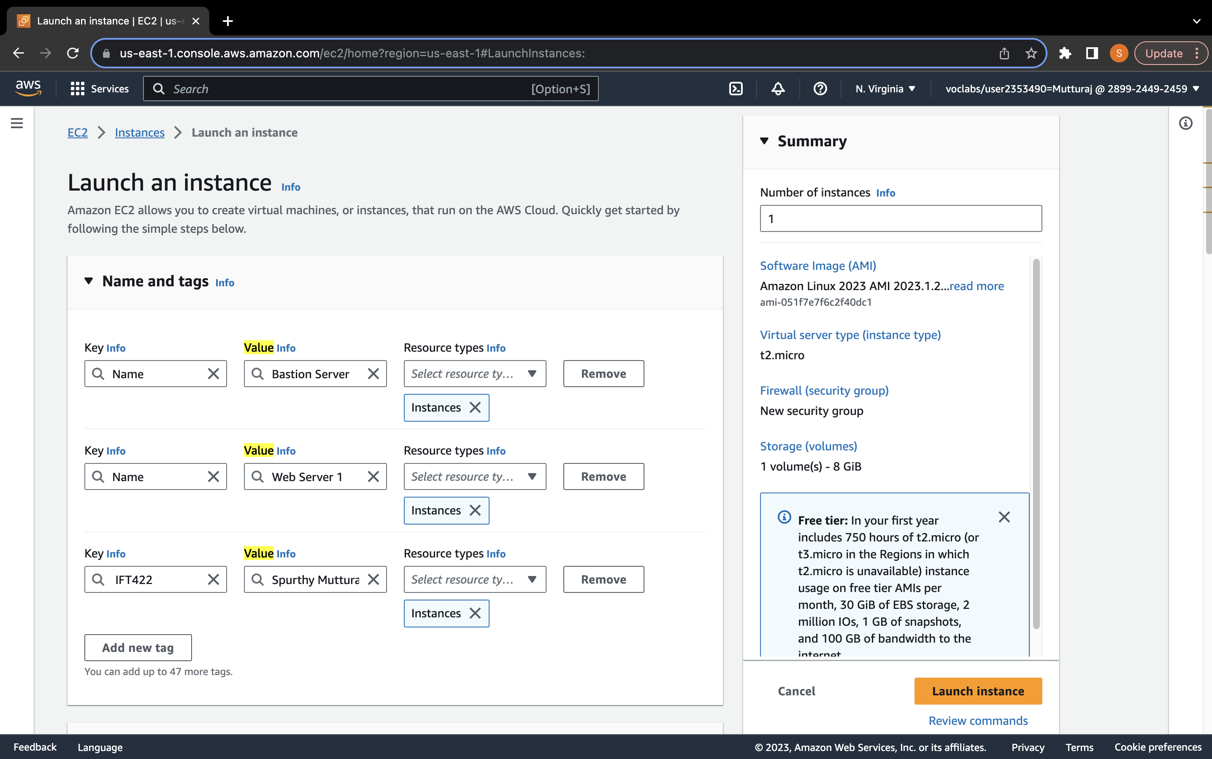

Figure 2
Screenshot of
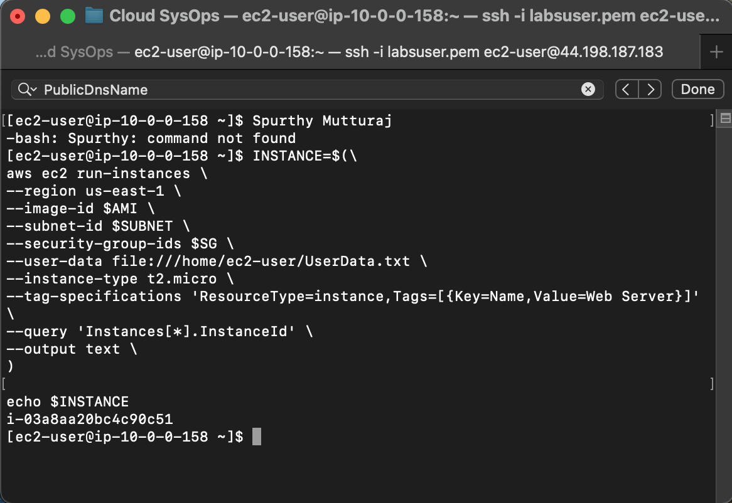

Note. The screenshot is Module1 Knowledge Check of AWS Academy Cloud Operations class.

Figure 3
Screenshot of
