**A Comparison Between New Energy Vehicles Owner Reviews**

**and Internal Combustion Engine Vehicle Owner Reviews in the Chinese Market**

Yixuan Liu

University of California, Los Angeles, Los Angeles, United States of America

Corresponding Author: ethanliu0626@ucla.edu

**Abstract.** The issue of energy has received much attention from all aspects across the world, including the automotive industry. Both policies and technology development have pushed automotive manufacturers to turn to new energy vehicles (NEVs) from traditional internal-combustion engine vehicles (ICEVs). To understand how consumers in the market perceive these two different types of vehicles, the study sets out to investigate car owners’ reviews of both types of vehicles. A total of 30000 reviews from 20 models (10 from each type) including reports of the most satisfying parts and the most unsatisfying parts of the vehicles are analyzed. The results show that the two types of car owners demonstrate differences when discussing satisfaction in dimensions of exterior design, engine power, and space. The results also show that they demonstrate differences when discussing unsatisfaction in dimensions of interior design, space, range and battery, new car pickup time, and engine power, of which the latter three are specific to vehicle type. Finally, the study also finds a stronger unsatisfied sentiment in ICEV owners’ reviews than in NEV owners’ reviews.

**Keywords**: Automotive Industry, New Energy Vehicles, Car Reviews, Consumer Perception, Consumer Satisfaction, Consumer Unsatisfaction, Natural Language Processing

1. **Introduction**

In accordance with the Goal of Carbon Peak and Carbon Neutrality of the Chinese government, the new energy vehicle industry in China demonstrates a promising prospective. By the end of 2020, China had the largest stock of NEVs in the world, with a number of 4.92 million [3]. The sales number of NEVs in 2021 in China skyrocketed to 3.52 million, which took the lead in the global market [5, 7]. The term new energy vehicles designated by the Chinese government includes battery electric vehicles (BEVs), plug-in hybrid electric vehicles (PHEVs), and fuel cell electric vehicles (FCEV). Corresponding to the NEVs are the traditional or internal-combustion-engine vehicles (ICEVs). Well-developed in the past century, ICEVs continue to be the type of vehicle that occupies the majority of the market, despite the rapid growth of NEVs.

On the consumer side, China has an unsatisfied driving population in terms of vehicles. At the end of 2021, China had 481 million licensed motor vehicle drivers, among which 444 million are automobile drivers. In 2021 alone, 27.5 million new driver’s licenses were issued [1]. The growth of the driving population drives the market demand for cars, especially NEVs.

As NEVs are increasingly competing with ICEVs for market share and have achieved significant success in recent years, it is crucial for both sides to understand the market and its consumers to survive and thrive. Along with the change of power sources (from fossil fuels to electricity) comes an overhaul of vehicles that consumers used to know. EIC system or “San Dian” System (Three Electric System – electric battery/electric motor/electric control) of NEVs’ introduces new features and functions or makes existing features more easily achieved. The change has impacted all aspects of the vehicle, including but not limited to its design, automobile-human interaction, and driving experience. How are these impacts perceived by the consumers? Do they have different recognitions or focuses for NEVs and ICEVs in terms of those features? A previous study on Douyin (the Chinese TikTok) shows that young adults who are 18-23 and live in 3-tier cities or below hold a great interest in NEVs and constitutes a great portion of potential NEV owners [1]. In the meantime, a great number of ICEV owners have the plan to acquire an additional vehicle that is expected to be an NEV [2]. Different economic and regional statuses as well as usage scenarios are bound to produce different demand focuses of consumers. As a result, knowing the answer to the previous questions could be important as it can guide not only the research and development team to improve design and manufacturing but also the marketing and sales department to target their promotion.

Thus, this study sets out to discover the difference in consumer perceptions between NEV owners and ICEV owners. More specifically, with the help of Natural Language Processing modules and KMeans clustering, the study creates clusters of tokenized words that could suggest focus factors of a vehicle when it is being reviewed and analyzes the reviews in the two interested areas - the most satisfied and the most unsatisfied about their vehicles – with cluster keyword frequency and sentiment.

1. **Methods**

The study collects car owners’ reviews posted under “Kou Bei” (“Word of Mouth”) section of a leading Chinese automotive business website, Autohome. A Chinese web scraping program called Bazhuayu is used to systematically and automatically collect review data. A total of 37275 reviews are collected and each record has six fields, which contain title, username, time, car model, satisfaction, and unsatisfaction. An example of reviews is shown below.

|  |  |  |  |  |  |
| --- | --- | --- | --- | --- | --- |
| **Title** | **User Name** | **Time** | **Car Model** | **Satisfaction** | **Unsatisfaction** |
| A Car That You Would Like to Drive Away After Test-driving | Leileilei | 2022-06-22 Posted | Tesla Model Y | Good handling, really great speakers, turn ratio is adjustable, plenty of space, good looks, pleasingly simple interior, and good vision | Seat belt button rattles with plastic part when driving; Baidu Navigation is not that useful |

For each type of vehicle, reviews of the top 10 best-selling models in the past 6 months (2022.01 to 2022.07) in the Chinese market are collected and sales ranks are retrieved from [www.16888.com](http://www.16888.com). For NEVs, a total of 15387 reviews are collected and the 10 selected models are Tesla Model Y, BYD Song PLUS New Energy, BYD Qin PLUS, Tesla Model 3, BYD Han, Li Auto One, BYD Haitun (Dolphin), BYD Tang New Energy, BYD Yuan PLUS, and GAC Aion Y. 3 models originally in the top 10 are excluded because their price ranges are below 100000, which fall far below other NEVs and their ICEV counterparts. For ICEVs, a total of 21888 reviews are collected and the 10 selected models are Nissan Slyphy, Volkswagen Lavida, Volkswagen Bora, Great Wall Motor Haval H6, Toyota Camry, Toyota Corolla, Honda CR- V, Changan CS75 PLUS, Honda Accord, and Toyota Levin. To achieve class balance, two random sample of 15000 reviews for each of the two types are selected using Python and the study only uses these two sets of reviews for analysis. The detailed numbers of reviews for each car model and type are presented in Table 1 below.

Table 1. Detailed Numbers of Reviews Collected for Each Car Model

|  |  |  |
| --- | --- | --- |
| **Type** | **Models** | **Number of Reviews Collected** |
| NEV | Tesla Model Y | 160 |
| BYD Song PLUS New Energy | 801 |
| BYD Qin PLUS | 3,899 |
| Tesla Model 3 | 215 |
| BYD Han | 3,909 |
| Li Auto One | 393 |
| BYD Haitun("Dolphin") | 896 |
| BYD Tang New Energy | 3,909 |
| BYD Yuan PLUS | 572 |
| GAC Aion Y | 393 |
| ICEV | Nissan Slyphy | 820 |
| Volkswagen Lavida | 2,735 |
| Volkswagen Bora | 1,634 |
| Great Wall Motor Haval H6 | 2,770 |
| Toyota Camry | 1,753 |
| Toyota Corolla | 40 |
| Honda CR-V | 2,557 |
| Changan CS75 PLUS | 1,190 |
| Honda Accord | 784 |
| Toyota Levin | 717 |

The Python package “Jieba” is used to process the Chinese language. An automobile-related dictionary is obtained from Sou Go Dictionaries and loaded into the package to improve its performance. The reviews are tokenized with the package and stop words are removed based on a list of Chinese stop words retrieved from GitHub [4]. More words are manually removed since they are not relevant to our topic, merely meaningless standalone, or simply referring to the car brand or model (e.g., “feel”, “a little”, “not enough”, “Corolla”, “BYD”). A Python code script that is retrieved online and was written by an online user named “Su Ge Lan Zhe Er Miao” [8] is used to generate clusters of tokenized words. The elbow Method is used to determine the number of clusters and 10 is selected (See Figure 1). Then, 10 clusters are generated using K-Means algorithms.

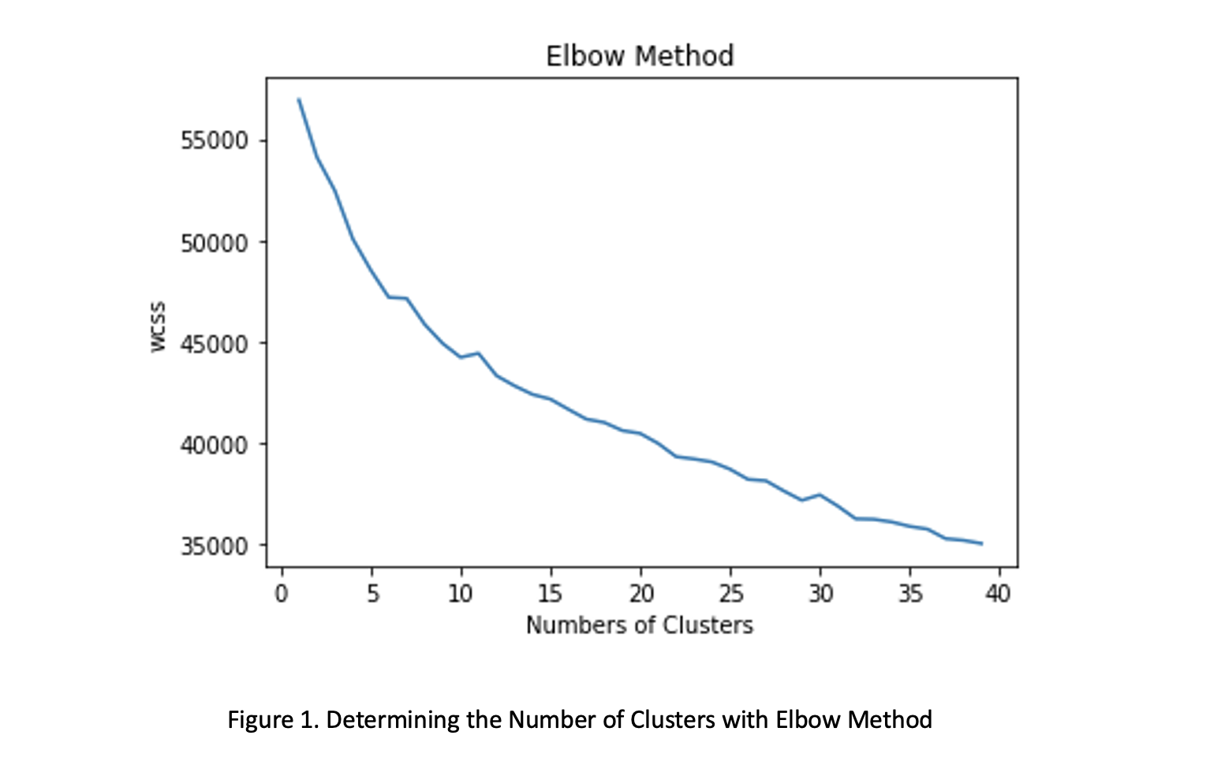

Figure 1. Determining the Number of Clusters with Elbow Method

After generating the clusters, the 20 most frequent keywords for each condition (NEV-Satisfied, NEV-Unsatisfied, ICEV-Satisfied, ICEV-Unsatisfied), 80 in total, are counted and presented with bar graphs and word clouds to be analyzed. Word clouds are generated with a Python code script retrieved online by “Qin Fen De Qing Feng” [6].

Finally, sentiment analysis is conducted on each of the four conditions using SnowNLP package and their mean scores are calculated. An individual t-test is conducted between NEV-Unsatisfied and ICEV-Unsatisfied to see if their means are significantly different.

1. **Results**

**3.1 K-Means Clustering**

A total of 10 clusters are created with tokenized and vectorized words and phrases from all reviews (Silhouette Coefficient = 0.108). The top 10 keywords for each cluster are shown below in Table 2.

Table 2. Top 10 Keywords for Each Cluster

|  |  |
| --- | --- |
| Cluster # | Keywords |
| Cluster 1 | time, car pick up, discount, wait for car, wait for car time, price, car pick up time, too long, smell, price discount |
| Cluster 2 | interior, plastic, design, smell, appearance interior, weird smell, workmanship, interior plastic, material, color |
| Cluster 3 | exterior, space, impressive, interior, design, pretty, face value, fashion, configuration, exterior impressive |
| Cluster 4 | space, back seat, trunk, fuel consumption, spacious, ride, back seat space, trunk space, configuration, space space |
| Cluster 5 | fuel consumption, fuel saving, urban area, hundred kilometers, exterior, space fuel consumption, fuel consumption fuel consumption, commute, plug in |
| Cluster 6 | soundproof, noise, effect, soundproof effect, high speed, engine, tire noise, sound, tire, not good |
| Cluster 7 | configuration, design, face value, driving, chassis, price–performance ratio, price, entity, car body, handling |
| Cluster 8 | kilometer, kilometer, range, fuel consumption, configuration, space, high speed, car pick up, price, recharging |
| Cluster 9 | seat, back seat, space, back seat seat, adjust, comfort, configuration, electric, leather, comfortability |
| Cluster 10 | power, space, fuel consumption, starting, acceleration, engine, performance, speed increase, exterior, driving, powerful |

**3.2 Word Frequency and Word Clouds**

Word frequency is calculated for each condition and word clouds are created based on the frequencies. Figure 2 through Figure 9 demonstrate the top 20 keywords ranked by their frequencies for each condition (NEV-Satisfied, ICEV-Satisfied, NEV-Unsatisfied, ICEV-Unsatisfied) along with their word clouds, respectively.

For NEV-Satisfied reviews, the top keywords are (from the most occurrences to the least) exterior, space, power, fuel consumption, face value, design, range, exterior, configuration, driving, cost-performance ratio, car model, overall, acceleration, car body, beautiful, impressive, fuel-saving, recharging, and fashion.

NEV-Satisfied

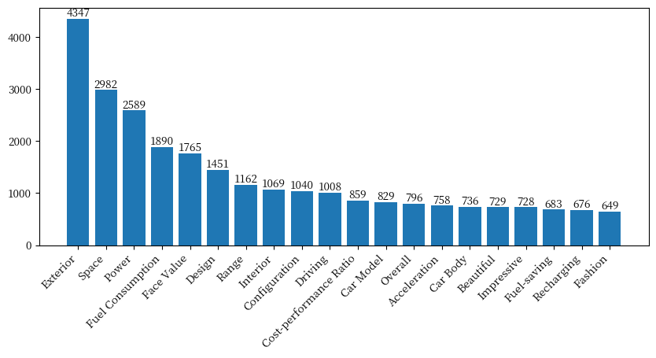

Figure 2. Top 20 Keywords of NEV Satisfied Reviews

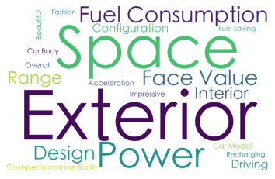

Figure 3. Word Cloud of the Top 20 Keywords of NEV Satisfied Reviews

For ICEV-Satisfied reviews, the top keywords are (from the most occurrences to the least) space, exterior, fuel consumption, power, configuration, impressive, interior, face value, beautiful, fuel-saving, cost-performance ration, design, fashion, back seat, shape, trunk, overall, high speed, car body, driving.

ICEV-Satisfied

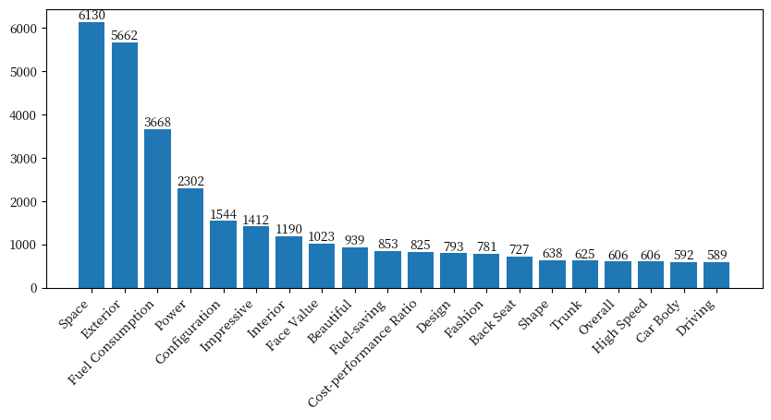

Figure 4. Top 20 Keywords of ICEV Satisfied Reviews

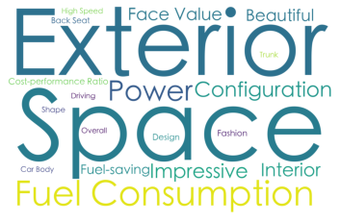

Figure 5. Word Cloud of the Top 20 Keywords of ICEV Satisfied Reviews

For NEV-Unsatisfied reviews, the top keywords are (from the most occurrences to the least) space, time, interior, car pick up, back seat, seat, noise proof, discount, high speed, smell, range, design, noise, wait for car (pick up), recharging, trunk, effect, chassis, weird smell, overall.

NEV-Unsatisfied

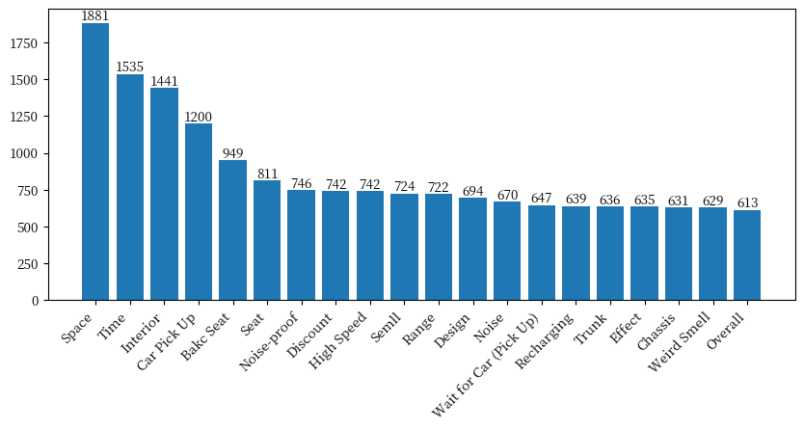

Figure 6. Top 20 Keywords of NEV Unsatisfied Reviews

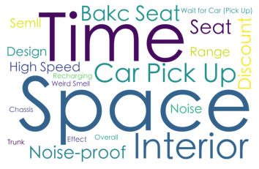

Figure 7. Word Cloud of the Top 20 Keywords of NEV Unsatisfied Reviews

For ICEV-Unsatisfied reviews, the top keywords are (from the most occurrences to the least) interior, fuel consumption, power, noise, starting, strange noise, seat, back seat, noise proof, engine, plastic, space, configuration, high speed, noise, tire noise, stiff, not good, discount, meaty.

ICEV-Unsatisfied

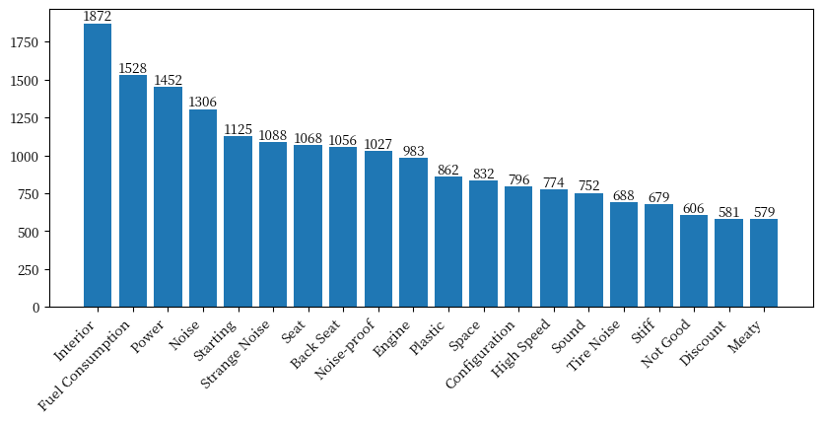

Figure 8. Top 20 Keywords of ICEV Unsatisfied Reviews

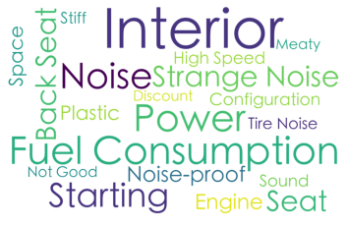

Figure 9. Word Cloud of the Top 20 Keywords of ICEV Unsatisfied Reviews

**3.3 Sentiment Analysis**

Separate sentiment analyses are conducted on the four conditions with a score of 1 being completely positive and 0 completely negative. The mean sentiment score for NEV-Satisfied is 0.80 (SD = 0.32). The mean sentiment score for NEV-Unsatisfied is 0.40 (SD = 0.37). The mean sentiment score for ICEV-Satisfied is 0.82 (SD = 0.29). The mean sentiment score for ICEV-Unsatisfied is 0.34 (SD = 0.36).

An individual t-test is conducted and the result shows that the sentiment scores of NEV-Unsatisfied and that of ICEV-Unsatisfied are significantly different (p << 0.05).

1. **Discussion**

The study aims to investigate the difference in consumers’ perceptions of NEVs and of ICEVs. To investigate this question, the study conducts analyses on the car owner reviews of the automotive business website Autohome, focusing on the parts of vehicles that they are most satisfied and most unsatisfied about. A K-Means clustering analysis is used to find focus areas of car owners when they are reviewing their vehicles. The satisfied and unsatisfied reviews for both types of vehicles are then cut and counted to get the most frequent words that could suggest car owners’ focus points in their reviews. Four lists of the top 20 keywords are created for each condition for comparison with one another. Finally, sentiment analysis is applied to see whether NEV car owners and ICEV car owners have a difference in unsatisfaction about their vehicles.

**4.1 K-Means Clustering**

The clustering analysis produces 10 clusters of words. However, it is noteworthy that these clusters are not strictly distinct, as some frequent keywords overlap across clusters (e.g., space, exterior, interior, etc.) and the silhouette score is relatively low. In addition, some clusters have no clear topics that could be concluded (Cluster 7 & 8 specifically). Despite these limitations, the clustering does provide insight into what some focus factors could be based on their top keywords. Cluster 1 focuses on time and price, mainly referring to the pick-up time for a new vehicle ordered. This corresponds to the later keyword analysis results. Cluster 2 and 3 respectively focus on the interior and exterior design of a vehicle, which captures how the vehicle looks, both inside and outside. Cluster 4 focuses on spaciousness and storage. Cluster 5 focuses on fuel consumption. Cluster 6 focuses on noise-related issues. Cluster 7 and 8, as mentioned before, present unclear topics as they have a mixture of keywords. Cluster 9 focuses on car seats and comfortability. Finally, Cluster 10 focuses on the engine, power, and handling of a vehicle. These clusters correspond to the results of a previous automotive consumers survey, recapturing several focus factors that the survey has discovered such as exterior design, cost(fuel-consumption), interior design, price, power, and handling [2].

**4.2 Word Frequencies**

To answer the research question, the study focused on the comparison between NEV owners’ reviews and ICEV owners’ ones. Using the clusters obtained, conditions can be compared in terms of their absolute number of occurrences as well as individual keyword rank orders.

**4.2.1 Word Frequencies – NEV Satisfied and ICEV Satisfied**

The top 20 keywords for NEV Satisfied and ICEV Satisfied demonstrate several distinctions. The distribution of top keywords, more specifically, the top 5 keywords appear different. For NEVs, a vehicle’s exterior design, which belongs to Cluster 3, is the single leading focus factor when owners review their vehicles, far more than space, which ranks second. On the contrary, for ICEVs, space, which ranks first, and exterior design, which ranks second, are comparably favored. The focus on exterior design in the top 5 keywords is further strengthened by other top keywords that belong to the same cluster and co-occur with the exterior design, such as face value (5th), design (15th), beautiful (16th), impressive (17th), and fashion (20th). Despite that the occurrences of Cluster 3 words total closely (9669 vs 10610), these words often co-occur with each other and simply comparing their absolute number of occurrences offers little information. Thus, the leading position of exterior design should be viewed with more consideration. This emphasis compared to other factors is likely to reflect the major customer group of NEVs – young consumers in their 20s and 30s, who would pay more attention to the appearance of their products [2]. Another possible reason is the homogeneity of NEVs in terms of both hardware and software. Models in the market usually provide similar driving experiences, which makes the look an important factor to be considered.

In the dimension of Cluster 10, which is related to engine and power, acceleration only appears in the top 20 keywords for NEV Satisfied reviews. This clearly reflects the better accelerating capability NEVs have compared to ICEVs in reality and suggests this could well be a magnetizing point for consumers who are interested in NEVs. Besides acceleration, driving receives almost two times more mentions by NEV owners than by ICEV owners. However, it is unclear whether this is a real reflection of better driving experience offered by NEVs or a misleading representation caused by the fact that NEVs are more related to auto-driving or assisted driving and that these prefixes are dismissed by the NLP algorithms. A further and detailed investigation is needed to solve this question.

Another difference is in the dimension of Cluster 4, which emphasizes space. ICEV owners mention space as their satisfying part of their vehicles over two times more than NEV owners. This may suggest one consumer-recognized advantage that most models of ICEV have over their NEV counterparts.

**4.2.2 Word Frequencies – NEV Unsatisfied and ICEV Unsatisfied**

The top 20 keywords for NEV Unsatisfied and ICEV Unsatisfied again show greater distinctions. The most obvious one is the top keywords for each type. For NEVs, space is the most unfulfilling factor while for ICEVs, the interior design is. Since Cluster 4, which emphasizes passenger seat and storage space, and Cluster 9, which emphasizes seat and space as well, are overlapping, it is impossible to tell what proportion of mentions belongs to which cluster. But if we view these two clusters as a whole, NEV owners have far more complaints in terms of space and seats in general (4277 vs. 2956), which suggests a potential disadvantage of NEVs. However, this discrepancy might also be a result of sampling bias – sampled models of ICEVs have more SUVs than those of NEVs, which might explain fewer complaints about space for ICEVs. If whether space is a real distinguishing factor between NEVs and ICEVs remains uncertain, the interior design appears to be certain. Cluster 2 emphasizes the interior design of a vehicle, and the cluster keywords suggest two aspects of the interior – smell and looks. From the top 20 keywords, the difference is obvious. The mentioning of smell and weird smell occurs frequently in NEV Unsatisfied reviews but not in ICEV Unsatisfied reviews and the indirect mentioning of looks – plastic, which in this context suggests something looks cheap – occurs frequently in ICEV Unsatisfied reviews but not in NEV Unsatisfied reviews.

Unsatisfied reviews have also uncovered several disadvantages that are more related to either NEVs or ICEVs. For NEVs, the words in Cluster 1 (e.g., time, car pick up, wait for car) are mentioned significantly frequently. This reveals a great unsatisfying concern in the NEV market – the long waiting time for new vehicle pickup. This reflects a deeper difference between NEV and ICEV market situation in terms of their sales models [11]. The sales of ICEVs usually rely on local dealers while many NEVs are sold directly to consumers by manufacturers. The direct sales model, despite saving sales costs, leaves manufacturers with few vehicles in stock as buffers and the supply can be easily disrupted by various difficulties including shortages of batteries, chips, and auto parts. In addition to pick up time, battery-related concerns are also frequent as range and recharging both appear in the top 20 keywords for NEV Unsatisfied reviews, which shows a worrying factor unique to NEVs due to their nature.

For ICEVs, different focus factors are expressed. Corresponding to the battery to NEVs, the engine raises unique concerns for ICEVs. The overwhelming number of mentions of power systems as their unsatisfaction about ICEVs might suggests a huge disadvantage of ICEVs compared to NEVs. Finally, in the dimension of Cluster 6, which focuses on noises, ICEVs fall far behind NEVs in terms of owners’ satisfaction. For ICEVs, the number of occurrences of words in Cluster 6 is more than 3 times higher than that for NEVs. This confirms the results from a previous study by McKinsey & Company that 32% of NEV consumers regard low noise as one of the top reasons why they choose NEVs [5]. The difference in power and EIC systems are very likely to contribute to this discrepancy.

**4.3 Sentiment Analysis**

Since the reviews have already had satisfaction (positive) and unsatisfaction (negative) distinctions, there is no point in conducting sentiment analysis on all the reviews. However, through the exploratory reading of reviews, it is noticed that many entries for unsatisfying part of the vehicle are actually made “reluctantly” – the website requires every user who posts reviews to fill in both the most satisfying part and the most unsatisfying part. Thus, some vehicle owners may put random or neutral reviews in the most unsatisfying part section. To confirm this, separate sentiment analyses are conducted, and the results do demonstrate that NEV owners’ unsatisfying reviews are significantly less negative than ICEV owners’ in general. This could be interpreted that ICEV owners tend to have more unsatisfying experiences with some features of their vehicles while NEVs owners tend to have less unsatisfying experiences.

The study offers some useful insights into the difference in consumer perception of NEVs and ICEVs, but it nonetheless has clear limitations. The first one is the data. Despite that the numbers of reviews are balanced between NEVs and ICEVs, the numbers of reviews for each car model within the groups are heavily imbalanced in some cases. This is largely because some models are relatively new and thus receive far fewer reviews from their owners than models which have been sold in the market for years. More importantly, there is still a huge gap between sales numbers of NEVs and those of ICEVs [2], which leads to a huge difference in consumer bases. When the sample is not balanced among car models, it is very likely that features of a certain model that do not necessarily belong to its type could be amplified or diminished based on its sample size. A second limitation is the problem of co-occurrence of keywords. In the study, keywords found in the same cluster have meanings that are close to each other. It is very likely that similar keywords may co-occur when owners are discussing a certain focus factor. This co-occurrence could, in certain cases, boost the hotness of a certain topic considering that the analysis is based on the frequencies of the keywords. Another limitation comes from the NLP tool. The study utilized “Jieba” Chinese word segmentation module to cut the reviews into single words or phrases. The module succeeds in finding most keywords, however, some phrases that are specific to the context might be lost. For example, for NEVs, one supposedly attracting factor is their high-tech elements, such as auto-driving or assisted driving as intelligentization and network connectivity have been the most expected trends of the automotive industry [1]. However, the module would cut auto and driving or assisted and driving into separate words, which would cause a loss of its original information. This might explain why the study fails to find any hint for technological aspects of NEVs.

Future studies could improve the current study in several ways. It is possible to bring in more inclusive and balanced data that would eliminate the possibility that a certain dominant car model would over-represent its type. Future studies can also take a micro view of the data instead of the macro view of the current study – for instance, by looking closely at each review and analyzing its topic individually based on certain classifying processes. They can also improve the NLP processes by introducing more industry-specific dictionaries as references for the word segmentation module to produce better word segmentation that serves the purpose.

1. **Conclusion**

The results show that NEV owners and ICEV owners do have different focuses when reviewing their vehicles while similarities exist. For satisfaction, similar as they are, NEV owners show great favor on the exterior of their vehicles as well as their power while the space of ICEVs is considered an advantage. For unsatisfaction, more differences emerge as NEV owners reasonably complain more about the space while ICEV owners complain about the interior design of their vehicles. Type-specific concerns are also brought up as new vehicle pick up waiting time and recharging are mentioned for NEVs and engine problems are pushed into the spotlight by ICEV owners. The results also show that owners of the two vehicle types have significantly different average unsatisfaction towards their vehicles, of which NEVs receive less negative reviews in general.

The current study has limitations due to the sample and the analyzing tool. Both the imbalance of car models represented in the sample and co-occurrence could introduce biases to the results. The unintentional cutting of keywords or key phrases might omit information that provides more insights. A more inclusive and detailed analysis is needed for deeper insights into the consumer perception difference between NEVs and ICEVs.

The need for a clear understanding of the consumer is imperative as the market of NEVs is booming across the globe. The current study has discovered several differences between the consumer perception of NEVs and that of ICEVs. Yet broader, deeper, and longer analyses would expand on the findings and help business decision-makers to make the right decisions.

1. **Literature Reference**
2. Accenture, Dian Dong Qi Che: Bu Zhi Yu Dong Li Xi Tong De Ge Xing, 2021
3. China Automotive News, China Association of Automobile Manufacturers, Ocean Engine, TrendInsight Ocean Engine, Beijing Jintaijue Brand Planning Co.Ltd. White Book on the Development Trend of New Energy Vehicles, 2022.
4. China EV100, DongCheDi, Ocean Engine TrendInsight, China New Energy Vehicle Market Insight 2021, 2022.
5. He Hui, Jin Lingzhi, How China put nearly 5 million new energy vehicles on the road in one decade, 2021.
6. lighting66ban, Lighting66ban/stop-word: Zhi Shi Tu Pu - NPL Chu Li De Ji Chu - Ting Yong Ci, GitHub. 2018.
7. McKinsey & Company, 2021 Qi Che Xiao Fei Zhe Dong Cha, 2022.
8. Pang Junwen, Shi Yan, Mou Junyu, 2021 Nian Quan Qiu Xin Neng Yuan Qi Che Shi Chang Hui Gu, 2022.
9. Qin Fen De Qing Feng, Python Gen Ju Ci Pin Zi Dian Huo Zi Fu Chuan Hui Zhi Ci Yun Tu. Python Gen Ju Ci Pin Zi Dian Huo Zi Fu Chuan Hui Zhi Ci Yun Tu_Qin Fen De Qing Feng De Bo Ke-CSDN Bo Ke_Gen Ju Zi Dian Sheng Cheng Ci Yun, 2018.
10. Sales of new energy vehicles in December 2021 - China Association of Automobile Manufacturers(CAAM), 2022
11. Su Ge Lan Zhe Er Miao, [NLP Wen Ben Ju Lei] Shi Yong k-means Dui Wen Ben Shu Ju Jin Xing Ju Lei, heywhale.com, 2019.
12. Wang Zhan, Wei Shen Me Xin Neng Yuan Qi Che Ti Che Shi Jian Chang, 2022