A Fail-Safe String-Level Reconfigurable Battery Management System Using Discrete Back-to-Back P‑MOSFET Switches: Design and Rover Validation on a 3S2P Li-Ion Pack
Harshwardan Patil, Krish Rajgor, Nihar Lad, Dr. Anjana Rodrigues
Department of Electronics and Telecommunication Engineering
Mukesh Patel School of Technology Management & Engineering (MPSTME)
SVKM’s NMIMS (Deemed-to-be University), Mumbai, India

Abstract—Lithium-ion strings that are hard-wired in parallel cannot isolate one faulted string without disconnecting the whole pack. This paper presents the design, firmware and hardware validation of a string-level reconfigurable battery management system (BMS) for a 3S2P Samsung INR18650-30Q pack that powers a tracked mobile rover. Each string, and the load, is switched by a bidirectional high-side channel built from a common-source back-to-back IRF4905 P-channel MOSFET pair and a discrete NPN level shifter; base pull-down resistors hold every channel open whenever the microcontroller is in reset or unpowered. Firmware on an STM32F446RE runs a deterministic 20 ms loop in which a latching safety layer may only open switches, and a separate reconfiguration state machine is the only code permitted to close one. A close is allowed only after an inter-string voltage gate that bounds the true difference below 100 mV under load, break-before-make confirmed by current readback, and a 500 ms cooldown; any state the controller cannot explain forces a reset-only lockout. The unmodified safety and reconfiguration modules passed 22 and 18 host-simulated scenarios and 800 randomized runs without an invariant violation. On hardware, the level shifter produced a gate-source voltage of −10.8 V, both sensors reported string voltages with zero I²C errors across all switching states, and on the rover an injected over-current isolated the affected string while the other string kept the rover driving in 20 of 20 trials for each string. The absence of per-cell sensing, temperature sensing and a precharge path is stated as a limitation.
Index Terms—Battery management system, reconfigurable battery, fault isolation, bidirectional MOSFET switch, functional safety, embedded firmware, mobile robot.
I. Introduction
Battery packs for electric vehicles, mobile robots and stationary storage connect cells in series to reach the bus voltage and connect series strings in parallel to reach the required capacity. In a conventional pack these connections are fixed, and the performance and safety of the whole pack are limited by its weakest cell [1]. When one string develops a fault, a fixed-parallel pack offers only two responses: keep operating with the faulted string connected, or open the pack contactor and lose all power. For a mobile platform the second response stops the mission.
Reconfigurable battery systems (RBS) replace fixed connections with controllable switches so that the topology can change at run time [1], [2]. Reported benefits include fault tolerance, reduced balancing effort and, in system-level studies, extended pack lifetime [1], [3]. The cost is additional switching hardware, whose losses and complexity are a recognized challenge [2], [4]. Control of such systems ranges from rule-based logic to optimization and learning methods [5], [6].
This work targets the simplest useful granularity: switching at the level of whole series strings rather than individual cells. The objective is not to maximize energy but to guarantee that a faulted string can be removed from a live bus while the healthy string continues to supply the load, and that the switches never create a hazard of their own. Two hazards dominate. First, a single MOSFET will not block current in both directions due to the body diode that exists in a MOSFET, meaning that an ‘open’ string can still pass current to the bus. Second, if a string is closed onto a bus at a different voltage, a current circulates through the string and is only limited by the small loop resistance. The contributions of this paper are: • A bidirectional high-side string switch built from discrete parts (back-to-back P-channel MOSFETs and an NPN level shifter), with design equations, a fail-safe default-off mechanism, and a documented topology error that an ordinary on/off bench test does not reveal. • A layered firmware architecture in which a latching safety layer can only open switches and a separate reconfiguration module is the only code that can close one, subject to five enforced guarantees. • A paralleling gate that bounds the true inter-string voltage difference under load without knowing the exact path resistance. • Verification at three evidence levels, reported separately: calculation, host simulation of the unmodified firmware with fuzzing and mutation testing, and bench and rover tests on fabricated hardware. Throughout, results are labelled by their source. The results from simulations are not considered to be measurements, and the system is considered to be a proof of concept for ISO 26262 and IEC 61508 concepts, without claiming compliance.
II. Related Work
In related work, Han et al. [1] review BMS hardware that is reconfigurable, management principles and optimization, and they identify fault tolerance as one of the important advantages of reconfigurable BMs hardware: If there is a fault in a fixed configuration, it can spread to neighbouring cells. Steinhorst et al. [2] discuss reconfigurable and distributed battery-management architectures and note that the limited energy efficiency of the extra hardware is a key challenge. Tang et al. [4] classify reconfigurable topologies by the number of switches per cell, which makes the switch-count cost of fine-grained reconfiguration explicit. Pinter et al. [5] review control algorithms for RBS and group them by control strategy and implementation aspects such as reconfiguration frequency and control topology.
At system level, Škegro et al. [3] model electric-vehicle packs and report that dynamic reconfiguration can extend battery lifetime by more than 20%, particularly at high pack voltage; this figure is their modelled result and is not claimed for the present system. Morstyn et al. [9] demonstrate distributed state-of-charge balancing between the modules of a reconfigurable storage system, using a current controller that prevents current spikes during topology transitions, on four 6 V lead-acid modules. Lemeon and Regash [10] propose a reconfigurable pack for fault isolation and lifetime extension and evaluate it in MATLAB/Simulink. Canilang et al. [11] present a modular fault-tolerant BMS with module-, component- and ground-level isolation, and Gao et al. [12] implement real-time fault diagnosis and protection on a 12-cell series pack. Zhao et al. [6] estimate state of charge in reconfigurable modules with a deep-learning model.
The present work differs in emphasis. It uses string-level rather than cell-level switching, discrete components rather than gate-driver ICs or converters, and rule-based logic whose every closing decision is gated by sensor-confirmed conditions. It is evaluated on fabricated hardware in a moving vehicle rather than in simulation alone.
III. System Architecture
A. Pack and Platform
The pack consists of two strings, A and B, each of three Samsung INR18650-30Q cells in series (3S1P). Table I lists the cell ratings used in this work, taken from the manufacturer specification [13], and the string values derived from them. The test platform is a tracked differential-drive rover with two brushed DC motors driven by an L298N dual H-bridge module, and a manual kill switch in the power path (Fig. 1).
TABLE I
Cell Ratings and Derived String Values
Quantity | Value | Source
Cell nominal voltage | 3.6 V | [DS] §3.2
Cell charge voltage | 4.20 ± 0.05 V | [DS] §3.3
Cell discharge cut-off | 2.5 V | [DS] §3.8
Max. continuous discharge | 15 A (25 °C) | [DS] §3.7
Rated charge current | 4 A | [DS] §3.4
Standard discharge capacity | ≥ 2950 mAh | [DS] §7.3
Initial impedance (AC 1 kHz) | ≤ 26 mΩ | [DS] §7.5
String nominal / max. / min. | 10.8 / 12.6 / 7.5 V | Calc. (×3)
IRF4905 R_{DS(on)} max. | 20 mΩ at V_{GS} = −10 V | [14]
IRF4905 V_{GS(th)} | −2.0 to −4.0 V | [14]
[DS] = cell specification [13].
TABLE II
Symbols Used in (1)–(3)
Symbol | Meaning | Value and source
I_{B} | NPN base current | Calculated, (1)
V_{D} | 1N5400 forward drop in base path | 0.6 V, typical value (assumed)
V_{BE} | NPN base–emitter drop | 0.7 V, typical value (assumed)
R₁, R₂, R₃ | Base resistor, base pull-down, gate pull-up | 1 kΩ, 100 kΩ, 10 kΩ (PCB netlist)
I_{C,sat} | NPN collector current in saturation | Calculated, (2)
V_{CE(sat)} | NPN saturation voltage | 0.3 V; datasheet max. at I_{C} = 150 mA [15], used as upper bound at ≈1 mA
V_{SRC} | Source-node voltage (= string voltage when on) | 11.9 V, assumed operating point; bench 11.86–11.96 V
V_{GS(on)} | Gate–source voltage, switch on | Calculated, (3)
[15] = onsemi P2N2222A datasheet, as numbered in the paper’s reference list.

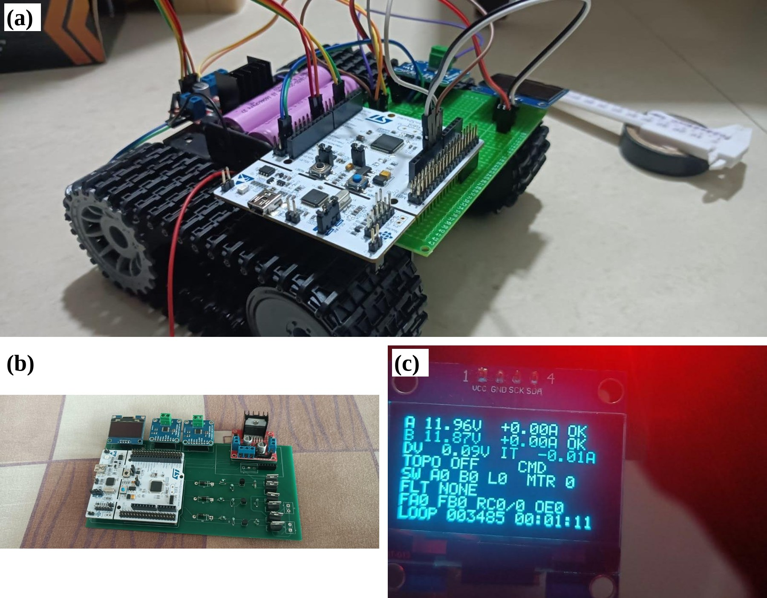
Fig. 1. Hardware.
Fig. 2 shows the power path. String A and string B each reach a common node (BUS).
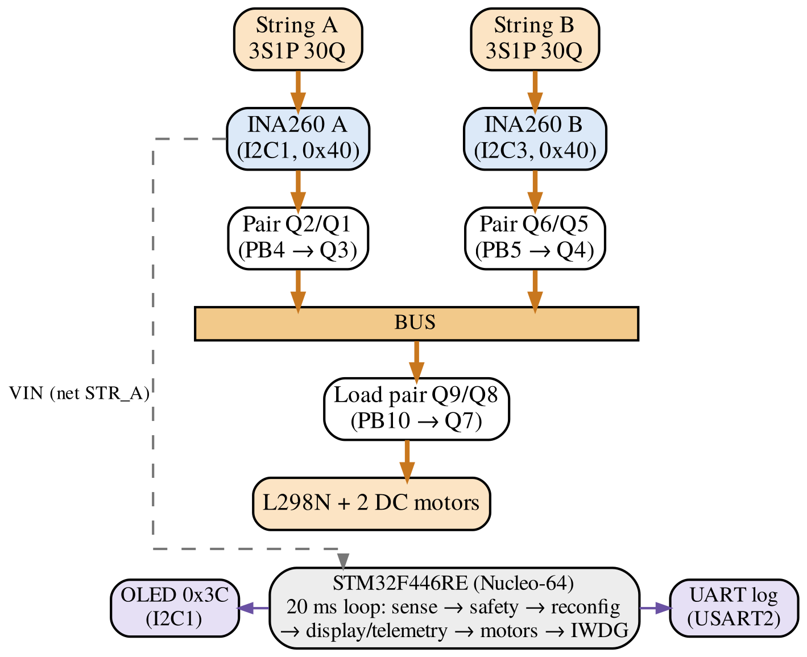
Fig. 2. Power path and control architecture.
B. Bidirectional High-Side Switch
Each channel (Fig. 3) uses two IRF4905 P-channel MOSFETs [14] whose sources are joined at a node (SRC_A, SRC_B or SRC_load in the netlist) that connects to nothing except the two sources and the 10 kΩ gate pull-up. The drains face outward, one to the string and one to the bus. The two body diodes therefore point toward the common source node. With both devices off, current from the string forward-biases the first body diode and reverse-biases the second; current from the bus does the opposite. Both directions are blocked, which a single device cannot achieve.
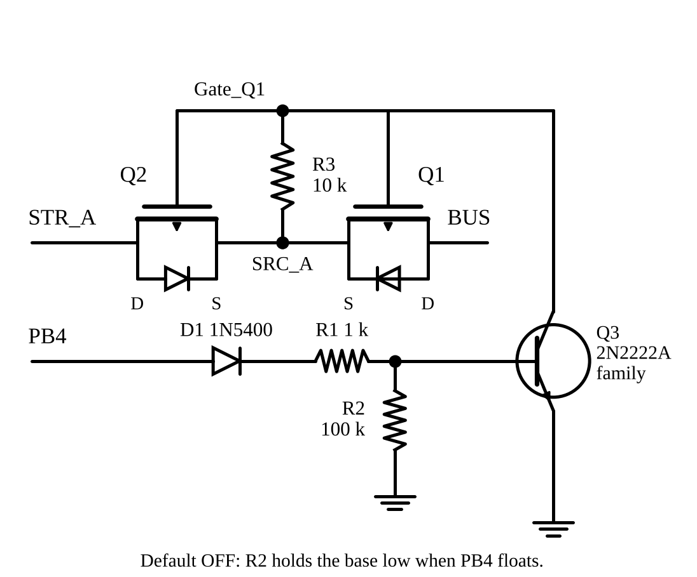
Fig. 3. One switch channel (string).
This arrangement was not reached directly. In earlier versions of the breadboard and the first schematic both sources were tied to the battery rail. That circuit still switches the load on and off, so a functional test passes, but one MOSFET is bypassed by copper and one direction conducts through a body diode regardless of the gate. An isolated string could then receive current from the bus through the path resistance. The error recurred in three representations of the circuit and was finally caught by reading the generated netlist, in which a correct channel produces a three-node net containing exactly two MOSFET sources and one resistor.
C. Level-Shifter Gate Drive
The STM32 GPIO provides 0 V or 3.3 V, whereas the IRF4905 needs its gate pulled about 10 V below its source. A GPIO cannot do this, and connecting it to the 11 V gate node would damage it. An NPN transistor of the 2N2222A family [15] performs the level shift: when signal pin is high, base current flows through a 1N5400 diode and a 1 kΩ resistor, the transistor saturates, and it pulls the shared gate node down. With the values of Fig. 3 at a string voltage of 11.9 V (all values calculated, with typical junction drops assumed):
I_{B} = (3.3 − 0.6 − 0.7) / 1 kΩ − 0.7 / 100 kΩ ≈ 1.99 mA (1)
I_{C,sat} = (11.9 − 0.3) / 10 kΩ = 1.16 mA (2)
The datasheet minimum DC gain is h_{FE} = 50 at I_{C} = 1 mA and V_{CE} = 10 V [15], so the available collector current exceeds the required 1.16 mA by a factor of about 50 × 1.99/1.16 ≈ 86, which drives the transistor deep into saturation. The resulting gate-source voltage is
V_{GS(on)} = V_{CE(sat)} − V_{SRC} ≈ 0.3 − 11.9 = −11.6 V. (3)
This exceeds the worst-case value of −4.0 V and the value at which RDS(on) is guaranteed (RDS(on) min = −10 V) [14]. It is approximately −12.3 V at 12.6 V on the string (at full string), which is within the ±20 V gate rating. There is a lower limit on the voltage (at 7.5 V) which drops down to approximately −7.2 V, which is still within the voltage limit but not within the specified RDS(on) condition; the on-resistance is then higher than the maximum specified in the datasheet, and this is covered with margin in Section IV- C.
When the GPIO is low, no current flows in the 10 kΩ resistor, so gate and source sit at the same potential and V_{GS} = 0 V. The pull-up returns to the floating source node, not to the battery rail; returning it to the rail would leave V_{GS} at about +0.7 V because the source node settles one diode drop below the string. Turn-off is limited by the pull-up charging both gates on the shared net. Using the datasheet maximum gate charge of 180 nC per device [14], which is specified at a higher drain current and voltage and is therefore an upper bound, the turn-off time with |V_{GS}| ≈ 10 V is approximately
t_{off} ≈ 2Q_{g}R₃ / |V_{GS}| ≈ 0.36 ms (4)
(2 × 180 nC × 10 kΩ / 10 V), about 55 times shorter than one 20 ms control cycle. In the firmware, however, break-before-make is proven by current readback, not by this timing estimate (Section IV-C).
Conduction loss per closed pair is I²· 2R_{DS(on)}. With the 20 mΩ maximum per device, a 1.19 A load (a 10 Ω test resistor at 11.9 V) dissipates 1.19² × 0.040 ≈ 57 mW per pair (calculated).
D. Fail-Safe Default State
During reset, boot or brown-out the GPIO pins are high-impedance. The 100 kΩ base pull-down holds each NPN off in that condition, so every pair is open and every string is disconnected without any software action. In firmware, the switch pins are written low through the GPIO bit set/reset register before they are configured as outputs, and the error handler forces all three pins low with a single register write before disabling interrupts, without calling any library function that might itself have failed.
E. Sensing, Display and Telemetry
Each string has a Texas Instruments INA260 current, voltage and power monitor with an integrated 2 mΩ shunt, 1.25 mA current resolution and 1.25 mV bus-voltage resolution [16]. The breakout modules have their address pins fixed, so both respond at 0x40. Instead of adding an address translator, the two sensors were placed on separate buses: sensor A on I2C1), which it shares with a 128×64 OLED at 0x3C, and sensor B on I2C3. The sensors are wired into each string with external leads, upstream of the string switch, so that each sensor reads its own string voltage even when the string is disconnected. This placement is a precondition for the paralleling gate of Section IV-C. Status is shown on the OLED, one display page per control cycle, and logged as comma-separated values over the ST-Link virtual COM port (USART2).

IV. Firmware Architecture
A. Deterministic Control Loop
The firmware is a tick scheduled super-loop with the following period: 20ms and order: (1) Read both sensors, (2) Run the safety layer, (3) Run the reconfiguration state machine, (4) Process operator and bench commands, (5) Assemble a status snapshot, (6) Send one OLED page or a telemetry line, (7) Gate the motor driver, (8) Toggle a heartbeat LED, (9) Refresh the independent watchdog (IWDG). Safety runs occur after sensing and before anything that can close a switch. The watchdog is refreshed last; therefore, only a cycle after the sensing and safety is complete gets more time.
Every I²C transaction has a 20 ms timeout and two retries. If the retries fail, the driver de-initializes the peripheral, drives SCL manually for nine clock pulses to release a slave holding SDA low, and re-initializes. Each bus recovers independently.
t_{WDG} = (RLR + 1)·PR / f_{LSI} = 500 × 32 / f_{LSI}, (5)
which is 0.5 s at the nominal 32 kHz and spans about 0.34 s to 0.94 s over the oscillator tolerance range given in the device datasheet [17]. A hung loop therefore ends in a reset, and a reset ends in the all-off hardware state.
B. Safety Layer
The safety layer enforces the safe operating area of each string (Table III). Voltage limits are three times the cell limits in Table I; the discharge limit is set 3 A below the cell’s maximum continuous rating, and the charge limit equals the rated charge current [13]. Because only string voltage is measured, these act as average-per-cell limits.
TABLE III
Safety-Layer Rules per String
Fault | Condition | Class | Response
OV | V > 12.60 V | String | Open string, latch
UV | V < 7.50 V | String | Open string, latch
OC dsg. | I > 12 A | String | Open string, latch
OC chg. | I > 4 A | String | Open string, latch
Sensor lost | Read fails after retries | Global | All off, latch
Stuck switch | > 200 mA in an OFF string (after 100 ms) | Global | All off incl. load, latch
Debounce: 3 consecutive samples (except sensor lost)
Five rules govern the layer. (i) A limit must be exceeded on three consecutive samples; one good sample resets the count. (ii) Faults latch and never clear themselves. (iii) Only an MCU reset clears a fault, and a reset only makes a string eligible again; it does not reconnect anything. (iv) Losing a sensor turns everything off, because the controller can no longer confirm that the unseen string is open. (v) A stuck switch opens everything including the load switch, because the load switch is the only remaining break.
The calculated trip latency for a sustained limit violation is
t_{trip} = 3 × 20 ms + (0 … 20 ms) = 60 … 80 ms, (6)
where the second term is the phase of the fault relative to the sampling instant. This is far too slow to interrupt a hard short circuit, so short-circuit protection must be provided by a fuse in each string. The safety layer re-applies its decisions in every cycle: if any other code turns a faulted string back on, it is forced off again within 20 ms. Code that wishes to close a switch must first consult the layer’s block mask. After any reset, no switch may close until each sensor has delivered three valid samples, so a fault that is still present re-latches before anything connects.
For demonstration, a fault-injection hook replaces the current seen by the safety layer for one string with a value 1 A above the discharge limit. Debounce, latching and switching then run on the normal code path, while the display and log still show the measured current and mark the fault label as injected. The stuck-switch check always uses the measured current, so injection cannot fake a stuck switch.
C. Reconfiguration State Machine
The reconfiguration module (Fig. 4) runs immediately after the safety layer in each cycle. It is the only code that turns a switch on, and it never turns on a switch that the safety layer blocks. It never needs to turn a switch off to protect the pack, because the safety layer does that. Each step begins by comparing the commanded switch states with the GPIO output register: an opening performed by the safety layer is accepted as a fact, while any other difference indicates that other code moved a switch and leads to LOCKOUT.
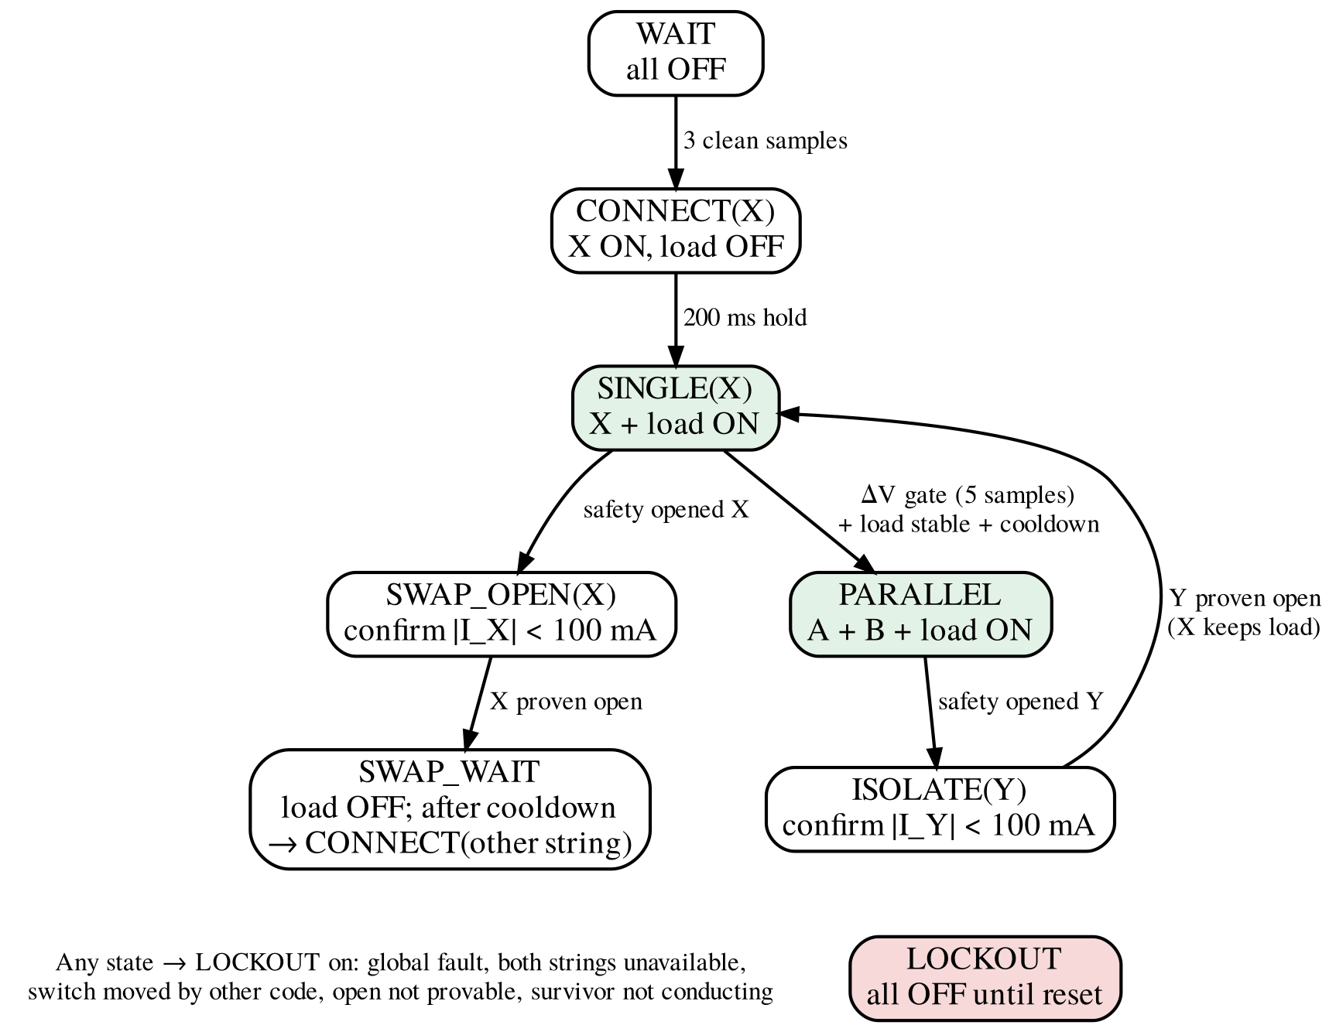
Fig. 4. Reconfiguration state machine.
After boot the controller waits for the safety layer to report ready, closes one string with the load switch still open, and holds this state for 200 ms. The hold is longer than the 160 ms the safety layer needs to judge a freshly connected string (a 100 ms settling interval plus three samples), so a string that is out of limits is rejected before it reaches the motors. The load switch then closes. Paralleling is compiled in only when a bench test has confirmed that each sensor reads its own string while that string is disconnected; otherwise the inter-string voltage measurement would be meaningless and the firmware runs on one string at a time.
Table IV lists the five guarantees of the module. Each is asserted on every switch-on command in the host test harness of Section V.
TABLE IV
Guarantees of the Reconfiguration Module
 | Guarantee | Enforced by
G1 | A and B commanded on together only after the ΔV gate passed on the samples immediately before the close | Gate check before close; parallel compiled in only if sensors are string-side
G2 | Break-before-make: old string proven open by current readback before a new string closes | SWAP_OPEN confirmation (3 samples < 100 mA)
G3 | Never closes a switch that the safety layer blocks | Block-mask check before and inside the close routine
G4 | At least 500 ms between topology changes, including safety-forced openings | Cooldown timer restarted on every change
G5 | Any unexplained state leads to all-off until reset | Command/output reconciliation; LOCKOUT

Paralleling gate. While string X is connected and carries current I_{X} and string Y is open, both sensors read string-side terminal voltages. The bus voltage is V_{bus} = V_{X} − I_{X}R_{path}, where R_{path} is the unknown resistance between X’s sense point and the bus. The voltage that will drive the join current is
ΔV_{real} = V_{Y} − V_{bus} = ΔV_{lo} + I_{X}R_{path}, (7)
with ΔV_{lo} = V_{Y} − V_{X}. Because ΔV_{real} is linear in R_{path} and 0 ≤ R_{path} ≤ R_{max}, its magnitude is bounded by the larger of |ΔV_{lo}| and |ΔV_{hi}|, where ΔV_{hi} = ΔV_{lo} + I_{X}R_{max}. The gate requires both bounds to be below 100 mV on five consecutive samples (100 ms), with the load current stable (change below 200 mA between samples) and the cooldown expired. R_{max} = 50 mΩ is the sum of two 20 mΩ MOSFETs at their datasheet maximum, the 2 mΩ shunt, and an 8 mΩ allowance for wiring and the higher on-resistance at low gate drive; the allowance is an assumption still to be confirmed by measurement. Fig. 5 shows the consequence: the admissible window narrows as the load increases, is (−100, 0) mV at 2 A, and closes at 4 A. Under heavy load the system stays on one string and joins when the load falls.
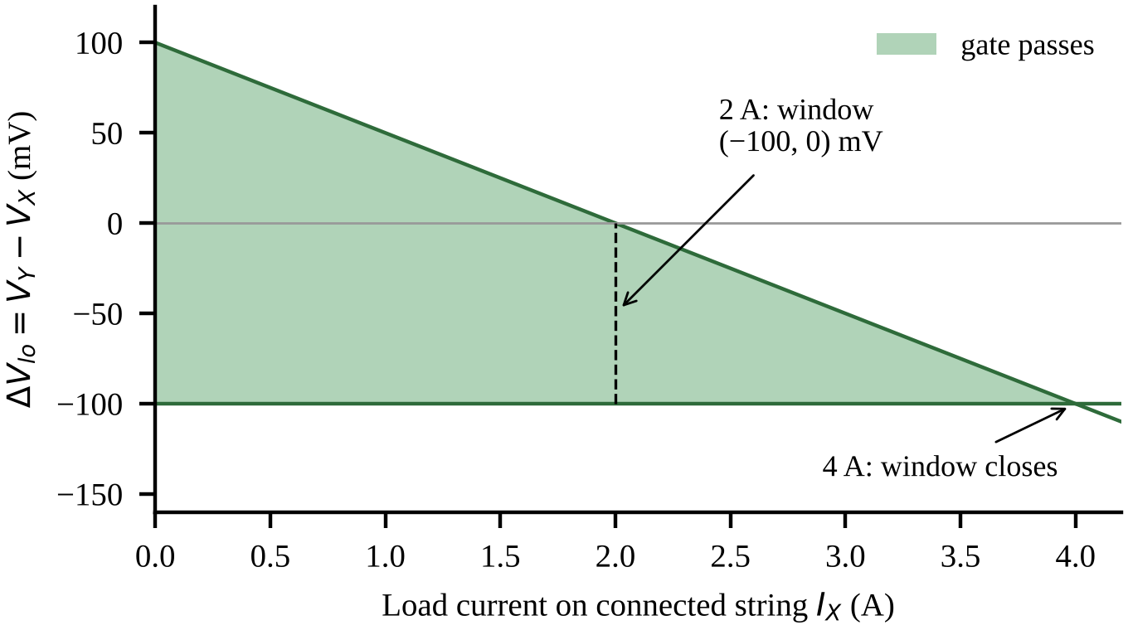
Fig. 5. Admissible region of the paralleling gate
Within the gate, the join current is bounded by the loop resistance of both strings and both pairs:
I_{join} ≤ ΔV / R_{loop} < 0.1 V / R_{loop}. (8)
Using the datasheet impedance limit of 26 mΩ per cell (measured at 1 kHz) [13] as an estimate, four MOSFETs at 20 mΩ and about 30 mΩ of wiring, R_{loop} ≈ 266 mΩ and I_{join} ≤ 0.38 A. Counting only the four MOSFETs (80 mΩ) gives a pessimistic bound of 1.25 A. Both are an order of magnitude below the 12 A trip (calculated; not yet measured). Because the board has no precharge path, the controller always starts on the string with the higher voltage: only then can the load pull that string down toward the idle one and close the gap.
Isolation while paralleled. When string Y is opened, whilst strings X and Y are tied together, no switch needs to close, as string X is already doing the load. The module goes into ISOLATE when the current in Y drops below 100 mA for 3 samples in a row, and sees if X is the current path to the load. If the string does not open in 300ms, or a survivor that has no current through it when the load was drawing 1.5A or more before the trip, results in LOCKOUT. Play from any string. If the single motor string X is opened, the motors are left commanded until it is proven X is open.
This order is important, when the motors were stopped first, a stuck pair read almost zero current, this would appear as a successful opening and the other string would then be closed onto it. The proof must also be that X had to be carrying at least 300 mA just before the trip, as if there was no current just before the trip, there would be none just afterward and that would prove nothing. Only then the load switch is opened, a cooldown time is measured, followed by a dead time and then the other string is connected via the CONNECT hold. There are no resets in software and a faulted string does not get retried. This limits the number of topology changes that can occur during a boot, and, with the cooldown, acts as a protection against oscillations.

D. Failure Modes and Effects
Table V summarizes the failure modes analysed for the switching hardware and the control code, following the structure of ISO 26262 and IEC 61508 analyses [7], [8]: what fails, how it is detected, and the safe response. Two entries are not detectable by the controller and are mitigated only by hardware: a pair shorted before power-up with no load current flowing, and inrush into the motor driver’s input capacitance when the load switch closes, which lasts far less than one sampling period.
TABLE V
Condensed FMEA of Switching Hardware and Control Code
Failure | Detection | Safe response
Close onto a string at large ΔV | ΔV gate, both bounds, 5 samples | Join refused; stay on one string
Sensor reads bus, not string | Not detectable in firmware | Parallel compiled out unless bench-confirmed
Pair stuck closed during swap | Open never confirmed; STUCK at ≈160 ms | LOCKOUT; new string never closed
Open not provable (no load before trip) | Pre-trip current < 300 mA | LOCKOUT
Joined pair fails open or intermittent | < 100 mA while total ≥ 1.5 A | Open it; no rejoin until reset
Other code moves a switch | Command ≠ output register | LOCKOUT
Loop hangs | IWDG timeout | Reset into hardware all-off
HAL fault | Error handler entered | Direct register write: all off
NPN shorted C–E | Current in an OFF string | STUCK: all off incl. load
Pair shorted before power-up, no load | Not detectable | Fuse; bench procedure
Load-switch inrush into driver capacitance | Not visible at 20 ms sampling | Fuse; precharge in next revision

V. Verification Method
Results are reported at three evidence levels that are kept separate: calculated (equations with stated inputs), simulated (host execution of firmware against a plant model), and bench (measured or observed on the fabricated hardware). No simulated number is used as a hardware result.
Host simulation. The safety module and the reconfiguration module were compiled on a PC with strict warning flags (gcc, C99, ‑Wall ‑Wextra ‑Wpedantic ‑Wconversion ‑Wshadow), without modification, and executed against a plant model: open-circuit voltage and internal resistance per string, a 30 mΩ switch pair, a current-sink load, injected faults (stuck pair, failed-open pair, lost sensor) and ±3 mV / ±5 mA measurement noise. A switch stub checks guarantees G1–G4 on every switch-on command, using the plant’s true voltage difference rather than the sensed one. Fuzzing ran 400 randomized 30 s runs per build with random start voltages (10.6–11.8 V), motor current (0.3–3.3 A), on/off events, injections and failed switches. Mutation testing introduced deliberate bugs to check that the harness detects them.
The simulation verifies decision logic and sequencing only. It contains no hardware abstraction layer, no sensor conversion or I²C timing, no switching transients, wiring inductance or capacitor inrush, and its resistances are assumptions.
Bench and rover. Bench tests were performed on a breadboard prototype of the switch channel and on the fabricated two-layer PCB, which carries the Nucleo-64 board, six IRF4905 devices, three NPN level shifters, both INA260 modules, the OLED and the L298N module (Fig. 1). Rover tests used the parallel build with lithium-ion cells and fault injection while the rover was driving.
VI. Results
A. Host Simulation
Table VI summarizes the simulation results. All 22 safety scenarios and all 18 reconfiguration scenarios passed, and no invariant was violated in 800 fuzzing runs. Of seven single-point mutants of the reconfiguration module, six were detected. The undetected mutant removed one of two redundant block-mask checks; every caller performs the first check, so the second is defence in depth, and a mutant removing both checks was detected. In the simulated parallel demonstration, string B opened 60 ms after the loop that received the injection, its open state was confirmed at 120 ms, and the load was never interrupted (simulated timing; not measured on hardware).
TABLE VI
Host-Simulation Results (Simulated)
Test | Result
Safety-layer scenarios | 22 / 22 passed
Reconfiguration scenarios (parallel build) | 12 / 12 passed
Reconfiguration scenarios (single-string build) | 6 / 6 passed
Fuzzing, 400 runs × 30 s per build | 0 invariant violations (800 runs)
Mutation tests, single mutants | 6 / 7 detected (1 redundant check)
Mutation test, both block-mask checks removed | Detected
Compiler warnings (strict flags) | 0

The swap path was also found by the simulation to be defective before hardware testing: the swap path would halt the motors before it would check the old string for open, allowing a stuck pair to pass as open. The corrected ordering described in Section IV-C is covered by a mutation test.
B. Switch Stage and Sensing on Hardware
Table VII compares the measured V_{GS} of the gate-source voltage is –10.8 V and is 0.8 V less in magnitude than the calculated –11.6 V due to the pack sitting below the assumed 11.9 V and due to the assumed drops across the junctions; it still exceeds the worst case of –4.0 V. The pair open had a load side read around 11 mV on the breadboard prototype, which is the minimum that the multimeter will read on that range. In a blocking test on the pair, the bus side read 0.9 mV with the string energized, i.e. less than 0.01% of the string voltage.
TABLE VII
Bench Measurements versus Calculation
Quantity | Measured | Calculated | Setup
V_{GS}, channel on | −10.8 V | −11.6 V | Proto.
V_{GS}, channel off | 0 V | 0 V | Proto.
Load-side voltage, off | ≈11 mV | — | Proto.
NPN base voltage, on | ≈0.7 V | 0.7 V | Proto.
Bus side, pair open | 0.9 mV | — | Pair
String A voltage, all states | 11.95–11.96 V | — | PCB
String B voltage, all states | 11.86–11.87 V | — | PCB
Inter-string ΔV | 90 mV | < 100 mV gate | PCB
I²C failed reads / recoveries | 0 / 0 | — | PCB
Loops at uptime 00:01:11 | 3485 | 3475–3525 | PCB
Proto. = breadboard prototype; PCB = fabricated board. The loop-count prediction assumes 20 ms per loop, a 1.5 s boot screen and an uptime display truncated to whole seconds.
An I²C scan was performed on the fabricated board and the OLED (0x3C) and sensor A (0x40) were detected on I2C1, while sensor B (0x40) was detected on I2C3, both of which returned the correct manufacturer ID (0x5449) [16]. The firmware then cycled the switches through all-off, string A alone, string A with load, all-off, string B alone and string B with load. Each sensor reads the string in question, as shown by the two readings: String A has read 11.95–11.96 V and String B has read 11.86–11.87 V in all states, so the readings did not depend on the state of the switch; this confirms that each sensor reads their own string, which is a precondition for paralleling. The inter string difference was 90 mV which is within the 100 mV gate. The failed-read and bus-recovery counters remained zero for both buses during all of the transitions, including the closing and opening of the load switch. This was a real risk, because the I²C lines run close to the power path.
The OLED photograph in Fig. 1(c) shows a loop count of 3485 at a displayed uptime of 1 min 11 s. Since 3485 × 20 ms = 69.7 s and the uptime display has 1 s resolution, the difference of 1.3–2.3 s is consistent with the boot screen that precedes the control loop, and with a 20 ms loop period in this run.
C. Safety Layer on Hardware
With the board powered from USB and no cells connected, the following checks passed: the reset cause and both sensors were reported at boot; an injected discharge over-current on string B latched and was shown as an injected fault; a command to re-close string B was rejected; closing string A with no cells latched under-voltage on A, as designed; the reset button cleared all faults; and disconnecting sensor B’s data line produced a sensor-lost fault that stayed latched after the line was reconnected, until reset. With the reset button held, the string A drive circuit measured below the NPN turn-on level and string A remained off.
D. Fault Isolation on the Rover
In the central test, both strings were attached to the rover and it drove in parallel. A fault-injection hook was used for injecting an over-current on one string. Table VII gives the results. In 20 of 20 trials with the fault on string B; and 20 of 20 trials with the fault on string A, the faulted string opened and the rover continued to drive on the other string. Because the controller is powered from net STR_A upstream of the string A switch, opening string A does not remove controller power. When faults were injected on both strings, both opened and the system ended in the all-off state, as required by the global rule that a pack with no available string is shut down.
TABLE VIII
Fault Isolation on the Rover (Bench-Observed)
Injected fault | Trials passed | Observed outcome
Over-current, string B | 20 / 20 | B opened; rover kept driving on A
Over-current, string A | 20 / 20 | A opened; rover kept driving on B
Both strings | — | Both opened; system all-off
Parallel build; both strings connected and rover driving at injection. Outcomes observed by the operator; timing not recorded.
These results were observed by the operator; trip latency, current transfer and the absence of a gap on the load switch were not recorded with an oscilloscope or a logged trace in these trials. They demonstrate the functional behaviour of the hardware and firmware together, not their timing.
VII. Discussion and Limitations
The results demonstrate that string level isolation is possible using cheap and discrete parts, and a simple and verifiable control structure. The most important design choice is that of separating the authority, whereby the safety layer is the one that can remove connections, and only the reconfiguration module can add connections when proven conditions are met. In these parallel case scenarios, no closing action is required and thus the load remained powered during the rover's trials.
The following limitations are structural or remain open:
- String-level sensing only The INA260 measures the total of three cells. Single cell can exceed 4.20 V or drop below 2.50 V without the total string voltage exceeding the limits.
- No temperature sensing. This is a hardware level fault that cannot be detected for lithium-ion batteries.
- No precharge path.There is no precharge branch and three switch pairs in the fabricated board. Paralleling relies on the voltage gate alone, and closing the load switch charges the motor driver’s input capacitance through the path resistance only. Fuses are required in each string.
- Firmware speed. The 60–80ms trip time protects against sustained overload, not short circuits.
- Over-current demonstrated by injection. The rover drivetrain cannot approach the 12 A trip, so over-current faults were emulated. Injection exercises the real detection-to-switching path but not the sensor’s response to a real over-current.
- Timing and inrush not yet measured. Trip latency, the join current bound of (8) and the dead time were not measured with an oscilloscope; the path-resistance allowance in the gate is an assumption.
- Controller supply. VIN is tied to string A. String A is therefore always slightly discharged by the controller, sensor A also carries the controller’s supply current, and a full string (12.6 V) exceeds the 12 V VIN maximum of the Nucleo board [18], which restricts string A to 12.0 V or less.
- Granularity. A single bad cell removes its whole string, which in a 3S2P pack is half of the capacity. This is the deliberate trade of string-level switching: fewer switches and lower conduction loss at the cost of coarser control.
The system is a student proof of concept that applies the vocabulary of functional safety (safe state, latching, watchdog, FMEA). It has not been assessed against ISO 26262 or IEC 61508 and makes no compliance claim.
VIII. Conclusion and Future Work
A string-level reconfigurable BMS was designed, fabricated and tested on a 3S2P lithium-ion pack powering a tracked rover. A common-source back-to-back P-MOSFET pair with a discrete NPN level shifter provides bidirectional blocking and a hardware default-off state. The firmware separates a latching safety layer that can only open switches from a reconfiguration module that can only close them, under five guarantees that were checked on every switch-on command in host simulation, under fuzzing and against deliberately injected code defects. On the rover, an injected over-current isolated the affected string while the other kept the vehicle driving in all 40 trials.
Future work will add a precharge branch and a strengthened reset pull-down on the string A channel, per-cell voltage and temperature sensing, oscilloscope measurement of trip latency and join current, and per-string state-of-charge estimation so that string alternation and charge balancing can be driven by measured state rather than faults alone.
Acknowledgment
The authors thank the Department of Electronics and Telecommunication Engineering, MPSTME, for laboratory facilities and instrumentation.
References
[1] W. Han, T. Wik, A. Kersten, G. Dong, and C. Zou, “Next-generation battery management systems: Dynamic reconfiguration,” IEEE Ind. Electron. Mag., vol. 14, no. 4, pp. 20–31, Dec. 2020, doi: 10.1109/MIE.2020.3002486.
[2] S. Steinhorst et al., “Distributed reconfigurable battery system management architectures,” in Proc. 21st Asia South Pacific Design Autom. Conf. (ASP-DAC), 2016, pp. 429–434, doi: 10.1109/ASPDAC.2016.7428049.
[3] A. Škegro, T. Wik, B. Bijlenga, A. Bessman, and C. Zou, “System-level assessment of dynamic reconfiguration for lifetime and cost outcomes in electric vehicle battery packs,” Nat. Commun., vol. 17, Art. no. 5980, 2026, doi: 10.1038/s41467-026-74951-8.
[4] F. Tang et al., “Reconfigurable battery system topology, operation and feature: A comprehensive survey,” J. Energy Storage, vol. 168, Art. no. 122573, 2026.
[5] Z. M. Pinter, D. Papageorgiou, G. Rohde, M. Marinelli, and C. Træholt, “Review of control algorithms for reconfigurable battery systems with an industrial example,” in Proc. 56th Int. Universities Power Eng. Conf. (UPEC), 2021, doi: 10.1109/UPEC50034.2021.9548259.
[6] Q. Zhao, F. Tang, and B. Zhang, “Adaptive SOC estimation of reconfigurable battery modules based on a hybrid deep learning model,” Electronics, vol. 15, Art. no. 2208, 2026, doi: 10.3390/electronics15102208.
[7] Road Vehicles—Functional Safety, ISO 26262:2018, International Organization for Standardization, 2018.
[8] Functional Safety of Electrical/Electronic/Programmable Electronic Safety-Related Systems, IEC 61508:2010, International Electrotechnical Commission, 2010.
[9] T. Morstyn, M. Momayyezan, B. Hredzak, and V. G. Agelidis, “Distributed control for state-of-charge balancing between the modules of a reconfigurable battery energy storage system,” IEEE Trans. Power Electron., vol. 31, no. 11, pp. 7986–7995, Nov. 2016.
[10] M. Lemeon and J. Regash, “Development of a reconfigurable battery pack architecture for fault isolation and lifetime extension,” Trans. Energy Storage Syst. Innov., vol. 2, no. 1, pp. 52–58, 2026, doi: 10.17051/T-ESSI/02.01.06.
[11] H. M. O. Canilang, A. C. Caliwag, and W. Lim, “Novel battery management systems: Enhancing flexibility and fault tolerance,” J. Energy Storage, vol. 107, Art. no. 114898, 2025.
[12] Z. Gao, C. S. Chin, J. H. K. Chiew, J. Jia, and C. Zhang, “Design and implementation of a smart lithium-ion battery system with real-time fault diagnosis capability for electric vehicles,” Energies, vol. 10, no. 10, Art. no. 1503, 2017, doi: 10.3390/en10101503.
[13] Samsung SDI Co., Ltd., “Specification of product: Lithium-ion rechargeable cell for power tools, model INR18650-30Q,” Version 1.0, Feb. 2015.
[14] Infineon Technologies AG, “IRF4905PbF HEXFET power MOSFET,” datasheet, Rev. 2.1, Apr. 2026.
[15] Semiconductor Components Industries (onsemi), “P2N2222A amplifier transistors, NPN silicon,” datasheet P2N2222A/D, Rev. 7, Jan. 2013.
[16] Texas Instruments, “INA260 precision digital current and power monitor with low-drift, precision integrated shunt,” datasheet SBOS656C, Dec. 2016.
[17] STMicroelectronics, “STM32F446xC/E: Arm Cortex-M4 32-bit MCU+FPU,” datasheet DS10693.
[18] STMicroelectronics, “STM32 Nucleo-64 boards (MB1136),” user manual UM1724, Rev. 17.

