**Application and Development Practices Laboratory**

**Mini Project Report**

April - July 2022

**CEG FORUM – to connect every CEGian**

Adusumalli Nithin- 2021103502

Deepak Kumar V- 2021103518

Dhivagar M- 2021103553





Abstract:

The biggest support for a college or any educational institution to function successfully is their alumni. If it has a strong connection with their alumni then the institution has a great advantage in connecting its students to the outer world. Every year the number of graduates completing their degree is increasing drastically. As a result, the competition for jobs is becoming more and more difficult. Alumni can render a helping hand to their alma mater to develop its students into a complete graduate with required skills. It is because they have a better connect with the industries and they knew the requirement of the industry and what kind of graduates they are looking for. If the students themselves have a good rapport with their alumni, it is even more advantageous. Our website solves this problem as the users can share their experience, and interactions which will be open to the users as they can see it in our website. The details of the user who share their answers to a particular question will also be displayed. Information posted by the seniors and experience shared in our website will be useful for the freshers to know about the college and the kind of environment that prevail in the college.

Generally, there are people who fear to express what they feel. Hiding the feelings and expressions inside will one day end up in big psychological issue. Interactions help a bit in this issue, as user anonymously share what they feel, they can share about their feelings, regret, or apologize someone for their wrong doing anonymously. Since the details of the user are hidden, he/she doesn’t need to worry as their details will be hidden. Letting out their feelings will surely benefit them to overcome that situation.

Introduction:

College is a place where we learn a lot apart from the syllabus. College is an inevitable part in everyone’s life After graduation, we not only take the knowledge that we learnt, out from the college but also the memories that we created in those 4 years. Nothing can be compared to our college memories. It is very important to create a good rapport between the juniors, seniors as well as alumni so that they could help each other in their academics and seniors could guide and support their juniors in various ways. The actual backbone of a college is their alumni. Forum is a place where today’s youngsters ask and clarify man ask and clarify many of their questions. It would be great if a college has its own forum exclusively for its students to interact between them and share their own experience and memories of their college life. It also shows the widespread of their alumni across various parts of the world. The alumni support will have a great impact in the career guidance, placement and internship opportunities of the students which can be maximized through this platform. Every mistake is an experience and every failure is a lesson.

We have come up with our website named CEG FORUM - an intra-college forum exclusively for CEGians through which they can interact with each other. This website creates a strong network between CEGians. The users can ask and clarify any kind of doubts in this website.

Environmental Support:

A web application is a mixture of initial components that are fused together to give the desired result. These initial components are not physical as we thought. They are actually the programming languages we have used to construct the resultant web application. These different programming languages are used for two main sectors in web development. Each sector has its own set of programming languages. These two sectors are termed as: Front-end and Back-end. Front end languages basically include HTML (for designing the layout and printing the content of a page), CSS (for styling the components of a web page), JavaScript (for making the components of a web page more interactive). Back-end languages vary based on the developer’s wishes. Back-end sector also includes its own preferred database to store the information created or given to the web application.

The languages used for our application ‘CEG forum’ is selected after comparing the pros and con of different languages and finding the suitable database for the selected language. Front-end languages include HTML, CSS, JavaScript to create static web pages with no information fetched from the forms or database. Back-end language we have implemented in this project is Django. And the database we have used is MySQL, which is arguably the best database software for Django. The reason we have selected this particular language is because the syntax for the commands in Django are similar to that of Python which we have already learnt in the 12th standard. Also, Django comes up with thousands of packages which can be easily implemented into our project. There are even packages for hashing passwords and authentication which automatically generates custom error messages for us to display.

The reason why MySQL is selected roots upon its usage efficiency when paired up with Django. The efficiency will be high when used with Django. The data fetched from MySQL database will be in the form of dictionaries which can be easily accessed using the do operator in Python. The syntax for this database is also similar to that of JavaScript which will make our work easier. The terminal used to show the status about server is Windows Terminal.

For recursive templating of a particular snippet of HTML, CSS code is done with the help of Embed JavaScript Scripting (EJS). This can be a really a useful feature if you want to show the information fetched from the database directly in the HTML file itself without the help of an external JavaScript file or Document Object Model manipulation techniques. We can directly embed JavaScript code into our file with some special operators and design a template for one post and apply it to all other posts created in our web application.

The public and static assets such as CSS files, JavaScript files, images and icon images used in our application are stored in the public directory. And our server is interlinked with this directory so that the assets can be accessed without enter the absolute path of the asset. A relative path will finish the job easily. The HTML files we created are stored in a separate directory named ‘views’. All the different pages in our web applications have its source code inside this directory. A ‘. env’ file is used in our project to sore all the confidential tokens such as API secret key and cloud API key. These tokens act as environmental variables in our project.

We have integrated all the components listed above to create this forum web application.

Implementation:

Our web application mainly consists of two main sections and many sub sections are associated with it. It also consists of the basic components a typical application should have, such as a landing page, login page, sign up page and profile page.

Components:

The login and registration page allows the user to login to their dashboard or create an account.

As this was a forum, we don’t have a landing page because we have only students of CEG in the forum. So, we have designed the website with the data of students. So students and Alumni who needs to sign up for the forum has to enter their CEG registration number and mail id registered to the college by creating a password.

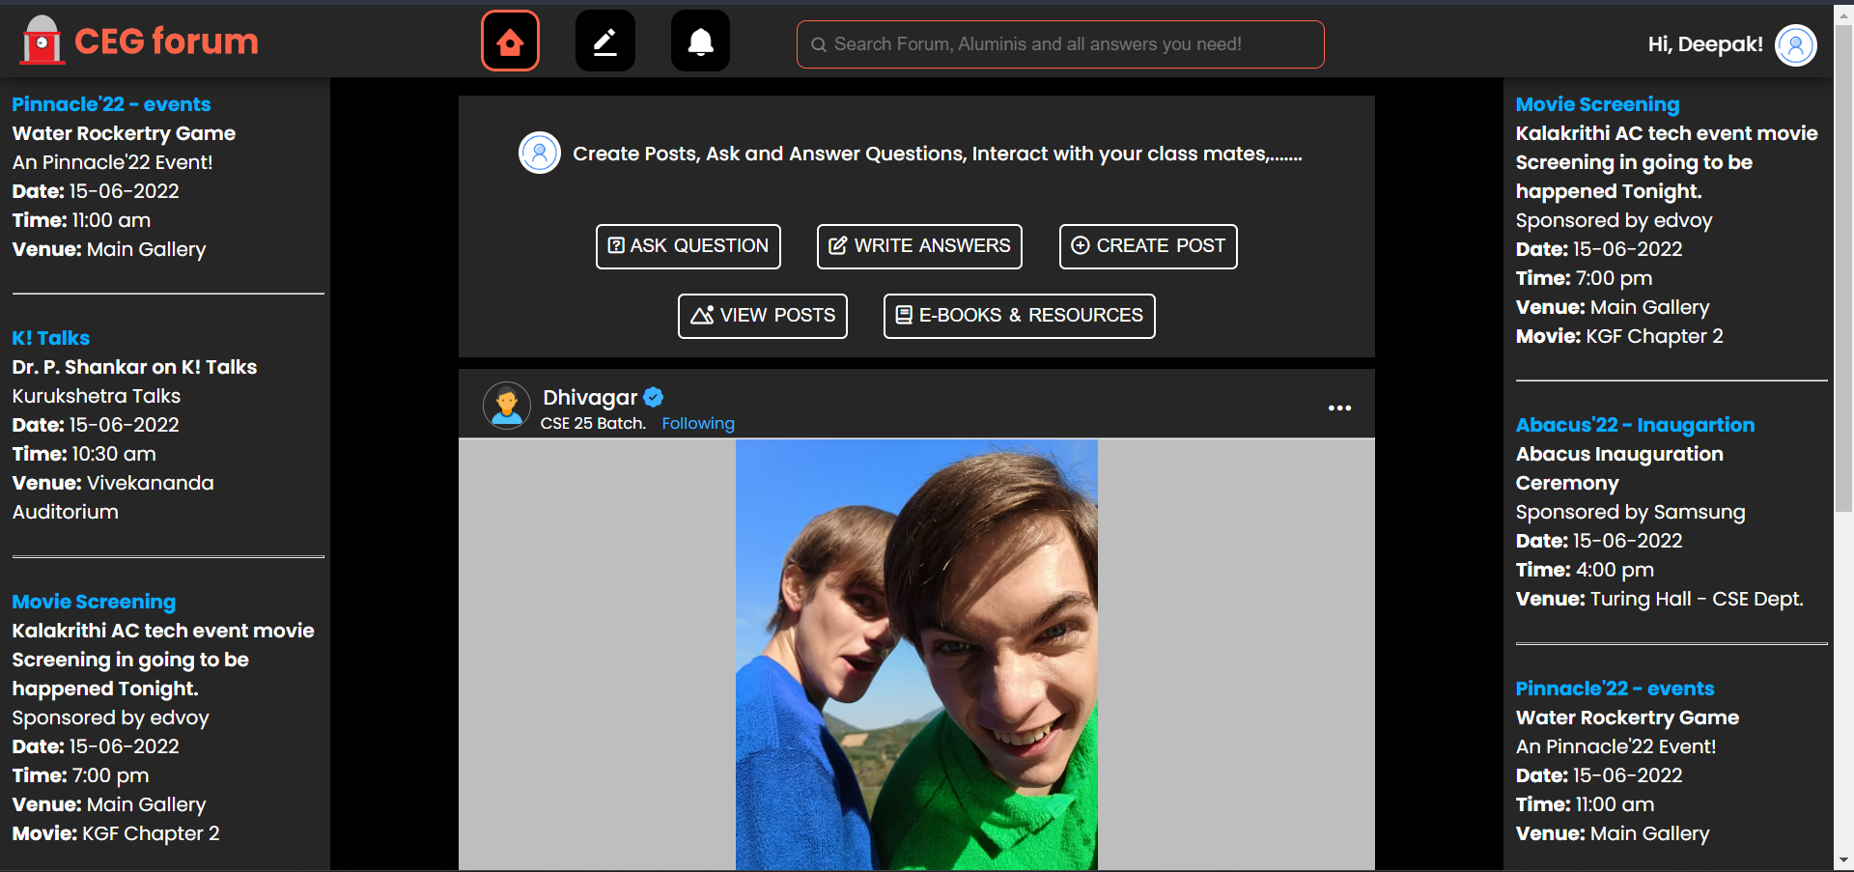

(Dark-mode)

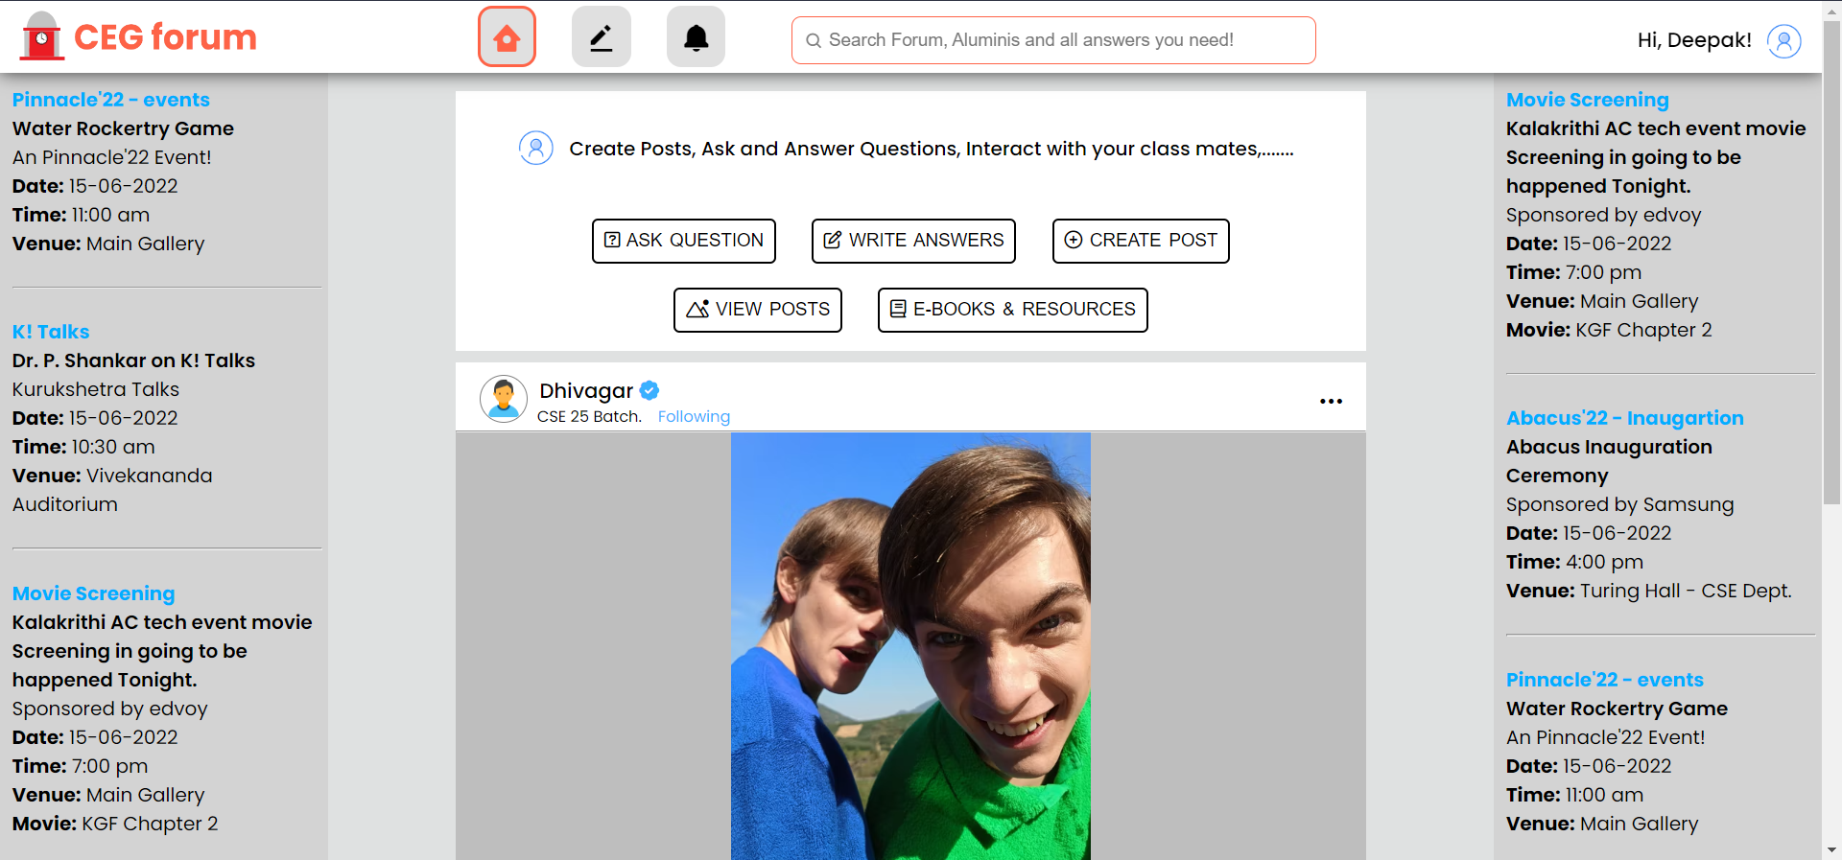

(Light-mode)

After completing registration, a wonderful dashboard will be generated for every user which has light and dark modes. Our application will automatically detect the theme of your browser and apply it. After logged in, the user will be granted the ability to ask and answer questions, create post, edit profile, access e-books, etc.,

We have an event banner at both the corners in which the important events of our college can be showcased and user can hide it if he doesn’t want to see it.

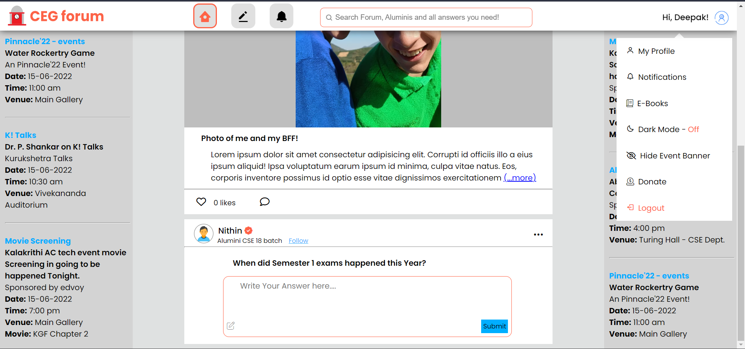

We have a menu in the corner of the webpage which opens up when user clicks on his profile. The menu has options like my profile, Notifications, E-Books, Mode switch, Show or Hide Event Banner, Donation and Logout.

In the header navigation, we have the logo, three buttons namely Home, Q&A section, Notifications, search bar and a User Menu and profile photo.

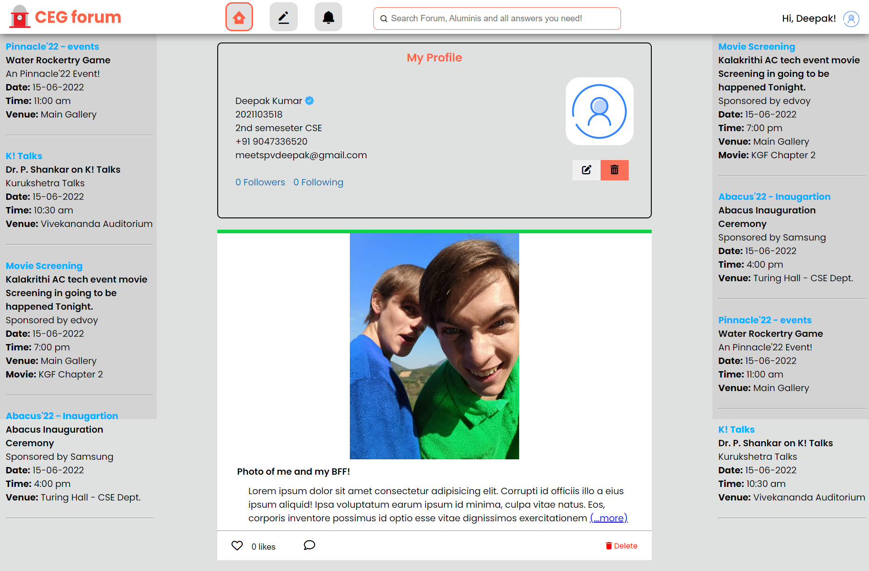

We have my profile page where user can see and edit his profile. Here we display the basic user details, his posts, likes, comment section. Here we also display the following and followers count also.

Under my posts in my profile, we have an option to like and comment post. We have the same option also in landing page of the searched user.

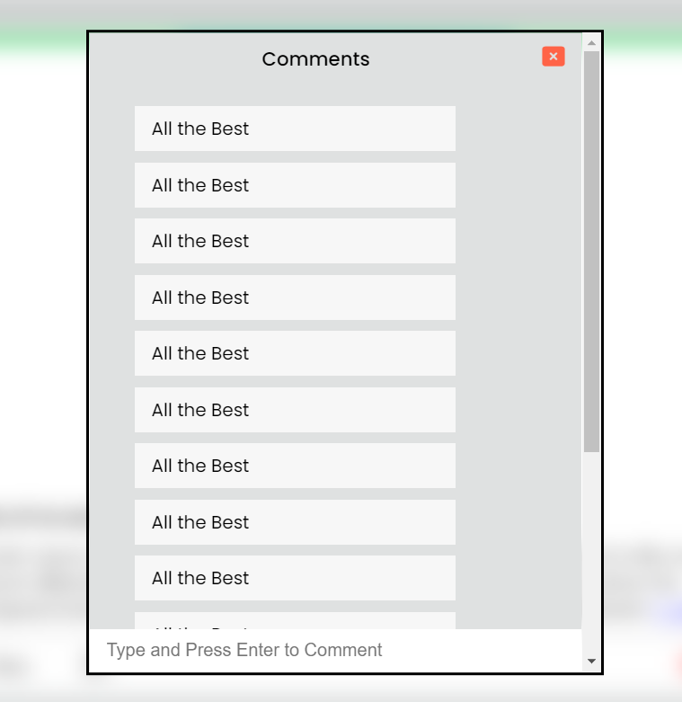

This comment option is used to comment Under posts. Any users who were logged in can comment under any posts, so that everyone can be interactive.

This option is brought by JavaScript DOM. We have blurred the background of HTML page and brought a popup with a close button. So that the user experiences a flawless and interactive commenting.

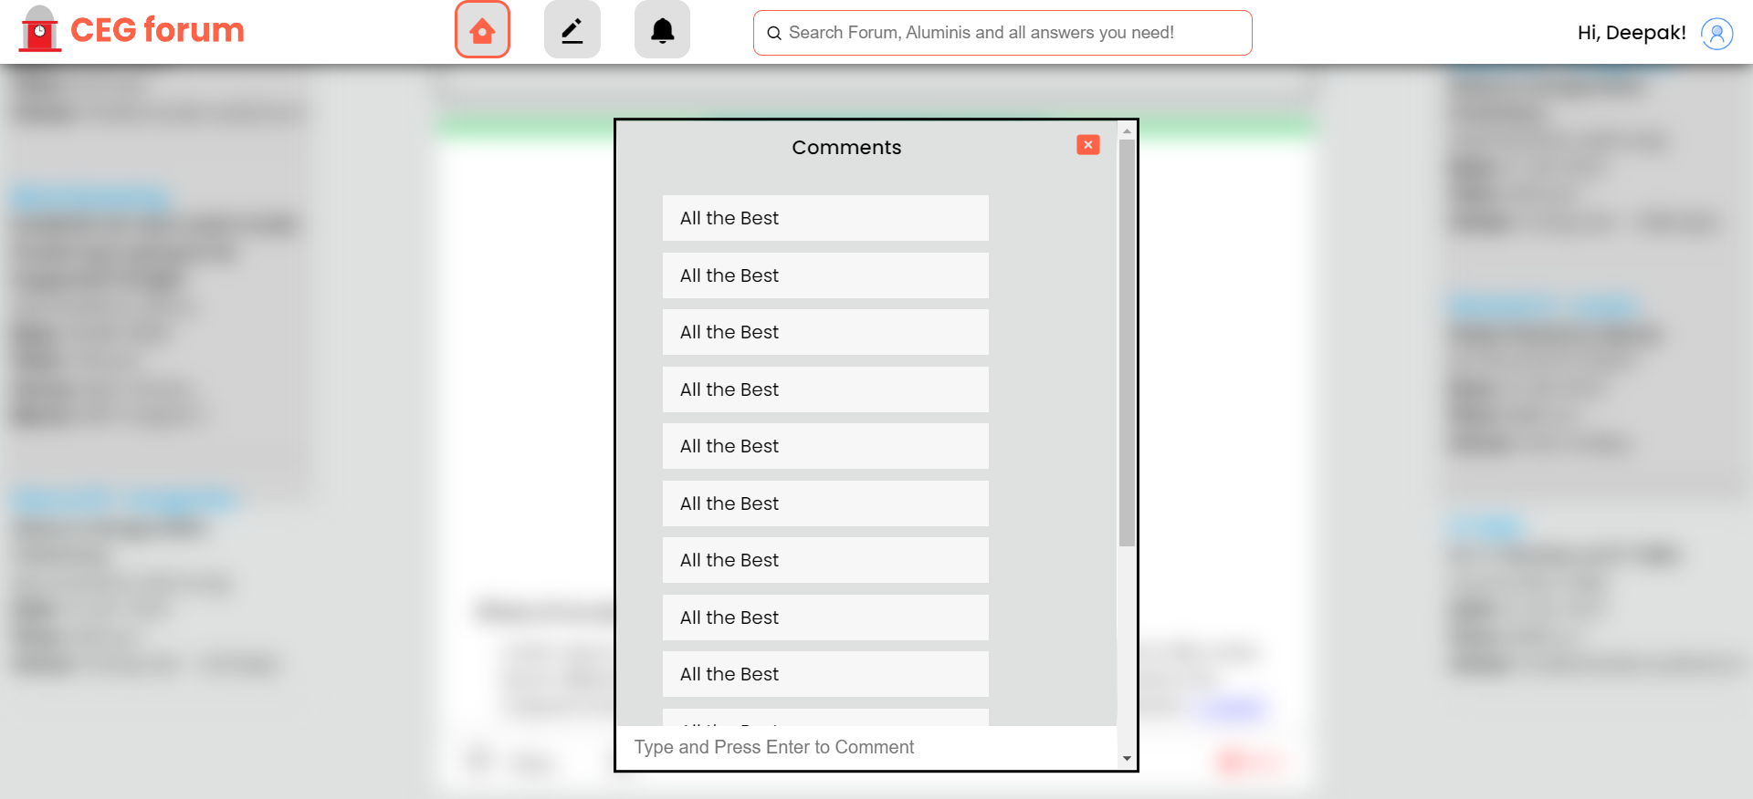

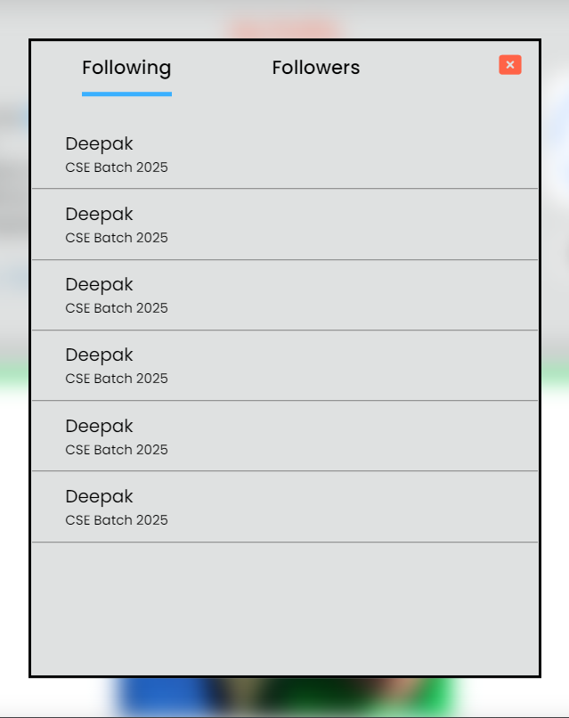 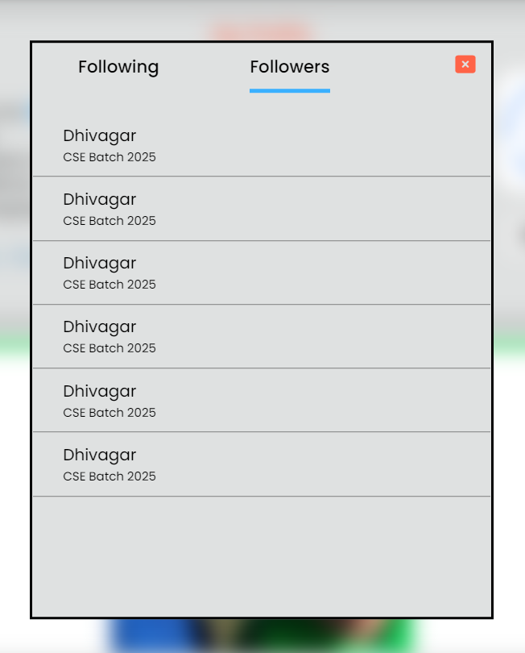

This following / followers option is used to see the users followers. Any users who were logged in can have followers and do follow.

This option is also brought by JavaScript DOM. We have blurred the background of HTML page and brought a popup with a close button. So that the user experiences a flawless and interactive usage.

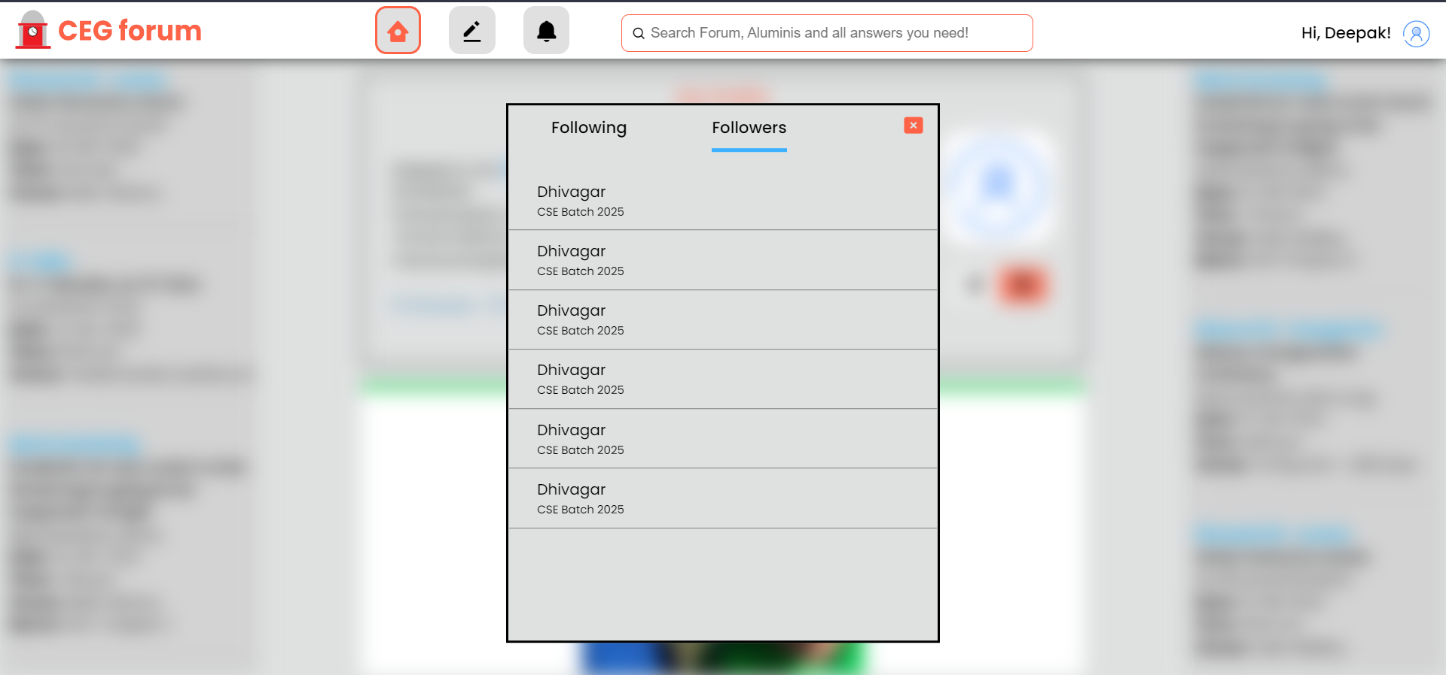

Searching for Users and Alumni



We have a search bar in the header which enables user to search for their alumni and friends.

We have a land page for this search bar

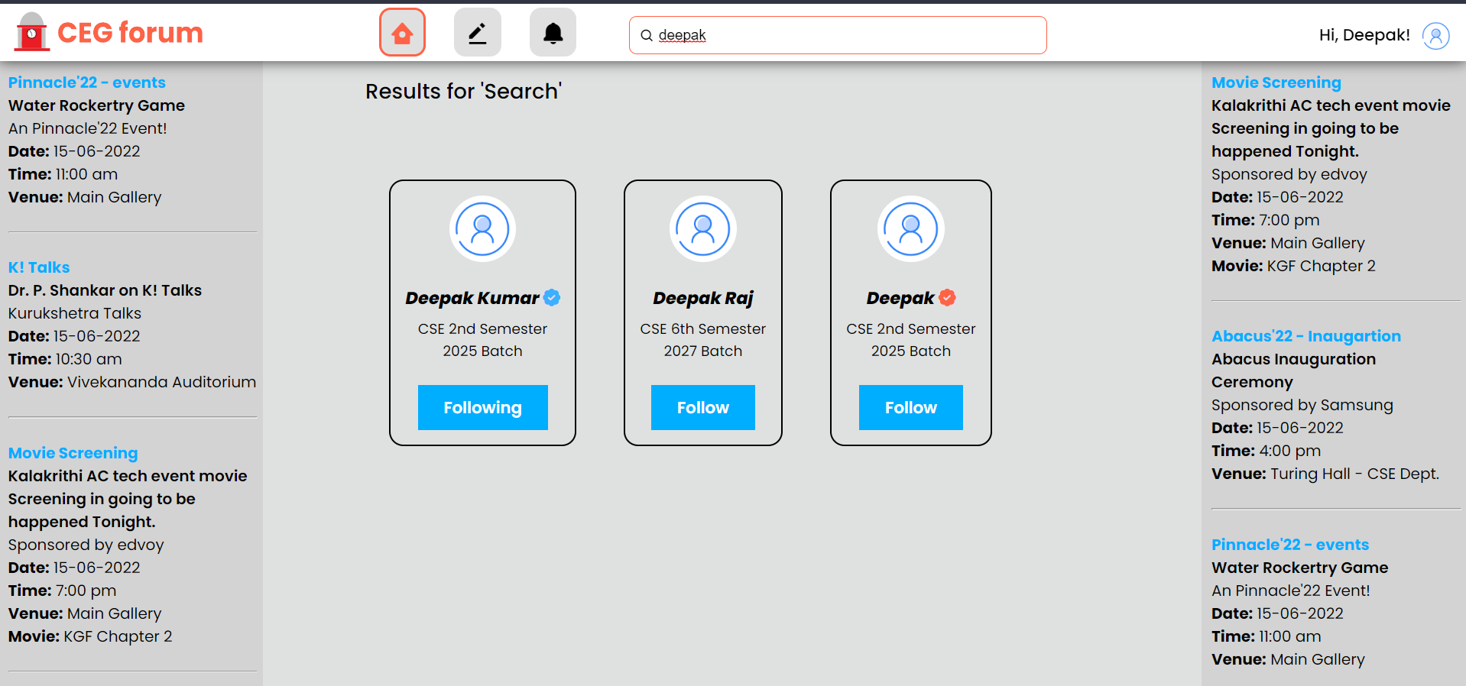

This result box displays user who were available in the searched name. It was listed in boxes with a button to view their profiles.

Notifications

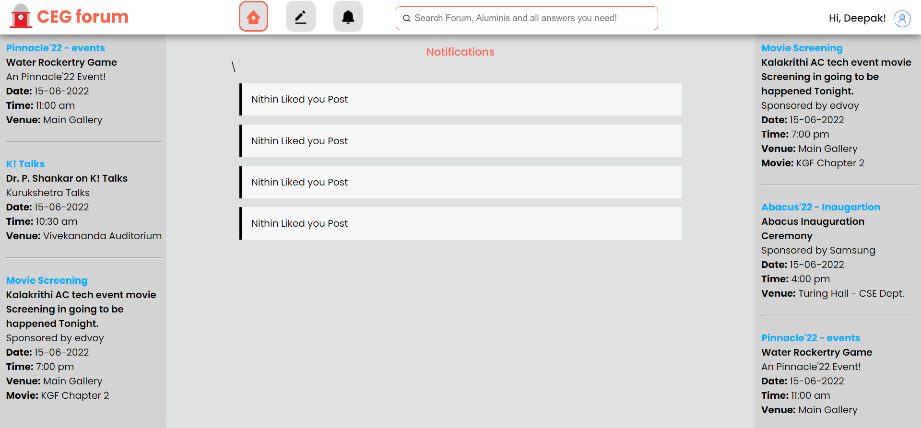

We also have a notification panel where user is notified for every added follower, new comments.

In this user can have a shortlist of all the actions that were happened.

Creating a Post

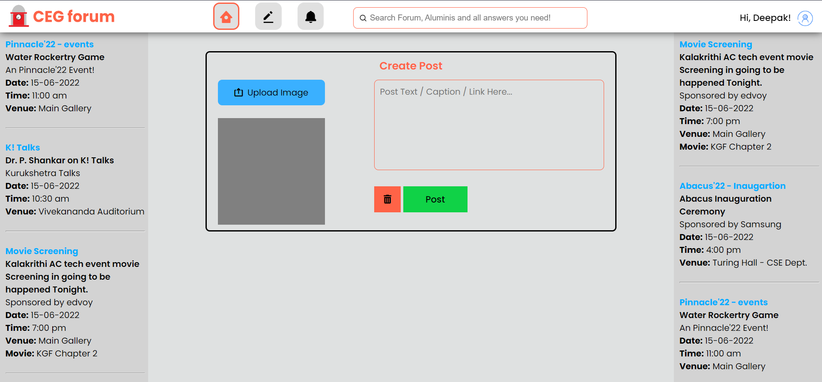

Every user can create a post with images and caption so that it will be posted and displayed for their followers. Followers can like comment on their posts.

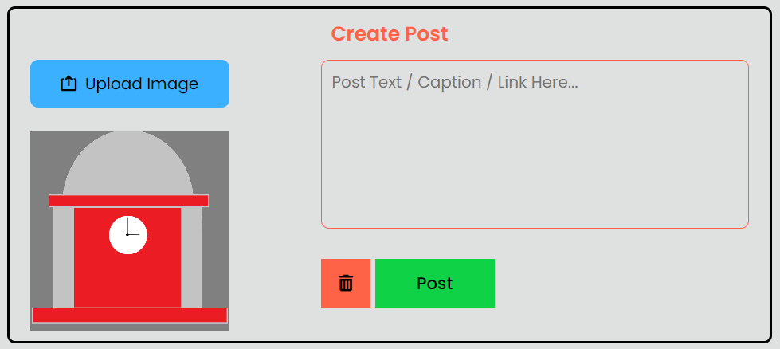

Conclusion:

The web application tests our ability to the fullest. It is really impressive to see our efforts in action. All the languages we have used in our web application. It is not only beneficial for us but also for our peers. We created this application by knowing the wishes of others in our mind. We can say that we have also gained a lot of experience in Application Development with the help of this project. We hope to expand our skills in this department in the near future.