
MUKESH PATEL SCHOOL OF TECHNOLOGY MANAGEMENT AND ENGINEERING
NMIMS, Mumbai
Software Engineering
Project Progress, Phase 2: Design and Implementation
MalXplain
An Improved Lightweight and Interpretable Machine Learning
Approach for Detecting New Obfuscated Malware Variants
Submitted by
Pravara Jain (K020)
Yash Mehta (K035)
Somya Soni (K063)
B. Tech. Computer Engineering, Cyber Security
Academic Year 2026 to 2027

Table of Contents
1. Introduction
1.1 Purpose of This Document
1.2 The System in Brief
1.3 Notation Used
2. Functional Block Diagram
3. UML Diagrams
3.1 Use Case Diagram
3.2 Class Diagram
3.3 Sequence Diagram
3.4 Activity Diagram
3.5 Component and Deployment Diagram
4. Implementation
4.1 Repository Structure
4.2 Module Inventory
4.3 Execution Order and Runtime
4.4 The Colab Notebook
4.5 Deployment and Links
4.6 Results Verified So Far
5. Phase 2 Deliverables
References
List of Figures and Tables
Figure 1. Functional block diagram of the MalXplain pipeline.
Figure 2. Use case diagram.
Figure 3. Class diagram of the implemented package.
Figure 4. Sequence diagram for the live detection scenario.
Figure 5. Activity diagram, training and evaluation.
Figure 6. Activity diagram, explanation and reporting.
Figure 7. Component and deployment diagram.
Table 1. Module inventory.
Table 2. Execution order and measured runtime.
Table 3. Verified results against the base paper.
Table 4. Phase 2 deliverables and where each one is found.

1. Introduction

1.1 Purpose of This Document
Phase 1 of this project established what is being built and why, through a review of twenty seven recent studies and an analysis of the limitations of the base paper. This document covers Phase 2, which is the design of the system and the state of its implementation. It presents a functional block diagram of the pipeline, five UML diagrams describing the structure and the behaviour of the software, and a description of the code that has been written, together with the links at which the running system can be inspected.
Every diagram in this document was derived from the source code as it actually stands, not from an intended design. Each operation named in the class diagram is a function that exists in the repository, and the message sequence shown for live detection is the sequence the dashboard actually performs.

1.2 The System in Brief
MalXplain reproduces and extends the work of Madamidola, Ngobigha and Ez-zizi [1], which trains a malware detector on a single malware subtype and tests it against the fourteen subtypes it has never seen. The dataset is CIC-MalMem-2022 [2], which holds 58,596 memory dump records divided evenly into 29,298 benign and 29,298 malicious samples across fifteen malware subtypes.
Four enhancements go beyond the base paper, each addressing a limitation its authors state explicitly: hyperparameter tuning, a comparison of five classifier families under the same withheld subtype protocol, a complete cross subtype error analysis, and the conversion of SHAP output from a plot into a written analyst finding produced by a locally hosted language model.

1.3 Notation Used
The functional block diagram follows the usual engineering convention in which processing blocks are rectangles, data stores are drawn open at the top and bottom, and arrows carry data rather than control. The UML diagrams follow UML 2.5 notation. One modelling decision is worth stating plainly, because it affects how the class diagram should be read. The implementation is a Python package organised as cohesive modules of functions rather than as a hierarchy of objects, and only Dataset is a class in the source. In the class diagram each module is therefore modelled as a class whose operations are its public functions, which is the standard way of expressing a procedural package in UML. The stereotype on each box states which kind it is.

2. Functional Block Diagram
The pipeline is a directed flow from a single input, the raw dataset, to two consumers, the verification report and the dashboard. Eleven functional blocks sit between them. Figure 1 shows the flow and the three data stores that carry results between stages.
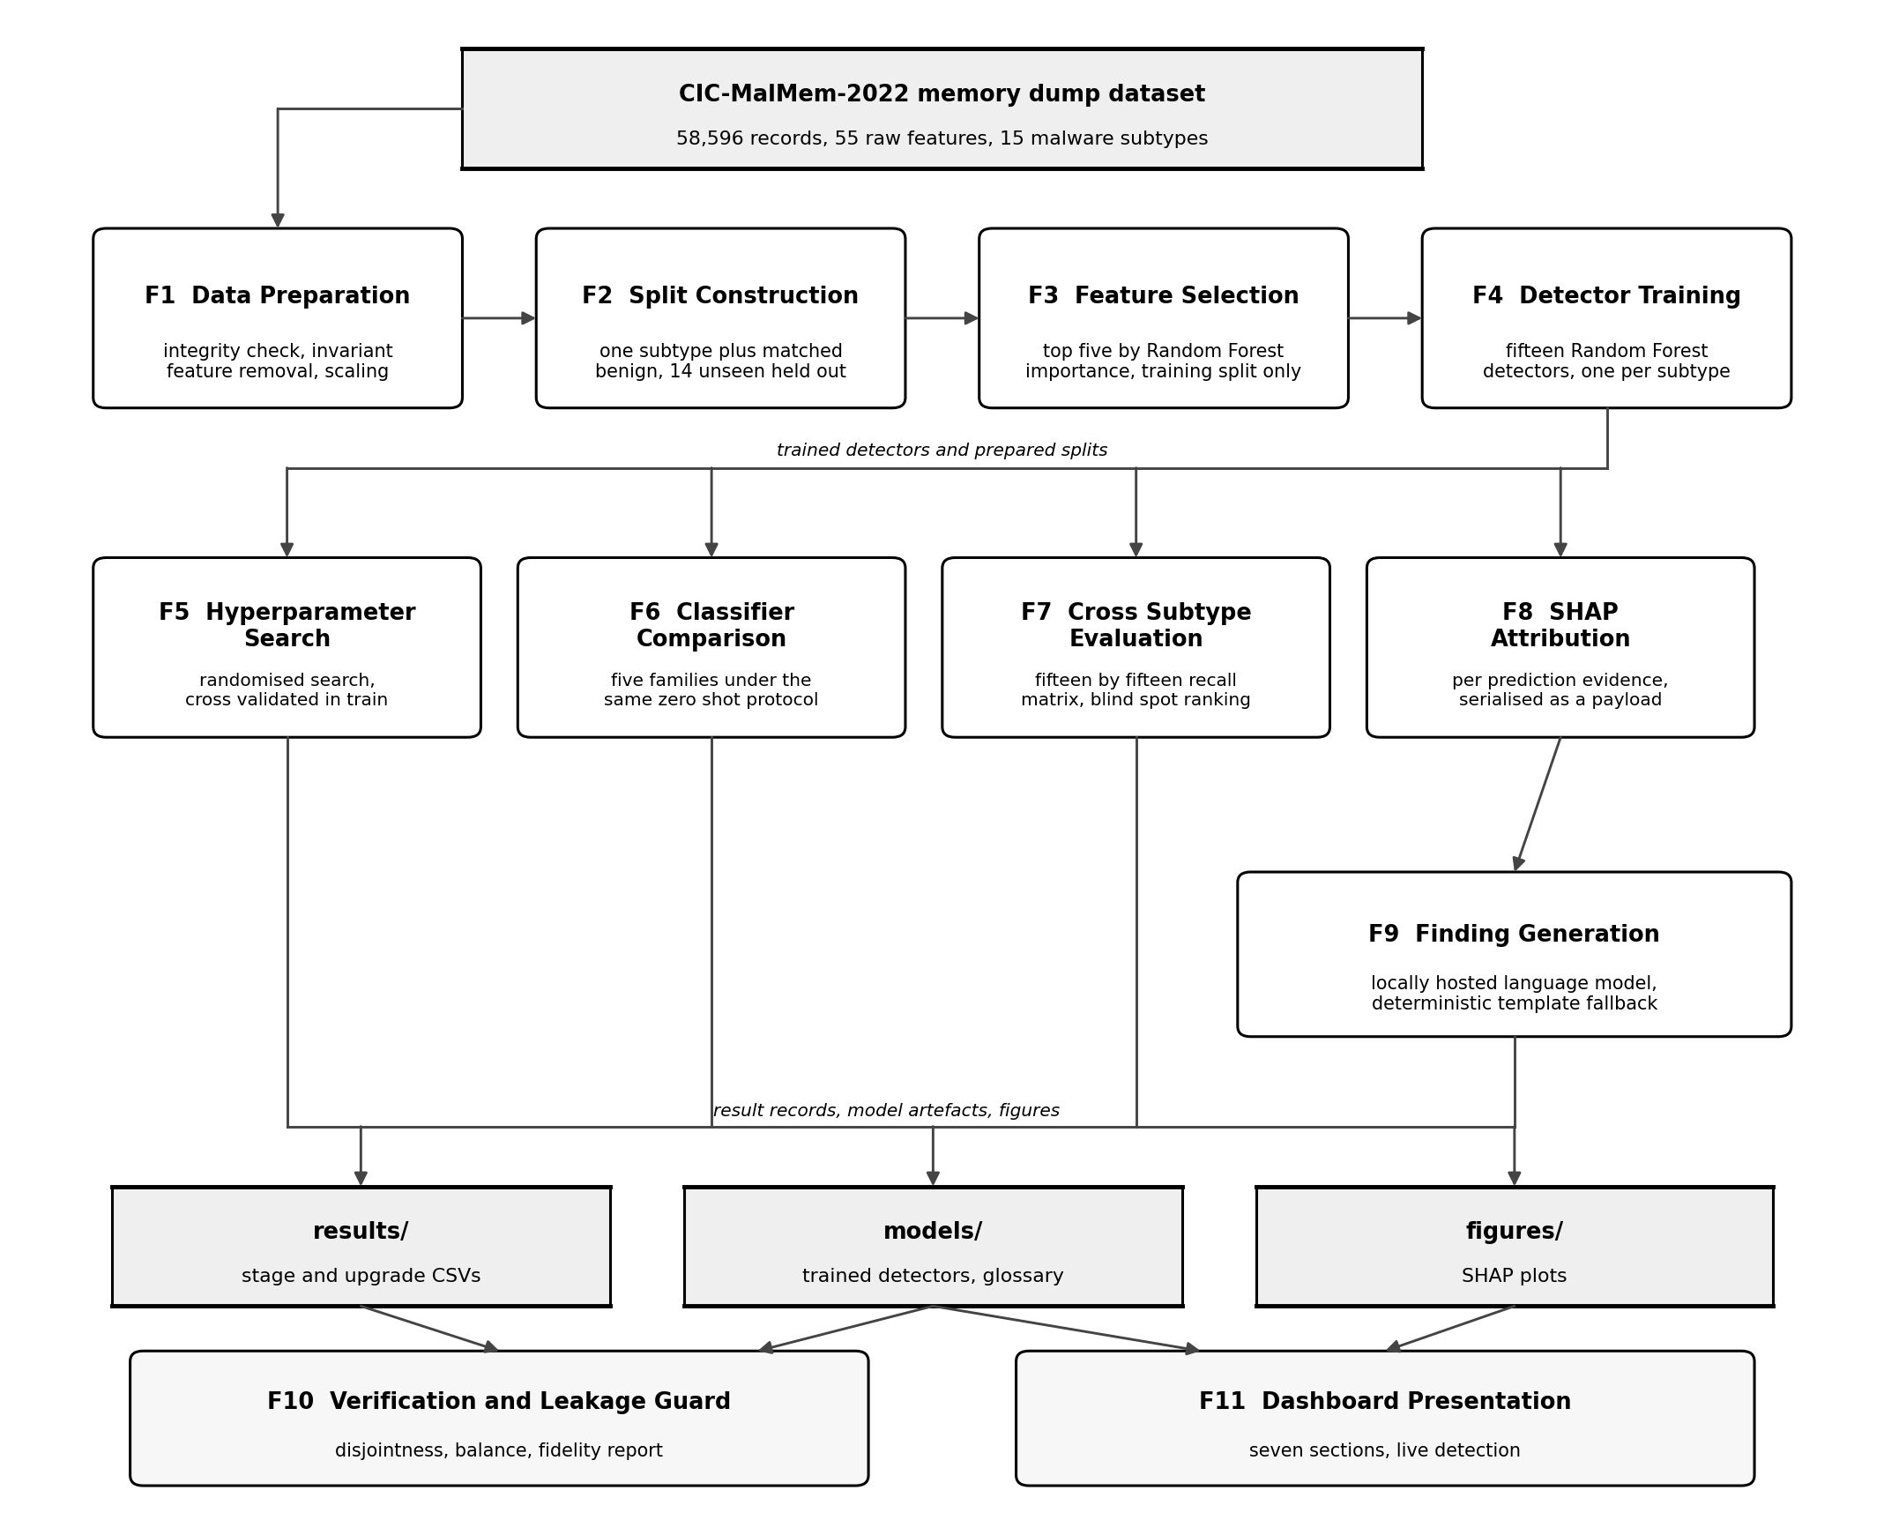
Figure 1. Functional block diagram of the MalXplain pipeline.
Block F1 loads the dataset and refuses to continue unless the record count, the class balance and the subtype count match the figures published in the base paper. It then removes the three features that hold an identical value for every record and scales what remains, reducing fifty five features to fifty two. Block F2 constructs the withheld subtype split: for a chosen subtype it assembles a training set containing only that subtype plus an equal number of benign records, and a holdout containing the fourteen other subtypes, which the detector never sees. Block F3 ranks features by Random Forest importance inside the training split alone and keeps the top five, which is the step that makes the resulting detector small. Block F4 trains the detector and repeats the whole arrangement once for each of the fifteen subtypes.
Blocks F5 to F8 all consume the trained detectors and the prepared splits, which is why they are drawn from a common bus rather than in series. F5 searches hyperparameters with cross validation confined to the training split, so the unseen holdout is never used for model selection. F6 repeats the protocol across five classifier families to establish whether the generalisation observed is particular to Random Forest. F7 evaluates every detector against every subtype and ranks the results, which is what exposes a blind spot that an aggregate accuracy figure conceals. F8 computes SHAP attribution for an individual prediction and serialises it into a structured payload.
Block F9 receives that payload and produces a written finding. It sends the evidence to a locally hosted language model and falls back to a deterministic template when no such service is reachable, so the system never fails during a demonstration. The payload deliberately excludes the ground truth label, so the model cannot restate an answer it was handed. Blocks F10 and F11 are the two consumers: the verification block asserts that training and test sets are disjoint across all fifteen splits and compiles a fidelity report, while the dashboard presents the whole result set in seven sections.

3. UML Diagrams

3.1 Use Case Diagram
Two human actors use the system and one external service supports it. The researcher runs the pipeline, from preparing the dataset through to verifying that the reproduction matches the published figures. The security analyst is the operational user, who browses the results and runs live detection on a chosen sample. The local language model service is a secondary actor: it participates in the finding use case but never initiates anything, and the system continues to function when it is absent.
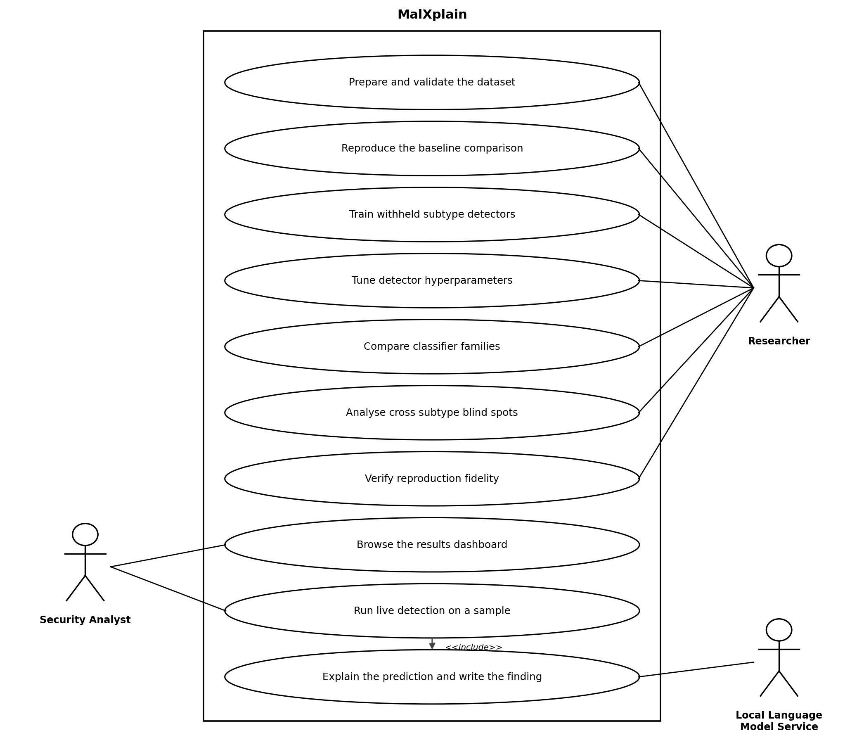
Figure 2. Use case diagram.
Running live detection includes explaining the prediction and writing the finding, which is shown as an include relationship because the analyst cannot obtain a verdict without the explanation being produced as part of the same interaction.

3.2 Class Diagram
Figure 3 shows the structure of the implemented package. Dataset is the only genuine class in the source: it is a dataclass that carries the scaled feature matrix, the binary label, the family and subtype labels and the feature names, and it exposes the sorted list of the fifteen subtypes. Everything else is a module, modelled here as a class whose operations are its public functions.
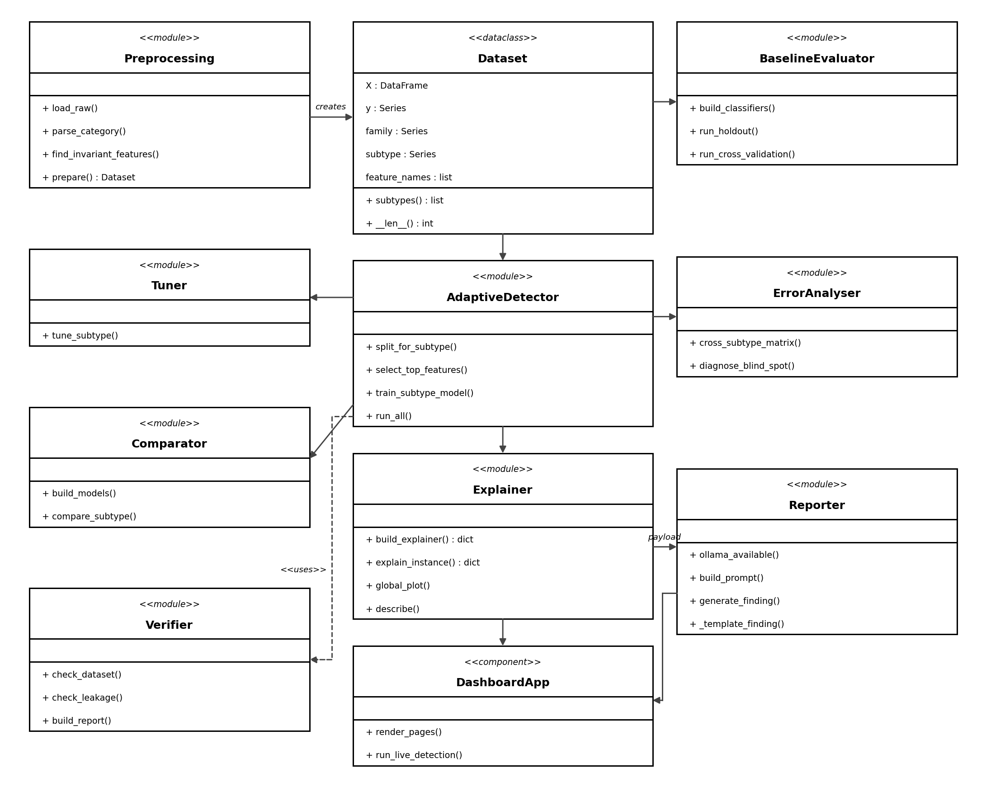
Figure 3. Class diagram of the implemented package.
Preprocessing creates the Dataset, which every other component consumes. AdaptiveDetector is the centre of the design, since the withheld subtype protocol it implements is what Tuner, Comparator, ErrorAnalyser and Explainer all operate on. Explainer passes a structured payload to Reporter, which is the only component that talks to anything outside the process. Verifier depends on the preparation and splitting operations in order to re-derive the splits and assert that they are disjoint, which is shown as a uses dependency rather than an association because it holds no reference of its own.

3.3 Sequence Diagram
Figure 4 traces the live detection scenario, which is the interaction a marker or an examiner is most likely to want to see demonstrated. The analyst chooses a detector and a sample on the dashboard. The dashboard builds the explainer context, which trains the reference detector once and caches it, then requests an explanation for the chosen sample.
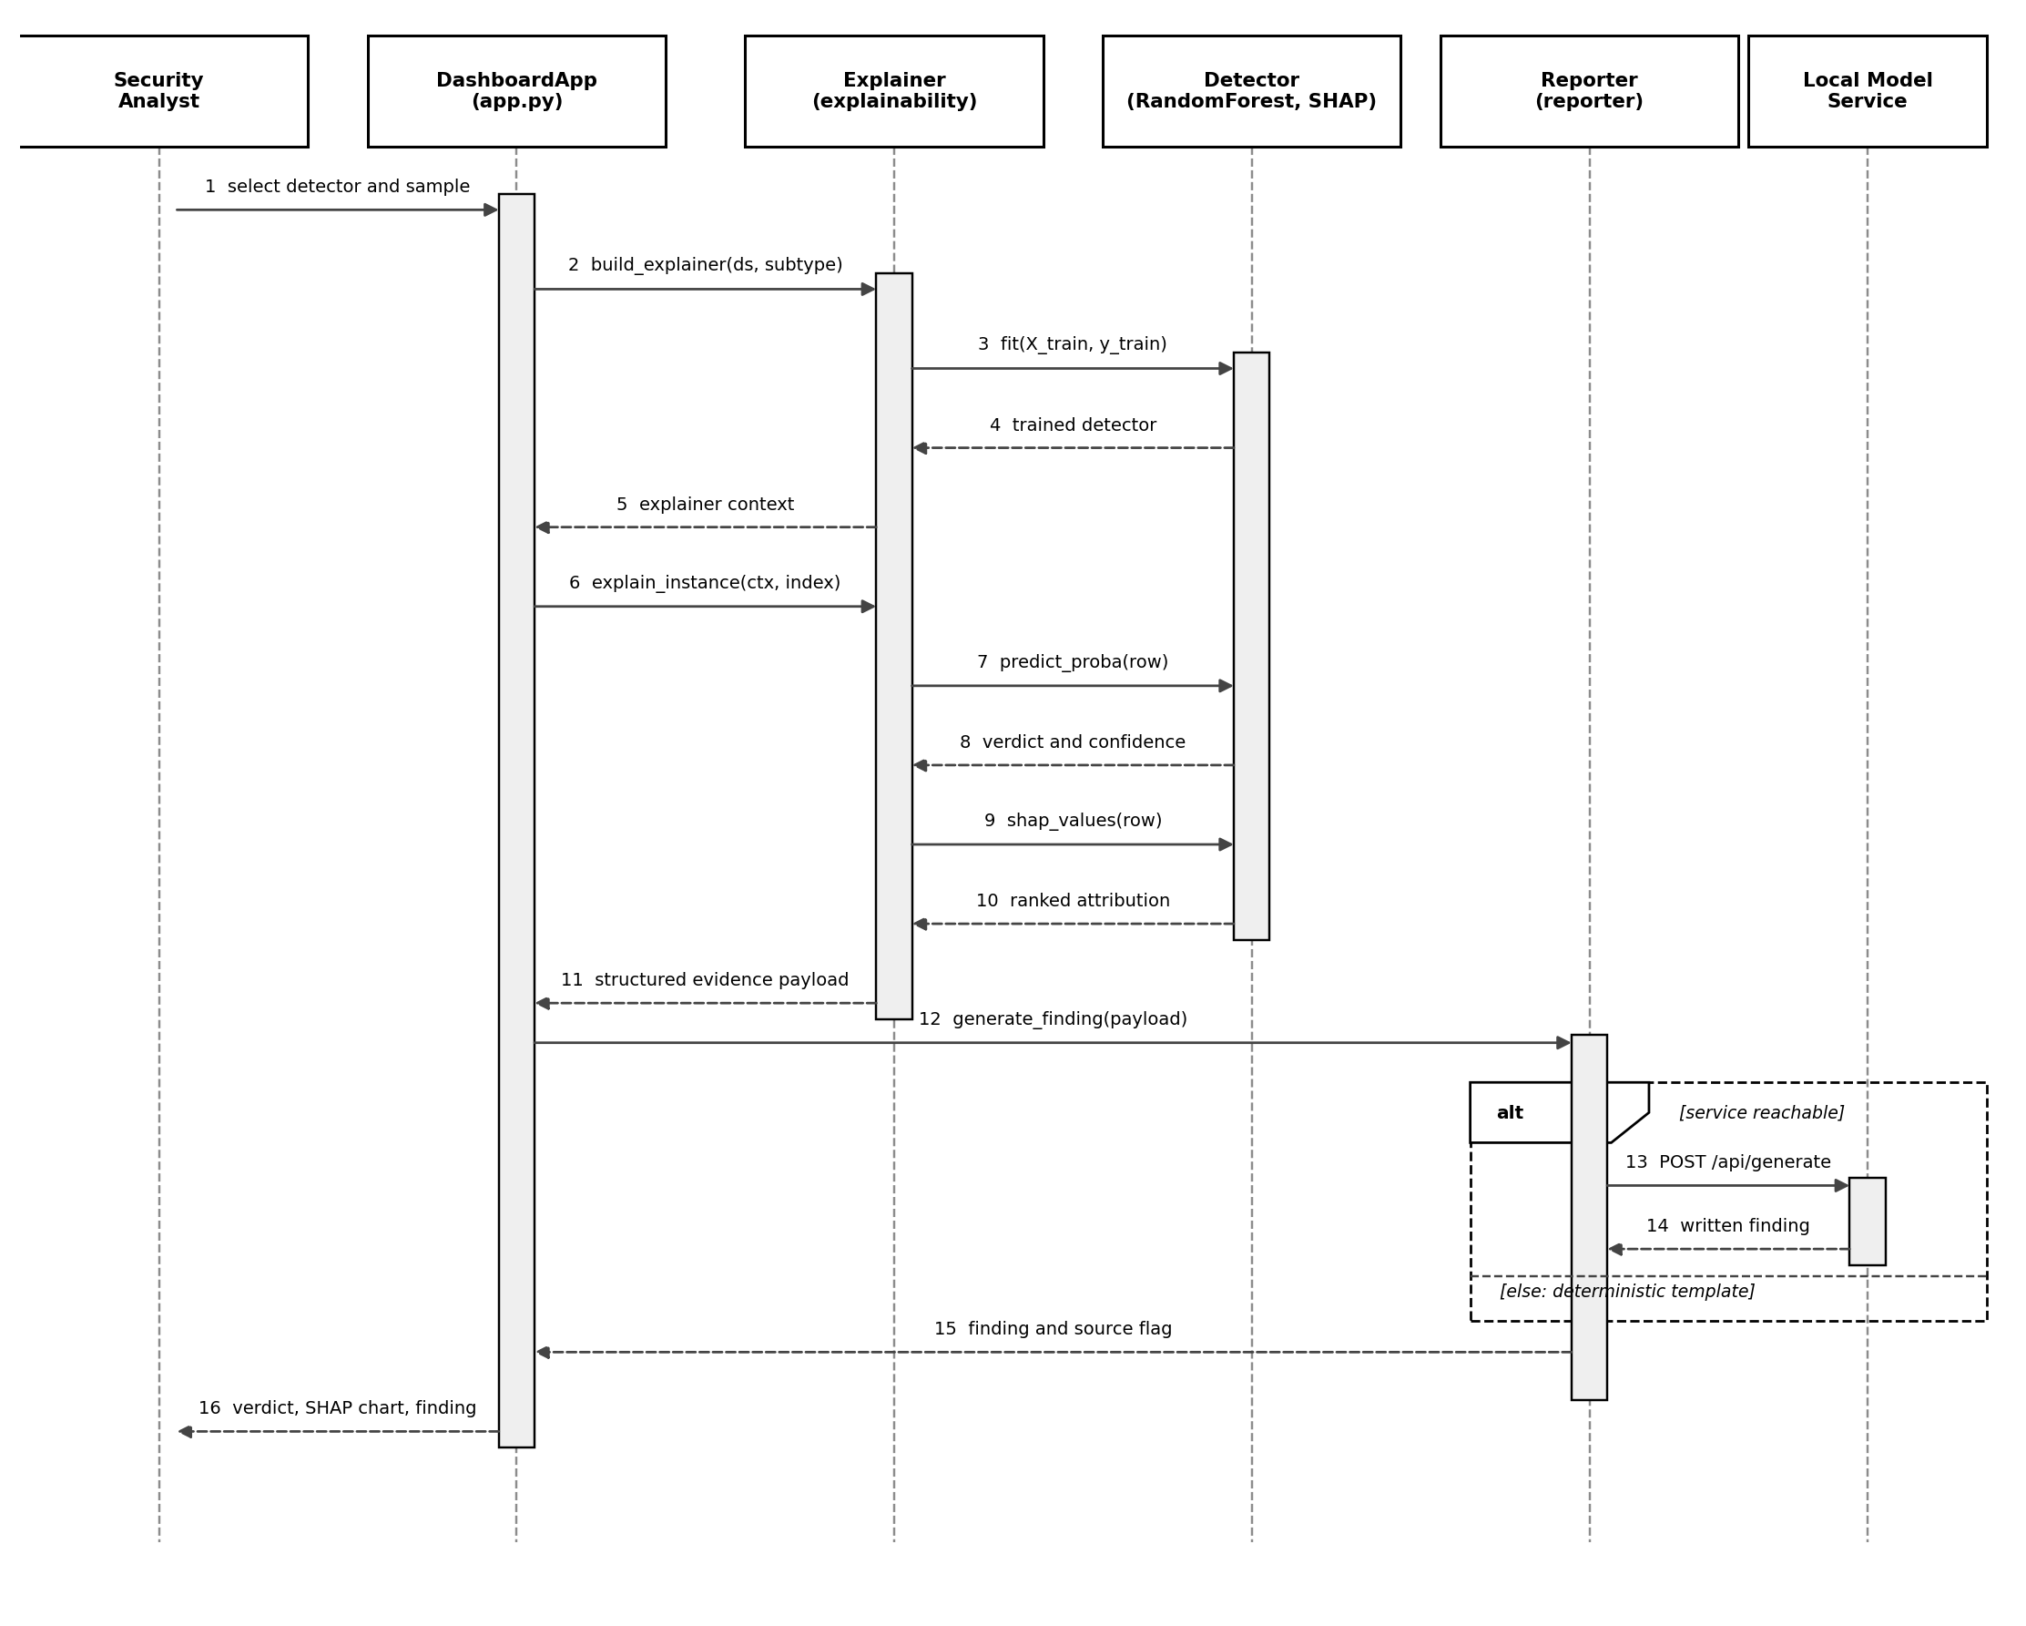
Figure 4. Sequence diagram for the live detection scenario.
The alternative fragment at the foot of the diagram is the part worth noting. When the local model service is reachable the reporter posts the evidence to it and receives a written finding. When it is not, the same call returns a finding assembled from a deterministic template, and the source is flagged so that the interface can state which path produced the text. The hosted deployment always takes the second branch, because no model service runs beside it.

3.4 Activity Diagram
The activity diagram is split across two figures for legibility. Figure 5 covers preparation, the per subtype loop and the three parallel evaluations. The integrity decision near the top is a real guard in the code and not a formality: if the record count does not match the published figure the pipeline raises an error and stops, rather than proceeding with a dataset that would silently invalidate every later comparison.
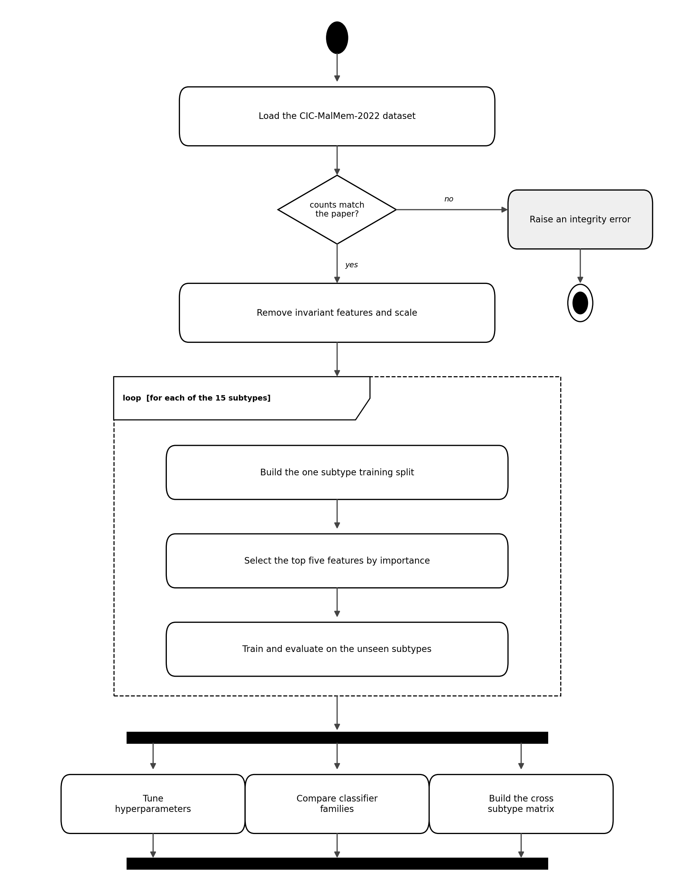
Figure 5. Activity diagram, training and evaluation.
The loop runs fifteen times, once per malware subtype, and each iteration builds its own split, selects its own five features and trains its own detector. The fork that follows is genuine concurrency in the logical sense rather than in the implementation: tuning, classifier comparison and the cross subtype matrix are independent of one another and depend only on what the loop produced, so they may be run in any order or in parallel.
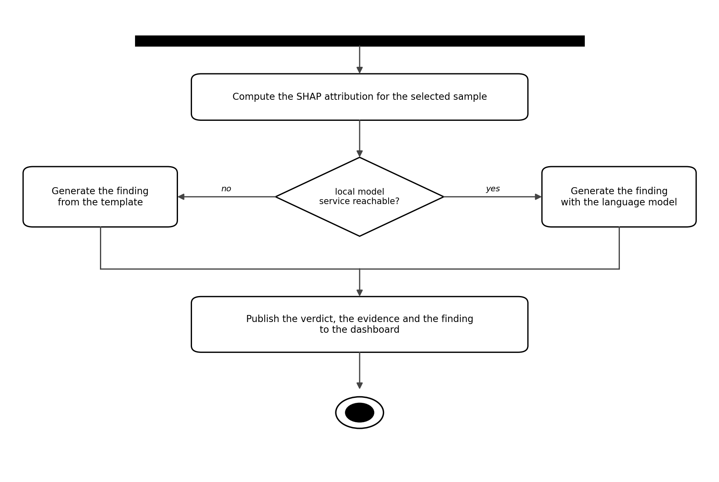
Figure 6. Activity diagram, explanation and reporting.
Figure 6 covers what happens for a single sample. The decision on the reachability of the local model service is the same branch that appears in the sequence diagram, expressed here as control flow rather than as message passing.

3.5 Component and Deployment Diagram
Figure 7 combines the component view with the deployment view, because the interesting fact about this system is that the same components behave differently depending on where they are deployed.
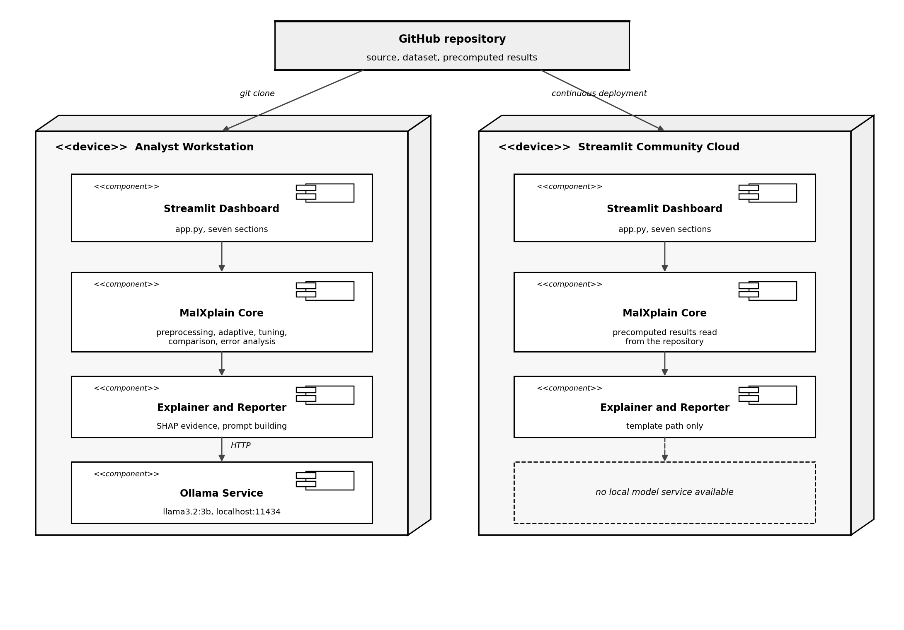
Figure 7. Component and deployment diagram.
Both nodes run the same dashboard and the same core, obtained from the same repository. The difference is the local model service. On the analyst workstation the reporter calls it over HTTP on the loopback interface, so findings are written by the language model. On Streamlit Community Cloud no such service exists, so the reporter takes the template path. This is why the hosted link demonstrates the pipeline and the evidence, while the language model layer is demonstrated locally.

4. Implementation

4.1 Repository Structure
The repository is public and contains the dataset, so a clone is immediately runnable without a separate download step.
malxplain/
data/Obfuscated-MalMem2022.csv the CIC-MalMem-2022 dataset
src/
preprocessing.py data preparation and integrity checks
baseline.py Stage 1, seven classifiers on known malware
adaptive.py Stage 2, fifteen withheld subtype detectors
tuning.py Enhancement 1, hyperparameter search
comparison.py Enhancement 2, five classifier families
error_analysis.py Enhancement 3, cross subtype matrix
explainability.py Enhancement 4, SHAP evidence payload
reporter.py language model reporting and fallback
verify.py leakage guards and fidelity report
charts.py, theme.py dashboard presentation helpers
app.py the Streamlit dashboard
scripts/setup.py one command bootstrap
results/ models/ figures/ generated outputs

4.2 Module Inventory
Table 1 lists each module, what it is responsible for and the operations it exposes. The operation names are exactly those in the source.
Module | Responsibility | Key operations
preprocessing.py | Load, validate and prepare the dataset | load_raw, parse_category, find_invariant_features, prepare
baseline.py | Reproduce the conventional split comparison | build_classifiers, run_holdout, run_cross_validation
adaptive.py | Withheld subtype protocol and detector training | split_for_subtype, select_top_features, train_subtype_model, run_all
tuning.py | Hyperparameter search inside the training split | tune_subtype
comparison.py | Five classifier families under the same protocol | build_models, compare_subtype
error_analysis.py | Cross subtype recall matrix and diagnosis | cross_subtype_matrix, diagnose_blind_spot
explainability.py | SHAP attribution and evidence payload | build_explainer, explain_instance, global_plot, describe
reporter.py | Written finding, with a template fallback | ollama_available, build_prompt, generate_finding
verify.py | Leakage guards and the fidelity report | check_dataset, check_leakage, build_report
charts.py, theme.py | Dashboard figures and visual styling | reproduction_chart, blindspot_heatmap, shap_bar
app.py | Seven section dashboard and live detection | page rendering, cached model loading
Table 1. Module inventory.

4.3 Execution Order and Runtime
The modules are designed to run in order, since each stage consumes what the previous one wrote. Table 2 gives the order and the measured runtime on the development machine. These timings are for the full pipeline and are the reason the hosted dashboard reads precomputed results rather than recomputing them on each visit.
Step | Command | Approximate runtime
1 | python -m src.preprocessing | under 1 minute
2 | python -m src.baseline | about 3 minutes
3 | python -m src.adaptive | about 4 minutes
4 | python -m src.tuning | about 8 minutes
5 | python -m src.comparison | about 6 minutes
6 | python -m src.error_analysis | about 4 minutes
7 | python -m src.explainability | about 2 minutes
8 | python -m src.verify | under 1 minute
Table 2. Execution order and measured runtime.

4.4 The Colab Notebook
The Python implementation is also provided as a single Colab notebook, organised so that each stage of the pipeline occupies its own cell and can be run and inspected independently. The first cell clones the repository and installs the dependencies, after which the stages run in the order given in Table 2. Two behaviours differ from a local run and are stated in the notebook itself. There is no language model service on Colab, so the reporting cell takes the template path and prints the source flag that says so. The full pipeline takes roughly half an hour on a Colab runtime, so the notebook also offers a shorter path that loads the precomputed results committed to the repository, which lets every figure be reproduced in under a minute.

4.5 Deployment and Links
The repository is at https://github.com/spy-ka-y/malxplain and all three team members have write access to it.
The dashboard is deployed at https://malxplain.streamlit.app and redeploys automatically on every push to the main branch. Seven sections are available: an overview, the reproduction results, each of the four enhancements, and a live detection page on which a memory dump sample can be selected, classified, explained and reported on interactively.

4.6 Results Verified So Far
Table 3 reports the state of the reproduction as measured by the verification module, which recomputes each figure rather than restating it.
Check | Base paper | MalXplain | Status
Dataset records | 58,596 | 58,596 | exact match
Features after removing invariants | 52 | 52 | detected independently
Stage 1 best classifier | Random Forest | Random Forest | max deviation 0.0006
Detectors above 99 percent | 11 of 15 | 11 of 15 | exact match
Mean absolute deviation | not applicable | 0.0023 | faithful
Training sets balanced 50/50 | by design | all 15 splits | asserted
Train and test disjointness | by design | all 15 splits | asserted
Lowest performing subtype | Zeus | Zeus | same subtype
Table 3. Verified results against the base paper.
The principal original finding so far comes from the cross subtype matrix. TIBS is detected at only 87.8 percent mean recall when it is unseen, falling to about 64 percent for the Zeus, Ako and Refroso detectors, a weakness that an aggregate accuracy figure hides entirely. Feature level diagnosis shows that the missed TIBS samples carry a markedly higher average number of loaded libraries per process, which makes them resemble benign software.

5. Phase 2 Deliverables
Table 4 maps each item the brief asks for to where it is found.
Deliverable | Where it is
Functional block diagram | Figure 1, Section 2
UML diagrams | Figures 2 to 7, Section 3
Python implementation organised in a Colab notebook | Notebook submitted alongside this document, described in Section 4.4
Remaining project files as a ZIP | Archive submitted alongside this document
GitHub link | https://github.com/spy-ka-y/malxplain
Running system | https://malxplain.streamlit.app
Table 4. Phase 2 deliverables and where each one is found.

References
[1] O. A. Madamidola, F. Ngobigha and A. Ez-zizi, "Detecting new obfuscated malware variants: A lightweight and interpretable machine learning approach," Intelligent Systems with Applications, vol. 25, 200472, 2024. doi: 10.1016/j.iswa.2024.200472
[2] Canadian Institute for Cybersecurity, University of New Brunswick, "CIC-MalMem-2022 obfuscated malware memory dump dataset," 2022.

