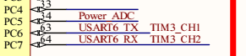C:\Users\Administrator\AppData\Roaming\Tencent\Users\2846191416\QQ\WinTemp\RichOle\M~~[`L[ZNZ1FWA1}G5ZINLE.png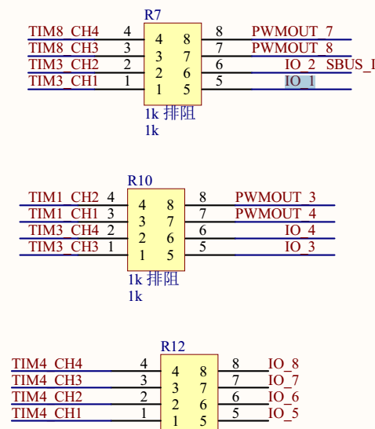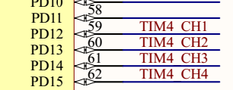

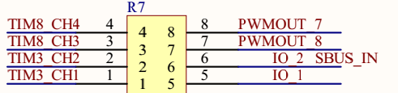



|  |  |  |  |  |  |  |  |  |  |
| --- | --- | --- | --- | --- | --- | --- | --- | --- | --- |
| Io | Aux1 | Aux2 | Aux3 | Aux4 | Aux5 | Aux6 | Aux7 | Aux8 |  |
| Cpu io | Pc6 | Pc7 | PB0 | PB1 | PD12 | PD13 | PD14 | PD15 |  |