For this project I choose to use an HTML table to represent the grid of the A\* Pathfinding, it kind of looks like a tabletop game. The user will click on a start point with the first click and an end point with the second click; then the path will be drawn instantly from the start point to the end point and the h(x), g(x), f(x) values will be displayed in each cell. And the final steps and path length will be displayed in a box at the bottom of the screen. The grid can be configured at the bottom as well as the obstacles, simply enter the number of rows and columns desires and the grid will be repopulated. Enter the index number of a certain cell to change it to an obstacle, do this before setting start and end points.

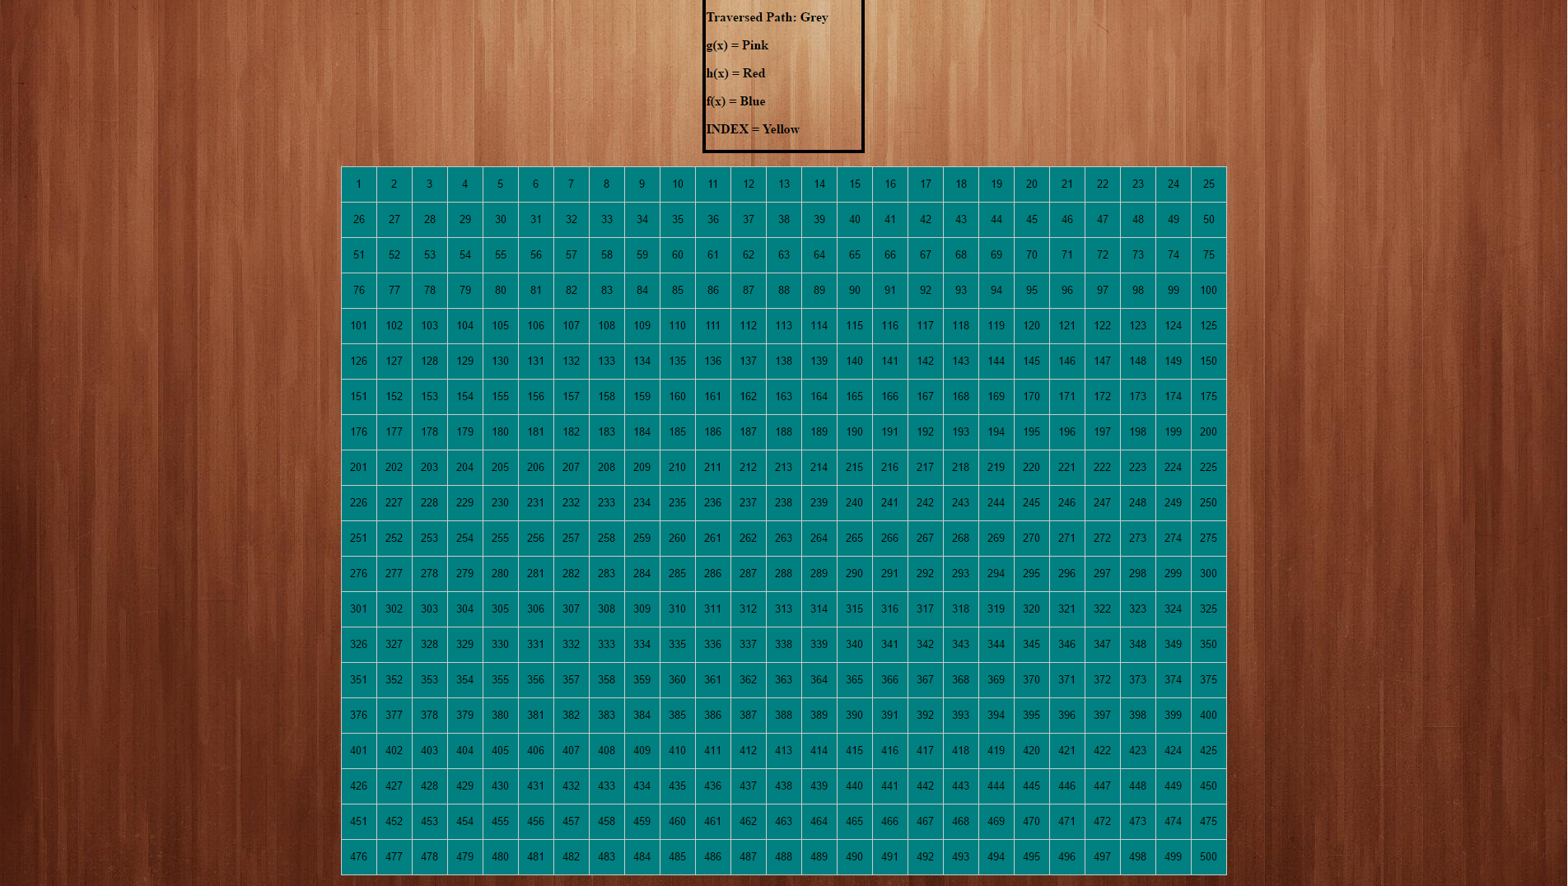

Here is the grid starting out

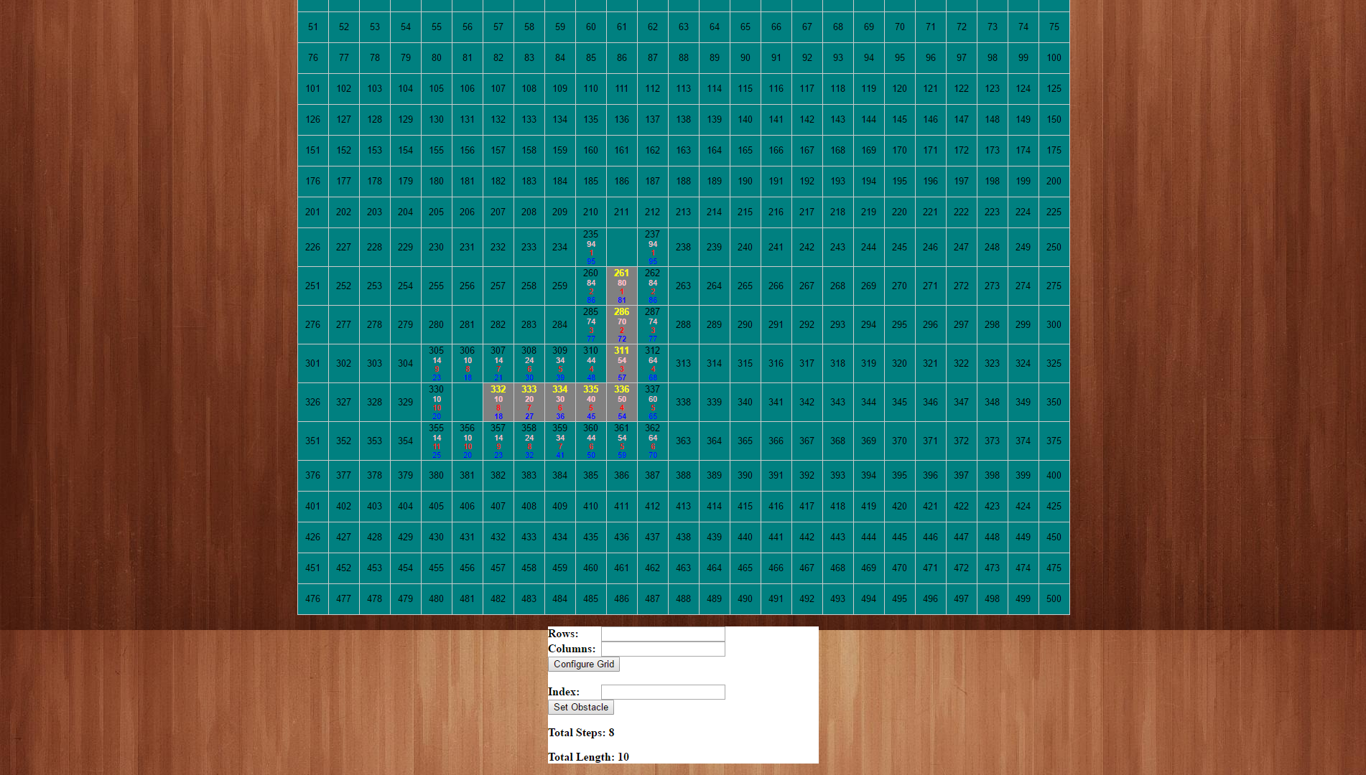

Here is the grid after clicking on a start point and end point, as you can see the steps and length is drawn at the bottom